OR Society People Analytics Special Interest Group
AGM 18th September 2018

Background
The People Analytics Special Interest Group has been running for just over a year, having been set up in July 2017. At the time of the AGM the group had 113 subscribers, of whom 75 were Operational Research Society members.

Our first meeting was on 17th April 2018. We heard from a range of speakers about different aspects of People Analytics:

Time to Hire and Recruitment Diversity Reports (Konrad Wyszogrodzki - Ministry of Justice)

Forecasting the Age of the DWP’s future workforce (Shane Kennedy – Department for Work and Pensions)

Equality and diversity in the legal profession: Using administrative data to understand intersectional penalties and privileges (Dr. Danat Valizade - Leeds University), and

People Analytics: The state of the field (Andy Charlwood - Leeds University).
The AGM took place during our second meeting on 18th September 2018. At this meeting we had talks about
- Demonstrating the alignment between analytics and business needs: Linking HR process and function to workforce productivity and business success - James Holdstock (TfL), Feraz Ishfaq (Financial Times)
- How McKinsey use advanced analytics in their people decisions - Keith McNulty, McKinsey
- People analytics: are businesses using people data to its full potential? - Edward Houghton, Head of Research and Thought Leadership, CIPD

A write up of the talks will be shared on the People Analytics SIG pages on the OR Society website: https://www.theorsociety.com/Pages/SpecialInterest/PeopleAnalytics.aspx

AGM
During the AGM, the chair, Jill Millichamp called for additional volunteers for the committee (offers were received from Hazel Challenger, Catriona Smith and Kate Brosnan), and it was agreed that the committee would be formed thus:
Chair: Jill Millichamp (DWP) –Call, officiate and conduct meetings
Secretary: Tommy Fennelly (IBM) – minutes the meeting, keeps membership up to date, Updates Future meetings page of OR Society
Event Communications: Katie Gronow (DfT) – advertises events and writes report for HR Society
Event Planning: to be covered by other committee members – organises room/Video Conference/speakers
Other volunteers are always welcome to help with organising events or suggesting speakers, or to take a core role on the committee (please get in touch with JILL.MILLICHAMP@DWP.GSI.GOV.UK if you wish to get involved in any way).
It was agreed that the Terms of Reference for the group would stay the same.

Finding out about our group
We used the September meeting to find out about the member of our group, and those who attended the meeting – we wanted to know about the areas they worked in, what their interested were, and what they wanted from the SIG.
Question 1: How would you describe your role?
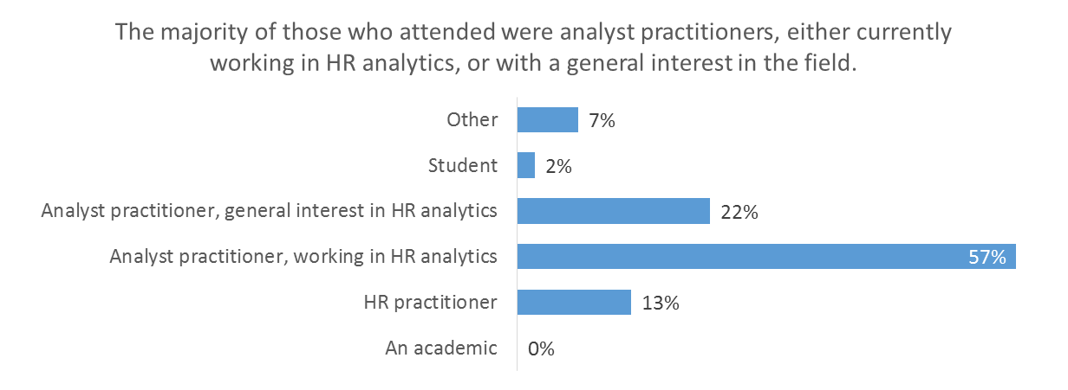

Question 2: What are the main areas you work in in People Analytics (up to 3 answers each)
Question 3: Why are you here and/or what are you hoping to get from the People Analytics SIG?
Responses to this question could be broadly categorised into the following groups (number of responses in brackets)
- To find out more about how other people/organisations do People Analytics - tools, techniques, best practise, etc (31)
- The find out what People analytics is being done elsewhere – what problems is it addressing, what innovative and new ideas are being looked at, what are the latest trends, and what is having an impact (25)
- For networking (9)
- To find out about how HR and analysis functions are structured and work together in different organisations (8)
- For general interest (7)
- For benchmarking (2)

Katie Gronow
10/10/2018

