A Principled Basis for Decision: Enduring Operational Research (OR) subjects and principles for Quality Assured Analytics
Ian M. Mitchell ª
ª Department for Business Energy and Industrial Strategy , London, UK
Ian.Mitchell@beis.gov.uk

Abstract
In a world of change, some things don't. This paper proposes that efficiency, effectiveness, human interactions and behaviour remain perennial foci for many OR analytic models and that quality analytics depend on perennial principles of assurance. Professor Pat Rivett's three subjects for his 1964 BBC documentary about Operational Research: Cutting the Queue, Playing It Through and The Human Factor, are examples of analysis of efficiency, effectiveness and behavioural OR. These remained major subjects for OR in 2018 although the means to analyse them have evolved. Confidence in analysis is the other perennial aspect. The presentation describes the Department for Business Energy and Industrial Strategy (BEIS) approach to model assurance. Analytical tools for Big Data and Artificial Intelligence provide wider domains for OR. In that wider domain clarity of purpose and assurance of quality will remain essential enablers for a principled basis for decision.
Keywords: Quality Assurance; efficiency; effectiveness; interaction; behaviour; Basis for Decision ; Pat Rivett
Introduction
2018 saw OR60, the Diamond Anniversary of the annual OR conferences in Britain. The occasion was an opportunity to celebrate the longevity of the discipline and the success of the pioneers who embedded OR as a basis for decision into British industry, academia and government.
Professor Pat Rivett was President of the OR Society in 1962-63 and took up the first chair of Operational Research at a British University in 1964. He introduced OR, the science of complexity, to Britain in 1964, presenting “Basis For Decision”, three 45-minute episodes on the new television channel BBC2.
Watching these it is striking how many of his comments remained relevant in 2018. Some subjects of OR also remain perennial as does the essential need for confidence in any analysis to adopt it as the basis for decision.
This paper reviews the content of the “Basis For Decision” programmes, and books by Rivett over the next 30 years. It describes the Modelling Integrity approach in use by the Department for Business Energy and Industrial Strategy (BEIS). It discusses perennial principles, concluding that OR remains a pioneering socio-technical process. These include those identified and explored by Pat Rivett over the course of some 30 years.

“Basis For Decision” – the Television Programme
2.1 Recovering History
In 2010 the author joined the Operational Research Unit (ORU) at the Department for Business Innovation and Skills. Maurice Kirby’s book on the British Experience of Operational Research (OR) prompted conversation with Richard Fitzgerald of the ORU about a British Broadcasting Corporation (BBC) programme on OR. Richard had obtained BBC records of what had been shown at 8pm on Tuesdays starting on 14 July 1964, the Programme As Broadcast (PAsB), and confirmed that the BBC no longer had copies of “Basis For Decision.” The three episodes were “Cutting the Queue”, “Playing it Through” and “The Human Factor”.
On browsing the OR Society Archive listing the author noted that there were two untitled 16mm film cans each containing 45 minutes of footage. Inquiry to the archivist revealed that these were the first two episodes of “Basis For Decision”. The archive had no means to play them so the BBC was offered the films to restore part of their corporate history and to make these available within the OR Society on modern technology.
In 2012 the first two episodes arrived on DVD from the BBC. They were impressive in scope and inspired the hunt for the missing third episode. The International Labour Organisation (ILO) held copies until the 1980s; “Basis for Decision” had achieved international impact and it was this impact that led to the recovery of the third episode. In 2013 we learned that Australia’s Sydney and Monash Universities both had copies of “The Human Factor.” Monash University was willing to send their copy and so in April 2016 the third episode at last became available in a viewable format in the UK.
The first, second and part of the third programmes comprise case studies. These show a spectrum of approaches in use on a range of operations. The last part of the third programme is a debate about the uses and limitations of OR. The emphasis on the social aspects of OR increases through the series. The importance of value judgements becomes clear in the third part as do the challenges from political pressures.
The next sub-sections describe each of the episodes.
2.2 Episode 1 Cutting the Queue
The first programme opens showing men in suits around a table, some smoking, talking about a pressing problem. Their problem is the number of ships idling in Swansea Bay waiting to unload for the Steel Company of Wales. From the studio Rivett introduces the significance of the problem; the idle ships drive the cost of living: Transport costs add to the cost of steel, so this affects the wider UK economy because so many things contain steel or are made on machines themselves made from steel. He mentions the origin of OR as the scientific study of military operations, which spread to scientific observation and analysis to solve complex management problems, and that “Complexity is my business.”
Rivett suggests that complexity is only skin deep, and that there are eight types of structure, each being a skeleton of cause and effect. Although the structures are not listed in the programmes the 1963 “Manager’s Guide to OR” which he wrote with Russell L Ackoff lists them as do his books in 1968 “Concepts of OR and 1994, “The Craft of Decision Modelling”.
The Port Talbot problem can be addressed by using the queuing structure of In Service Out. Figure 1 is the example figure for the template for this abstract; it is an example of a perennial OR subject and approach, describing the same structure that Rivett used to model the problem in Port Talbot in 1964.

Figure 1 Input/output diagram

Figure 2 shows the diagram from “Basis For Decision”, representing the unloading of a ship.

Figure 2 In Service Output diagram from “Basis For Decision”

Rivett explains that OR uses an In Service Out structure to model the ore unloading problem. The same structure can be applied to similar situations such as busses, trains, post offices and factories; anywhere where losing time is the key factor. Port Talbot is a tidal port, so the size of ships interacts with tides, and the layout of the port to determine the amount of iron ore delivered. There are two interested organisations, a shipping company and a steel company. Reduction of time in queues is the problem for both. The cost of the waiting ships has a trade off with the additional costs from unloading the ships faster so finding a fair share of the costs is essential to the success of both companies.
Rivett then introduces John Murdoch from the Cranfield College of Aeronautics who demonstrates a mechanical model of a factory store, with figurines moving from a queue to a service counter then away. Matching average rates directly between input and output results in lengthening queues of the figurines at the factory store. A graph of the optimal solution for the system design (Figure 3) shows that a compromise between acceptable queue length “not too long” and acceptable idle time “not too high” for the storeman has to be found.
Figure 3 Diagram of average queue length (x) to average idle storeman time (y)
In passing Rivett mentions the use of statistics or the mathematics of probability and that all post offices are going over to a system with each desk offering all services in order to reduce queues. Ray Jackson describes his model of a Doctor’s Surgery to compare waiting times for patients and doctors resulting from an appointment-based system using 4-minute, 5 minute and 6-minute intervals compared with the former first come first served approach, that could lead to waiting times of over 90 minutes.
A doctor concludes that he would never return to this previous system. That such appointment systems are now near universal is a reminder of how an innovation becomes the new normal.
Observing that “Whenever we have a problem in OR we build a model of it” Rivett demonstrates the use of a model of a system representing the essential features of the problem, demonstrating a physical analogue model (Figure 4) to optimise the location of a factory acting as a distribution centre for the UK.

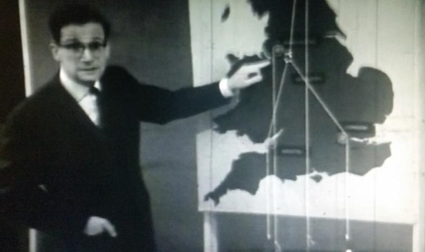
Figure 4 A Physical Model for Factory Location
A metal ring is positioned by the combined pulls of weights representing the number of lorryloads going to each of several destinations, 10 to Newcastle, 40 to Manchester, 20 to Bristol and 40 to London. Where the ring ends up shows the most efficient location for the distribution centre; Coventry would be the cheapest location. This physical linear program can show how much additional force representing additional travel costs is needed to move the ring to somewhere more attractive, such as Stratford on Avon.
Mathematical models enable experiments to be done quickly at low cost. Reconciliation of conflicting aims through analysis can reduce conflict between different people with different objectives. David Owen and Roger Grison of the British Iron and Steel Research Association (BISRA) discuss Port Talbot, with footage from there and Newport showing how ships can be unloaded using different types of crane. Port costs and shipping costs offset one another and graphs of the time to unload show a shared optimal point is a compromise at 50% idle time for the berths.
A Mr Thomas describes a model used for experiments of the whole port of Port Talbot, considering spring and neep tides and how these affect delay times for ships then their unloading at berths. Historic records showed the patterns of how ships arrived providing input data. The Swansea Bay model required one hour of computer time to produce six months of schedule giving shipping delays. Experiments included effects of dredging on arrival rates to assess whether the consequent increase in despatch bonuses offset costs of dredging. Mr Cartwright of management, in suit and hard hat on the dock side, endorses the analysis: “OR has greatly assisted in reducing the area of uncertainty surrounding many of these decisions.”
Rivett describes stock control as a problem with levels of stock being 30% higher than necessary, recommending use of the mathematics of variability.
Ian Davidson interviews National Coal Board Chairman Lord Robens of Woldingham who identifies OR as one of the “greatest tools of management” saving hundreds of thousands of pounds per year with application to any complex managerial problem, including stocks. From his place on the National Economic Development Council (NEDC) Lord Robens’s view is that if every firm in this country used OR the result would be a 4% increase in Gross National Product (GNP) “quite easily”. Rivett concludes the episode defining the purpose of OR to: “provide the people controlling these operations with a firmer “Basis For Decision”.”

2.3 Episode 2 Playing It Through
Rivett uses The Great Train Robbery to illustrate the technique of Critical Path Scheduling (CPS) or Network Planning as shown in Figure 5.
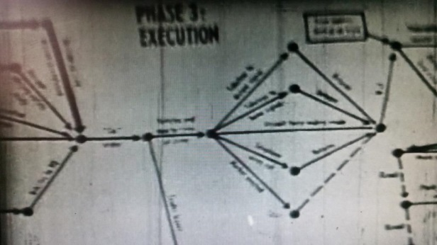
Figure 5 A Network Model for Armed Robbery
He moves to construction of a factory, then preparation of a Sunday Lunch, translating critical path network to time chart before introducing the use of CPS for construction of buildings, then merchant and passenger ships.
A Mr Morrison talks over ship blueprints and charts of “ladders” grouping task lists. Computer based scheduling enables confidence in offering delivery of a ship for a firm contract date. These task diagrams assisted in communication between firms. Lithgow’s work on the ‘Oriana’ installed an extra crane and made use of pre-cut sections to speed up the build. Networks were also used for Kincaid’s work on engine building for the ‘Oriana.’ This illustrated that by reviewing the situation as it developed, Network Planning suggested ways to change the operation in order to preserve the schedule for the benefit of both organisations.
Rivett summarises shipbuilding as a large scale but pretty simple scheduling structure. He contrasts this with the complex food production where variability in the rates of flow causes problems beyond the reach of calculation. This introduces the need for experiments. He uses the example of a pedestrian trying to cross Picadilly Circus to explain the benefits of experiments with physical or mathematical models; simulations that can develop understanding of the likely range of outcomes to inform planning and implementation.
Dr KD Tocher introduces the United Steel sequence of processes as a complete “system” of steel production with the Rolling Mill as the limiting step. He explains the challenges arising from the variable nature of different processes and the need for decisions hours in advance of implementation. Experiments in simulation explored how to avoid “a vicious spiral” of delay that could lead to disastrous loss of production. Using a computer simulation needed a whole new language to build a computer model of the operations. To see whether the computer model was valid real managers provided a realistic plan to test it. The simulations are also shown as a way to exercise new managers testing their decisions.
The last section describes wargaming at West Byfleet in the Army Operational Research Establishment (AORE). Rivett introduces Ronald Shephard, later Professor Ronnie Shephard, the founder of the International Symposia for Military Operational Research (ISMOR) as shown in Figure 6.
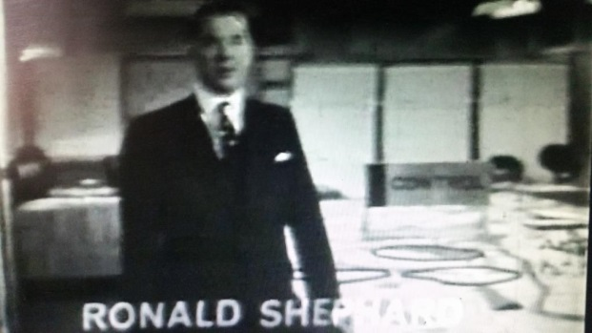
Figure 6 Ronald Shephard beside the West Byfleet Wargame Control map
This section illustrates the pioneering use of games for analysis for situations, driven by value judgements from humans, for example trading ground for casualties or time. Information available is limited to the players based on what their forces are modelled as being able to see. The outcome of many actions in battle are subject to the laws of chance. The computer here provides a random number generator to resolve chance interactions tabulated in a classified book of rules. Shephard notes that “The validity of the book of rules is of the utmost importance” depending on field trials, historical analysis and military judgement.
Rivett summarises that problems of complexity may be beyond calculation but experimental simulations can provide guidelines for decision.
2.4 Episode 3 The Human Factor
Episode 3 opens with Ian Davidson interviewing Lord Robens on Pit Closures and OR’s contribution to manpower problems. Rivett introduces the idea of 4 balls to juggle with in any management problem: illustrating these as 4Ms - Machines –Materials- Money and Men.

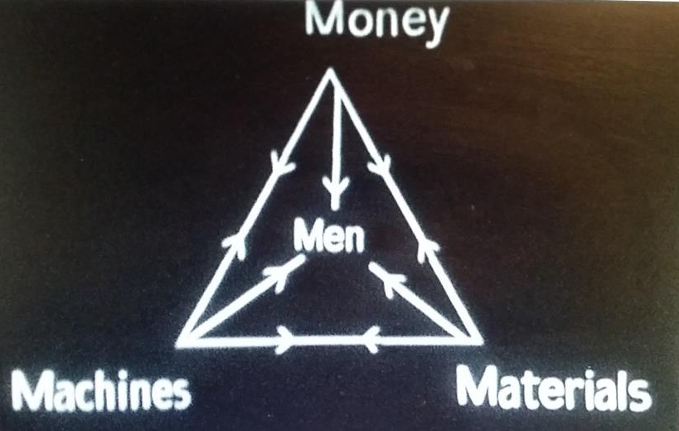
Figure 7 The 4Ms
He notes that the first two episodes considered machines, materials and money as the dominant factors. The fourth M stands for men, by which Rivett means everyone on the payroll; those running the organisation and working in it. Where the human factor is the dominating factor in a problem OR must tackle it directly so there are overlaps with social science. He emphasises OR as a “practical action science” solving problems rather than building an academic understanding of human nature.
Dr BT Houlden, Director of OR at the National Coal Board, describes a study of 60 factors covering thousands of miners and ex-miners of which distance to work from home and length of service were the most important factors to estimate numbers of miners willing to move between pits. This informed recruiting strategy but not the wider social impact. Lord Robens explains the operational impact of these individual decisions on the pit closures under consideration. Rivett compares the benefit of using purely external factors to inform mine planning moving to Professor RW Revans of Manchester’s study of internal factors, on the morale on a hospital’s effectiveness and reduce waiting lists.
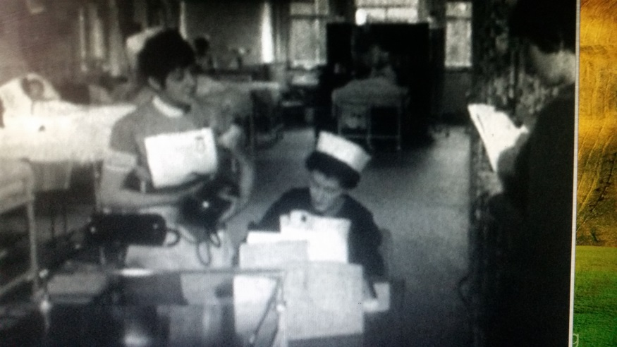
Figure 8 Observer and observed in Hospital
The study used Activity Sampling for the first time in this country. Observations were made at random intervals selected with a random number chart to achieve a random sample. The metrics were student nursing wastage rates and the duration of patient stays by type of illness. The latter varied between 7.5 to 12.1 days in a direct correlation to the wastage rate. The next stage looked for a factor driving these results.
The programme shows female observers talking to Ward Sisters and student nurses in interviews. These informed the design of structured questionnaires with agree or disagree scales to measure attitudes to superiors and subordinates. A study of 15 Hospitals found strong correlation between the quality of Sisters’ attitudes (morale) and the metrics of effectiveness (patient stays) and efficiency (nurse wastage). In a low morale hospital communication suffers as orders go down the hierarchy but little valuable information returns so the organisations cannot adapt to change because they lack feedback and become extremely anxious places to work.
Rivett suggests future uses of OR may move to marketing, the effect on sales of advertising and discounts. This is in keeping with OR’s introduction of measurement to areas not previously measured. He suggests that Government is the biggest potential area for OR and introduces three speakers, one for each of local government; central government; and governments of undeveloped countries.
Ray Ward describes Local Government OR on efficiency of routine and clerical operations such as stock control and school transport looking 10 years ahead planning by estimating children populations and the extent of built up areas to generate these.
Stafford Beer notes “a strange void when it comes to government”, a lack of scientific appraisals for decisions on policy making in civil government. He emphasises that OR is at its most worthwhile addressing large and complex systems too involved to fit into the head. Despite accepting OR models of flows of traffic past a roundabout, he notes a steadfast refusal to discuss the national transport problem as a whole, “Government needs to make models of most aspects of the economy”; OR is not just any type of “coherent thinking”.
Beer mentions his work for Puerto Rico and notes use of OR for US Defence administration, city planning, reorganisation of the Patent Office, Post Office operations and public health. In the United States funding drives studies at the national level. In France economic recovery was supported by the Commissariat aux Plans. This has urban and regional development plans for Rennes, Nantes, Grenoble, La Rochelle and Paris. These cover hospitals, schools, transportation, fuel, power and agriculture. They informed the Common Market negotiations. Russia may be slow with OR within the individual firm but is using models from cybernetics to study the redesign the structure of the state.
Sir Charles F Goodeve notes governments deciding to act without precise knowledge are like “Driving in a Fog”. His experience in India, found prime objectives were focused on national needs and so were more obvious than in the UK where questions turn on the division of affluence. He describes steel forecasts where studies found that the new factor of positive feedback that would come from initial demand for steel would lead to a landslide in demand so raising the forecast need for steel by a factor of 10 to 1 million ingot tons per year.
Rivett introduces a debate on the limits to OR. Figure 9 shows Ian Davidson in the centre chairing, from left, Denzil Freeth MP, Parliamentary Secretary for Science, and John Barber, Financial Director of the Ford Motor Company leading on the limits to OR, with Professor GA Barnard, the President of the OR Society and Stafford Beer to argue against these.

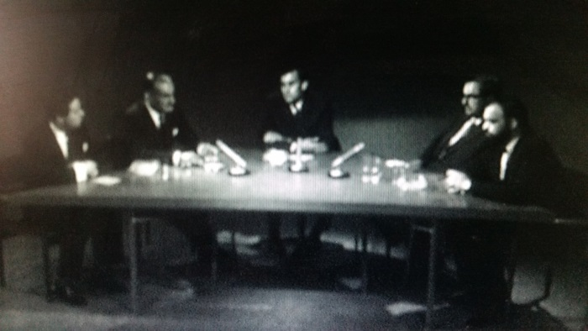
Figure 9 Debating the limitations of OR
Freeth proposes three limitations to the applicability of OR; unknowns, value judgements and unique decision points.
Where there are many unknowns or a key factor must be unknown, the government has to take a hunch decision. For example, for the British and French Governments to decide whether to invest in Concorde, a key factor was whether it would pay which depended on competition, yet there was no way of knowing if Russia would enter this field. Barnard replies that certain factors may be unknowable or unmeasurable but creating a model makes explicit the relationships involved, exposing many otherwise hidden factors. Statistics, defined as decision making in the face of uncertainty, can also be helpful.
Freeth argues that decisions that are value judgements are not amenable to being put into a computer. The selection of route of the M4 motorway over the Berkshire Downs turned on amenity and aesthetic judgements to put against economic effects. Beer replies that economic benefit and disturbance to amenity can be measured; 90% of what people regard as important can be measured although people do not believe that this can be done. Freeth emphasises the aesthetics; in theory one can produce a situation on paper to upset the least number of people for the best effect for each route. In life it is often the people who are rarely interested who are the ones who need to be satisfied.
Freeth’s second point was that decisions in government or industry are often unique and taken with great speed, such as whether to go to war or not, for the firm to react to a takeover bid, and for the individual on whether to marry or not. Barnard replies that Dynamic Programming in OR considers how to trade delay in making a decision versus the quality of decision made. During the Suez Crisis oil companies used computer models of movements to reroute tankers rapidly moving oil via alternative routes.
Barber notes that the most common complaint is the lack of data. Companies that naturally produce data like chemical and oil also have high capital expenditure for expensive assets. These produce data by their nature so are where OR has had its greatest effect; people heavy organisations are more difficult to help because the facts are not there, lending support for the establishment of a British Business School. Barnard notes that Management tend to run businesses to make products but businesses should generate information about their products to improve these.
Rivett sums up OR as an applied science that deals with two forms of problem: intellectual ones about models and practical ones about working with people in their organisations. Measuring things that have not been measured before is where OR can make the greatest contribution; this is its pioneering aspect. Rivett concludes with the hope that:
“as our research continues that our help to management will expand not only at the executive level but at the policy level so that Managers at all levels have a firmer Basis for Decisions on industry and government.”
The final frame is shown in Figure 10 “Basis for Decision” overlaid on the Houses of Parliament.
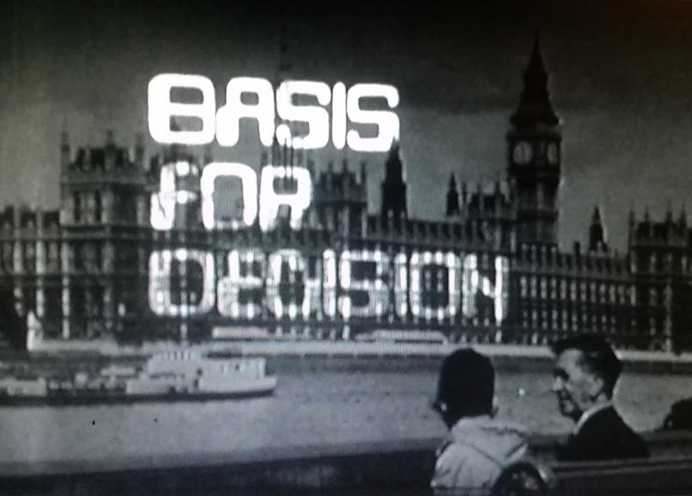
Figure 10 Closing image from “The Human Factor”

Perennials
Rivett’s books from 1963, 1968 and 1994 complement the 1964 BBC series. Rivett mentioned eight structures in the first episode but did not describe what these were. The 1963 Guide on page 63 lists the eight describing them as the Form and Content of Problems. They appear in 1968 as section titles of the chapter on Formulation of Problems, in a different order and without Routing.
1963 1968
1.Inventory Inventory
2.Allocation Allocation
3.Queuing Queuing
4. Sequencing Sequencing
5. Routing -
6.Replacement Replacement and Maintenance
7. Competition Competition
8. Search Search
The 1968 book also has separate chapters on the methodology of model building, queueing, allocation and competitive problems and simulation. Its preface acknowledges the influence of several who presented their work in “Basis for Decision” - Eddison, Owen, Stafford Beer, R.W.Shephard and Professor K.D. Tocher. Many of the examples illustrated in the programme appear in the text. The Queueing chapter’s examples echo sequences from “Cutting the Queue” such as offloading iron ore at a port. “Playing It Through”’s wargames and steel production appear in the chapter on simulation. The Human Problems chapter opens with the same 4Ms as “The Human Factor” episode.
The chapter on synthesis emphasises the importance of models lying “at the core of the operational research method”.

Quality Assurance of Models.
There are many forms of model. Rivett demonstrated a variety of physical analogues in “Basis For Decision” as well as mathematical models. The forms of model change with time, location, culture and technology; there were no spreadsheets in 1964 although some of the models described could have been implemented in these. Assurance of the reliability of any model output used to inform a decision is critical to its value. Kirby cites Ronald Shephard on the question of confidence:
“A decision reached by OR methods is not necessarily different from the decision that would be reached by other methods; a right decision is a right decision, irrespective of whether it is obtained by sticking a pin into a list of all the alternatives, or by a piece of OR Work. The basic difference is the degree of confidence that can be placed in the correctness of the result.”
Quality Assurance of models is a perennial enabler for OR because it offers ways to decide the level of confidence that should be placed on models. Basis for Decision mentions the importance of validity of models in each episode, particularly for the simulations used to play through experiments. As George Box remarked: “Remember that all models are wrong; the practical question is how wrong they have to be to not be useful.”
At OR40, also held at Lancaster in 1998, Jim Shalliker presented “Spreadsheet Models: the Good, the Bad and the Ugly.” Some terminology was different from 2018 but the fundamentals were similar especially regarding documentation, structure and clarity, verification and validation. The 2018 BEIS resources for assurance of models addressed the requirements of the Aqua Book, the Treasury’s guidance on producing quality analysis for government. The majority of models in BEIS were implemented in Excel spreadsheets so the system addressed these directly.
The BEIS Model Report template includes Scope, Specification, Model Map, and Technical Guidance. As a handover document from one analyst to a successor it preserves corporate memory. The Quality Assurance (QA) Log available from Gov.uk provides a way to assess the quality of the model using a Multi Criteria Analysis, structured as thirty criteria in five nodes covering:
Documentation – Formally identify and agree on model purpose and deliverables to enable a robust and coherent design, and enhance maintainability/adaptability/ease of handover to new analysts.
Structure and Clarity – Designing models as modules with the input, processing, output structure shown in Figure 1 and discussed at length in “Cutting the Queue”.
Verification – Auditing of formulas and code - are the sums being done right?
Validation - Are those the right sums to be doing for the question at hand?
Data and Assumptions – Where did these come from? Who from? How certain are they? How credible are they? From “Basis for Decision” Shephard observed the wargame’s book of rules the data and assumptions as being of the “utmost importance.” Freeth’s remark during the debate in the third episode, about potential Russian competition to Concorde is striking in that the Tupolev-144 did exist, yet this was to have no impact on Concorde’s viability. In contrast the American approach to air transport is not mentioned.

Perennials of OR
The Haldane Report of 1918, paragraphs 12 to 14 evokes characteristic of OR but not by that name. Haldane concluded “that in the sphere of civil government the duty of investigation and thought, as preliminary to action, might with great advantage be more definitely recognised.” He identified the principle “of placing the business of enquiry and thinking in the hands of persons definitely charged with it, whose duty is to study the future, and work out plans and advise those responsible for policy or engaged in actual administration.” He urged that “ in all Departments better provision should be made for enquiry, research, and reflection before policy is defined and put into operation.” Paragraph 56 calls for “the continuous acquisition of knowledge and the prosecution of research, in order to furnish a proper basis for policy.”
The Air Ministry’s 1963 history of “Operational Research in the RAF” suggested that the term “Operational Research“ dates from the Air Exercises of 1938, 20 years after the Haldane Report. The operational problems of efficiency, effectiveness and human behaviour are apparent in the work of the 1930s on Air Defence in Bawdsey and Biggin Hill. Sir Robert Watson-Watt described OR as “explicitly directed to the better, more effective and more economical conduct of similar operations in the future.” Efficiency, effectiveness and economy have remained the goals of OR studies since.
The use of models is universal and perennial. They are one of the three distinguishing characteristics of OR cited by Rivett in his Guide for managers. Paul Harrison’s diagram at Figure 11 illustrates the process of OR translating a real problem from its initial context into a mathematical representation of the problem, a model.
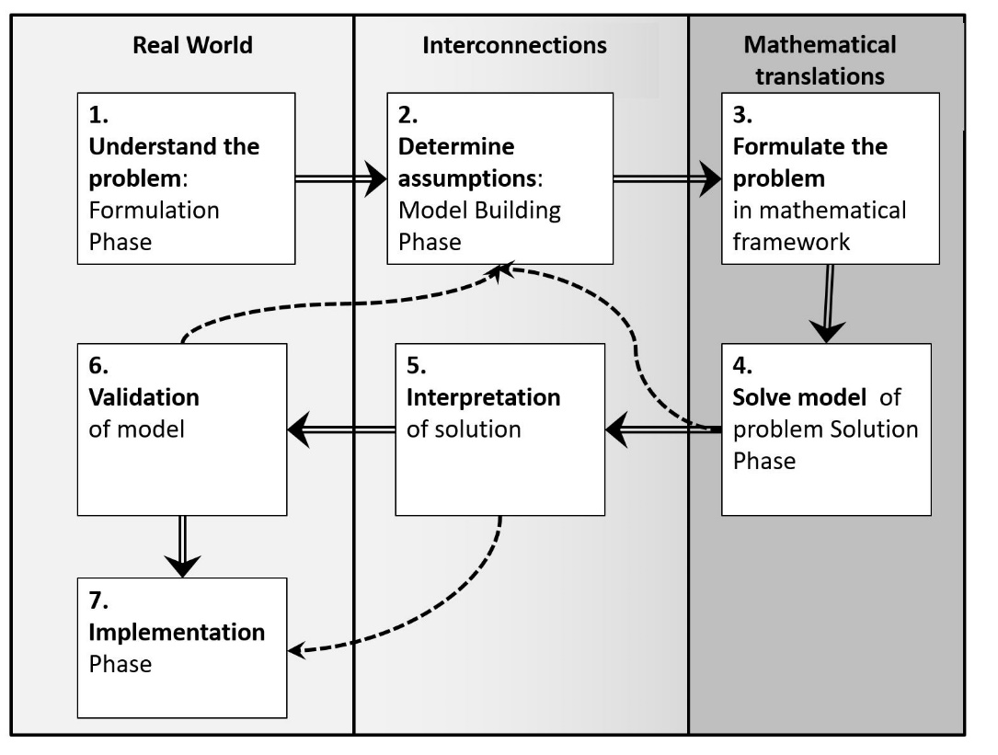

Figure 11 Harrison’s diagram of OR Methodology: a perennial process
The mathematical representation is solved and then translated back into the original context where action is implemented. During solution and validation dotted lines show possible feedback loops to model building. There is also the destructive temptation to jump from interpreting the solution direct to implementation, avoiding validation.
The division between the real world and the world of mathematical models brings out OR as a support to operations in the real world; the model is not an end in itself. The decisions supported depend on the decision maker’s concerns, some of which are perennial. Efficiency, Effectiveness and the Human Factor
Efficiency- changing the ratio of outputs to inputs; These take many forms, often financial but also in terms of time or the Loss Exchange Ratio of battle models. “Basis For Decision”’s models identified overall benefits in the operation of docks, post offices and surgeries through cutting the queue. The OR Society IMPACT magazine of Spring 2018 das two cover articles on cutting the queues, one at Dover and the other on decontamination.
Effectiveness – exploring the achievement of an organisation’s aims; The models act as experiments, some in virtual environments with human decision making. Tactics, techniques, procedures and technologies can be tested by playing it through. The June 2018 PHALANX magazine cover story was a Cyber Wargaming workshop and it contained a feature on strategic wargaming.
The Human Factor and its connections to the measurements of harder items are perennials with much pioneering work on Problem Structuring Methods as summarised by Rosenhead. Freeth’s point about value judgements on route selection for motorways is particularly interesting. The 2017 consultation by Highways England on the route of the A303 past Stonehenge used a multi criteria structure and explored trade-offs through ranges of weights applied to Freeth’s criteria of economic benefit, aesthetics and amenity.
Rivett proposed 4 “M”s; standing for Materials, Machines, Money and Men. The last reflected the culture of 1964 but the generic areas remain of interest. Translating the 4th M, Men, to People would require Ps for the others; perhaps Physics, Power, Pounds and People. Alternatively, substituting Minds for Men would preserve the original trio, and emphasise the importance of individual subjective perspectives and preferences.
Whether “Ms” or “Ps” the scope for analysis seems compatible with Raworth’s calls in “Doughnut Economics” for as broad an approach to models, matching that suggested by Stafford Beer’s comments from the third episode of “Basis for Decision”.
Rivett’s 1994 book identified nine principles. They were:

- It is not enough to think that you understand what you read or hear. You should ask what you were expected to understand and what interpretations others will form.
- Always question the assumptions which lie behind the question given and also question the origin and scale of each measurement in the data.
- Think before embarking on analysis. Check whether the situation is sensitive or robust.
- Just because the normal distribution is so endemic, it does not mean that it is always present.
- Expect the objectives to change during a study.
- Forecasts should always make plain their assumptions. Assess the accuracy needed before using a forecast. Remember that the most dangerous piece of input data is a probability that can neither be refuted or confirmed.
- Examine carefully the boundaries set on a problem. A model can deal with a greater span than can the brain of any manager. Management boundaries do not coincide with model boundaries.
- Napoleon’s principle applies to objectives
“On s’engage et puis on voit.”
- If you want to kill a problem quickly and painlessly, do not mess about. Go for the jugular.

OR is a socio-technical process. The debate on the utility of OR in the third episode of Basis for Decision shows the vital importance of the sponsor of OR, the decision maker. The decision maker is a gate keeper, deciding whether OR is used or not. Stirrup observed lost opportunities in the lack of traction within the new Royal Air Force in 1918 experienced by Lord Tiverton for his studies on strategic bombing, a prototype of OR 20 years ahead of its time. As the resident OR adviser to a directorate of equipment capability in the Ministry of Defence the author observed his client move from a view of OR as a “Necessary Evil” essential for Business Cases to survive scrutiny to a useful basis for decision on the balance of investment in military capability.
Rivett’s closing remark to the BBC series is a worthy perennial aspiration for OR:
“So that managers at all levels have a firmer basis for decisions on industry and government.”
Acknowledgements
Richard Fitzgerald’s interest and tenacity were vital to the recovery of the three episodes of “Basis For Decision” complemented by the generous support of the OR Society, the OR Society Archive at the Modern Records Centre, University of Warwick, the library of Monash University, the Kaleidoscope Group, Lancaster University and the BBC.
References
Box GEP and Draper NR (1987) Empirical Model-Building and Response surfaces John Wiley and Sons New York p 74 cited by https://en.wikiquote.org/wiki/George_E._P._Box#Empirical_Model-Building_and_Response_Surfaces_(1987)
British Broadcasting Corporation (1964) “Basis For Decision” - The use of Operational Research
GOV.UK (2018) BEIS Modelling Quality Assurance tools and guidance Tools and guidance to help people with Quality Assurance of analytical models. https://www.gov.uk/government/collections/quality-assurance-tools-and-guidance-in-decc
Haldane, R. B. (1918) Report of the Machinery of government committee. Cn 9230 H. M. Stationery office. [The Avenue press (L. U. Gill & son, ltd.,) printers], Reference number: b21369483 Persistent URL: http://wellcomelibrary.org/item/b21369483, Catalogue record: http://search.wellcomelibrary.org/iii/encore/record/C__Rb2136948
Harrison (1983). Operational Research. Kluwer Academic Publishers: London. Page 37
Her Majesty’s Treasury (2015) The Aqua Book Guidance on producing quality analysis for government
Highways England (2017) A303 Stonehenge Amesbury to Berwick Down Technical Appraisal Report Volume 1 HE551506 page 84 5.2.40
Kirby, M W (2003) Operational Research in war and peace The British Experience from the 1930s to 1970 Imperial College Press: London and the Operational Research Society: Birmingham
Military Operations Research Society (2018) PHALANX The Magazine of National Security Analysis Volume 51 No 2
OR Society (2018) IMPACT Spring 2018
Raworth K J (2017) Doughnut Economics Seven ways to think like a 21st-Century economist Random House London
Revans RW (1964) Standards for Morale Cause and Effect in Hospitals , Oxford University Press for the Nuffield Provincial Hospitals Trust
Rivett P and Ackoff R (1963) A Manager’s Guide to Operational Research John Wiley & Sons London
Rivett P (1968) Concepts of Operational Research CA Watts & Co Ltd London
Rivett (1994) The Craft of Decision Modelling John Wiley & Sons Chichester
Rosenhead J (1989) Rational Analysis for a Problematic World - Problem Structuring Methods for Complexity, Uncertainty and Conflict.
Shalliker J (1998) Spreadsheet Models: The Good. The Bad and the Ugly. OR40 Lancaster handout
Shephard R W(1961) Some aspects of Measurement in Operational Research. Modern records Centre University of Warwick. (Cited by Kirby at page 25)
Stirrup J, (2005) “Inside and Outside the Box: Individual Creativity versus Military Orthodoxy” Journal of the Royal United Services Institute for defence studies Volume 150 No 6 page 46

