People Analytics Special Interest Group
AGM 2022 & People Analytics and the Future of Work Meeting Notes

Welcome from Katie Gronow (Chair of the People Analytics SIG Committee)
People Analytics SIG AGM
The current committee introduced themselves and their interest in people analytics.
The Secretary’s brief covered the membership of the group as well as the committee, currently in the region of 750, and the events held in the last year and the timeline of the group. In the Chair’s brief Katie gave an overview of the seminars held during the year, which included wellbeing and a joint event with WORAN. The format of the meetings has been scene setting and then the implications for People Analytics with case study example of related analysis that has been done.
At the AGM the Chair Katie Gronow, Secretary Cat Smith and events coordinator Hazel Challenger stood down. Maureen Usiagwu (Capgemini) was elected as the secretary of the group. Attendees were asked to consider the role of the Chair or in assisting in running and coordinating events. [NB – after the event Ho Law volunteered to join the committee in a general role]
Scene setting: Future of work (Professor Emma Parry)
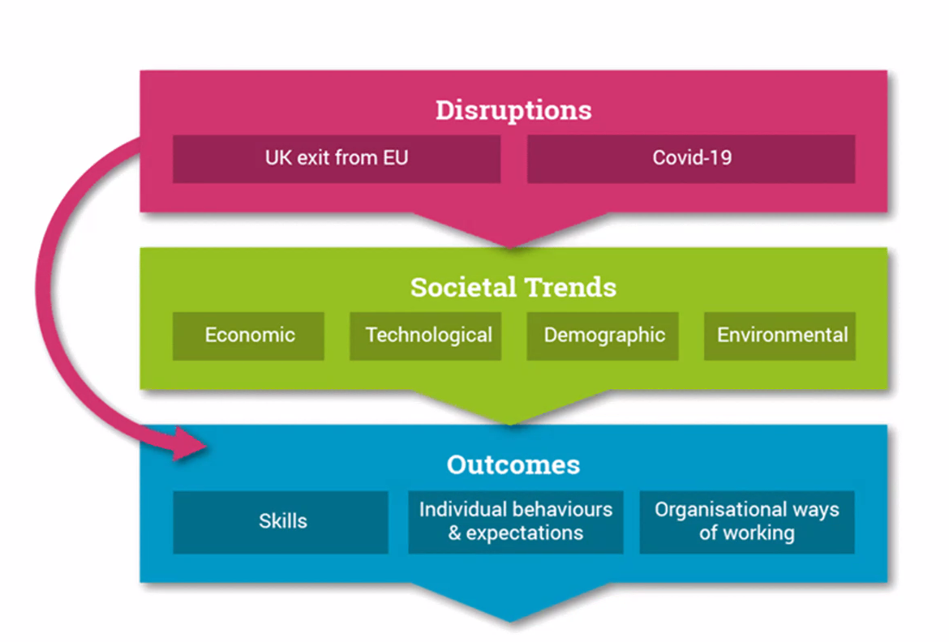
Emma Parry introduced herself and her interest in context and how this affects the workforce and how we manage people. Emma’s focus is on how the changing context of how work affects people, which in turn affects the data collected and the analytics we can do, helping us to make predictions and plan for the future. Emma talked through her framework for the changing world of work which looks at disruptions, such as Brexit, as well as social trends and how these translate into outcomes.

There are big issues and challenges around the labour market with a large amount of churn and difficulties in recruiting and retaining. A lot of Emma’s work has looked at woman in the workforce as well as health trends e.g., increase in obesity, family trends and structures which impact on people and ways of working. Disruptions don’t just influence work but other long-term trends – technology very much influenced by Covid-19 e.g., use of Zoom and MS Teams.
Emma emphasised the importance of understanding outcomes in relation to the drivers of change. A lack of both capability and availability of skills can pose a problem. In Emma’s experience, the evidence for generational differences is not strong, but individual behaviours and expectations are changing over time, for example expectations around work life balance.
Challenges that analytics can help us understand
There is an increasing need to compete for certain skills, organisations often have a lack of an understanding of what those skills will look like for them in the future. There is a real need to predict this going forward.
Digitalisation and automation has an impact on the quality of work that an individual undertakes. We talk less about job quality and more about productivity. What is the impact of automation on the quality of jobs, and how do we understand the impact??
The idea of a linear career structure is disappearing and skills needs are constantly changing. How can we upskill, reskill, or redeploy people as skills change?
How can we use technology better? Emma has done a lot of work around wearable technology to better understand the workforce. She emphasised the benefits in terms of wellbeing and understanding how the workforce is feeling.
How are demographic trends affecting the workforce and what that means for their needs? There are fewer economically active people in the labour market – older workers are leaving the labour market alongside a lot of churn. How can we get good data about that and its implications?
Attitudes to ways of working are changing. How can we understand our employee value proposition and whether we are in keeping with changing workforce attitudes in relation to flexibility and inclusion etc…?
Flexible career paths. There is a role for people analytics to understand and predict how changes in the way of working can affect employee outcomes. There is evidence that younger people coming into work want more flexibility in their careers, including side hustles, can we collect good data on that?
Emma concluded that there are a lot of opportunities, with the need to think how business data as well as external data can be used in our analysis.
How People Analytics can shape the Future of Work (Nigel Dias)
Nigel introduced the group to the terminology he uses around people / HR analytics. He tends to use data driven HR rather than People Analytics – where the objective is solving people problems, seeing People Analytics as a slightly loaded term.
The aim is to be the goggle maps of HR, not to tell the organisation what a successful HR objective is, e.g., how quickly should they close a skills gap, but to provide evidence to inform the choices they will be making to achieve decisions
Therefore:
Data driven HR - enabling the organisation to make better decisions, by using HR data to answer HR questions.
Nigel is not an advocate of maturity models – most organisations are operating at a number of levels of maturity at once. It is more helpful to break it down into the types of questions that can be answered. Over the years Nigel has collected data through the HR Analytics Thinktank and tracks the progress of analytics and what is needed.
Questions:
- Descriptive - what happened?
- Diagnostic - why did it happen?
- Predictive - what will happen?.
- Prescriptive - what should we do?
There is a decision architecture within HR Analytics - there are people making a number decisions around similar themes. You can then look at the decisions being made and group them by themes. Some questions are being asked perennially, some are new, and some difficult. Not surprisingly the biggest recent change was caused by Covid-19 pandemic.
Opportunities for analytics in HR include identifying whether issues are supply or demand driven. For example, the great resignation is not a consistent problemit is a hotspot problem. What analytics can do is help an organisation get an understanding of the problem and respond appropriately to it.
Nigel looked at how HR functions grow as they reach higher levels of maturity. Nigel offered advice on how to improve maturity, which is through understanding the question. He thinks of analytics as a continuous approach, at the moment companies want to answer questions that they didn’t have five years ago. In the initial stages of the Covid-19 pandemic organisations were forced to make decisions whether they had the data or not – you can make decisions on gut instinct; however, would it not be better to use data? The business case for data driven HR is not the case to do it, but the business case of avoiding the impacts of what happens if you don’t do it.
Nigel has looked at how we can generate the workforce of the future. Which involves considering both the supply and demand side, as well as articulating the risk to HR strategy. For example, it is not just about predicting attrition and but also what can we do in response to it, and also making the links between this and organisational productivity. The benefits of analytics lie in understanding the link between the performance of the organisation and its people.

