IOR Conference Papers 6th December 1971

BEYOND LOCAL GOVERNMENT REFORM:
SOME PROSPECTS FOR EVOLUTION
IN PUBLIC POLICY NETWORKS

Conference papers originally published in 1971 by the
INSTITUTE FOR OPERATIONAL RESEARCH
A unit of the Tavistock Institute of Human Relations

Contents: page:
Information on forthcoming conference * 1
Outline of conference papers * 2
Preface **
By John Stringer, Director IOR 3
Inter-agency decision processes: practice and prospect **
by J.K. Friend and C.J.L. Yewlett 4
Planning: Magic and technique **
by J.M. Power 32
Conference attendance list 52

* these papers were attached to the invitation letter
** included in the bound set of papers pre-circulated to participants
BEYOND LOCAL GOVERNMENT REFORM: SOME PROSPECTS FOR EVOLUTION IN PUBLIC POLICY NETWORKS
papers for conference on 6th December 1971
Royal Society of Arts, London WC2, 3.00-5. 30 pm

INFORMATION ON FORTHCOMING CONFERENCE
Title: BEYOND LOCAL GOVERNMENT REFORM: SOME PROSPECTS FOR EVOLUTION IN PUBLIC POLICY NETWORKS
Date: Monday, 6th December, 1971, 3.00 - 5.30 p.m.
Location: Royal Society of Arts, 8 John Adam Street, London WC2 (parallel to Strand, on the Embankment side)
Chairman: LORD FULTON OF FALMER
Programme:
Chairman's Introduction (3.00 p.m,)
Introduction of two conference papers:
INTER-AGENCY DECISION PROCESSES: PRACTICE AND PROSPECT
by John Friend and Christopher Yewlett, IOR
'PLANNING: MAGIC AND TECHNIQUE'
by Dr. John Power, University of Sydney
Opening of discussion by invited speakers:
DR. JEREMY BRAY, author of Decision in Government
PROFESSOR N. LICHFIELD, School of Environmental Studies, University College, London
A.W. PETERSON, Esq., CB, MVO, Director-General and Clerk to the Council, Greater London Council
General Discussion
Closing contribution by JOHN STRINGER, Director of IOR.
Tea served after close of conference (5.30 p.m.)
Papers: An outline of each of the two conference papers is attached. Complimentary copies will be sent before end of November to all those attending; after the conference, sets will be generally available at a price of approximately £1.00 on application to the Institute at its Coventry address.
Institute for Operational Research,
4 Copthall House,
Station Square,
Coventry,
CV1 2PP
OUTLINE OF CONFERENCE PAPERS
Conference on 6th December 1971
BEYOND LOCAL GOVERNMENT REFORM: SOME PROSPECTS FOR EVOLUTION IN PUBLIC POLICY NETWORKS
First Paper: INTER-AGENCY DECISION PROCESSES: PRACTICE AND PROSPECT by John Friend and Christopher Yewlett, IOR
In the public sector, problems of planning and policy-making frequently have to be confronted at an inter-agency level, and those concerned may find themselves having to cultivate skills differing significantly from those now being increasingly advocated as relevant to processes of internal management and co-ordination. This point has important implications for the evolution of relationships between agencies and of patterns of public accountability; and these implications will be discussed with special reference to the current proposals for local government reform. Some speculations will also be offered about the future evolution of existing professions and the possible emergence of new ones,
The paper will draw extensively on an analysis of issues arising in the planned expansion of Droitwich in Worcestershire, which is being managed through a joint committee of County and District Councils in accordance with regional policies for dispersal of population and industry from the West Midlands conurbation. Reference will also be made to some recent experience in working with officers of both large and small authorities to test the practical application of new approaches to planning under uncertainty.
Second Paper: 'PLANNING: MAGIC AND TECHNIQUE'
by Dr. John Power, University of Sydney
When faced with threatening uncertainties against which he has no practical defences, man will resort to magical activities. These often form matrices out of which practical techniques subsequently develop.
In recent years, increasing political attention has been focussed on possible threatening features of our future, Thus, planning (which may be defined as the politics of the future) is presently in a confused state. Although more effective techniques are rapidly being developed, recent literature is still strongly magical in tone. In particular, formal organisation, which is basically inert, is endowed by many writers with apparently magical potency.
The paper will review a wide range of recent books which have concerned themselves with differing aspects of the planning process - corporate, physical, social, community and economic. An attempt will be made to sift the technical advances from the magical residue in each of these books. Finally, the relationships between the techniques will be explored in an attempt to see how they might be integrated into a technology of planning, useful to any policy-maker, whatever his ideology.
PREFACE
Decision-making in the public sector is becoming increasingly dependent on advanced problem-solving skills. Moreover, the nature of the problems in the public sector is such that these skills need to be deployed in a way that cuts across organisational boundaries to a very great extent. The papers presented here consider these points from two very different perspectives. Their common ground is that the design of organisations and the development of planning techniques ought each to give explicit recognition to the need for flexible networks of interaction in the decision-making process.
The first paper examines this theme in relation to the impending reform of local government in the United Kingdom. It derives directly from a research project entitled 'Decision Networks in Regional Development' being undertaken by the Institute for Operational Research with the support of the Social Science Research Council. The paper draws largely on an analysis of problems faced in the planned expansion of a Midlands town in accordance with regional dispersal policies.
The paper starts from the perspective of operational research, and hence from a concern for the effectiveness of problem-solving methods, and attempts to extend this concern into fields of considerable organisational and political complexity.
The second paper starts from the perspective of political science. Its author, Dr. John Power of the University of Sydney, has been spending a sabbatical year at IOR, working mainly in association with the 'Decision Networks' project. His paper is not specifically related to local government and ranges over several recent trends in thinking about planning and its political implications before converging on the same theme of inter-agency planning. An important conclusion is that there is need to make explicit provision for a role concerned with the continuous formation and adaptation of planning networks and to support this role with a methodology adequate to the task.
The two papers are presented at this time because some wider discussion of their joint theme seems particularly timely and important, and not because the papers are to be regarded as definitive statements of the outcome of the work on which the authors have been jointly engaged. The preparation of a more comprehensive report is currently under way, and the processes of final interpretation of field studies are now leading to an intensive and, I believe, creative interaction between the complementary disciplines they represent.
The present opportunity to expose some of the general themes of our work to open debate has been provided by the SSRC and is one which I very much welcome. I hope that, as well as illustrating the potential of multi-disciplinary approaches, the results will be of value to those who are grappling with the daunting complexities of organising the formation of public policy.
John Stringer
Director
Institute for Operational Research

INTER-AGENCY DECISION PROCESSES: PRACTICE AND PROSPECT
by J.K. Friend and C.J. L. Yewlett
Public Planning as a Multi-Organizational Process
In the public sector, the making of strategic decisions has to be understood not merely as a corporate but also as an inter-corporate process. This point is familiar enough to most politicians, political commentators, town planners, and senior administrators in both local and central government. It is, however, not always so familiar to management scientists and consultants who are accustomed to working within industrial firms. In the industrial context, it is a little easier to live with the view of planning as an activity to be organized wholly within a given hierarchical framework, where objectives can be clearly formulated and then methodically pursued.
The importance of the inter-corporate aspect of public planning and policy formation has been borne out consistently in the experience of the Institute for Operational Research over the first eight years of its existence. It was much in evidence during the Institute's early research into the decision processes of local government, even though this was based primarily on observations within what might appear to be the most monolithic form of authority within the existing system; the large, free-standing County Borough. With the virtual disappearance of the all-purpose authority under the current reform proposals, it is to be expected that the problems of inter-authority planning will become even more pervasive in future, not only within the local government system but also at its interfaces with other public and private bodies.
Some of the difficulties of bringing the perspectives of management science to bear in relation to inter-agency decision processes were brought out by John Stringer, now director of IOR, in a paper published in 1967 entitled 'Operational Research for Multi-Organizations’ . An opportunity for IOR to explore further the problems of multi-organizational planning in the public sector was presented by the award in 1969 of a grant from the Social Science Research Council for a project entitled 'Decision Networks in Regional Development'. This paper presents some of the main perspectives emerging from this work, which is due to finish in early 1972.
The field of regional development can be defined to embrace all forms of action through which governmental bodies can influence the future distribution of population, wealth and opportunity within and between some set of geographical divisions of a nation. It therefore abounds in problems of planning at the interfaces between different public agencies and, insofar as the realisation of planned regional change involves selective interventions in the future of particular localities, it is inevitable that local authorities will come to assume something of a pivotal role.
Figure 1 illustrates the particular institutional perspective which has been adopted for the project in the form of a 'base map' in which local authorities are shown as occupying a central position, flanked by four other broad classes of decision-making system, both governmental and non-governmental. It is the interfaces of local government with these other systems, as well as the interactions of local authorities with each other, that will be of particular interest from the point of view of this paper. However, it is hoped that some at least of what we will say will have general relevance to multi-organizational processes other than those of regional development, where the more pivotal roles may shift towards the realm of central government or its appointed agencies, towards the realm of private enterprise, or towards voluntary associations which represent particular residential, occupational or other sectional interests.
Figure 1: Institutional Base Map
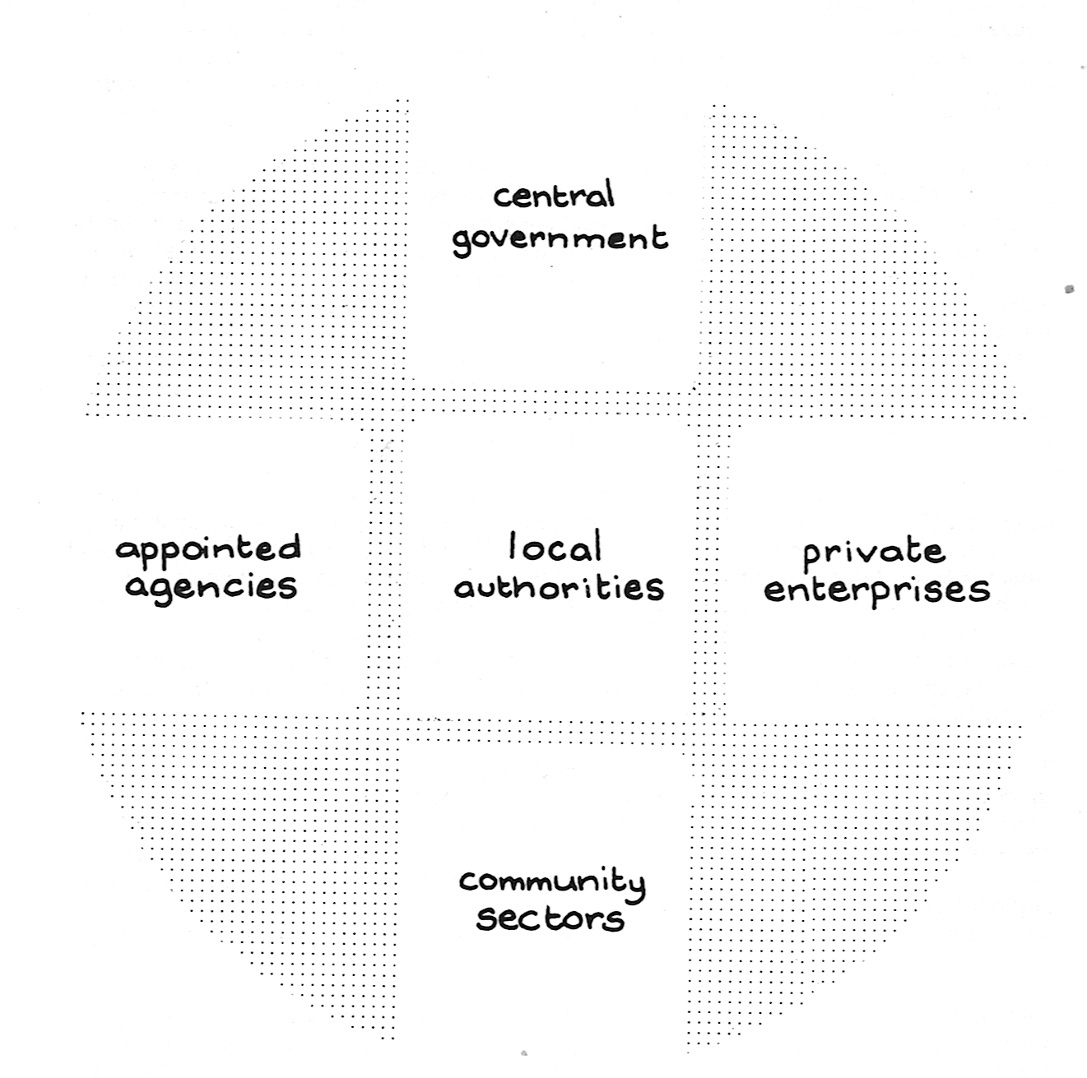

The distinction shown on figure 1 between local and central levels of government may of course become less clear-cut where directly elected authorities exist at the state or provincial level. However, in the United Kingdom - leaving aside the special case of Northern Ireland - a clear dividing line can be said to exist insofar as all the public institutions at present operating at a regional level can be plotted in figure 1 as falling either within the sector of appointed agencies (The Regional Economic Planning Councils), or that of central government (The Regional Economic Planning Boards, the regional offices of the Department of the Environment and, outside England, the Scottish and Welsh Offices), or that of local government (the standing conferences of local planning authorities). The situation may of course become modified in future; in particular, the Crowther Commission on the Constitution is due to report on the question of possible devolution of central powers to regional levels of government, although few observers foresee the introduction of independent elected bodies at a regional level as a likely outcome, at least within England.
Organizational Relationships in a Town Expansion Scheme
The main focus for the research of the last two years has been one small town in the West Midlands region of England, whose size and character are currently being significantly changed by the processes of regional development; the Borough of Droitwich in Worcestershire, the population of which is being increased fourfold over a 15 year period, in accordance with regional policies for relieving congestion within the city of Birmingham and its associated conurbation. This expansion, which began in 1964 when the population of the town was just over 8,000, is being managed in a somewhat unusual way - by a joint committee of the County Council and the local Borough Council, with the latter acting as receiving authority for some 'overspill' population from Birmingham through an agreement under the Town Development Act. A simplified representation of the network of agencies concerned is plotted in figure 2, using the organizational base map of figure 1.
Figure 2: Network of Organisations concerned with Droitwich Town Development
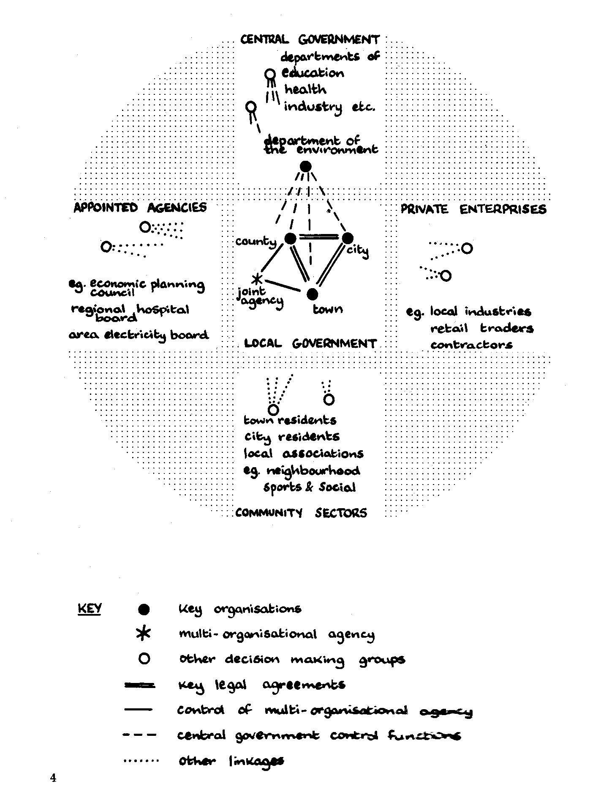
The network of decision-making processes which has evolved around the relationships of figure 2 is a complex one; but so also are the sets of decision problems with which this network must contend and the sets of community interests which are affected. In other planned expansion schemes under the Town Development Act, the organizational structure chosen has differed from that at Droitwich in that the principal role in the development has been undertaken directly by the exporting city, the county council or the receiving town; in one or two cases, a tripartite agency has been set up, with the exporting city directly represented. In expansions executed under the New Towns Act, which are generally on a larger scale, the principal role is played by a centrally-appointed Development Corporation, thus shifting much of the responsibility for initiation of change into the 'appointed agency' sector of the organizational base-map. Where development is on a smaller scale, or is more directly linked to the needs of a specific employer, then the initiating role may sometimes shift into the sector of private enterprise.
One point of general interest in the Droitwich arrangement is the existence of an explicit working relationship between upper and lower tier local authorities, with reference to a long-term task which is intrinsically difficult and which impinges closely on the interests of both town and county. Similar forms of collaborative working between tiers are likely to become increasingly pervasive, albeit in relation to a variety of different types of task, after the implementation of the local government reform proposals.
The processes of planning and negotiation leading up to the initiation of the Droitwich Town Development programme in 1964 were complex and prolonged. Their formal outcome took the shape of a set of interlocking agreements whose content is set out diagrammatically in figure 3. These agreements imposed certain commitments on all the four agencies identified in the central area of figure 2, in varying combinations as shown just below the column headings. The agreements also ranged over various areas of policy which are listed, according to broad but not always mutually exclusive headings, in the left-hand margin of the diagram. Naturally, the different documents placed their main emphases in different policy areas, as illustrated on an impressionistic basis by the depths of the shaded blocks in figure 3.
Significantly, the degree of emphasis given to a policy area did not always correspond to the degree of commitment expressed to specified lines of policy within that area. In some policy areas, it was considered necessary to emphasise that commitments were to be explicitly deferred until a later time; in other areas, it was felt desirable to couch statements of intent in deliberately 'soft' or flexible terms, whether through niceties of legal phraseology or through use of relatively non-committal cartographic conventions. Figure 3 uses different intensities of shading to illustrate the broad balance between 'hard', 'soft' and deferred commitment in each policy area, again on an impressionistic basis. Taking the example of policy for housing development and management, the comparatively large areas of heavy shading in the first, second and fourth columns indicate a substantial degree of 'hard' commitment in such aspects as location, density and allocation procedure, coupled with areas of more 'soft' commitment in aspects such as programming and degree of control over private development. On the other hand, the crucial policy area of central area redevelopment was left comparatively open at the agreement stage, pending more detailed planning studies and processes of negotiation with the various interests concerned.
Figure 3: Droitwich Town Development: Content of Agreements
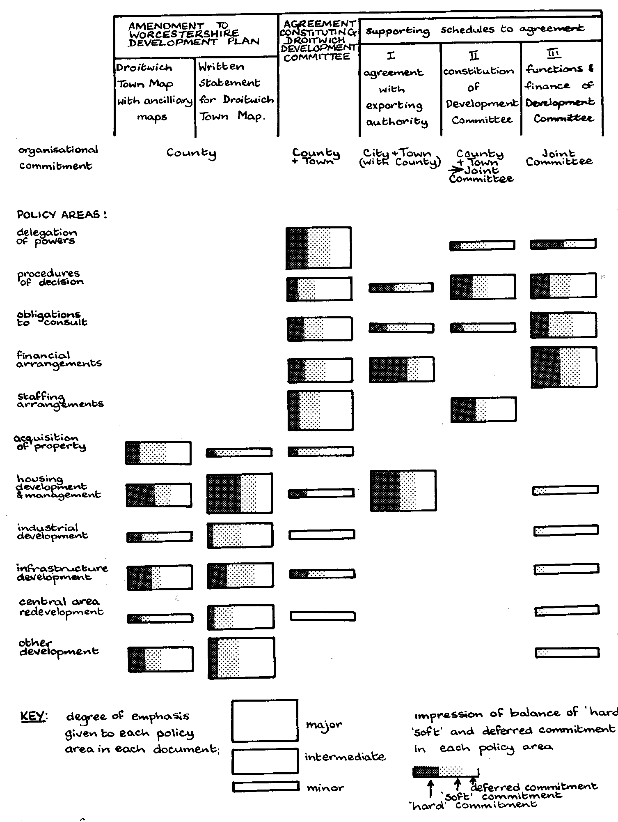
The question of balance between commitment and flexibility in a formal statement of intent is of course important in the outcome of any bargaining process between parties whose interests may be intimately affected, yet who are conscious of the need for a certain amount of flexibility in relation to prospective changes in their environments. Such changes were clearly to be anticipated in a comprehensive expansion programme with a proposed duration of 15 years, during which all kinds of new social, political, technical or economic trends could be expected to emerge and interact. Indeed, now that the planned time-span of the programme is almost exactly half complete, a number of ostensibly 'hard' commitments included in the original agreement have had to be modified in response to contingencies which could scarcely have been predicted during the negotiating process. As a general proposition, it can be argued that the significance of any published plan or inter-agency agreement can lie as much in those areas of decision which it sets out to leave deliberately open, as in those in which explicit commitments are made. The issues arising in the recent negotiation of British entry into the European Economic Community suggest that such a proposition may be equally tenable at the international level of interagency bargaining.
The IOR research team in Droitwich has been following events subsequent to the agreement within most of the policy areas indicated in figure 3, through a combination of attendance at meetings of decision-making groups, interviews with individuals, and analysis of key documents. In some of the policy areas - most notably those concerned with central area redevelopment, financial arrangements and consultative obligations - some particularly difficult problems of inter-agency adjustment have arisen, and it is our belief that some lessons can be drawn which should be of general relevance to the working of the new two-tier structure on which the current legislation for local government reform is based.
The pattern of relationships between the three main parties to the management of the Droitwich development programme is illustrated in figure 4. On the elected side, the joint committee charged with the main responsibility for the programme consists of eight members each from the County and Borough Councils, with the chairman appointed by convention from among the Borough members. The disparity in size between the two 'parent authorities' means that the committee membership includes exactly half the elected members of the local Borough Council, but only a small (though in fact influential) minority of the County Council membership. On the professional side, the Development Committee is directly responsible for a specially recruited group of administrative and technical staff, together with other staff on secondment from the two parent authorities. Certain other skills available within the parent authorities are drawn on in accordance with various part-time agency arrangements.
The configuration of figure 4 provides a classic example of a 'multi-organization', defined by Stringer as a union of parts of several organizations brought together through the mutual interaction of individuals in the performance of a common task. In this instance, the task was defined as that of managing the expansion of Droitwich according to the set of agreements shown in figure 3. As indicated by the drawing of a 'task boundary' in figure 4, the Development Group was the only one of the three constituent organizational groups exclusively concerned with this task; and it was evident that for many purposes the officers of this Group, working from a common set of offices in the town, had come to function as a cohesive working team, sharing a common motivation to fulfil the planned expansion programme expeditiously and to high professional standards. In addition, however, the absence of any direct representation of Birmingham as exporting authority gave the officers of the group a sense of special responsibility for keeping in mind the interests of prospective immigrants to the town as well as its existing residents.
The sixteen members of the joint committee were of course accountable in a more direct and immediate sense to their respective electorates; and inevitably, there were times when conflicts emerged between the interests of those electorates and the declared objectives of the expansion programme. In the case of the County Council representatives, the reconciliation of any such divergences was not usually difficult. The original aim of Worcestershire in promoting the development at Droitwich had been to play its share in coping with the Birmingham overspill problem, and with the problems of regional change in the West Midlands generally, through concentration of new development in locations which would not threaten the integrity of the green belt protecting the County's boundary with the conurbation. To promote this aim, the County had been prepared to underwrite many of the initial costs of the Droitwich scheme, and its main concern with the execution of the development programme was to ensure that it went ahead smoothly and without unreasonable additional cost to the County ratepayers.
Figure 4: Multi-Organisational Structure Of Droitwich Town Development
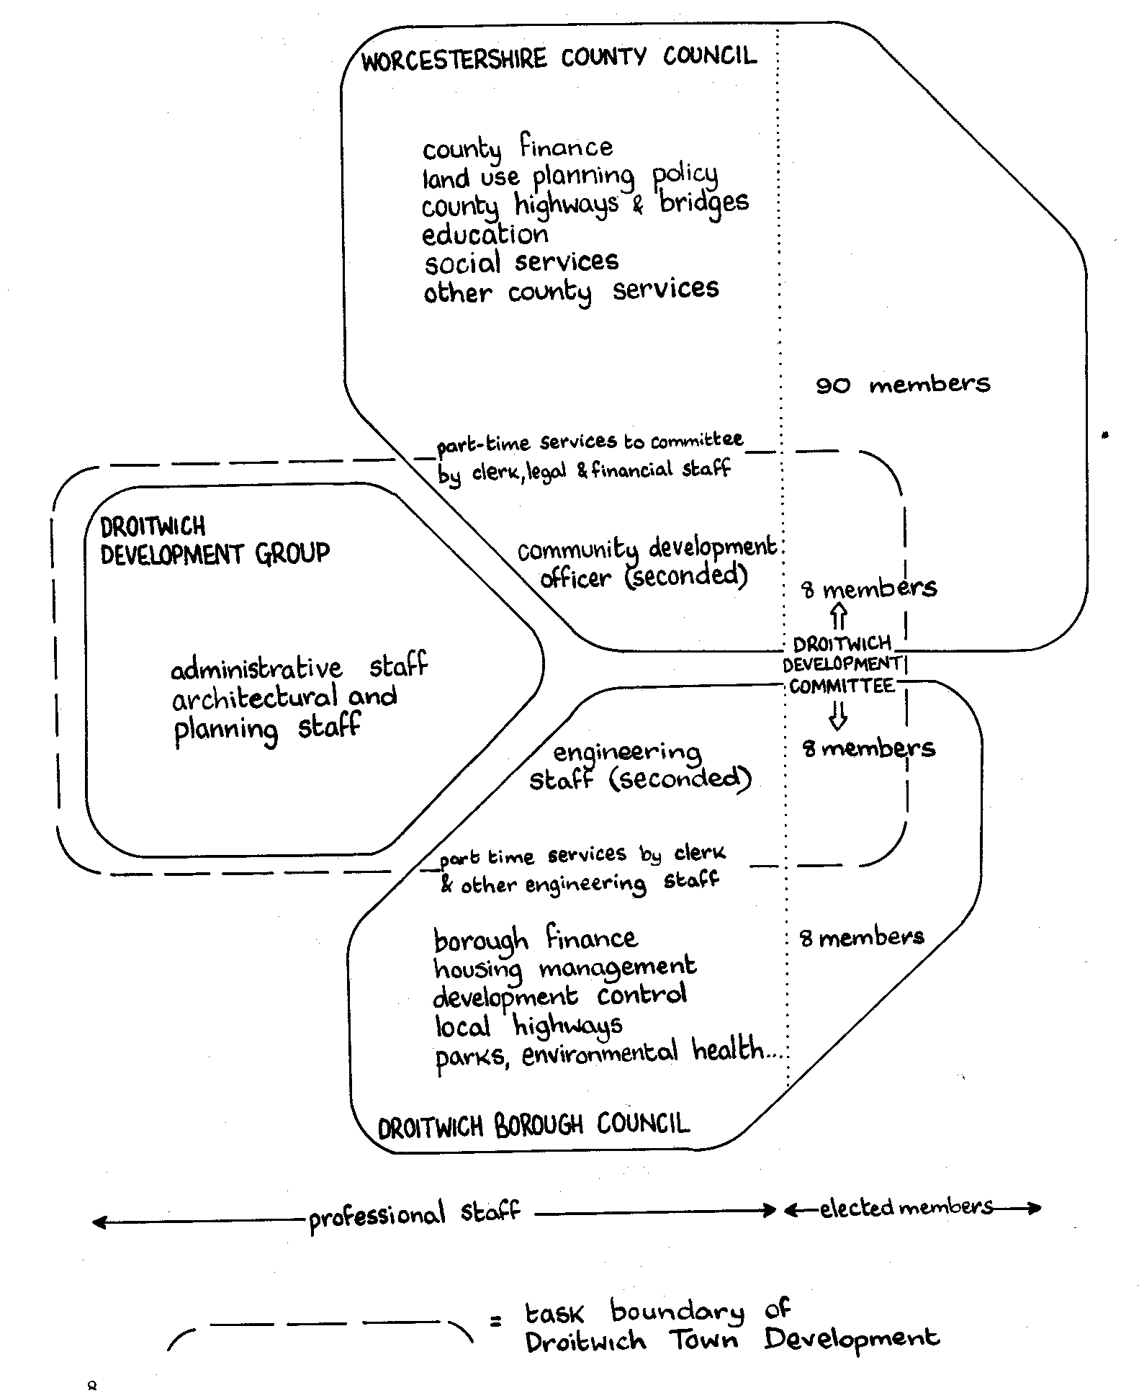
The interests of the local Borough Council, on the other hand, were much more intimately affected by the decision processes of the Development Group and its controlling committee, particularly where those processes impinged closely on long-established residential and commercial interests, as in the redevelopment of the town's central area. Also, although it could be claimed that virtually all the initial costs of the expansion were being met in full from County or other external sources, the exact mechanism for allocation of costs was a matter for continuous and detailed bargaining between treasurers, at a level of technicality which it was not always easy for the ratepayers or their representatives to follow. The financial base of the local Borough Council, while expected to grow steadily with the progress of the development programme, was initially slender and highly vulnerable to the outcome of this allocation process. The outcome was in fact such that the initial expenditures falling directly on the local rate account were confined largely to those proportions of sewerage, highway and open space developments which could be expected to have been incurred even if the town had continued to expand through natural growth alone; however, a consciousness of financial risk was always present among locally elected members, and this manifested itself in recurrent demands, both within and outside the Development Committee, for more detailed costings of proposals and for fuller consultation at the formative stages of their preparation.
Such demands tended to create difficulties for the technical officers of the Development Group, whose initial activities in the preparation of master plan and central area plan proposals had been funded from County Council sources, but who subsequently found themselves coming under increasing pressure to allocate salary and other running costs as fully as possible against specific capital projects. Under such conditions, time spent in exploring the implications of alternative design solutions could only too easily be construed as excessive or abortive expenditure. In fact, it was evident both to the officers concerned and to ourselves as observers that, in a many-sided development programme impinging closely on a variety of existing community interests, the processes of planning were necessarily complex, continuous and intrinsically multi-organizational in nature. In consequence, the officers of the Development Group had had to cultivate skills which differed significantly in character from those which are conventionally associated with the preparation of an initial master plan, its translation into a capital investment programme, and the subsequent implementation of a set of well-defined development projects. Furthermore, these skills could not be seen simply in terms of an ability to control the processes of implementation through occasional adjustments to previously agreed plans; rather, they required judgements of what kind of strategy to adopt in contending with a continually shifting pattern of uncertainties, arising from an economic, political and social environment which was not merely uncertain but often turbulent in the sense defined by Emery and Trist.
Meanwhile, we were aware of a persistent sense among many members of the Borough Council - and particularly among those not serving on the joint Development Committee - that the exercise of shared rather than exclusive control over the skills of the Development Group was depriving them of a role in decision-making which was commensurate with their direct accountability to existing residents. Justifiably or otherwise, it could be suspected that the proposals formulated by the experts might sometimes conceal debatable value judgements behind arguments which it was difficult to challenge on technical grounds. As in local government generally, it was not easy for the member to ascertain how fully the professionals had explored the range of available options; and sometimes the suspicion would arise that courses of action which had become more or less irrevocable could and should have been challenged at an earlier stage of the decision-making process.
Despite the persistence of such tensions in certain areas where interests were most clearly in conflict, there was also much evidence of a gradual and largely successful process of adjustment in the attitudes and mutual relationships of the individuals participating in the Droitwich 'multi-organization' during the first seven years of its existence. Lindblom, in 'The Intelligence of Democracy' , explores the concept of co-ordination through various modes of partisan mutual adjustment between decision-makers who do not necessarily subscribe to a shared set of values or objectives, as opposed to more conventional concepts of co-ordination which place their emphasis on the role of some central source of authority or arbitration, through which commonly accepted values may emerge and any sectional conflicts can where necessary be resolved.
In the case of the Droitwich expansion, such a source of central authority could hardly have been created without violating the essential principle of joint control by County and Borough Councils. Although all parties to the management of the scheme were formally bound by the terms of the original agreement, and there was an explicit legal provision for appointment of an arbitrator in the last resort, the evidence was that the terms of the agreement were usually looked to in practice more as a set of working constraints than as a source of shared values. For this reason, we came to see the processes of decision-making at Droitwich as a particularly clear illustration of the principle of co-ordination through partisan mutual adjustment in practice. Furthermore, it provided us with a demonstration that this kind of co-ordination could lead, at least in the longer term, to substantial progress in the performance of a difficult and complex task.
However, the processes of adjustment at Droitwich imposed some difficult stresses from time to time, falling most heavily on certain individuals playing key roles at the interfaces between organizations. One of these individuals was the Chief Administrative Officer of the Droitwich Development Group, in his role as principal adviser to the joint committee; another was the Chairman of that committee, whose task required him to strike a continuing balance between the sometimes conflicting demands of providing leadership to the Committee and representing the interests of his parent Council. To a lesser extent, similar stresses were borne by the remaining seven Borough representatives on the Committee, with their dual responsibility for representing the Borough's interests at meetings of the joint committee, and for imparting to their other colleagues on the Borough Council an appreciation of the complexities which were being encountered in the management of the development programme. The latter responsibility proved to be the more difficult to fulfil in practice, especially because the technical advice of the Development Group staff was not directly to hand at the meetings of the Borough Council and its various specialist committees.
The evidence of other planned expansion schemes, whether managed under the Town Development Act or the more centralised New Town machinery, suggests that the kinds of stress which are borne by those operating at the boundaries between organizations - or fulfilling the 'boundary control' functions as defined by Miller and Rice - may be as much an inherent reflection of the problems to be tackled as a direct consequence of any particular organizational structure. However, it is only to be expected that the choice of a different organizational configuration will tend to shift the major points of stress and thereby produce certain effects, beneficial or otherwise, in terms of operational efficiency, levels of responsiveness to local interests, and adaptability to various forms of external change. The balance of advantage between these different types of effect, while it may be strongly influenced by such yardsticks as scale of planned development, can hardly be drawn in the last resort without confronting questions of basic political judgement. Predictably, the majority of committee members at Droitwich, from either parent authority, expressed the view that the management of the scheme through a joint agency of existing elected authorities was to be preferred to the alternative of control through an appointed New Town Development Corporation. On the other hand, there were several of the officers who expressed a strong preference for the latter arrangement, from experience of the working frustrations and uncertainties generated by the more diffuse patterns of accountability at Droitwich.
Many of the problems of co-ordination between tiers of local government encountered at Droitwich seem likely to arise more widely, if not always in an identical form, in the relationships between county and district authorities in the new local government structure. Recapitulating, these problems can be defined as the problem of balance of flexibility and commitment in entering into formal relationships between authorities; the problem of Incidence of risk as well as incidence of predicted expenditure in relation to the differing resources of the parties concerned; the problem of effort to be devoted to exploration of alternatives, with the associated problem of shared or independent access to technical expertise; and the problem of identifying those organizational roles which will carry the main stresses of partisan mutual adjustment, so as to discover ways of helping the individuals concerned to discharge their difficult responsibilities both to good effect and with a minimum of personal frustration.
Such problems seem likely to manifest themselves more generally in any situation where far-reaching changes within a local community are being induced by an external agent, whether this agent be a jointly sponsored professional group as in Droitwich, a New Town Development Corporation as in other larger towns, or one of the new county councils acting directly, perhaps with a range of functions and set of resources at its disposal which made it significantly more powerful than those of its present counterpart. In any such situation, it is only to be expected that the members of the district council affected, who may be responsible for only a comparatively limited range of executive functions and therefore have comparatively few areas of choice directly within their discretion, will find it difficult to muster the technical or analytical skills to challenge the assumptions underlying any proposals for change which the external agent may put forward, and thereby to fulfil their local representative functions to the satisfaction of their electors.
A General Framework of Analysis
Before exploring further such problems of inter-authority decision-making in a reformed local government, it will be useful to make brief reference to a more general framework for the analysis of relationships between decision-making bodies in any kind of problem-solving situation. This framework, illustrated in basic form in figure 5, derives from a general model of decision-making which was presented in chapter 5 of 'Local Government and Strategic Choice' but which, following suggestions by Dr. John Power, has now been modified to make it fit more directly into a sociological frame of reference.
Figure 5: General model of a decision process
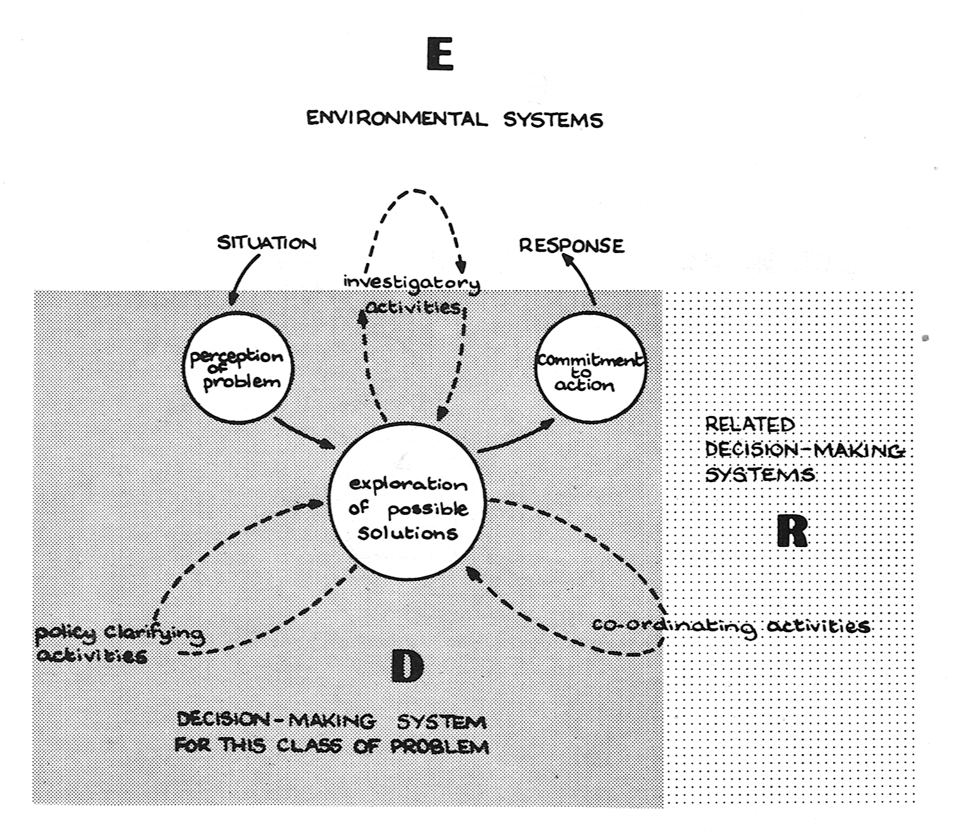
The vantage point of figure 5 is that of any decision-making system (D) responsible for dealing with some given class of decisions. This reflects the point that it is usually around a perception of recurrent classes of decision problem, into which such transient decision problems as may from time to time arise can be classified, that most permanent organizational structures and rules of procedure tend to evolve. Of course, the complexity of many issues faced by public authorities can mean that such classifications of basic problem types often become ambiguous and far from mutually exclusive. It may therefore become quite difficult at times to identify exactly how some newly perceived problem should be classified. Accordingly, figure 5 treats the act of classifying a newly-perceived problem as calling for decision within D as the first stage in a three-part decision process, in which the succeeding stages relate respectively to the exploration of possible solutions and the final commitment to particular lines of action.
Initially at least, the exploration of possible solutions will generally be the concern of a particular individual or group within D carrying a direct responsibility for dealing with the class of issue concerned. However, such initial explorations will sometimes tend to lead into certain wider processes of exploration which are indicated by subsidiary loops in figure 5. Firstly, there may be processes of policy exploration and formulation within the wider realm of D itself, in order to clarify any uncertainties relating to aims, value judgements or past precedents. Typically, this involves taking soundings among individuals or groups who are super-ordinate to the individual or group at the 'core' of the exploratory processes. Secondly, there may be processes of co-ordination, bargaining or collaborative planning with some set of related decision-makers (R) outside D, who may be located either in other organizations or in different parts of the same organization. Finally, there may be processes of investigation, through various forms of survey or analysis, into those parts of the decision-makers' environment (E) where processes of communication with individual decision-makers are either less practical or, in the judgement of the decision-makers, less justifiable. Such 'environmental systems' might include, for instance, individual residents or traders within a town or neighbourhood whom the decision-makers consider to be either too many in number or too loosely organised to justify any approaches with a view to entering into joint planning or bargaining activities. Of course, it may be that the direct involvement of such interests appears justified in the exploration of some areas of decision but not in others; the drawing of a boundary between the realm of R and that of E therefore becomes a matter o1 local judgement in relation to the field of decision D currently under review.
The extension of a decision-making process into a wider realm involving direct interaction with other decision makers will of course be of special relevance to our theme of inter-agency planning; and the implications of such an enlargement of the field of exploration are pursued further in figure 6.
Figure 6. Extended model of a decision process
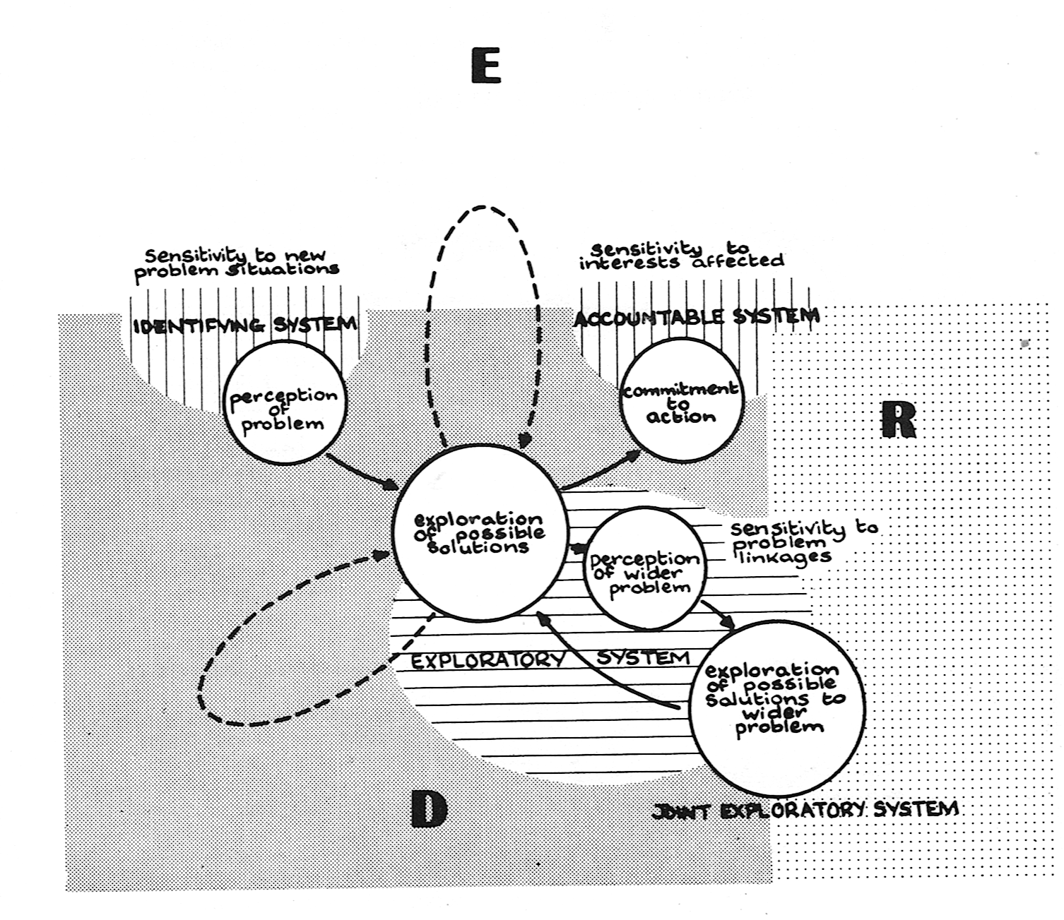
Typically, the extension of an initial field of exploration within D across the boundary with other realms R requires a perception by somebody operating within D that the choice to be made within the field now under review may be significantly influenced by the assumptions made about the future actions of other parties with whom some form of joint planning or bargaining may be possible. Such a process of joint exploration will then be of significance only insofar as it is thought likely to make a worthwhile contribution towards reducing the overall range of uncertainties in selecting a preferred course of action. To this end, it may be by no means essential that the exploratory process should result in commitment to a complete plan of action over the whole extended field of review; and indeed, a preferred strategy for the management of current uncertainties will often in practice involve leaving options open in all but the most urgent parts of the field of choice as initially defined within D. In general, the wider the range of exploration in which some set of decision-makers become jointly involved, the more subtle the range of strategies open to each of them at any point in time, and the more continuous and complex the potential field of partisan mutual adjustment is likely to become.
Some further insights into the problems of joint exploration at the boundaries between decision-making systems can be gained by looking on each system D as composed of three sub-systems associated with the successive stages of problem perception, exploration of solutions and final commitment to action. In figure 6, these sub-systems have been distinguished as the identifying system, the exploratory system and the accountable system respectively. Of course, many of the same people may be involved at each stage, but it is to be expected that involvement in the three sub-systems will become more and more differentiated as the complexity of the problems faced increases. Wherever such differentiation arises, the chief attribute required of the accountable system will be a responsiveness to the various constituencies of interest upon which courses of action selected within D are liable to impinge; while the special competence required within the initiating system will be a capacity to scan its environment in search of new problems which might be classified as falling within the realm of concern of D. The attributes required of the exploratory system will include not only the various forms of professional skill and local knowledge which may be relevant to the search for feasible solutions, but also a sensitivity to the processes of policy formulation within D, an awareness of the opportunities for worthwhile investigations within E, and - of particular significance to our analysis - a capacity to recognise potential relationships between problems currently being explored and other fields of choice within related realms R.
Thus, the exploratory system for problems originally identified as falling within D may also serve as an identifying system in relation to certain wider fields of exploration. Accordingly, involvement in the exploratory processes may broaden out from a comparatively stable and cohesive group within D to a more complex network of communication involving a number of other decision-makers, not all of whom may be in a state of continuing communication with each of the others.
Such a network, which we will call a D-network in that it provides a broad social and political context for exploration of possible solutions to problems within some recognised realm of decision D, may often cut across several lines of formal responsibility. Much of its strength may lie in its ability to modify its boundaries as changes are perceived in the nature of the problems to be faced, as new information comes to light and as new uncertainties begin to emerge.
Much of the effectiveness of such a network will depend on how far those at the 'core' of the exploratory system for D have the capability, and also the motivation, to build up external linkages in an intelligently selective way. The motivation to form appropriate linkages can often be strengthened by the introduction of some form of direct or indirect representation of other systems R in the accountable system for D; but the problem is by no means a simple one. One dominant source of difficulty is that the structure of linkages between problem areas may not always follow a pattern which is sufficiently predictable to be reflected through assigning formal veto rights or opportunities of consultation to the representatives of specified sets of external interests.
Consequently, a requirement of most inter-agency planning systems is that they should remain highly flexible and adaptive. It may be only in special circumstances that the difficulties of co-ordination between agencies can be significantly reduced merely by a decision to introduce some new form of central co-ordinating machinery or permanent organizational grouping; all too often, the effect of such changes may be only to remove the more obvious organizational barriers of the present while erecting new ones for the future.
Experimentation in Adaptive Approaches to Planning
The importance of a flexible approach to co-ordination within and between decision-making groups has been borne out, in the experience of IOR, not only through observation of decision-making processes such as those in Droitwich, but also through direct involvement in such processes, including in particular a practical experiment which was set up in 1970 to test the practical application of new aids to decision-making. These methods, based on the central technique of Analysis of Interconnected Decision Areas (AIDA) , had been developed through earlier research both in local authority planning and other fields. The experiment to test their practical value was set up under the auspices of the Centre for Environmental Studies and conducted in collaboration with the Institute of Local Government Studies at Birmingham University. Over a period of some six months in all, those involved in the exercise set out to explore a set of six different local planning problems in parallel, through a process of fortnightly meetings of local working groups, coming together once a month to exchange notes on progress. Some of the six problems were initially more closely defined than others; but all of them could be broadly interpreted in terms of 'what to do' about particular localities which were characterised by current pressures to take certain fairly immediate decisions, and also by a variety of longer-term uncertainties. These areas included a cathedral town congested with traffic, a strip of green belt land with unexploited potential for recreational use, an expanding seaside commuter area, and a neighbourhood of obsolescent housing threatened both by motorway proposals and by industrial pollution.
For each of the six problems, the exploratory system which was set up consisted of a member of IOR staff together with a small team of officers from the local authority or authorities concerned, drawn mainly from planning, financial and surveyors' departments. There were three instances in which the local authority team included representatives of different tiers of local government; in two cases, counties with associated county districts and, in the other case, the Greater London Council together with two contiguous London Boroughs.
One of the significant lessons from the experiment was that it proved by no means easy to reach agreement as to how widely the boundaries of the selected problem should initially be drawn, or even in some cases what the central focus of the exploratory process should be. A typical pattern of exploration is indicated in figure 7; the linked circles represent interdependent decision areas, relating in most cases to choices of location, timing, agency, design or policy commitment. Some of these might fall within the field of direct concern (D) of the small group of decision makers involved in the experiment, while others would fall within the fields of responsibility of related decision makers (R). Depending on the team's perceptions of the importance of different linkages in the overall network of problem areas, explorations might at any stage be extended beyond D according to some such pattern as that shown by the broken boundary line in figure 7. During the processes of exploration, the shape of this boundary might expand, contract or shift into different areas of the enlarged field according to processes of consultation or negotiation with other parties beyond the 'core' exploratory group.
Figure 7. Example of a network of related decision areas
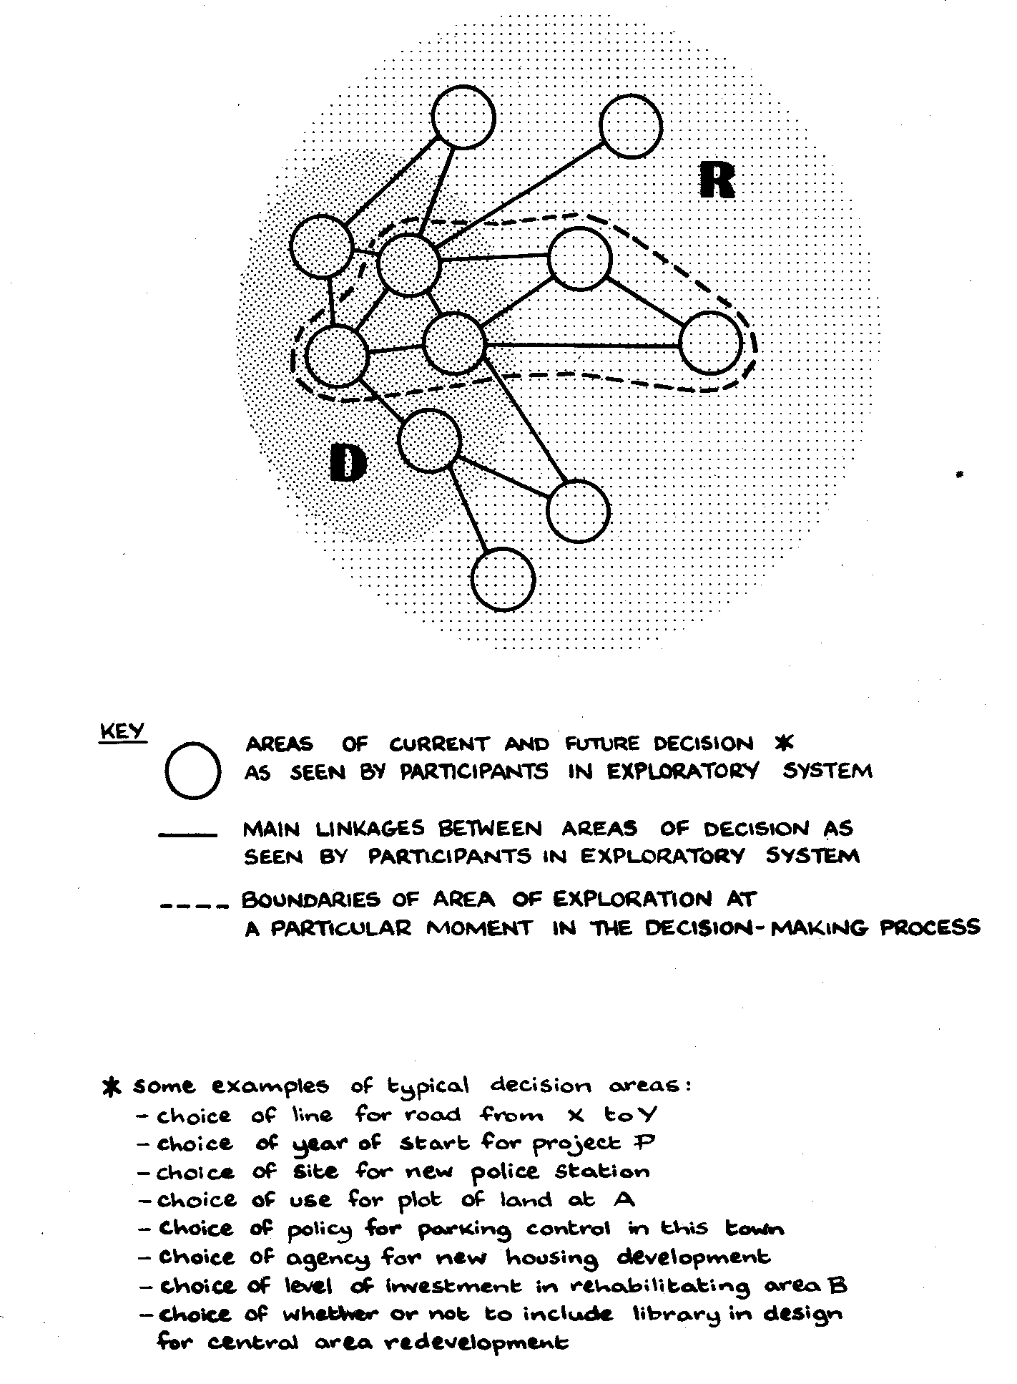
The experimental involvement of IOR staff in these six planning situations reinforced the impression drawn from our longer-term observations at Droitwich that, wherever a local community is in the throes of changes which are induced at least in part by external agents, the patterns of relationships between different areas of public decision may be of such complexity that they become very difficult for any one individual to comprehend fully, let alone to manage effectively with regard to all the interests affected. The processes of exploration may therefore extend to involve quite an extensive 'D-network', the members of which not only represent the interests of different decision making systems but may also bring different forms of professional expertise and different local perspectives to bear. The process of working within an extended network of this kind may often be time-consuming, but may, nevertheless, justify the costs involved insofar as it can help to ensure that important linkages do not remain unexplored, that crucial assumptions become more clearly exposed, and that decisions are not ultimately arrived at which become vulnerable to public criticism because of unanticipated adverse consequences on particular sectors of the community.
Co-ordination: Theory and Practice
In the skills which we saw being applied intuitively in situations of group decision-making at Droitwich, we were able to identify a number of points of contact with the more explicit techniques for structuring the exploratory process which we had been attempting to apply experimentally elsewhere. In Droitwich, as in the experimental situation, assumptions were continually being subjected to critical review, and structural connections between different problem areas were continually being postulated and debated. Against this background, alternative strategies for the 'management of uncertainty' were continually being appraised, in that suggestions were continually being made as to possibilities for further investigation, for co-ordination with other decision-making groups and for soundings among relevant interest groups, all in order to increase the level of confidence with which decisions could be taken. These various suggestions were in turn being continually debated and evaluated against a background of early pressures for commitment to clear courses of action in certain fields, combined with limitations on the time available for further analyses and consultations.
Such observations supported the proposition, argued more fully in the accompanying paper by John Power, that the forms of skill or discipline which are most relevant to situations where co-ordination is heavily dependent on processes of partisan mutual adjustment may be of a rather different nature to those usually stressed in the setting up of centralised frameworks of co-ordination within particular organizations. The philosophy of programme budgeting, for instance, places its emphasis on the introduction of a comprehensive centrally-structured framework for the processes of planning and bargaining between different functional groups. Such a discipline may clearly have relevance to the circumstances of a single corporate entity, within which activities which make competing claims on certain central pools of resources may be systematically compared in terms of centrally-negotiated sets of output criteria, given the assumption that corporate objectives and forward projections can be formulated with a reasonable degree of confidence - an assumption which may not always be easy to fulfil in practice.
It is sometimes argued that the main benefit of introducing more sophisticated frameworks of co-ordination at the centre can be in bringing about a climate wherein barriers to effective co-ordination between departments can be progressively broken down at the working levels. To this extent, central frameworks may act as a means of encouraging the more spontaneous emergence of skills appropriate to situations of partisan mutual adjustment. The extent to which such effects may be realised in practice may, however, be difficult to judge with any degree of confidence until more practical working experience has been accumulated.
Certainly, the acceptance of a central framework of co-ordination can hardly be regarded as necessary to effective processes of mutual adjustment, especially in circumstances where the exploration of solutions to problems involves working extensively at the inter-corporate as opposed to the purely corporate level. Taking again the case of the Droitwich expansion, we have already argued that such a central framework would be incompatible with the diffusion of responsibilities between the three parties to the local 'multi-organization’; with the interpretation of the original agreements as a source of constraints rather than shared objectives so far as many practical problems were concerned; and with the evidence that the initial master plan and capital expenditure projections had outlived much of their usefulness in the face of an increasingly volatile economic and political environment. The relatively small scale of the Droitwich expansion would of course in itself hardly have justified the introduction of any elaborate forms of centrally connective machinery; however, in the more recent and larger scale expansions of existing towns under the New Towns Act, where problems of both internal and external co-ordination may require to be confronted at a rather more formal level, it may prove considerably more difficult to develop a balanced relationship between the development of formal management systems within agencies and the encouragement of effective processes of mutual adjustment at the interfaces between agencies.
In their different ways, both the Borough Council and the Development Group at Droitwich could be regarded as comparatively small and cohesive organisations which, because of the extent and complexity of interaction with each other and with outside bodies generated by the expansion programme, had found themselves drawn into devoting more attention to cultivation of processes of mutual adjustment with other agencies than either could easily afford with the resources available to them. In the case of the Development Group, there was a continuing consciousness of the need to offset the cost of time spent in such activities against the accounts for specific capital projects; in the case of the Borough Council, the main constraining influences lay in the vulnerability of the local rate account and the limited range of professional skills directly at their disposal.
This leads to an important general question; in the development of its problem-solving capacities, how much emphasis should any particular type of public authority place on the ability to form and maintain external as opposed to internal linkages in an intelligently selective way? The answer must of course be influenced to some extent by the set of decision-making powers vested in that authority, and also to some extent by the set of interests to which it is accountable. The responsibilities of some authorities may cover a wide range of fields of decision, inter-related to such an extent that levels of uncertainty in the choice between alternative courses of action can be significantly reduced by forming more extended 'D-networks' within a purely corporate framework; other authorities may be responsible for important fields of decision whose exploration demands extensive working across the interfaces with other decision making bodies; while other authorities again may have comparatively limited fields of decision within their own discretion, yet be important insofar as they represent certain types or levels of community interest likely to be intimately affected by the decisions of other agencies. Such authorities may find that their effectiveness becomes almost wholly dependent on the ability to contribute constructively to the functioning of 'D- networks' at the inter-agency level, through the development of capacities to scan the areas of responsibility of other agencies, continually questioning options and assumptions, identifying salient relationships, helping to expose hitherto latent uncertainties, contributing to the formulation and re-formulation of problems, and participating in the search for mutually acceptable solutions.
The ability of an organization to work in this way across the boundaries with other organizations we will call its outwardly connective capacity, distinguishing this from the inwardly connective capacity through which it maintains a state of internal consistency or co-ordination between the actions of its component parts. To some extent, the opportunity for an organisation to develop its outwardly connective capacity may be opened up by allowing it some representation in the accountable systems of other bodies; this can, however, do no more than provide a formal framework within which ways must be found of cultivating appropriate forms of diagnostic and analytical skills. The more limited the powers of decision under the direct control of the organization concerned, the more dependent it is likely to become on the cultivation of such skills to exercise any significant influence on the processes of public policy formation. The processes of partisan mutual adjustment between agencies can now no longer be thought of as operating primarily through bargaining or negotiation, with concessions in the fields of decision D of one body weighed against concessions of equivalent value in the fields of decision D of the other; the element of intelligence capacity (in an outwardly connective sense) must now be considered as an integral part of the resources which each party can contribute to the mutual adjustment process.
Implications for a Reformed Local Government
The general proposition that the effectiveness of any public authority depends not only on the powers of decision directly under its control or the range of public services it provides, but also on the extent to which it can influence the actions of other bodies through developing its outwardly connective capacities, may seem in many ways rather an obvious one. However, at a time when the entire system of local government is about to undergo structural reform, we shall argue that it is important to recognise more explicitly the value of giving a special emphasis to outwardly connective capacities at certain levels of government, so that the institutions concerned can strengthen the influence they can exert on the actions of other governmental agencies, whether these agencies operate at a 'higher', a 'lower' or a parallel level in the overall government system.
Certainly, there is evidence within the existing structure of local and central government that certain types of authority can play a role in the making of public policy which is more than proportionate to the formal executive powers at their disposal. In figure 8, this is reflected by means of a model of the existing local government structure in England, in which each type of authority is located on a vertical scale according to the size of population served. The relative widths of the blocks representing different types of unit reflect a (purely impressionistic) view of the relative degrees of influence or 'weight' of each type of authority in serving the interests of those members of the public to which it is accountable, firstly in terms of accountability for management of specific public services, and secondly in wider terms including an impression of degree of influence over those areas of decision for which other levels of government may be managerially responsible.
Figure 8 Existing structure of local government in England (structure similar in Wales and broadly similar in Scotland)
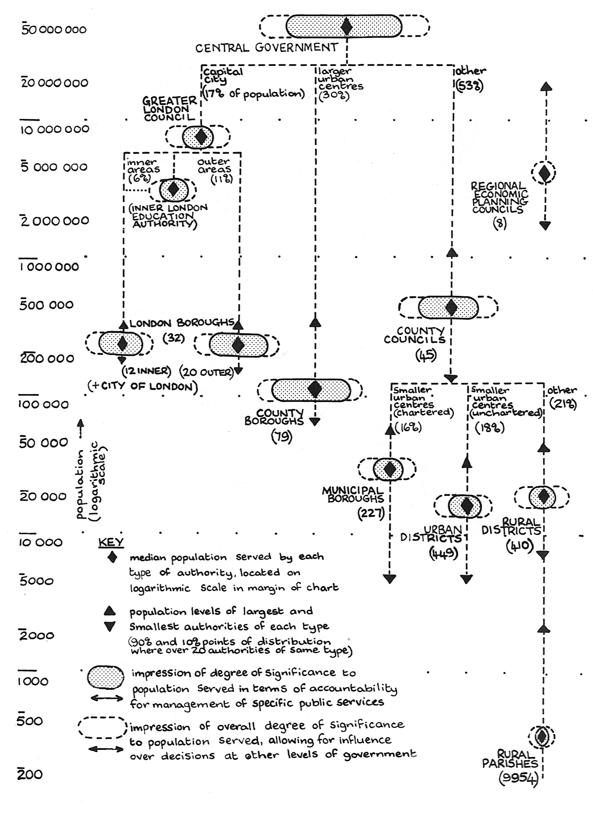
The basis for any judgements of relative influence such as those implied in figure 8 will always be debatable, and for this reason the horizontal scaling used in the diagram has been left deliberately imprecise.
Nevertheless, there are some sources of evidence to support the relative orders of magnitude suggested in figure 8. The relative orders of magnitude of the resources required for the public services managed by the County Councils as compared to their constituent districts, or for those managed by the London Boroughs as compared to the Greater London Council, are brought home to members of the public in their biennial rate demand notices; while differences in turnout levels at local and central elections give at least some indication of the perceived levels of importance of local government affairs generally in relation to areas of policy determined at the centre.
The impressions given in figure 8 of variations in the balance between direct executive powers and outwardly connective capacities at different levels reflect various pieces of evidence currently available. For instance, there is evidence that the Greater London Council, through its strategic planning and intelligence functions, exerts an influence significantly beyond that provided through the limited range of direct public services which it provides; while the two-tier structure within the Counties inevitably leads to a greater emphasis on outwardly connective capacities (at both county and district levels) than in the all-purpose County Boroughs. Bodies whose influence is exerted almost exclusively through outwardly connective capacities include at one extreme the more active of the Parish Councils elected to serve the interests of close-knit rural communities, and at the other extreme the Regional Economic Planning Councils, appointed by central government comparatively recently to perform a purely advisory role. While the latter clearly carry more weight than the former if the size of population represented is taken into account, it is by no means so apparent that even the most politically aware of rural parishioners would regard his Regional Economic Council as carrying more influence than his local Parish Council when judged on degree of expected impact on his or her own personal affairs.
The question of how far the significance of an authority to individual members of its electorate need be commensurate with possession of direct executive powers has been an important underlying factor in the debate over local government reform in Britain during the last few years. The argument that some levels of government might be influential even though possessing few if any managerial responsibilities was central to the proposals for Local Government in England produced by the Royal Commission under Lord Redcliffe-Maud, which are illustrated in figure 9 along with the later proposals for England introduced in the 1971 Reform Bill.
In figure 9, the supposition is made that, in the non-metropolitan Counties of England and the regions of Scotland, the effective functioning of the governmental system may require the outwardly connective capacities of District Councils to be more than commensurate with their limited range of executive powers in fields such as housing, environmental health, and development control.
While this supposition is broadly in accordance with the experience of existing authorities as reflected in figure 8, the extensive range of functions which the new non-metropolitan counties will exercise for both urban and rural areas may well call for a rather more explicit emphasis on the outwardly connective capacities of the new County Districts.
Figure 9 Proposals for local government reform
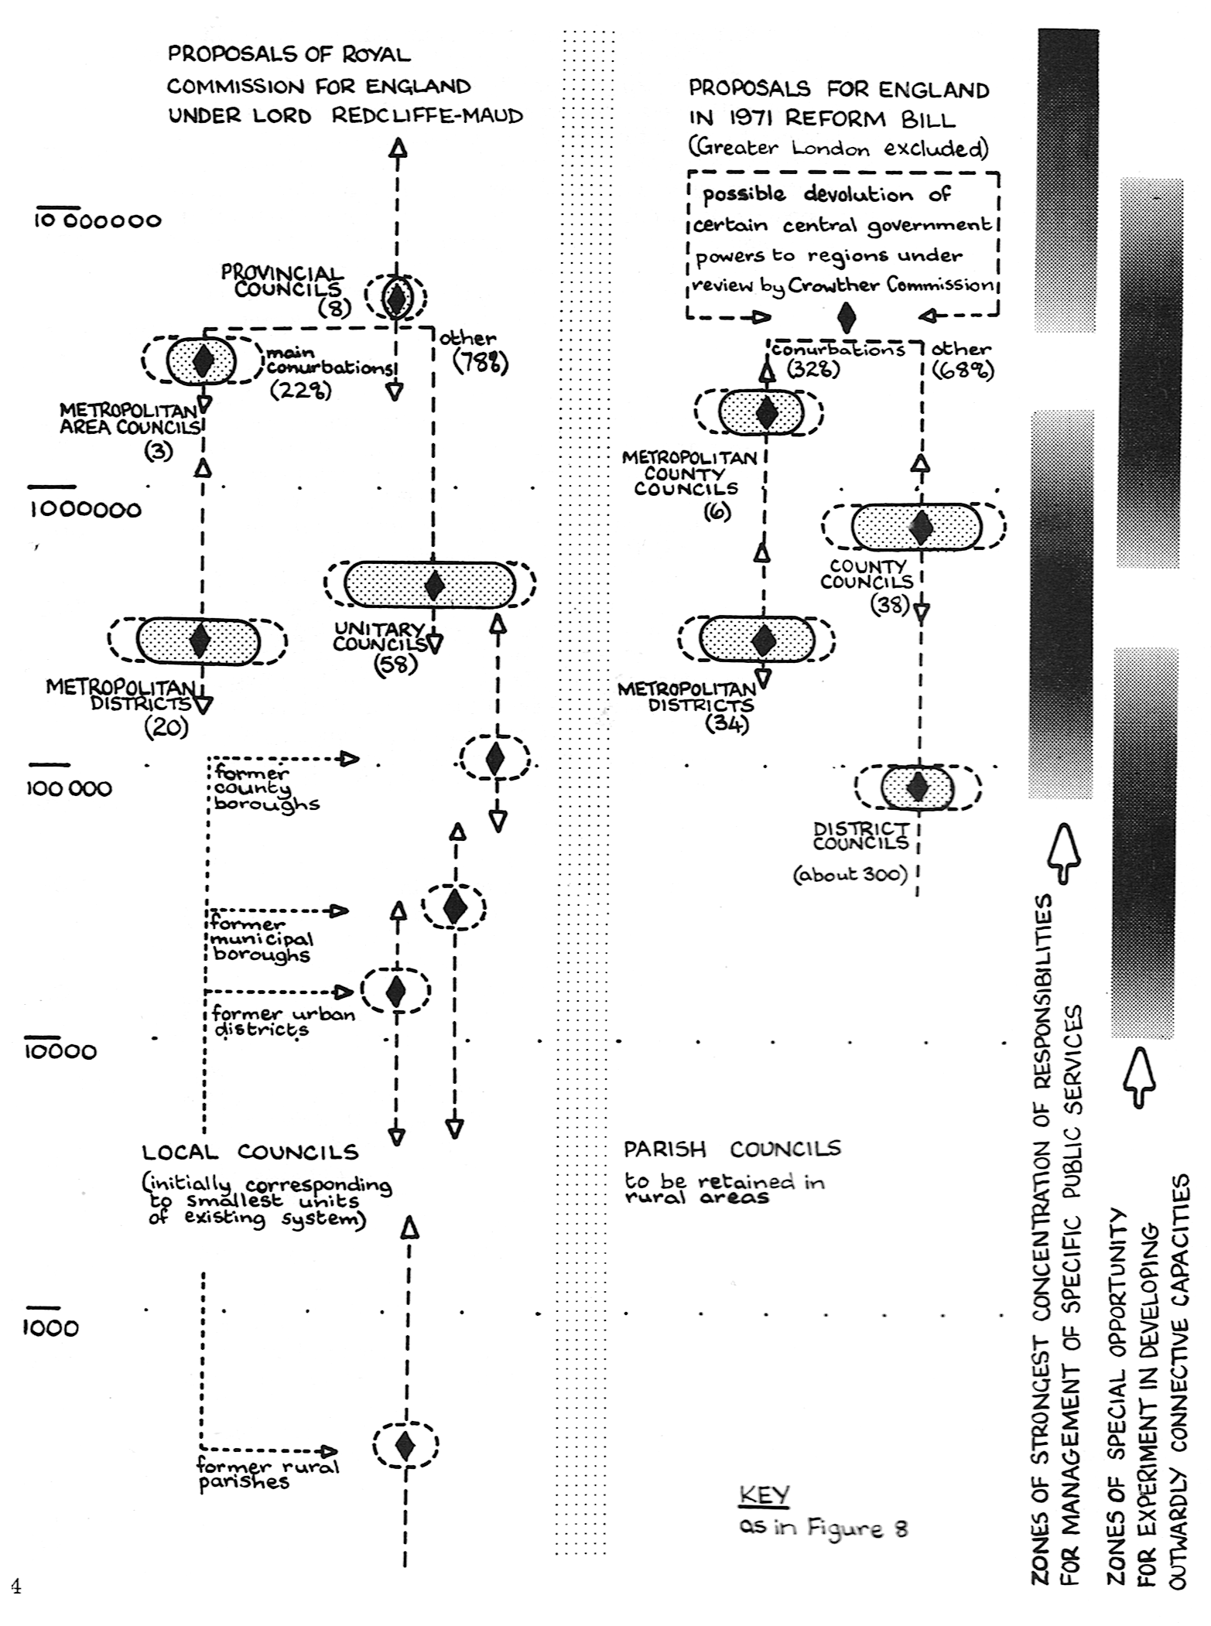
Even though these will generally cover larger areas than their counterparts within the existing county structure, and even though they are now to be allocated a wider range of executive functions than was earlier envisaged, their elected members are still likely to be keenly aware of the limitations of their corporate responsibilities and the need to seek ways of exerting a constructive influence over those decisions at county level which most closely affect the interests of their constituents.
Our observations of decision-making at Droitwich indicated clearly that elected members and staff of even the smallest of district councils were capable of making an important and distinctive contribution to the exploration of alternative policies at the inter-agency level, through their sensitivity to the many sets of interacting interests represented within their local electorates. However, there is also evidence that, throughout the local government system, these capacities can be by no means sufficient in themselves where the issues to be considered become complex and highly inter-related, and where the search for acceptable solutions requires increasing reliance on the judgements of a wide range of different experts, many of them primarily accountable to other levels of government. The exploration of important linkages between problem areas, the questioning of basic assumptions, and the choice of strategies for the managemerit of uncertainties are all activities in which representatives of a district council can be ill-equipped to engage unless they have continuing and direct access to some form of diagnostic and analytical capacity of a comparatively generalised nature. As we shall argue later, such 'outwardly connective' skills have already been developing within certain established local government professions, although they may have to be more explicitly recognised in future and where necessary reinforced. Such reinforcement is likely to become especially crucial in any future situation such as that in Droitwich, where an established local community becomes subjected to intensive change induced at least in part by the actions of outside agencies.
This argument can be developed more generally to form the proposition that there will in future be certain levels of the governmental system within which the encouragement of outwardly connective capacities may require to be given a particularly high priority. In the margin of figure 9, the general point is made that direct responsibilities for the provision and management of major public services will be concentrated primarily at two levels of government; firstly, the level of central government (subject to any future measures for increased devolution of decision-making to regional offices), and secondly that zone of local government which spans the broad population range of 200,000 to 1,000,000, including both the new non-metropolitan counties and also the proposed metropolitan districts. Above and below this primary zone of responsibility for local government services, figure 9 identifies two further zones corresponding broadly to the level of regional government (whatever form this may take in future) and the level of the non-metropolitan County District. At both these levels, it becomes much more difficult to pursue the development of planning and co-ordinative processes at a purely corporate level; working from a comparatively narrow resource base, it may become necessary to give much more explicit consideration to the development of outwardly connective capacities, if the particular levels of community interest which these institutions are designed to reflect are to be adequately represented in the networks of public policy formation.
In figure 9, the lines of demarcation between the primary zones of functional responsibility and those of suggested emphasis on outwardly connective responsibilities have been left deliberately imprecise. In such a classification, there will inevitably be certain types of authority - for instance the proposed Metropolitan Counties and also perhaps some of the larger cities with non-metropolitan district status, the position of which must be considered ambiguous, at least for the time being. Also, the question remains open as to how any experimentation in development of outwardly connective capacities might be organised at the more local level within the Metropolitan Districts; a question which clearly relates to much of the current debate over neighbourhood representation within the urban areas.
If the premise is accepted that it is important to find ways of reinforcing outwardly connective capacities at levels other than those where executive powers and resources are most strongly concentrated, and that this will require sustained experimentation during and beyond the coming period of reform, then the question arises of how this kind of experimentation might be most effectively directed and sustained in practice. To begin with, much could of course be learnt from a number of developments which have already been taking place in different parts of the country in the last few years. For instance, the role of the experimental Community Development Projects, recently set up under central government auspices in certain urban areas of multiple social deprivation, is essentially an 'outwardly connective' one; so is that of the wide range of existing voluntary bodies concerned with the mobilisation of community action and identification of social needs, whether over dispersed rural areas or within compact urban neighbourhoods.
Meanwhile, certain established professions within local government have for some time been adapting their basic skills towards the demands of their outwardly connective responsibilities. Prominent among these are the clerks, who have always carried a special responsibility for maintaining effective processes of both internal and external communication, and the town planners, whose professional activities inevitably force them to work within an inter-corporate framework. In the experiment referred to earlier, where IOR staff worked with teams of planners and other local authority officers on the parallel exploration of six different sets of local decision problems, one of the most encouraging lessons we were able to draw was that new forms of technology relevant to the processes of partisan mutual adjustment within and between different decision-making bodies could be assimilated and applied to practical problems in quite a short space of time, not only by professional planners but also by accountants and other professional staff from both county and district levels of local government.
Further lessons relevant to any future experimentation can be learnt from receni developments in planning at the regional and sub-regional levels, particularly in regions such as the West Midlands where a variety of different study teams have been engaged simultaneously in the exploration of closely related areas of decision. In such activities, the processes of continuing interaction with other professionals working at the executive levels of government have often come to play as central a role as the internally-managed processes of research, analysis and construction of large-scale systems models.
It is particularly at the regional and sub-regional levels that conscious attempts have been made to set up broadly-based inter-disciplinary teams within which town planners work together with economists, sociologists and several other professionals in the field of public policy-making. In a recent issue of the Journal of the American Institute of Planners, Alonso has put forward the view that the most fruitful result of such interactions may ultimately be the emergence of a new form of shared discipline among those who participate, rather than any benefits which can be gained from pooling the individual contributions of the several component disciplines. Although he sees such a development already taking place in what he calls the 'hard' social sciences which place their emphasis on large-scale urban and regional models, he argues that it is equally necessary within the 'soft' social sciences where generally accepted technologies have hardly yet begun to emerge.
Whatever progress may be made in future in the technologies of large-scale systems modelling, and in the development of central planning or policy review frameworks in the purely corporate context, it seems inevitable that any reinforcement of the outwardly connective capacities of governmental bodies at all levels will be heavily dependent on a more explicit recognition of the types of intuitive skill which are already evolving, on an increasingly broad front, in response to situations of inter-agency decision-making where there are many different sources of uncertainty to be managed, and where the boundaries of exploration at any one time may be by no means clearly defined.
The Scope for Experiment: Some Speculations
Drawing together the various lessons which can be learnt from recent trends in development of outwardly connective skills at local and regional levels, one promising strategy for experiment may be the introduction into one or two of the new district councils (or even into existing authorities of similar size) of at least one individual with an analytical bent who is directly charged with developing, at an explicit level, the authority's outwardly connective capacities in relation to the decision processes of other levels of government. In pursuance of this task, he would have to work within the context of whatever formal procedures had been set up for representation of his authority in the accountable systems of other relevant bodies, including in particular the County Council within whose area his district was located.
Given such a framework within which to operate, the assignment of an officer to develop new kinds of outwardly connective skill at district level could be expected, sooner or later, to make a significant impact on the degree of effective mutual adjustment at the inter-agency level. The activities of such an individual might include not only regular involvement in the affairs of various committees or working groups beyond the confines of his employing authority, but also the cultivation of relationships with individual officers through which he could maintain a general awareness of any crucial areas of decision within which clear proposals for action had not yet begun to emerge. In such a process, it might not always be easy to sift points of real significance at the interface between the authorities from matters of more limited technical judgement; and here it might well become especially important for the analyst to be able to direct his inquiries with reference to an explicitly developed analytical framework, capable of transcending the barriers between different fields of specialist departmental concern. Sometimes, such questioning might meet with a defensive response, and the individual concerned could find himself exposed to quite severe stresses in striking a balance between maintaining the confidence of his informant and that of his employing council. However, similar stresses are already contained within other public service roles, and one of the aims of the experimentation would be to discover how these stresses might be more effectively managed at the interface between representative bodies with widely differing levels of resources and formal powers at their disposal. As a last resort, any disagreement with representatives of other bodies over choice of assumptions, over ranges of available options, or over strategies for the management of uncertainty could of course be elevated to the level of formal dissent - even to that of objection at a public inquiry - but if this became anything more than a last resort, the individual responsible for developing the outwardly connective capacities of the district council would clearly be failing in his mission.
The main test of success for local experimentation of this kind would be the degree to which the cost of assignment of the individual concerned could be locally justified in terms of providing new openings for timely and effective influence over the actions of other decision-making bodies. The elected members of his employing council would have to be convinced that he was providing them with a resource that could amplify, rather than compete with, their attributes as local representatives; while the local electors would have to be convinced that they were being provided with a worthwhile service, through visible evidence in the local press, in public meetings and in other media that policy options of local significance were being more fully exposed to local debate, and opportunities for timely participation in planning were being more realistically created. At the periodic local elections, it would of course be open to opposition parties or individual candidates to argue that resources currently allocated to outwardly connective activities were either excessive or insufficient in relation to the returns provided. Whether or not the level of such expenditure tended to settle down to some ultimate equilibrium level might well depend on the degree of stability or otherwise in the evolution of the particular local community concerned.
The opportunity to establish any kind of equilibrium level could, however, hardly be created without a sufficient period of trial and error to allow the potential scope for reinforcing the council's outwardly connective capacities to be systematically explored and demonstrated. A particularly important problem could be that of finding ways to distinguish expenditure on such capacities as clearly as possible from any general administrative expenses concerned with the authority's own internal operations, as well as expenditure on specific executive functions such as housing, refuse collection and development control. Many of the existing outwardly connective activities of local authorities can all too easily become lost in the accounting system as administrative overheads; but activities designed to exercise effective influence over the actions of other governmental agencies form a legitimate and important part of any public authority's activities. The monitoring of the approximate order of cost involved could present an important challenge to the ingenuity of the accountants at any level of government, but perhaps most of all within any district councils engaged in experimentation with new forms of outwardly connective role.
Should local experimentation of the kind suggested yield promising results, a longer-term trend could be towards the emergence of a new type of profession based on the explicit recognition of a new form of shared discipline as envisaged by Alonso, its adherents operating on a widely dispersed basis but perhaps with an especially strong concentration at district council level. In the accompanying paper, Power has coined the term 'reticulist' (literally, 'net-worker') to explore further some of the implications of this kind of role.
In terms of career structure, any such profession might well look primarily to the regional level of government; whatever may be the future pattern of responsibilities for regional planning activities, it is only to be expected that the trend towards significant concentrations of outwardly connective skills at a regional level will continue. At this level, opportunities could be provided for initial training, for advancement to senior positions of a kind which few district councils could be expected to afford, and for short-term assignments in response to special local demands. Our analysis of the Droitwich situation suggests that such demands might be expected to arise especially where particular towns or rural areas have been proposed as potential centres of growth. The provision of outside assistance towards reinforcement of the local authority's outwardly connective capacities might do much to overcome problems of inequalities of expertise both during negotiation and during subsequent management of development programmes; assurances of such support should, perhaps, be regarded as just as important in practice as assurances of assistance in meeting the costs of sewerage and other infrastructure development.
Initially, individuals moving into new roles of the kind suggested would inevitably have their roots in established professions such as town planning, law, public administration or one of the social or management sciences. It might, however, be desirable that those concerned should already have been subject to influences causing them to modify their basic skills, whether through working in multi- disciplinary teams at regional level or through interaction with other professions in large existing authorities. Almost certainly, further adaptations would prove necessary on moving into a more exposed outwardly connective role under conditions of direct accountability to an elected district authority, with only a limited range of direct powers at its disposal but with a rich variety of local interests to represent. For instance, a town planner might have to learn to derive satisfactions from opening up a fully representative range of policy options without necessarily building up a commitment to a single creative solution; a lawyer might have to learn to adapt his skills in challenging the statements of others to relate more readily to complex sets of interrelated issues formulated in new and unfamiliar ways; while a management scientist might have to learn to live with persistent uncertainties about objectives and to take a more modest view of the practical relevance of elegant mathematical models.
Any speculation about the emergence of new professional disciplines in the longer term inevitably raises questions of relationship to existing professions, and especially the town planning profession, which has recently been much preoccupied with uncertainties about its status in the reformed local government structure. Although the planner's skills are already perhaps more of an outwardly connective nature than those of any other local government profession, the planner also has certain more closely-defined responsibilities in particular fields of decision; at the local operational level, he must concern himself especially with decisions of acceptance, rejection or conditional approval of planning applications from private developers and, at the more strategic level, with decisions on forms of policy statement to be written into published development plan documents, where the crucial judgement to be made may often concern how far commitments in particular fields of policy should be couched in 'hard', 'soft' or completely open terms. As part of the experimental process, it could well be important to compare the effects of reinforcing the connective capacities of district authorities both within and outside the context of departments having direct responsibilities for physical planning decisions.
A particularly important issue to be explored could be the relationship between a District Council, reinforced by the introduction of new analytical capacities, and the many different neighbourhood or sectional interest groups through which issues for policy exploration might from time to time be generated. Some difficult questions of priority for investigation might then arise; however, the crucial safeguard would be the accountability of the District Council to its electorate for the fair deployment of the analytical resources at its disposal.
Similar problems of priority in deployment of outwardly connective resources would of course have to be faced at regional level, as indeed they are often already faced in the management of regional study teams. And, at central government level, the crucial question might arise of how far it could be justifiable or desirable to deploy central funds in support of the experimental development of analytical capacities serving particular types of region or particular types of urban or rural area, bearing in mind any geographical inequalities of wealth or opportunity and any national policies for their redress.
There could be far-reaching repercussions in any movement towards the more clear-cut differentiation of certain levels of accountable government which could be seen to draw their strength more from the broad analytical and diagnostic resources at their disposal than from the set of executive functions directly under their command. Authorities whose executive responsibilities cause them to generate a high degree of internal momentum are unlikely to be as responsive to social change as agencies whose effectiveness, and indeed survival, may be dependent on working at the interfaces with other functional bodies. Already, experience in the embryonic institutions of regional planning suggests that they may be able to establish an effective role only insofar as they can develop new and significant forms of connectivity between the executive actions of central departments, local authorities and more specialist public agencies such as those accountable for water resources, communications and health. If the same ability to range widely but with discrimination over many different fields of specialist concern could effectively be fostered at a much more local level - and especially at a level which could be clearly distinguished from the level at which the major functional responsibilities were most strongly clustered - then the effects could be highly significant in terms of the capacity of the entire governmental system to adapt to its increasingly turbulent environment.
Perhaps the fullest justification for the many costs and anxieties likely to be generated by the structural reform of local government will only start to emerge if, once the dust has begun to settle, the processes of public planning can be seen more clearly as operating between authorities as well as within them, through networks of influence which are open to public participation at many different levels, and in which access to diagnostic and analytical skills is more evenly diffused than at present. This kind of openness can hardly be easy to achieve in practice, and, indeed, its realisation may be impossible without the acceptance of increased levels of cost, uncertainty and insecurity of purpose at many different levels of the governmental system.
The present time is hardly one at which to attempt to evaluate conclusively the merits or otherwise of innovations such as those we have been discussing. It is, however, in our belief important at this time to speculate as widely as possible about the opportunities for allowing new forms of connectivity to evolve in the networks of public policy formation; and to this end, to encourage a process of sustained local experimentation during the coming years of change. In embarking on any such experimentation, it seems likely that much of value can be learnt from the study of local arrangements for inter-agency planning in circumstances such as those of the Droitwich expansion scheme, where public authorities of modest resources have had to find ways of working constructively, together with others often representing widely divergent sets of interests, in confronting complex and often stressful problems of adaptation to a rapidly changing environment. The methods which have evolved may in many cases appear unsystematic and largely unspectacular; nevertheless, they may turn out to provide information of crucial importance in guiding the search for realistic planning processes throughout the increasing complex network of publicly accountable government.
Acknowledgement
We are indebted to many elected representatives and public officials, and especially to the members and staff of the Droitwich Development Committee, for their generosity in giving us unconstrained access to decision-making meetings - both formal and informal - and also for providing a responsive sounding-board during the crystallisation of the lines of thinking reported in this paper; for which, of course, we as authors must accept the full responsibility.

PLANNING: MAGIC AND TECHNIQUE
by J. M. Power
The Politics of the future
Planning, which may be defined briefly as the present politics of the future , is by now an activity which has found broad acceptance right across the ideological spectrum. As the future becomes increasingly uncertain and threatening, we seem to be closing ranks to confront it. How old-fashioned Mannheim now seems: 'conservative thought concentrates upon the past in so far as the past lives on in the present; bourgeois thought, essentially devoted to the present, takes its nourishment from what is new now; and proletarian thought tries to grasp the elements of the future which already exist in the present'. We are all different these days. Conservatives try nearly as hard as anybody else to grapple with the future. The distinctively chiliastic element in much 19th Century proletarian thought, which focused primarily on the future because it saw it as an escape from the exploitation of past and present, has all but disappeared. Among bourgeois thinkers, even as cheerful a figure as Drucker, who certainly has a very keen eye for 'what is new now', has recently warned us that, unless we skilfully guide future economic development, 'we can barely even hope to survive' . This decisive shift in attitude has probably been due to the pervasive cultural influence in recent years of statistical modes of thought, even on those who are still content to describe themselves as innumerate. It is now generally accepted that intelligible statements can be made about a universe characterised by a high degree of interdependence between its constituent parts, even when some of these parts are unstable, thus bestowing a high degree of uncertainty on the behaviour of the system as a whole.
Of course, the fact that there is fairly general agreement that we should be more strongly oriented towards our increasingly threatening future does not mean that there is any sort of consensus about the means we should employ or the goals at which we should aim when planning. On the contrary, contemporary debate on the politics of the future is getting progressively livelier, and certain familiar stances - liberal, conservative, socialist - are becoming clearly distinguishable.
However, these traditional stances seem to be of decreasing importance in the politics of the future. Cutting across these categories, and of much greater significance, is the distinction between those who favour authoritarian approaches to the problems which seem to lie before us, and those who do not.
Circumstances seem currently to be favouring the authoritarians, if only because of the present state of our knowledge of the future. While we are increasingly uncertain about the nature and direction of processes of social (and particularly organisational) change, we are becoming much more sure of our grasp of ecological trends, and these seem to be leading towards disaster. Thus, there are, not surprisingly, indications that the rapidly developing international movement of ecological concern, which has its roots in the American Left, is coming to possess a distinctly authoritarian flavour. For example, Ehrlich, who has done more than anyone else to arouse public awareness of the terrifying deterioration of our planet's life-support system, seems to view politics in the extremely simplistic and moralistic manner characteristic of the authoritarian. In this, Ehrlich may be a precursor of a coming dominant style of politics. If our ecological future is as black as Ehrlich paints it, it is highly likely that authoritarian movements, proposing tough and indiscriminate measures to control population growth and technological development, will come to power. If such movements are to be successfully resisted, governments will need to effect a rapid improvement in their techniques of monitoring social, technological and even cultural processes. Governments may then be able to make decisions which will guide societal development in a sensitive, selective and non-authoritarian manner, and yet at the same time foster the preservation and enhancement of our ecosystems.
At the present time, governmental intelligence is still in a rudimentary, ramshackle state. Remarkably little shrapnel from the knowledge explosion seems to have penetrated to the centres of decision-making in government. In relation both to what they need to know, and to the knowledge that is already available, governments have probably never been so ill informed. If, as economists such as Drucker have claimed, knowledge is becoming an increasingly important segment of our productive base, we have few mechanisms for reticulating it along lines where it may be of use to public decision-makers. We have no institutions which perform the same function for knowledge capital as stock brokers and their exchanges do for finance capital. The established professions and disciplines, like medieval guilds but with rather less justification, jealously guard their domains of putative expertise and competence. In this situation, it is hardly surprising that much contemporary writing on planning has a strongly magical flavour, because man has customarily resorted to magical activities wherever he has become aware that he is faced with threatening uncertainties against which he has no adequate practical defences.
In this paper, I shall be identifying a number of instances of magical thinking and criticising those which have tended to hamper our capacity to cope with the problems which await us in the future. In particular, I shall try to evaluate a number of recent contributions to the evolving technology of decision-making. Most of these contributions have been made independently of most of the others, for they come from a fairly wide range of disciplines. However, when some of the disciplinary magic is stripped away, and the substance of these contributions is revealed, some striking convergences of interest appear. Once these convergences have been identified and discussed, it should be possible to conduct an appraisal of the present state of our technology of decision-making, and of the most important gaps that must be filled if it is to develop further.
There are undoubted risks attached to this critical enterprise, for magic often performs the important function of sustaining our collective morale when we are faced with threats about which we can do little that is effective. Nevertheless, given the dangers which seem to lie in the future, the risks must be taken, for our prospects of survival to the end of the century may depend on the clarity of our vision. This clarity is extremely difficult to achieve, if only because magical and more practical techniques are so closely intertwined. Indeed, magical activities may themselves be viewed as diffuse techniques and, as Ellul has convincingly argued, often form matrices out of which more specific practical techniques subsequently develop. However, as practical techniques evolve, they usually do not simply displace their magical forerunners. Rather, the latter show great capacity for survival, and often can co-exist indefinitely with their more practical successors. The history of planning itself clearly demonstrates this. The activity is initially undertaken, more or less desperately, as an act of faith. Thus the governments which have made pioneering attempts to introduce national planning - the USSR after the First World War, and France and India after the Second - were those which were faced with particularly uncertain futures. After many initial failures and disappointments, some moderately effective procedures and techniques are devised or borrowed, and the term 'planning' begins to possess a more generally favourable connotation. Many of these borrowings also seem to have been prompted initially by a magical act of faith. Some of the planner's central concepts (and the techniques associated with them) - system, model, scenario, goal - have been borrowed from other disciplines where they have been used with success, the borrowings no doubt being inspired by hopes that their potency will magically survive transplantation. The successful use of such borrowed concepts may in turn be taken as a demonstration of their magical qualities, and further enhance the generally favourable contemporary image enjoyed by the activity of planning.
As planning has gained in general approbation, senior administrators have hastened to embrace it, thus modestly demonstrating their foresight and prudence. In addition, several professions and occupations have been only too happy to succumb to the same wave that has carried along the politicians and administrators and have thus spawned a variety of sub-professions and sub-disciplines whose titles end in planning: corporate, defence, manpower, disaster, community and population. The older established planning professions, especially town and economic, have increasingly felt the squeeze. Their predicament has been heightened by a parallel set of processes - the universal increase of specialisation of function both within and between the professions. As the share of each profession and sub-profession in the present began to shrink, it apparently sought to compensate by extending its narrowed concerns into the future. Of course, not all professionals have engaged in these imperialistic manoeuvres. Most of them have continued doing what they have usually done - administering, regulating, politicking and fighting. The aspirations towards planning have always been left to a minority of theoretical high-flyers.
The town planners, whose claim to large tracts of the future has always been based on a fairly shaky claim to expertise, have been particularly vulnerable to these processes. Town planning has thus been one of the most strongly magical of modern professions. For this very reason, however, town planners have succeeded in evolving techniques useful to any political decision-maker, and have also been particularly interested in and sensitive to other techniques that have been developing elsewhere. Town planners thus are simultaneously the most prone to magical practices, and the possessors of as complete an armoury of decision-making techniques as any other profession employed in the realm of public policy-making. In part, this state of affairs has been due to the fact that most important governmental decisions have consequences for the physical environment, and town planners have thus of necessity a wider spread of concerns than most of their other professionally trained colleagues (such as the engineers or educationists). Even more important has been a widespread propensity for political naiveté among town planners, which has led them to enter political thickets - such as the thorny problems of interdepartmental and inter-professional co-ordination - that their politically more prudent colleagues have tended to skirt. Indeed, many town planners seem caught in a simple semantic bind, and believe that the formal title of their profession requires them to tilt at all obstacles in the way of effective public planning. The problems confronting all planners are thus displayed in sharpest outline in the literature of town planning, and accordingly I shall explore at some length the ways in which magical thinking interferes with the effective use of decision-making technology by town planners. I shall focus my attention on two recent British books. The first of these is J. Brian McLoughlin's Urban and Regional Planning: A Systems Approach, which provides a good statement of the ecosystems approach to planning; the second is G. E. Cherry's Town Planning in its Social Context, the most recent British statement of the need for 'social planning'.
From these books, I shall take a few themes which seem to me to be particularly relevant to the search for a more effective technology of decision-making. These themes will then be pursued and developed in the course of a briefer discussion of some other recent writings in the fields of economic and corporate planning, and will finally be brought together in some concluding comments.
Town planning as a magical activity
The initial and continuing appeal of town planning for political romantics (who still seem to be grossly over-represented in the profession) has been the promise that Utopian ends could be achieved through the use of highly concrete means. While these means remained technically undeveloped, town planning was a highly rigid system of magical activity, almost completely ritualistic in nature. Ellul's characterisation of magical practices could hardly be bettered as an evocation of British town planning in the immediate post-war years: 'an aggregate of rites, formulas, and procedures which, once established, do not vary. Strict adherence to form is one of the characteristics of magic: forms and rituals, masks which never vary, the same kind of prayer wheels, the same ingredients.... for fomulae for divination... '
Out of this matrix, increasingly sophisticated techniques for land-use regulation have evolved in recent years, and this development has in turn affected the magical matrix. The town planning system has of necessity become rather more flexible, but the cost has been increasing confusion about the purposes of the profession. This confusion has been the product of a disconcerting trend: the greatest advances in effectiveness have been made in those areas which the profession customarily considers to be the dreariest. Thus, the town planners who have had the greatest impact on governmental outputs have been those who are perhaps best described as 'amenity policemen', whose techniques are slowly becoming more effective in protecting the senses and sensibility of the individual and his nuclear family from unjustifiable (and often unnecessary) assaults.
These amenity policemen, the proletarians of the profession, seem content to continue with their humble work. It is their fate to be performing work which, in our culture at least, does not seem of much intellectual interest. Their aims are mainly preventive: fewer children killed by cars on their way home from school; fewer workers developing ulcers as they spend frustrating hours on journeys to work; fewer housewives becoming dependent on barbiturates; and so on. Indeed, there is usually much greater intellectual stimulus in the study of the very states the amenity policemen are attempting to avert, for these can have fascinating sociological and psychological 'multiplier effects' - mourning, absenteeism and productivity loss, delinquency and divorce. The lot of the amenity policeman is relatively humble, not because his work lacks value, but because its impact on society is aggregative, and not directly structural. He thus takes his place beside those other valuable servants of the public - sewerage engineers, experts in garbage and bomb disposal, landscape architects. It is hard to see how a Utopian social system could be constructed on such a narrow base of expertise.
Of course, town planners of a Utopian bent have not been deterred by these developments. The most obvious reaction has been that of the social planner, who finds the traditional physical orientation of the town planner frustratingly restrictive, and wants the profession to adopt a more openly political stance. Rather more surprisingly, however, a strain of Utopianism has persisted even among the ranks of those theoretically minded physical planners who have concerned themselves with the development of a technology of the future, and have succeeded in marshalling an impressive array of forecasting and modelling techniques. As awareness of the humble nature of the work of the amenity policeman has increased, a new concept has emerged to put heart into Utopian physical planners - that of the ecosystem. Ecosystems embrace both social systems and their physical environments. They can be modelled. Our very survival may turn on their integrity. Surely then an expert in ecosystems, who can make predictions about their behaviour, should play a political role of overriding importance, co-ordinating the activities of other narrow specialists? This is the hope held out to physical planners by McLoughlin in his recent book.
He advances the political claims of the physical planner in terms of his supposed generalist skills:
'Generalists in any field are not supermen who know how to do everyone's job; they are simply specialists in the higher-order systems in the given context. Clear definitions of these systems and their sub-systems provide the operating framework for the generalist as well as illuminating the roles and relationships of other skills involved (see for example Loeks, 1967 and Mocine, 1966). Generalists may be defined as people who can:
(i) understand the nature and behaviour of the appropriate system;
(ii) distinguish elements and sub-systems within it and how their problems are approached by people with other skills;
(iii) co-operate in the setting of goals and objectives for the system;
(iv) devise the best methods of improving system performance;
(v) carry continuing responsibility for the performance of the whole system.
These criteria may be interpreted so as to refer specifically to the planning of towns and regions and provide a profile of the comprehensive or generalist planner’
Generalist physical planners are accordingly supposed to be able to co-ordinate the activities of a wide range of 'specialists' - such as demographers, economists, architects, engineers, surveyors, valuers, agriculturalists, geographers, geologists, sociologists, political scientists, psychologists, public administrators .
This claim to authority for the generalist planner illustrates nicely the magical potentialities of systems theory when it is used to interpret political phenomena. The conception of the generalist as a specialist in higher-order systems seems to me to be a valid one when one is studying a relatively simple ecological system. When applied to the government of such an enormously complex ecosystem as that of a city or region, however, it is hard even to imagine what could be meant by 'the best methods of improving system performance'. A theoretical framework which may be fruitful in guiding the study of one system may be of no use in the government of another system. Understanding and governing are not the same. Furthermore, even on the level of understanding, it is by no means clear to me why ecological systems should be considered 'higher order', even in the context of town planning. Imperialist sociologists could claim with more (but still not much) plausibility that social systems are of a higher order than ecological ones, and therefore they should control the activities of the physical planners.
McLoughlin, possibly inadvertently, himself lends some support to this view. The concluding words of his book are taken from Webber: 'as the barest minimum, the task is to seek that spatial distribution of urban populations and urban activities that will permit greater freedom for human interaction while, simultaneously, providing freer access to natural amenities and effective management of the landscape and of mineral resources. This is no mean task - and probably the meanest part of the task will be to disabuse ourselves of some deep-seated doctrine that seeks order in simple mappable patterns, when it is really hiding in extremely complex social organisation instead'. Perhaps politically ambitious planners should abandon ecological systems and instead become expert in social organisation?
This theme has been vigorously pursued in a recent book by another British town planner, Cherry. Although he argues that town planning has three constituent parts - physical, economic and social planning - he does not display much interest in the first two parts. Indeed, he evidently does not consider the function of 'amenity policemen' to be of much value: 'The history of planning control during these last two decades does not lack for evidence of concern for the environment: conditions may be attached to planning permissions such as 'in order to safeguard (or enhance) the amenities of the area' and planning permission refused on the grounds of 'detriment to amenity'. It may well be questioned, however, why there is so much concern about improvements to the physical environment when it seems to make relatively little difference to the people who are most affected. It is thus difficult to see what distinctive role the physical planner is to perform. According to Cherry, the central goals of the town planning profession are, and always have been, social, so it would seem that the physical planner can only be a subordinate to the social planner, unless he succeeds in learning some social science and thus convinces his colleagues that he is entitled to the status of social planner himself.
Those who attain this status are, like McLoughlin's generalists, evidently to play a co-ordinating role. For example, 'housing. . . is central to the built environment, and the social planner should offer a co-ordinating role over the whole field as well as providing a particular contribution in certain sectors'. .Again, 'Important agents in social planning are the public authorities, voluntary associations and relevant bodies like the churches; these act through the institutional framework and they channel technical and human resources to people and groups in society.
'In this area of operation the social planner's role will be to act primarily as a co-ordinator and as a source of intelligence for a number of people and organisations from a wide background. ‘
On the crucial question of just what is entailed by this 'co-ordination', Cherry is vague. Will the planner be content with offering advice? Or will he have some powers of compulsion? Cherry's answer is cryptic, if ingenuous: 'We can in fact suggest the planner's role to be permissive as much as authoritarian'. Evidently the authoritarianism of the social planner does not extend as far as attempting to impose a teleological view of society on its members: 'a first objective of social planning is to assist in the provision of both means and opportunity for the furtherance of relationships between individuals .... there are indications that for certain sections of the community it is difficult to derive a rewarding and meaningful level of intimate human contact. The social planner will see his role as assisting in breaking down the constraints which operate.
'.... this policy is directed simply towards a more effective functioning of society and greater satisfaction of individuals; the policy is not conceived as an essential part of a lofty view as to the purpose of society.... Social planning is a medium whereby social reformers might operate; it is not a reform movement in itself.' (my emphasis - JP).
Cherry here seems to be working with a peculiar conception of a reform movement. The broad (but surely far from simple) goals which he sets for the planning profession - 'a more effective functioning of society and greater satisfaction of individuals' - are supposed to distinguish the profession from a reform movement, but they would surely be sweeping enough to satisfy most reformers. Nevertheless, Cherry seems to me to be moving in the right direction for he has, without fully acknowledging it, taken a stride away from Utopian modes of thought he so admires. It takes only one (much smaller) step to reach a position where one can suggest that social planning is distinguished from a reform movement, not by its goals, but rather by the techniques which it uses to reach such goals as 'a more effective functioning of society' (about the meaning of which planners will endlessly dispute). These techniques may not have been yet developed very fully, and even if they had been, we might feel that those who have been trained in town planning are not particularly suited to apply them, but Cherry's argument does seem to me to throw into sharp relief the acute current dilemma of the town planning movement. Social planning, as Cherry uses the term, can only be performed by professionals who have succeeded in technicising a political function or set of functions, and thus has no more (nor less) in common with physical planning than it has with penology or geriatrics (or, if one prefers, penological planning or geriatric planning). Just as physical planners have frequently come into conflict with politicians, so they should expect to come into frequent conflict with social planners. Cherry, possibly because of a tacit Platonism, is reluctant to recognise this: 'The time is now ripe for planning to come of age, and in full maturity to develop its social philosophy and to reveal itself as a creative process in full harmony and integration with other social objectives'. The social planners, if they are to succeed as political technicians, will need to be rather more tough-minded than this, and probably they will no longer belong within the traditional town planning profession. This, it seems to me, is the prime lesson to be learnt from Cherry.
From McLoughlin, on the other hand, we can learn a good deal about the nature and future prospects of the physical planning rump of the town planning profession. It will continue to be divided into two, numerically unequal, categories. The first and largest of these are the amenity policemen, whose activities probably have a considerable cumulative impact on the quality of governments' output, but about which we know very little because their impact has seemed to be of such little intellectual interest. The second category, the ecosystems theorists, will become increasingly sophisticated in their research techniques, but will probably continue to have relatively little impact on public policy-making. They will probably also continue to console themselves for the widening gulf between their expertise and the processes of governmental decision by a magical reliance on forms, rather than results. McLoughlin himself provides a good example of this: 'Leaving aside questions of the adequacy of the methods of discussion in establishing national goals, say, in socialist and communist countries, or more recently (1964) in Great Britain for the National Plan, one point stands out clearly and this is the relative ease with which the 'performance requirements' can be spelled out for the nation as a whole by way of quantifying the goals. National planners have a rich variety of measures to choose from in giving dimensions to goal statements: population, income levels, production in various sectors, consumption, ownership of consumer durables, investment in plant, savings, etc., etc. These measures may be subsumed within or derive from some broader indicator - typically Gross National Product which was used in the British National Plan. (The operation of the 'goal hierarchy' is well illustrated in that document which indicated the rates of growth in sectors which were needed to achieve the goal of a 4 per cent per annum growth in G.D.P., and which in turn required the gaining of objectives in defined sub-sectors of the national economy)'. McLoughlin is evidently much more impressed by the relative ease with which goals were stated than he is by the enormous practical difficulties which eventually forced the abandonment of the British National Plan. By way of contrast, some economists have been prepared, whatever their political persuasion, to draw some hard lessons from recent experience of economic planning in Britain. Consider, for example, the curious convergence of views between two writers whose views of the planning experiments of the Wilson government could have been expected sharply to differ: Polanyi and Bray .
Economic Planning: A return to 'modified' laissez-faire?
Polanyi develops a conventional conservative critique of the performance of the economic planners in the early Wilson years. Unlike McLoughlin, he is not at all impressed by attempts to devise measures which 'may be subsumed within or derive from' growth in the GDP. He quite rightly emphasises the arbitrary nature of establishing target rates of economic growth: 'One criticism is that the growth targets of 4 per cent and 3.8 per cent per annum in the two (British) national plans were quite arbitrary and lacking in any rational basis. This is true, but it is also inevitable and not the fault of the practitioners of planning. For what else could they have done but fix an arbitrary figure?'
In Polanyi's view, it is neither proper nor feasible for government to attempt to regulate the economy by setting such arbitrary target growth rates. These targets will have to vary from projected growth rates, based on current trends. (Otherwise, there would be no point to the exercise.) However, governments of all ideological hues have been notoriously unsuccessful in achieving such planned variations. Furthermore, it is usually the case that such failures in planning are not immediately followed by a return by government to a more modest stance in its economic planning. On the contrary, the logic of the planning situation makes it highly probable that governments committed to economic planning will react to failure by resorting to increasingly coercive measures.
Accordingly, Polanyi advocates a much more modest, but nevertheless still vital role for government in economic affairs. It should adopt 'these conventional policies of exercising only broad environmental influences on the true functioning of the market mechanism'. In order to do this, it should of course use prudent foresight, project trends, and establish close consultative links with industry.
Bray, as a sometime junior minister in the Labour government, might be expected to be strongly opposed to such a modest conception of the state's role in economic life. However, although there are important political differences between Polanyi and Bray (the latter explicitly favouring a more active role for government in stimulating the economy), they both reject the indiscriminate setting of arbitrary (and largely meaningless) target growth rates for the G.D.P. Indeed, Bray does not seem to differ all that sharply from Polanyi's goal of a return to a modified form of laissez-faire: 'Such is the record particularly on investment that a serious case can be made out for laissez-faire. Present practices are plainly unsatisfactory. The alternative to laissez-faire is to advance to a more sophisticated system of economic management ... An abrupt return to laissez-faire is impracticable. The relaxation of all disciplines and the abandonment of all habits would lead to such violent changes in the transition that there would be a reaction calling for yet stronger central control, and we would never find out whether laissez-faire would have worked in the end. The most that would be possible is a gradual return to laissez-faire. A planned approach to this would be gradually to introduce carefully designed self-regulatory mechanisms which operate satisfactorily by themselves and in combination, keeping particular parts of the economy in balance instead of working centrally on the whole economy.. In the end this careful 'return to laissez-faire' would end up much like the developed system of economic management proposed here’.
Of course, a great deal depends on the extent to which laissez-faire is to be 'modified', and on this point Bray certainly differs from conservatives such as Polanyi. However, Bray's allusion to laissez-faire is not just a play on words, for he does believe that a freer flow of more precise and selective communication between government and industry could produce results which would be mutually satisfactory. Thus a vital part of Bray's sophisticated disaggregated system of economic management is 'a communication net intended to serve decision-making in several different levels and types of agency - within the firm, the locality, the occupational group, the industry, and the country as a whole - enabling them to pass information between them in that form most relevant to their decisions. Concepts like the pressure of demand in a firm or in an industry, or the pressure of employment in an occupation or in an area, are intended for this purpose. No one would be expected to or be able to grasp what is happening in all parts of the system at any particular time, any more than they do now. Model builders will be in great demand, and master model builders too, for building the key synoptic models to hold activities together and the patterns for models to be copied in particular local sectors. But no one will be expected to reproduce the universe on a slice of silicon’.
Although this is a highly suggestive passage, I find one of its emphases rather surprising. Having shown so clearly the highly political nature of economic 'management' - for what could be more political than the exchange of information relevant to corporate and governmental decision-making? - Bray then goes on to lay particular stress on the role of the model builder. Of course, the skills of the model builder would be in demand in such a system, but other skills, not mentioned by Bray, would be even more vital. In particular, his communication net would need to be staffed by experts in political communication, capable of striking such bargains as are necessary to maintain the flow of relevant information throughout the net. Unless this function could be performed (and it could not be done by bureaucratic means alone), the model builders would be working with inadequate, and often irrelevant and inaccurate, data.
Traditionally, such experts in political communication have been known as 'fixers', but we may be reaching a stage where this function will have to be put on a more technical basis. Especially in the field of economic planning, but increasingly elsewhere as well, governments are coming to the realisation that interventions into societal processes should be as discriminating as possible so that the costs of necessary interventions can be minimised. If these costs could be minimised, government could, by economising in the use of its political resources, more effectively implement more of its policies.
Now it would seem to be generally the case that the more radical the level of governmental interference with existing constellations of interests is, the more the costs will be. These costs will fall into two categories. First, there are the costs of committing limited resources - political and economic - in working towards governmental goals. Secondly, there are appreciable risks that the resources committed will be dissipated, and these risks increase sharply with the radicalism of the proposals. One may consider radical goals to be sufficiently important to justify taking the risks, or one may judge that the existing constellation of interests is so unstable that a policy of trimming will entail even greater risks than that of pursuing a course of resolute radicalism, but one can hardly deny that the risks exist. Of course, political thinkers (especially those of a conservative bent) have long been aware of this, but it is only recently that we have begun to develop techniques which enable us to estimate the various risks and costs entailed by differing courses of governmental action. Cost benefit analyses (especially those which attempt to establish 'trade-off rates' between social, cultural and economic variables, and such OR concepts as 'robustness' and 'sensitivity analyses' (which help us avoid making today's decisions the undesired constraints of tomorrow) may not yet have reached a high level of usefulness for the political decision-maker, but they have at least suggested that the traditional trimming tactic of always minimising one's current political risks may seldom be the best one in times of rapid changes. With all due caution, the skilful political decision-maker will try to use these techniques in order to deploy his resources economically, so that any risks taken will be commensurate with the reward envisaged. In order to do this, he will need, as I have already suggested, to economise where he can and become adept in the 'fixing' skills of 'partisan mutual adjustment', for these are the most economical ways of getting one's way (just as violence is the most expensive).
This view of the emerging role of decision-making technology in government has recently received more formal treatment by the American sociologist, Etzioni, in his discussion of 'interwoven planning': 'Much of the late-modern and early post-modern intellectual debate about experimentation has been concerned with the discovery of mechanisms which would allow for more control and more consensus-building. The search for such mechanisms becomes more critical as the societal awareness of the need for guidance seems historically to grow, and as new post-modern technologies seem to offer options for new kinds of planning. Encompassing and intensive societal guidance requires both high communication capacities and advanced knowledge-technology. Earlier attempts at macroscopic planning often failed not only because of the internally imbalanced consensus and control elements or the low level of investment in both components, but because the required facilities were not available. Attempts to introduce a high level of societal guidance into underdeveloped countries often led to prescriptive control because, among other ;reasons, the subtle art of contextuating control requires technologies that were not available in 1917 in Russia or in most underdeveloped nations in the modern period. The more developed nations, as they move deeper into the post-modern age, for the first time in history command the necessary means for the broad - but not overly specific - contextuating control that is more conducive to consensus-formation than prescriptive control and, hence, can achieve a higher total guidance level and greater societal activeness with a much lower level of alienation.'
Although it is stated in more generalised terms, Etzioni's 'interwoven planning' seems to me to resemble closely Bray's 'disaggregated system of economic management'. The optimistic assumptions which seemed to underlie Bray's system - for example, the assumption that more effective communication will lead to greater harmony between government and private interests and not to greater discord - are explicitly stated by Etzioni. Indeed, his optimism goes further. Government may well be gaining the capacity to exercise 'contextuating control' but will it exercise it in such a way as to bring about a 'lower level of alienation' all round? Current organisation trends do not seem to lend much support to this particular piece of optimism.
Corporate planning - A retreat to formalism?
After a careful and perceptive review of the literature on these trends, Davies has recently argued that formal lines of demarcation are beginning to become blurred at the level of organisational elites. Formal relationships of superordination/ subordination are giving way to more collegial forms of association between members of the organisational elite, who are also communicating more freely and frequently with elite members of other organisations. The resulting networks tend to blur the boundaries between many organisations, at least at the summits. Davies thus concludes: 'The main drive of our forecasts is towards meritocratic politics. If we imagine the figure of a St. Andrew's cross, whose bars are (from the bottom) Lay-Professional and Dissident-Established, what we expect is that these bars will close up. The Establishment will become more knowledgeable, the knowledgeable will become more powerful, the ordinary (and even the well-informed) citizen will have less grip and less say than he has at present. On the other side, there will be, with better government, less dissidence in total - and particularly among the well-educated, now better wired-in through their specialization - and what remains will be largely of an episodic and fragmented kind.'
Few of us would find such a future an appealing one. We may also feel that the picture Davies presents is over-simplified. Apart from anything else, some of the knowledgeable may well find ways of organising excluded citizens into new units of effective political action. (Recent work by professionals in developing community organisations in under privileged urban areas may well be an early manifestation of such a development.) However, it can hardly be denied that planners both inside government and out are becoming increasingly concerned with problems of establishing effective liaison with other knowledgeables. Therefore, however important the wider political issues raised by a possible meritocratic future, they are not particularly relevant to the central question I wish to consider in this context: the ways in which planning processes are being affected by and could themselves affect current organisational trends.
Given the continual blurring of so many formal organisational boundaries, planners are faced with an increasingly acute dilemma: how does one mark out a relatively self-contained area of planning concern, when all policy areas are becoming increasingly interdependent? This dilemma is heightened still further by the fact that our awareness of the nature of interdependence is developing at least as fast as are relationships of interdependence between organisations. (As is so often the case, social and cultural trends move in harness.)
One superficially attractive response to this dilemma is to adopt the entire world as one's planning oyster. M. F. Cantley has recently taken this approach, in a paper to which he has lightheartedly given the chilling title: 'Total Planning: A Review of Concepts and Problems'. However, in the course of the paper it becomes apparent that the title does not mean what it seems to mean: 'If the increasing connectedness of the world is making it more difficult to identify constancies of the sort which we have traditionally used to partition it into manageable sub-systems, then one bold answer is to model the world. (We can still accept its relationship to the rest of the solar system and the universe as conveniently regular.) Daunting though the scale of the system may appear, we can at least enjoy the advantages of a closed system, and use some of the gross results from this to help our study of the open sub-systems within it.' Cantley thus is not interested in total planning, but rather in modelling the world as an aid to organisational planning. This is a useful activity, but it should not be confused with the planning activity itself, whether total or partial.
The dilemma posed by increasingly greater interdependence is probably greatest for the corporate planners, whose success depends largely on their ability to define some distinctive identity for corporate clients. In this predicament, the standard response seems to be a reliance on magical forms. Thus we have Ackoff, one of the most prominent advocates of corporate planning, hoping that the body corporate can be held together by the emergence of a corporate general will from the writing of futuristic scenarios: 'Once the scenarios are prepared, the senior executives and managers of the company should read and discuss them. They may, and usually do, prefer a future that combines some of the features of several of the scenarios. An appropriate new 'composite' scenario should then be prepared. This process should be continued until a consensus on a preferred future is reached'. If only an operational consensus could be reached, Ackoff believes that 'a single control system can be applied to all decisions, whatever their origin'.
It is highly doubtful that such a control system could function in an organisation of any complexity, and its effects would probably be malign if it could. Recognising this, members of the elite of any organisation faced with such a threat both to their own autonomy, and to the efficient functioning of their networks, would have little difficulty in rendering a control system of this type quite ineffective. The easiest gambit would be to reach a consensus so vague that each elite member could salute it formalistically, without modifying his actual behaviour in any real way. Any attempt to use scenarios to form an operationally relevant consensus would of course be fiercely resisted.
Of course, such resistance can be overcome, but only at high cost, including the probable loss of some elite members who will move to an organisation milieu more sympathetic to their need for autonomy. Furthermore, even if internal consensus could be attained, corporate planners will still have to face the further problem of dealing with uncertainties caused by the interdependence between the organisation and its external environment.
Stewart, writing recently on problems of planning in British local government, has grappled with this problem. How can a local authority plan effectively when there are likely to be wild fluctuations in its financial environment, often caused by changes in the policies of the national government? In answering this question, Stewart, like Ackoff, seems to have placed his faith in the supposed potency of 'scenarios - presentations of alternative sets of policies that the authority could pursue.
'It is on the discussion of such scenarios that the political process could centre. Only a limited number of scenarios can be presented in the first instance, but they could be the start of a process of discussion and debate both inside and outside the Council. The scenarios would be presented in order to be modified.
'They would enable the Council to consider alternative choices both as to the level of resources and the broad allocation of those resources over 5, 10 or even 20 year time-spans. The objectives set by the authority would reflect the choices made.'
However, given the likelihood of at least a few large fluctuations in resource availability from time to time over which the local authority would have little or no control, it is hard to see how these scenarios (which would of necessity represent a tiny proportion of the possibilities) could provide a meaningful focus for political choices about the allocation of resources 5 years ahead, let alone the longer time-spans envisaged by Stewart.
It may seem strange that books such as these, urging that tight patterns of coordination should be imposed within the framework provided by formal organisation, should appear at the very time when the organisational framework is itself getting shaky and its lines becoming blurred. It is nevertheless perfectly understandable that we, who have grown up in the century of formal bureaucratic organisations, should pin our somewhat magical hopes for future stability on them. However impersonal and frustrating (and even frightening) our bureaucratic monoliths may have seemed, they have at least seemed secure reference points in our otherwise volatile environment. We have only just been warned by Schon that we and our organisations may be passing 'beyond the stable state'.
Beyond 'Beyond the Stable State'?
Indeed, no writer with which I am familiar is more alive to contemporary processes of social change than Schon. He is fully aware of the highly static nature of formal organisation: 'It is a negative but by no means entirely inaccurate characterisation of government agencies to say that they are memorials to old problems’ He is equally aware of the energising function of 'D networks' 'characteristically, there develop among federal agencies informal networks that can realistically be called 'undergrounds'. These are groups of individuals attracted to the idea of change in agency policy and practice, and committed to the use of the informal system to effect that change... Because most formal inter-agency measures fail, informal networks are often the chief means by which agencies can be co-ordinated in working on new problems that cut across their boundaries'. With typical directness, Schon identifies the further dilemma confronting the planner seeking to foster coordination by means of formal reorganisation: 'Attempts to institutionalise the informal system of agencies seem to embody a contradiction: the very vitality of informal systems depends on their informal status, their invisibility'. It is perhaps a tribute to the pervasiveness of a magical conception of formal organisation that awareness of this dilemma does not prevent Schon trying, nevertheless, to foster vitality by means of formal organisational design.
Accordingly, when he comes to the problem of trying to inject more creativity into the U. S. Federal government, he suggests that 'if the question is how to produce not a one-shot response but a continuing adaptation, then one useful and vocative image is that of a structure made up of pools of competence and task forces. The characteristics of such an organization are these:
'Pools of competence are organized around disciplines or skills. These may be in the nature of 'content' skills - statistics, computer programming, accounting, economics, social service, engineering - or 'process skills' such as planning, program management, co-ordination. These skills must be relevant to the demands of federal program and policy, and available when government requires them ….
'On the other hand, there would be a series of task groups responsible for specific projects. These would have shorter life cycles than competence pools. Members of competence pools would move in and out of task groups, in the manner of project management systems in individual firms. Projects would be managed so as to achieve their goals according to given criteria of performance and cost.
'Such a system requires an intelligence function which identifies requirements for new projects and determines the effect of ongoing activity; and a control function which monitors projects, presses for modification and determines the life-cycles of the projects. Both are part of a system of program management which organizes into coherent, connected wholes.
'Clearly, such an approach is inappropriate to management of the routine functions of government, to the relatively standard performance of tasks with long life-cycles like those performed by the Bureau of the Census, the Post Office, the Bureau of Labor Statistics, and the like. '
Schon is himself aware of some of the difficulties inherent in this proposal. In particular, he sees that it could create pockets of volatility and unpredictability in the governmental bureaucracy, thus threatening such traditional norms as legislative supremacy, and equity and uniformity in the application of policy.. There are, however, other difficulties of which Schon does not seem fully aware, possibly because he seems rather too strongly committed to over-sharp distinctions between 'routine' and 'innovatory' activities in government, and between 'formal' and 'informal' modes of interaction. Thus, any attempt to concentrate innovatory actors in Schon's project teams would almost certainly result in the quick paralysis of the 'routine' agencies (who presumably would lose many of their innovators to the more glamorous project agencies), followed shortly by a general paralysis afflicting the project agencies as much as anyone else. A more realistic and effective approach would seem to be one of accepting and even accentuating the existing wide dispersal of innovators throughout the governmental machine and attempting to improve both the communications between, and the organisational resources at the disposal of, the members of actual and prospective 'D networks'. This proposal rests on a view of D networks as aformal, rather than exclusively formal or informal. Because Schon sees these networks as being necessarily informal, he wants to put formal organisational walls around his innovators, presumably so that they can interact freely within these walls. However, it is in most cases not necessary to construct such walls in order to foster interaction in D networks, for the emergent shape of organisations, both governmental and non-governmental, is itself hastening increased autonomy for members of organisational elites, with consequent freedom to form D networks across formal lines of authority and responsibility. As these lines become more blurred, it becomes increasingly difficult to define the goals of any individual organisation. As we have seen, corporate planners such as Ackoff react to this state of uncertainty by insisting that goals must somehow be agreed on, so that they can form the basis of coordination.
At this point, it becomes possible to suggest an alternative approach to the problem of achieving co-ordination. Instead of attempting to force an aformal network into the rigid moulds of formal organisation, the planner should try to design a structure which will distribute organisational resources to points where they will most facilitate the work of those D networks he wishes to foster.
Planning and the reticulation of knowledge
At present we do not possess the knowledge and skills to enable the planner to approach this task with any assurance. However, the 'network' metaphor seems to be gaining in popularity among a number of writers who, despite disparate disciplinary backgrounds, share a common concern with the application of knowledge to social action. Thus, in addition to the social scientists already discussed - Etzioni, Bray and Schon - Mayer, a social anthropologist, has recently made some theoretical advances on the pioneering work of Barnes and Bott on social networks; and there has been continuous growth in the discipline of Network Analysis, which is technically concerned only with sequential relationships between organisational tasks, but in application serves as a means of connecting groups. The independent emergence of the network metaphor in so many different contexts may be an indication of our growing need to rid the concepts of centrality and co-ordination of their traditional connotation of hierarchy. It is thus a metaphor which is highly congruent with emergent processes of decision-making. It may well be that we are about to reach a point where there will be sufficient convergence of disciplinary concerns for the emergence of a new specialism, concerned with D networks, to occur. If this were to coincide with increasing recognition of the significance of such networks for public planning and policy-making, the specialism might well gain speedy recognition as a new profession, that of the reticulist (to coin a term that seems apposite).
Although such a profession would no doubt rapidly invent its own magical practices and rituals (endowing, as I have done in this paper, networks with magical potency), it would not be as congenial a harbour for political romantics as town planning has been. It would, after all, represent the successful technicisation of a traditional political function - what Wilensky terms the 'contact man' who 'supplies political and ideological intelligence the leader needs in order to find his way around modern society; he mediates the relations of the organisation and the outside world.... He is valued for his knowledge of the political and social topography of the containing society - the kind of realistic political intelligence that tells him who can make what decisions or who has what information and how and when to reach him; for his 'contacts', which are so well developed that they become non-transferable; and for his skills in exploiting these contacts - skills in private inquiry, consultation, negotiation, mediation.
Of course, politics has always had those who have performed a reticulist function - fixers, contact men, and, of course, members of Parliament and of other elective bodies. However, with the growth in modern times of increasing organisational interpendence, political leaders are probably already finding that the supply of naturally gifted fixers falls far short of the demand. It is at this stage that the demand arises for technicisation, for the development of techniques that can be learned by large numbers of trainees, whatever their natural skills. This demand becomes all the more urgent, as we come to appreciate the strong possibility that many of the still largely unmonitored and unregulated activities that we are all engaged in may be doing irreparable damage to our ecosystems. Continued reliance on technically untrained political actors to perform reticulist functions may be seen to be increasingly unsatisfactory.
It will be fairly obvious, however, that such a new profession would not receive a particularly warm welcome in many existing political circles. Reticulists would be seen by many existing power wielders (quite correctly) as potential rivals. They would, after all, be specialising in the gathering, production and reticulation of information and knowledge relevant to public policy-making. These reticulists could hardly hope to gain entry to many political circles, let alone survive there once admitted, if they were not able to offer to existing insiders a favourable bargain - the prospect that the reticulists could generate more power than they themselves would claim; and thus be able to offer the surplus to existing power wielders.
The central concern of a reticulist profession would accordingly be the relations between knowledge and power. On the research side, a primary aim would be the extension into an inter-organisational context of work currently being done, in such fields as industrial sociology and organisational development, on the relationships between patterns of organisation and the nature of problems that are being tackled. More specifically, the reticulist research worker would concern himself with such questions as: can one observe any consistent relations between the shape and structure of D networks, and the nature of the 'D's' being explored? How can the resources of formal organisation be distributed so as best to facilitate the work of differing D networks? By what mechanisms and procedures do members effect partial closures of D networks, and under what circumstances can these closures be dysfunctional?
Armed with some answers to these questions, the reticulists in the field should be able to develop progressively various techniques which will enable them to mobilise and optimise the distribution of political resources. For example, if he is employed in servicing a communication net in Bray's disaggregated system of economic management, the reticulist should be able to monitor with increasing sensitivity a wide range of relevant D networks; to advise government which of these are pursuing purposes which follow its policies and which are working against them; and finally, to make estimates of the political and other costs entailed in various strategies which would facilitate the workings of the former networks and hamper the operations of the latter.
If reticulist practices thus become institutionalised, this last task of estimating costs might well become the most important one, because of the continuing claims which it would make on the reticulist's creativity. As we have seen, the 'investment' risks of governmental intervention rise sharply as the range of intervention widens and its intensity deepens. Over time, reticulists may well be able to amass systematically knowledge about the costs entailed in differing types of governmental intervention. Not only would such knowledge be of considerable use to governments continuously confronted with problems of political resource deployment, but perhaps more importantly it might help to preserve some independence for the hapless members of the public. Governments which over-commit themselves are sorely tempted to resort to increasingly coercive measures. If a government fails to plan effectively by mobilising societal energies along its guidelines, it probably will adopt a more authoritarian stance towards the future. From the government's point of view, this would be a rationally calculated risk, for there is a chance, albeit a small one, that an increase in coercion could increase its control over society. Whatever happens, it is in any case the public which puts up the stakes. On balance, then, the citizen's freedoms would probably be more threatened by a continuation of the present haphazard system of governmental intelligence than it would be by the rise of a reticulist profession. While the use of reticulists would place considerable new power resources in the hands of central government, reticulists could well be employed by other institutions, public and private, thus redressing the balance somewhat.
For all citizens, reliance on government for anything is a highly dangerous business. However, the likely ecological and social disasters which lie in the future will not disappear if we ignore or make magic passes at them; they will probably only become more catastrophic. It is in itself an indication of the depth of our predicament that only effective governmental planning can now minimise the impact of these disasters. To revert in conclusion to the distinction with which I began: the more effective are our present politics of the future, the less unpleasant may be our anticipated politics of the future.

BEYOND LOCAL GOVERNMENT REFORM: SOME PROSPECTS FOR EVOLUTION IN PUBLIC POLICY NETWORKS.
6th December 1971
CONFERENCE ATTENDANCE LIST.
ADKINS, M. The Economist Intelligence Unit Planning Services
ALLEN, C.G.M. Director, Covent Garden Market Authority.
BANBURY, J. Research Fellow, The Industrial Sociology Unit, Imperial College
BARNARD, K. Research Officer, King Edward's Hospital Fund.
BEAMONT, J.B. Under-Secretary, Scottish Development Department.
BENINGTON, J.O, Director, Community Development Project, Coventry.
BENJAMIN, Dr. B. Civil Service College.
BENNETT, A.A. Project Co-ordinator, Tamworth Borough Council.
BEVAN, G. Dept. of Industrial & Business Studies, University of Warwick.
BINNS, D.J. General Manager, Warrington Development Corporation.
BIRCH, R.A. Home Office.
BLYTH, Dr. K.W. Nuffield Foundation, Assistant Director
BROADBENT, Dr. A. Centre for Environmental Studies
BROKENSHIRE, D.P. Treasurer, Chigwell U.D.C.
BROWN, R.G.S. Dept. of Social Administration, University of Hull.
BROWNING, Y. Director of Town Development, Winsford U.D.C.
BRYANT, D.T. Human Resources Centre, Tavistock Institute.
CAIRNS, W. Controller of Development and Corporate Planning, Swindon B.C.
CAMHIS, M.M. 3 Sinclair Gardens, London W14
CARTER, K.R. Institute for Operational Research.
CARUS, R. Director, Open University Scotland.
CASWILL, C.J. Committee Secretary, Management & Industrial Relations, Social Science Research Council.
CAULCOTT, T.H. Civil Service Department.
CHADDERTOH, F. Planning Officer, London Borough of Havering.
CHERRY, G.E. Deputy Director, Centre for Urban & Regional Studies, Birmingham University
CHILCOTT, J.A. Principal Private Secretary to Permanent Under-Secretary, Civil Service Department.
CLARK, Dr. A.W. Human Resources Centre, Tavistock Institute.
CLARK, J. National Association of Parish Councils.
CLAYDEN, P.M.L. National Association of Parish Councils
CLEMENS, K. Messrs. Drivers Jonas.
COCKBURN, Miss C. Centre for Environmental Studies.
COLLCUTT,Prof. R.H. Manchester Business School.
COLLINGS, A. Social Science Research Council.
COOK, Prof,S,L. Department of Industrial Administration, University of Aston.
COOPER, Mrs, A. Social Science Research Council.
CORDEY-HAYES, Dr.M„ Centre for Environmental Studies.
CORDLE, P. City Treasurers Department, Coventry.
COUSSELL, Mrs.P. Institute of Marital Studies, Tavistock Institute,
COWLING, Mr. East Midlands Regional Development Council, Technical Unit.
CRICK, Prof.B, Birbeck College, London.
CRIPPS, E.L. Urban Systems Research Unit, Geography Dept. Reading University.
CROSS, D.T. Clare Hall, Cambridge.
DAVID, Miriam E. Research Officer, Queen Mary College, University of London.
DAVIES, G.D,G. Social Science Research Council.
DELAFONS, J Assistant Secretary, Dept. of the Environment, London.
DIAMOND, D.R. ` London School of Economics.
DONOVAN, Mrs. University College, Londoin
DRAPER, Dr. P.A. Dept. of Community Medicine, Guy's Hospital Medical School.
DUMMER , J.W. Principal assistant Secretary, Forward Planning Division, Wessex Regional Hospital Board.
EASTERPIELD,Dr.T.E. MS(OR), Civil Service Department.
EDDISON, R.T. Horstedpond Farm, Uckfield.
ELTON, Dr. M.C. Institute for Operational Research.
ELTRINGHAM, G. Planning and Development, Teesside County Borough.
EYNSTONE, Mrs. G. Centre for Applied Social Research, Tavistock Institute.
FABRICIUS, Col. R. Chairman, Droitwach Borough Planning Committee.
FALUDI, Dr. A. Department of Town Planning, Oxford Polytechnic.
FLOWERDEW, A.D. London School of Economics.
FOORD, T. Town Clerk, Worthing.
FOSTER, C.D. Head of Centre for Urban Economics, London School of Economics.
FOSTER, Miss I. Hon.Secretary, Regional Studies Association.
FOSTER, Dr. M.J. Human Resources Centre, Tavistock Institute.
FOX, J.W.R. Assistant Secretary, Royal Institute of British Architects.
GOLDSMITH, M. Director, Science Policy Foundation,
GRAY, S.G. Secretary, Tavistock Institute,
GREVE, Prof.J. Dept. of Sociology and Social Admin, University of Southampton.
GROOM, Dr. K. Local Government OR Unit
GUISE, Coun.C.A. Worcestershire County Council.
HAGUE, N. Hampshire County Council
HALL, D.R. Geography Dept., The Polytechnic North London.
HARDIE, M.C. Director, The Hospital Centre.
HARRIS, Miss J. Defence Operational Analysis Establishment.
HAYCRAFT, I.E. Chief Executive, Operational Research Society.
HICKLING, D.A. Institute for Operational Research.
HICKS, D. Chepstow.
HOLLAND, Prof.W.W. Dept. of Clinical Epidemiology and Social Medicine, St.Thomas's.
HOLLIDAY, J.C. Head of Department of Town Planning, Lanchester Polytechnic.
HUNTER, Dr. J.M.H. Institute for Operational Research.
JACKSON, R.R.P. OR Unit, Department of Health and Social Security.
JAMES, E.K.G. Chief Scientific Officer, Civil Service Department.
JEFFRIES R.D, Director of Operations, London Borough of Hammersmith.
JEFFREY, N. Geography Dept., London School of Economics.
JESSOP, Mrs. M.
JOHNSON, D. Department of the Environment.
JONES, Dr. J.T. Department of Health and Social Security.
KELL, J.W.H. Town Hall, Barking.
KENNE A, Dr. T.D. Secretary of Geography and Planning Committees,
Social Science Research Council.
LANDAU, R. Ladbroke Walk, London.
LAYTON, Mrs. E. Under-Secretary Education, Royal Institute of British Architects.
LOMAS, Dr. G.M.A. Greater London Council.
LYDDON, W W.D.C. Chief Planning Officer, Scottish Development Department.
MADDICK, Prof.H. Director, Institute of Local Government Studies, Birmingham Univ.
MARTIN, C. Pergamon Press, Oxford.
McDOWELL, D. Nuffield Teacher Enquiry, York University.
McKENNA, J.W.B. Deputy City Engineer, City of St. Albans.
MEIKLE, A.W. County Architect, Worcestershire County Council.
MILLER, Dr. E. Centre for Applied Social Research, Tavistock Institute.
MONK, M.J. London Borough of Greenwich.
MOORE, G.C. Town Clerk, Bradford.
MORTIMORE, R.H. Programme Planning Manager, London Borough of Greenwich.
MORTON, Mr. G. Deputy Director, West Midlands Regional Study, Birmingham.
MORTON, Miss J. New Society.
MURRAY, Dr. H. Human Resources Centre, Tavistock Institute,
NICKLIN, E.A. Chief Admin. Officer, Droitwicth Development Committee.
OGDEN, W.M. Lanchester Polytechnic.
OLIVER, H.L . Director of Programme Office, Greater London Council, OLLERENSHAW, Dame Kathleen Manchester Polytechnic.
OSBORN, E. Intelligence Unit, Department of Planning and Transport, Greater London Council.
OVERTON, Miss G.M. Institute for Operational Research.
OXBURGH, W. Director, Planning & Transport Research & Computation Co.Ltd.
PAHL, Dr. R.E. Darwin College, University of Kent in Canterbury.
PAILING, Miss K. Department of the Environment.
PEASE, Miss R. Department of Health and Social Security.
PETTS, Mrs. M. Holborn Library, Theobalds Road, London.
PHELIPS, J.M.C. Deputy Clerk, Worcestershire County Council.
POWELL, A.G. Director, Strategic Plan for the North West, Salford.
RAPOPORT, Dr.R. Human Resources Centre, Tavistock Institute.
REAL, E. Messrs. Drivers Jonas.
REID, J.J. County Health Department, Bucks.
RHODES, S. Secretary, Rural District Councils Association.
RHYS, G. Ch. Architect & Planning Officer, Droitwich Development Commit
ROBERTS, L.R. Assistant Town Clerk, London Borough of Camden.
ROBINSON, D. Nuffield Teacher Enquiry, York University.
ROSENHEAD, J. London School of Economics.
ROSSITER, B.H. Deputy City Architect & Planning Officer, Coventry.
SEEAR, Lady London School of Economics.
SHARPE, L.J. Nuffield College, Oxford.
SHERMAN, A. Wates Ltd., Norbury , London.
SHUTLER, M.F. Civil Service Department,
SIMPSON, Prof.M.G. OR Department, Lancaster University, Cartmel College.
SKELTON, P. Coventry Community Development Project.
SMITH, Allan, School of Environmental Studies, University College.
SMITH, Dr. C.S. Director, Civil Service College, Social Policy and Social Admin.
SMITH, D. Centre for Environmental Studies.
SMITH, D.G. Research Division, Defence Operational Analysis Establishment Byfleet.
SMITH, R. Centre for Urban & Regional Studies, Birmingham University.
STAPLETON, D.J. Deputy Director of Social Services Coventry Corporation
STERN E. Human Resources Centre, Tavistock institute.
STEVENS, Mrs. S.M. Polytechnic South Bank.
STEWART, Prof.J.D. Institute of Local Government Studies, Birmingham University,
STEWART, R.H. Robert Matthew, Johnson Marshall and Partners.
THOMAS, H.D. Head of Town Planning Department, Oxford Polytechnic.
THOMAS, Miss M.P. Committee Secretary, Political Science Committee, Social Science Research Council.
THOMSON, W.R. County Surveyor, Worcestershire County Council
THURSFIELD, P. Local Government OR Unit.
TOPHAM, E. Senior Research Officer, East Midlands Economic Planning Board
TURNER, T.P. Civil Service Department.
VIOLA, P. Local Government OR Unit
WATT, C.A. 33 The Vale, Stock, Essex
WEDGWOODOPPENHEIM, F. Institute of Local Government Studies, Birmingham University
WOODALL, R.E. Metra Consulting Group
WOODHOUSE, D. Institute of Marital Studies, Tavistock Institute.
WRATTEN, B.J. Director, Basingstoke Development Group.
YEWDALL, G.A. Manager, Corporate Planning, Swindon Corporation.
A representative Municipal Journal
A representative City Planning Officer, Liverpool County Borough.

J. K. Friend and W. N. Jessop. Local Government and Strategic Choice: an operational research approach to the processes of public planning. Tavistock Publications, 1969.
J. Stringer. Operational Research for Multi-Organizations. Operational Research Quarterly, December 1967.
F. E. Emery and E. L. Trist. The Causal Texture of the Environment. Human Relations, Vol. 18 (1965), pp. 21-32.
C. E. Lindblom. The Intelligence of Democracy: decision making through mutual adjustment. New York, Free Press; London, Collier-Macmillan, 1965.
E. J. Miller and A. K. Rice. Systems of Organization. London, Tavistock Publications, 1967.
J. Luckman. An Approach to the Management of Design. Operational Research Quarterly, Vol. 18, pp. 345-358, 1967.
The LOGIMP Experiment: a collaborative exercise in the application of a new approach to local planning problems. Centre for Environmental Studies Information Paper IP 25, 1970.
W. Alonso. Beyond the Inter-Disciplinary Approach to Planning. Journal of the American Institute of Planners, May 1971, Vol. 27, No. 3, pp. 169-173.
At the outset, it is useful to distinguish the present politics of the future - which is concerned with the arrangements we are now making in order to cope with anticipated future states - from the anticipated politics of the future - which is concerned with such topics as 1984. Of course, we could use both meanings simultaneously. We may anticipate that the planning style of politics will come to predominate in the future.
Karl Mannheim, Essays on Sociology and Social Psychology, Routledge and Kegan Paul, 1953, p.113.
Peter Drucker, The Age of Discontinuity, Pan, 1971, p. 171.
See Paul R. and Anne H. Ehrlich, Population, Resources, Environment: Issues in Human Ecology, W. H. Freeman, 1970, pp. 312-3, 322-4, where the Ehrlichs display complete and sweeping contempt for American (and Russian) leadership and their policies, and place their faith, in America at least, in the election of 'more intelligent and responsible candidates 'by a new grass-roots political movement'. If only such candidates could be elected, they apparently could speedily clean up the environment, because 'state and federal legislatures could easily stop pollution if they wished to do so' (p. 271). When highly intelligent and sophisticated people like the Ehrlichs held such crude stereotypes of politics, this suggests, to me at least, a significant measure of authoritarianism.
As Malinowski puts it: 'magical ritual, most of the principles of magic, most of its spells and substances, have been revealed to man.... in those gaps and breaches left in the ever-imperfect wall of culture which he erects between himself and the besetting temptations and dangers of his destiny'. Bronislaw Malinowski, Magic, Science and Religion, Doubleday Anchor, 1954, p. 81. Magic, in his view, is a quality 'of the relation between men and the thing', -but is not, like science, 'based on the normal universal experience of everyday life .... founded on observation, fixed by reason'. Rather, 'magic is based on specific experience of emotional states in which man observes not nature but himself'. (Ibid, pp. 75, 87). While magic is thus 'directed towards the attainment of practical aims', the ultimate criterion of its worth is the attainment of subjective reassurance, not effective manipulation of the physical world.
See Jacques Ellul, The Technological Society, Vintage, 1967, esp. pp. 24-27.
Ellul, op. cit. , p. 24.
Michelson has recently surveyed carefully the existing evidence on the social effects that the physical planner's activities may produce. He lists twenty-four tentative findings, and not one of them suggests that these activities have any important direct effect on the structure of society. Most of the findings are concerned with questions of individual and familial life-style. See William Michelson, Man and his Urban Environment: A Sociological Approach, Addison-Wesley, 1970, pp.193-195.
A balanced account of many of these techniques has recently been given by McLoughlin, op. cit. As I shall argue shortly, this is also a highly magical work.
McLoughlin, op.cit. pp. 306-307
Ibid, p. 309
Ibid, p. 312.
G.E. Cherry, Town Planning in its Social Context, Leonard Hill, 1970.
Ibid, p.116
Ibid, p. 136
Ibid, p. 150
Ibid, p. 166
Ibid, p. 58
Ibid, p. 58
Rather more cautiously, Friend and Yewlett observe in their companion. paper: 'it could well be important to compare the effects of reinforcing the connective capacities of district authorities both within and outside the context of departments having direct responsibilities for physical planning decisions.'
However, McLoughlin has recently been exploring this area, in a study which could be of considerable importance.
McLoughlin, op. cit., pp. 111-112.
George Polanyi, Planning in Britain: the Experience of the 1960's, Institute of Economic Affairs, 1967.
Jeremy Bray, Decision in Government, Gollanez, 1970.
Polanyi, op. cit. , p. 102
Ibid, p. 106.
Bray, op. cit., pp. 216-7.
Ibid, p. 249.
For a recent discussion, see N. Lichfield, Evaluation methodology of urban and regional plans: A review, Regional Studies, Vol. 4, No. 2, August 1970, pp.151-165.
Suggestions of ways in which these and other relevant techniques can be applied and developed in planning contexts are contained in J. K. Friend and W. N. Jessop, Local Government and Strategic Choice, Tavistock, 1969
These have been exhaustively analysed by Charles E. Lindblom in The Intelligence of Democracy, Free Press, 1965.
As Ellul has drily noted: 'When it appeared that the State would be compelled to use force, the organisational sense of the Romans led them to abandon a given project rather than attempt to maintain it by force. Force is never economical, and Rome was economical in all things.' op. cit. p. 31.
Etzioni's terminology needs some clarification here: According to his Preface, 'the modern period ended with the radical transformation of the technologies of communication, knowledge and energy that followed World War II.... The post-modern period, the onset of which may be set at 1945....'. One can only wonder what will follow post-modernity.
Etzioni, op. cit. , p. 485.
A. F. Davies, Politics in a Knowledgeable Society, Public Administration (Sydney), Vol. XXIX, No. 2, June 1970, pp. 85-108.
Down below, of course, things may remain much as they have always been. It may even be, as some writers such as Graham Bannock (in The Juggernauts) have suggested, that the limited job autonomy of non-elite members may actually be shrinking as the technical control proficiency of the elite improves.
Davies, op. cit., p. 95.
Proceedings of 1971 Annual Conference of Operational Research Society
Russell L. Ackoff, A Concept of Corporate Planning, Wiley, 1970, p. 29.
Ibid, p. 112.
This in fact seems to have happened in one of the firms to which Ackoff acted as a consultant - General Electric. Ackoff himself reports that, although in GE's Lamp Division 'the plan that was produced received the almost unanimous support of management and staff', in the event the 'company has not been as successful in keeping the (planning) efforts, once launched, afloat', Ibid, pp. 133,129.
J. D. Stewart, Management in Local Government: a viewpoint, Charles Knight, 1971, pp. 71-72.
Donald A. Schon, Beyond the Stable State: Public and Private Learning in a Changing Society, Temple Smith, 1971.
Ibid, p. 162.
'D networks' are discussed at some length in the companion paper by Friend and Yewlett.
Ibid, p. 171.
Ibid, p. 173. This dilemma is at its most acute in disaster planning, where one attempts to design organisational forms which will be able to accommodate the natural leaders who inevitably arise in a post-disaster situation. For a discussion of this and other problems of disaster planning, based on a case study of the 1967 Tasmanian bush-fire disster, see R. L. Wettenhall and J. M. Power, Bureaucracy and Disaster, Public. Administration (Sydney), Vol. XXVIII, No. 4, December 1969, pp. 263-277 and Vol. XXIX, No. 2, June 1970, pp. 165-88.
Schon op. cit. , pp. 173-5
See Adrian Mayer, The Significance of Quasi-Groups in the Study of Complex Societies, in M. Banton (ed.) The Social Anthropology of Complex Societies, Tavistock, 1968, pp. 97-122. Mayer is particularly interested in those bounded networks which are directly relevant to social action. These he terms 'action sets'. He suggests that the term 'network' when used alone carries a suggestion of unboundedness. This is in one sense undoubtedly true, for a moment's reflection will show that any social network has potentially an infinity of ramifications. In practice, members of a D network will have to reach certain tactical decisions on the tentative closure of the network at certain key points, but at many other points the boundaries of the network will remain fluid. However, to term such a partially closed network a 'set' means that other valuable connotations of network - such as intricacy in the patterns of interrelationship - are lost.
See A. Battersby, Network Analysis for Planning and Scheduling, 3rd Edition, MacMillan, 1970.
Harold L. Wilensky, Organizational Intelligence: Knowledge and Policy in Government and Industry, Basic Books, 1967, p. 10.
In their companion paper, Friend and Yewlett suggest that governmental institutions in Britain have now reached a point where the techniques of the reticulist could receive more explicit acknowledgement. They also identify some of the disciplines of which the reticulist should have at least some knowledge - town planning, law, public administration, and some of the social and management sciences. This may seem an impossible heavy load if one takes seriously the pretensions of contemporary disciplines to breadth and propensity of expertise. I have long since realised that professional training for my own discipline, political science, is ludicrously over-extended, covering as it does the best part of a decade. Properly and intensively taught, a reasonably bright student should be able to get the hang of political science in three to six months, at the most. It would be quite easy to test this proposition, by finding out how long it would take a freshman student to gain a general understanding of the argument contained in Etzioni's The Active Society. As a lengthily sustained exercise in synthesising high critical intelligence, a commitment to action research, and stylistic turgidity, this book is unequalled. Once a student has mastered it, he need have no fear of any other politically relevant work in the social sciences. It took me a full week of intensive effort to get through its 700 pages - how much longer would it take a freshman student, suitably guided and advised? I am beginning to suspect that what I believe to be true of political science and sociology is no less true of the other disciplines mentioned by Friend and Yewlett.
For recent brief reviews of this work see Paul R. Lawrence and Jay W. Lorsch, Developing Organisations: Diagnoses and Action, Addison-Wesley, 1969, and Charles Perrow, Organisational Analysis: A Sociological View, Tavistock, 1970.
It is not made any less risky by the naive benign view of government which pervades the planning literature. One finds virtually no echoes of Popper's well known caution '(governmental) intervention is therefore extremely dangerous. This is not a decisive argument against it; state power must always remain a dangerous though necessary evil'. K. R. Popper, The Open Society and its Enemies, Vol. II, Routledge and Kegan Paul, 1962, p. 130. Admittedly, sentiments such as these receive eloquent expression in the conclusion of Kahn and Wiener's essay in futurology, The Year 2000. More typical of the writers discussed in this paper, however, is Bray, who finds Kahn's quite justified apprehensiveness about the future, a 'remarkable declaration of scepticism'.

