

COOR/53 2T 305

Operational Research Society National Event
OR, SOCIAL SCIENCE & STRATEGIC CHOICE
A discussion of themes emerging from the work of IOR 1963-1979
Wednesday, 24th October 1979
The Royal Society, London

Papers in order of Presentation:
From IOR to COOR: A Brief History
by John Friend 2
Organisational Change and Operational Research
by Don Bryant and John Luckman 13
Operational Research and Multi-Organisations
by Michael Norris 26
Using Strategic Choice as a Framework for Communication
by Allen Hickling 37
OR and Strategic Choice: Some Reflections
by John Friend 56
Central Policy and Local Variety: Some New Theoretical Perspectives
by John Friend 61
Opening of General Discussion
by John Stringer 72

Tavistock Institute of Human Relations
Centre for Organisational and Operational Research
London: Tavistock Centre, Belsize Lane, London NW3 5BA
Coventry: 4 Copthall House, Station Square, Coventry CVI 2PP

1980 Tavistock Institute of Human Relations, London

PREFACE
These seven papers were prepared as contributions to a one-day National Event of the Operational Research Society held in London in October 1979, on the theme of "OR, Social Science and Strategic Choice".
The main aim of the event was to stimulate discussion within the OR world of the wider implications for OR practice of the work carried out by the Institute for Operational Research since its inception in 1963 as a joint enterprise of the Operational Research Society and the Tavistock Institute of Human Relations. A further aim was to explain the background to the recent transformation of IOR into COOR - the Centre for Organisational and Operational Research - to discuss its implications in terms of the original aims set for IOR by its two parent organizations.
The introductory paper outlines the history of IOR's development from 1963 to date. The five subsequent contributions, all by current members of COOR's staff, discuss the general implications of the unit's experience in working with people from other organisations on important issues of decision-making, work organisation, planning and policy-making in various fields of public and industrial life. The broad themes covered include the bringing together of OR and social science approaches to organisational problems; the challenges of inter-organisational decision-making; the use of 'intermediate' decision technologies as an aid to communication among decision-makers; and the reconciliation of central policymaking with a desire to encourage local variety and experimentation.
The brief final paper, by a former Director of IOR, John Stringer, relates the previous contributions to the wider debate on the future of operational research; a debate which has a long history but was given a fresh stimulus in early 1979 in two provocative papers by Russell Ackoff in the Journal the Operational Research Society.
The staff of COOR wish to express their thanks to George Mitchell, now President of Operational Research Society, for taking the chair at the Event. They are also indebted to all those others present at the meeting who contributed to the debate both of the individual papers, and the wider issues covered in the closing session.
John Friend
Chairman
COOR 4th January 1980

FROM IOR TO COOR: A BRIEF HISTORY by John Friend
Opening Paper for OR Society National Event on 'OR, Social Science and Strategic Choice', 24 October 1979.
Introduction
The main aim of this event is to stimulate some discussion about the relevance to the wider OR world of what we in IOR - or COOR as it has now become - have been doing over the 16 years of our existence so far. In the light of this aim, it will not be very useful if we spend much time being introspective about the organisation itself - its history, its internal politics and its day-to-day concerns. Yet, the products are very much a reflection of the process of IOR's development, with all its ups and downs; so a modest dose of history at the outset will help to provide background to the more outward-looking and critical discussion which we hope will get going during the course of the day.
What we say in this introductory talk will fall under a series of broad headings, starting with some background on the origins of lOR. Then we want to say something about the Tavistock context and what it has meant to us. This will lead on to a quick review of some key phases in IOR's development, and the fields of work in which it has so far engaged. This in turn will lead to comments on some of the perennial dilemmas which we face; and - finally - to our new manifestation as COOR and what this might imply for our relations with the wider OR community. Our change of name does represent an important turning point of a sort, though, to put it in perspective, it is only one of many such turning points we seem to have faced during our life so far.
The Idea of an IOR
If I may begin from a personal perspective, my first introduction to the idea of an 'Institute for Operational Research' came in the early sixties, when I was a fairly typical member of the Society, working in industry and serving as Secretary of a regional group - SWORDS - which was then trying to negotiate its terms of affiliation to the national Society. I was dimly aware that the idea of setting up a new research institute was somewhere around in the national Society's Council; those who were much more directly involved in the debate included Sir Charles Goodeve, Neil Jessop and other Council members of the time. In these early days, the way in which such a new institute should be set up, and how it might be financed, were open questions.
At that time, Russell Ackoff was spending a year at Birmingham University and - as he was to put it later - played the modest (yet crucial) role of marriage broker in introducing the Society to the Tavistock Institute of Human Relations. The Tavistock Institute - which was soon to provide an administrative and spiritual home for the new research institute - was, it still is, an independent social science research organisation,. based London.. It is registered as a company not for profit and as a charity a as in the case of other such independent research institutes, it answers a Council of people drawn from various walks of life.
Implications of the Tavistock Link
Several aspects of the work of the Tavistock Institute in the early sixties suggested a natural community of interest. First, there was an interest in systems thinking, expressed in Tavistock through the idea of the soio-technical system of which more will be said later. Then there was the idea of 'action research', implying a mode of relating to decision-makers not far removed from that of OR itself; that of regarding responsibility to clients - both organisational and individual - as a valid base from which to develop new insights of wider research significance. And, on the horizon, there were ideas emerging about an ecological approach to the increasingly complex inter-relationships among the many kinds of organisations through which human societies manage their affairs.
The leading member of Tavistock staff involved in the early discussions with the OR Society was Eric Trist, then the Chairman of TIHR's Committee on Resources, Organisation and Social Change; the other main sub-division of Tavistock at that time was a Committee on Family Psychiatry and Community Mental Health which, as the name suggests, had more of an orientation to problems of human relations at an individual and family level coupled with a commitment towards a psycho-analytical approach. Inevitably, the early negotiations between the Society and TIHR were complex - and it is interesting to look through the six or seven successive drafts of the initial statement of what the new IOR might do which have come to us through Neil Jessop’s files. It was only gradually that the ideas of addressing social policy issues, and of forging a stronger link between OR and the social sciences, came to the fore. In the end, however, it was agreed that IOR should pursue four broad and complementary objectives. These were, in brief, to extend the field `usefulness of OR; to bring it into closer relationship with the social sciences; to carry out fundamental research; and to help in setting a standard of training.
Inevitably, there was an overriding concern about how to get the new research institute off the ground in terms of funding. Tavistock itself had no financial: resources to offer apart from what it could earn through specific research, training and advisory contracts - even the costs of premises and central secretariat had to be recovered, then as now, as overheads from these sources. In the event, IOR began life on 1 May 1963 on very much of a shoestring, with only one member of staff - Neil Jessop as Director - and with an initial buffer of £6000 provided by TIHR, half of it as a grant from a small central fund and half of it in the form of a loan. For the rest, the launching of IOR was essentially an act of faith on the part of both the Society and the Tavistock Institute. Administratively, the new body was recognised as an autonomous unit within the established organisational matrix of TIER; and, it was agreed that its development should be guided by an advisory committee including not only members of TIHR's Council but also two people nominated by the Council of the OR Society as the other parent body - as some people have said, having fulfilled the role of father to TIHR as mother in the parental relationship.

The first three years: Institution Building
At a risk of oversimplification, it is possible to review the subsequent development of IOR in terms of six broad phases, each of about three years, of which the sixth is still in progress. The first phase - broadly from 1963 to 1966 - we can see as one of institution-building, in which Neil Jessop faced the difficult task of simultaneously building up a body of research staff and a set of research projects which could pay for their salaries and other costs. While the hope was always that it would be possible to secure long term institutional funding from a foundation or similar source, the initial set of three projects which were negotiated were all of more finite duration, though they were encouragingly broad in their terms of reference. The first two - both of which involved joint working between the new members of IOR and experienced social scientists from other groups in TIHR - were concerned respectively with communications in the building industry and with policy-making in local government; the third was concerned with processes of adaptation and change in hospital management. We will be talking later about some of the experiences of joint working we found ourselves pitched into in these and later projects.
A further initiative in these early years, into which much effort was put by Neil Jessop and Sir Charles Goodeve, as Chairman of IOR's advisory committee, was a move to establish a 'basic research fund' to which firms and nationalised industries (especially those with substantial in-house OR groups) would be asked to subscribe to the tune of £1000-£2000 per annum each. While this fund never reached the critical mass which was hoped in the early days, it continued in existence for five or six years and helped to seed some fundamental work in fields such as capital investment and manpower planning which were of shared interest to the subscribing organisations. '
1966-9: Planned Expansion
The next three years. broadly from 1966 to 69, can be seen in retrospect as years of planned expansion, in which the staff of IOR was to grow from a core of about ten to more than twenty, largely through an influx of younger people with postgraduate qualifications in OR or related fields. This expansion was made possible partly by the efforts of John Stringer and others in building up a continuing programme of studies for the then Ministry of Health, following on from IOR's original hospital management study. By now a set of ideas had emerged from public sector work which, it was felt, could be carried back to industry; but more staff had to be appointed in advance of pro, and to this end a ten-year loan of £10,000 was secured from ICFC - the Industrial and Commercial Finance Corporation. In the event, however, those of the new generation who were not working on health studies quickly found themselves drawn into another programme of governmental work, for the newly established Civil Service Department, which was then just beginning to build up its activities in the management science/operational research field.
Just as these developments were unfolding, there came the sudden death of Neil Jessop, bringing a deep sense of personal loss to those of us who had worked with him, and creating a need for various adaptations in IOR's internal organisation. John Stringer, whom Neil has designated as his Deputy, was clearly a natural successor; but, in discussions among the staff, the opportunity was also taken to set up a more formal constitution of internal management in which decision-making powers were to be shared between the Director and an elected committee of staff. This was the first of a series of experiments in self-organisation which has continued over the subsequent years.
1969-72: Stable Programmes
The next three years up to 1972 can be seen as a period of stable programmes, in which income was assured through substantial rolling programmes of work for two government departments - the Civil Service Department and the Department of Health and Social Security - while a further programme of work on local government planning - stemming largely from the results of the original Coventry study - was being explored, and some continuity of theoretical development was provided through an SSRC-funded project: on inter-organisational planning. Seeds for the future were also being sown in other fields; for instance experimental seminars were being held to discuss ideas about 'soft' information systems, and workshops were being set up in Scotland to discuss possible work on organisational and manpower issues in the new structure for the Scottish Health Service.
But, towards the end of 1972, this general pattern was to be modified by a proposal for an internal merger which came from another group of Tavistock staff - these being seven social scientists from the then Human Resources Centre, including among their number some of the longer-serving members of Tavistock staff who had been most supportive in the launching of IOR and most active in working on some of the early joint projects.
1973-6: Internal Merging
The reactions of IOR staff to this merger proposal varied from the cagey to the enthusiastic; but the general spirit was encapsulated in the comment of one respected member of staff that we should be prepared to 'give it a whirl'. Accordingly, the necessary administrative changes were ratified early in 1973, and ushered in a more gradual period of internal merging in which sustained attention had to be given to implications both for internal practices and external relationships. The transition was made more complex in that it coincided with a period of radical change in the structure of the Tavistock Institute as a whole. For some years, TIHR had been working on a fairly clear-cut federal basis, with IOR as one of five distinct units of comparable size, each reporting to Council through its own 'sub-Council' - one of which had been constituted from the original IOR advisory panel. But the IOR/HRC merger was not the only change in group structure that was in the-offing in 1973; and, faced with an unusually fluid situation, leading members of Council became concerned to work towards a more unified management structure for the Tavistock Institute as a whole. For a period, John Stringer served both as Director of the newly merged unit and as Chairman of a staff committee charged with working out a more coherent form of organisation for the Tavistock Institute as a whole. This made it untimely to think of launching the merged unit with a new external name, even though support had been canvassed for various possibilities; these included IOOR (00 for organisational and operational) and IPOR (PO for policy and operational), both based on extensions to the IOR name which had already become 'well-established in various external fields of operations.
This period was one of ambiguity, insofar as those of us from an IOR background continued to operate as IOR externally, while becoming identified internally by the stop-gap name of MU (merged unit); for those from an HRC background, the most practical solution was to present themselves externally under the TIHR name. So far as work programmes were concerned, the growth of in-house OR groups in DHSS and CSD meant that there was some shrinkage in these formerly stable programmes, though this shrinkage was partially offset by a series of research projects on planning processes supported by the Department of the Environment. Although IOR people were by this time involved in very little industrial work, their colleagues from HRC remained involved in various studies of work organisation in industry, which helped to hold in check the gathering public sector bias.
1976-9 Collegiate Policy
The three years from 1976 can be looked on as a period which saw the growth of collegiate policy processes, within the continuing process of experiment with different organisational forms. John Stringer - who had latterly been taking a lead in developmental work in relation to the up-and-coming field of policy studies - left in the spring of 1976 to take up a Foundation Chair in the new Australian Graduate School of Management Studies. As part of the wider processes of change in Tavistock, the 'merged unit' now no longer reported to its own sub-council, and the consensus of staff was that it should move forward on the basis that unit decisions would rest with an elected management committee alone, as opposed to the previous balance between appointed Director and elected committee.
Later in 1976, there arose one of the periodic economic crises which had tended to recur ever since the birth of IOR - and, in a more agonising way than ever before, the staff had to come to grips collectively with difficult issues about strategies for retrenchment, including possible redundancies among the scientific staff. This meant a balancing of our own internal sense of community against the realities of survival as an economic unit in a sharply competitive world. While the actual redundancies were few, all of us who were involved had to think hard about where we stood, individually and collectively. Inevitably, some people moved to other pastures and the; experience left its scars on those of is who remained.
In trying to absorb the lessons of this traumatic experience, it was agreed in-1977 to revise the unit's Constitution around a model of collegiate responsibility, with the eleven then remaining members of scientific staff forming the initial membership of the 'college' within which responsibility for unit policy lay and within which the risks implicit in the enterprise were shared. While it was agreed that this college would choose a Chairman each year, this role was seen as one of scientific spokesman and coordinator; day-to-day administrative responsibilities were to be shared between an Executive Officer and a Finance Officer chosen by a wider constituency of the unit's staff.
1979 Onwards: External Re-orientation
In 1979, we have seen the unit entering a period of external reorientation in which the name of COOR - now approved by our Tavistock colleagues - is beginning to become known both among those who know us externally as IOR and also within the clientele of those from HRC - a name which had always assumed a lower profile in relation to external perceptions of the Tavistock Institute. In this transitional situation, it becomes important to bear in mind the various other constituencies of interest to which the unit relates - not least, the OR world and the national Society which, in the early sixties, assumed the paternal role in the parentage of IOR. We are also beginning to rebuild our working relationships with those members of TIHR Council who, through membership of the two former sub-councils, share much of our history; and we are exploring anew the possibilities for longer term institutional support which have appeared so important yet so elusive even since IOR was formed.
Fields of Work
So much for phases of development. Taking a more synoptic view of fields of work over the years, it is useful to refer to a diagram (Fig. 1) which was drawn up late in 1976 and which attempted to portray four main streams of 'continuing IOR work in the broad fields of Health and Social Services, Local Government, Central Government and Industry. While the last of these streams never developed into such a coherent programme so far as IOR was concerned, this deficiency was counterbalanced by the continuing work of HRC in this field. It is indeed something of a paradox - though one full of creative possibilities - that the experience of the social scientists should have become so rooted in more technological realms of organisational life while that of the OR people should have become so much concentrated in the social policy domain.
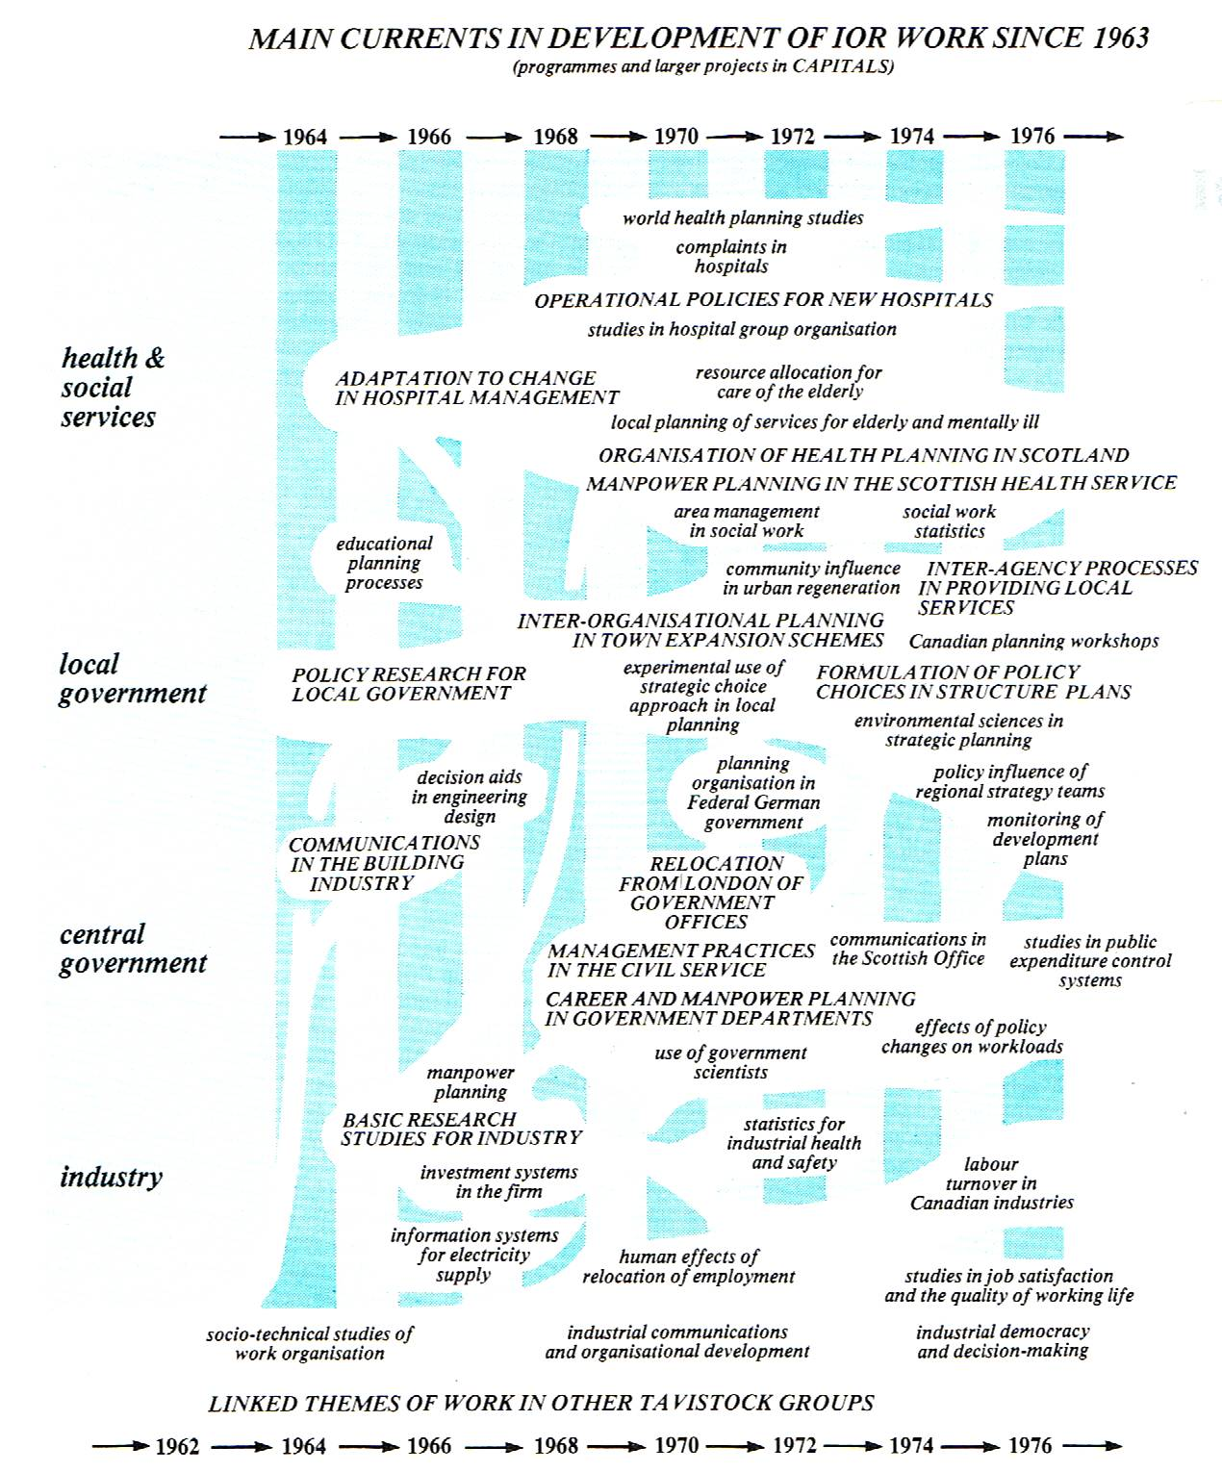
Figure 1: A View of the Work of IOR, 1963-76
The diagram only proved possible to draw at the cost of some gross simplifications, and the cross-threads shown offer only a hint of the various interrelationships between streams which help to give a coherence to the work of the unit. Perhaps these will become more apparent later today when we talk about two of the main cross-threads: that of inter-organisational relationships and that of central policy versus local variety.
It was tempting to try to bring the chart up to date by adding on another three years, showing which streams have waned, which have waxed, and which new streams of work have started. But this would have been a difficult and not very productive exercise for three reasons. First, the separation of streams becomes even more artificial, as we find ourselves working increasingly across the boundaries between industry, central and local government and voluntary organisations. Some examples of such work will be coming up later in the day. Secondly, the diagram was drawn up primarily to show the changing patterns of IOR's work, and thus does less than justice to the many strands of work which had developed within the HRC setting - even though some of these are hinted at in the lower part of the diagram. Thirdly, in 1977 the Scottish nucleus of IOR in Edinburgh, established largely to pursue a series of studies for the Scottish Health Service, presented its case for autonomy as a separate working group of Tavistock - catching the tide of devolution at a time when it was advancing strongly. The separate emergence of this group - now known as the Scottish Institute for Operational Research - would itself call for some revision in the layout of the diagram. Despite the separation, however, COOR and SIOR have since continued to collaborate, as sister units of the Tavistock, on some very challenging work north of the border, addressed towards issues ranging from regional policy to local community development.
Human and Other Resources
The resources of IOR and COOR have always resided primarily in the skills and experience of the research staff, and supporting administrative staff, who have worked with the unit, whether briefly or for a longer period. It is interesting to look back on the pattern of joining and leaving of research staff over the years: as Fig. 2 shows, the present core of tend includes five long-serving members of staff of the two constituent units. Of those who joined during the planned expansion phase from 1966 to 1969, it is perhaps surprising that none now remain in COOR; many of them have taken their experience into other fields of work at home and overseas, and continue to keep in touch in a variety of ways. Perhaps
one of the most remarkable examples of IOR`s achievements in the development of human resources has been the transformation of a laser physicist, Peter Hornby, into an expert in manpower aspects of health care planning, who has since worked extensively in this role in the countries of South and East Asia.
But some of the most useful inputs of ideas and experience have come from people who have worked with the unit not as staff members but as associates, from universities both at home and overseas, from government departments and local authorities, from the health service and other client organisations, and from other independent research institutes. Taken together, these people have amplified considerably both the range of disciplines brought to bear on the work and the depth of practical experience on which to draw.
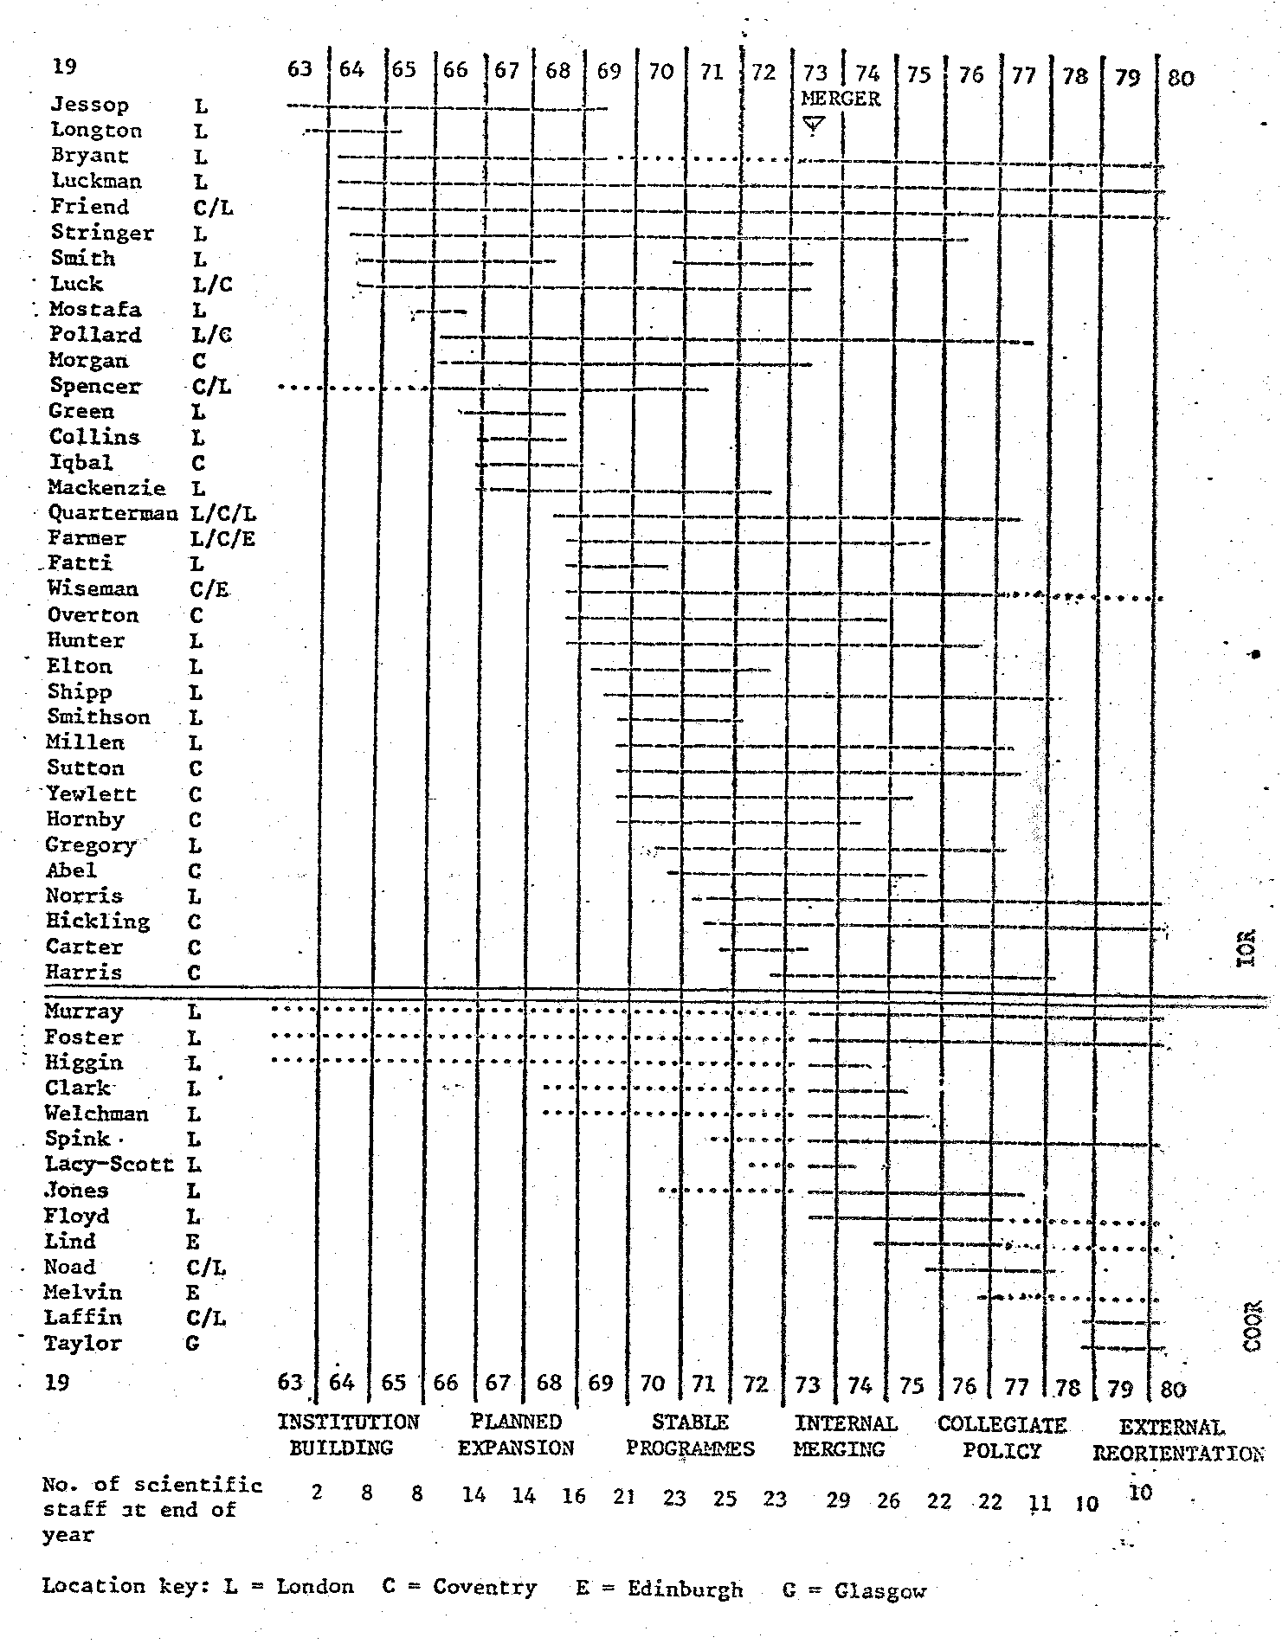
Figure 2: Research Staff of IOR and COOR, 1963-1979
Geographically, the unit has never been highly centralised. Though a majority of staff has always worked from offices in London - originally central London but more recently the Tavistock Centre in Swiss Cottage - the early field base in Coventry developed into a centre from which many projects concerned with local government, the health service and industry were managed, while the Scottish office in Edinburgh grew into the home base of SIOR. As Fig 2 shows, there has been much movement of staff from one base to another, and there remains much day-to-day travel on project work between London, Coventry, Edinburgh and a new project base in Glasgow. Many staff too work for extended periods overseas, so that sometimes the lines of communication can become attenuated for what is now a comparatively small nucleus of researchers.
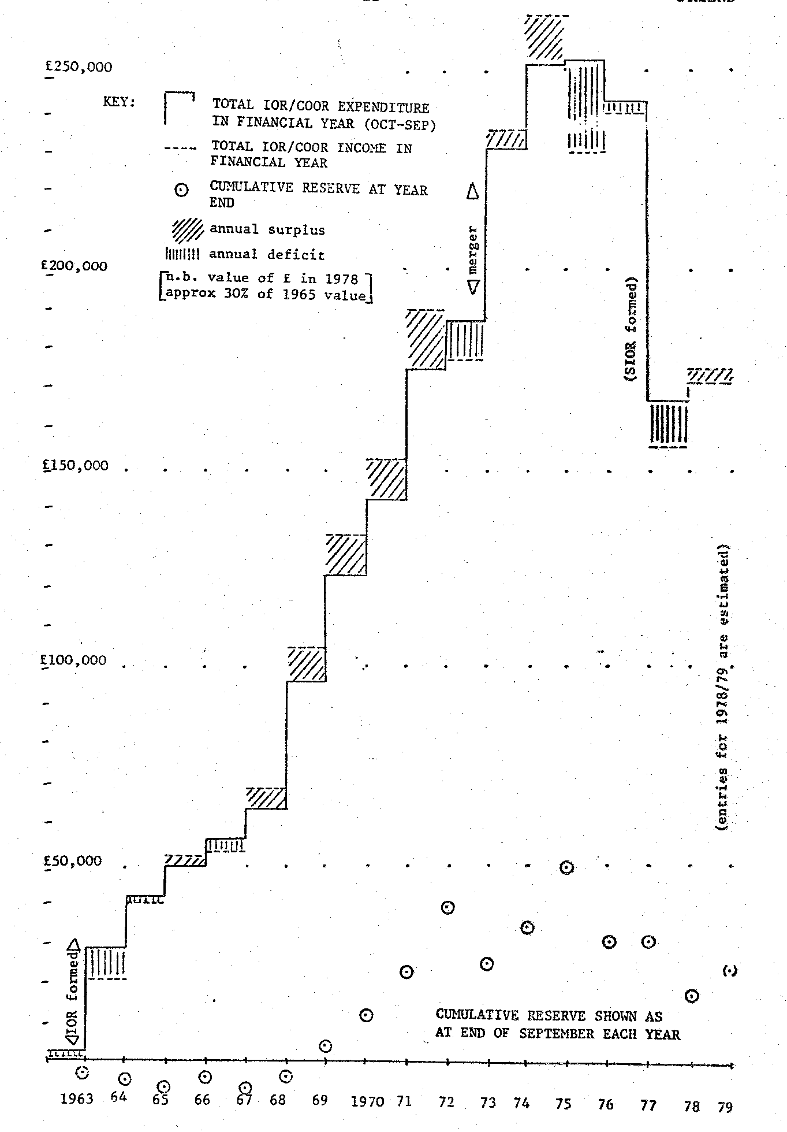
Figure 3: Financial History of IOR and COOR, 1963-1979
While the size of the group has shrunk from its peak of about thirty researchers to what now seems a more comfortable number, there are at present fewer younger people than we would wish, and the rectification of this position depends very much on future work patterns. And, as Fig. 3 indicates, the financial resources of the unit, always slender in the absence of any form of general institutional support, remain very small in relation to its aspirations to extend the frontiers of OR and the social sciences to meet all the various challenges which the eighties seem likely to bring.
Perennial Issues
This outline will have given a flavour of some of the basic dilemmas that have kept coming to the fore since the IOR experiment was launched. These include issues of survival and renewal when working on very tight economic margins; issues about the balance and interdependence of its activities, especially the balance between service to decision-makers and more basic forms of research, with all that is implied about a consultancy outlook versus a more academic stance; and issues about coherence of the unit versus openness to a wide range of collaborative relationships with other people in all the various fields of activity into which its staff have been drawn.
The Future of COOR
We will be coming back to these perennial issues again during, the day; some of them at least I am sure we share with OR people in other organisations. But I believe we should conclude this initial review by raising an' issue which is not perennial but transitional - the issue of what the future orientation of the new COOR should be. In some ways, we find the name a more appropriate one under which to work than the rather solid and institutional-sounding name of IOR, with its misleading suggestions of centrality in relation to the wider OR world - reflected in the fact that ever now and again individuals approach us on the assumption that we are a professional institute to which they can take out subscriptions.
But of course not all the effects of the change from the IOR to the COOR identity are beneficial. Apart from the goodwill that the IOR name has attracted over the years, people tend to hesitate over the pronunciation of COOR while, at a deeper level, all kinds of questions arise as to how the 'double-O' should be interpreted. Some may feel that OR on its own should be seen broadly enough to encompass the 'organisational. research' theme. Yet, after listening to our historical introduction, people here will perhaps recognise something of what the 'double-O' symbolises to us in terms of the merger and the aspirations that flow from it - aspirations that we feel are very much in line with the intentions of the founders of IOR..
Perhaps we can conclude by taking the pronunciation problem as a lead into the more basic question of what the '00' might mean. While we have suggested that the normal pronunciation of the acronym should be "C-double O-R", there are at least three ways of shortening this in conversation, which we can refer to as the 'cor', 'co-or' and 'coor' options respectively. These three pronunciations all suggest different things. The first suggests not only a mild expletive - to Southern Britons at least - but also the ideas of a 'core' or a 'corps' - both rather suggestive of ideas about centrality or coherence. The 'co-or' pronunciation, on the other hand, suggests coordination - which we at least would like to see as a more connective concept, not necessarily implying any centrality. Indeed, we might indeed see it as standing for an idea of 'together-choice' - the idea of choice being implied either by the conjunction 'or' or by the abbreviation for operational research, whichever you prefer.
Turning to the 'Coor' pronunciation, we can look first towards French, where the two words 'cours' and 'court' translate respectively as "course' or 'flow', which hints nicely at a sense of direction and continuity, and as 'short' - a realistic description of the unit's normal state of solvency: Apart from these French equivalents, we were a little disconcerted at one point to be told that 'coor' is the name of a particular brand of American beer. However, we were reassured when told by Russell Ackoff first that the name of the beer was really 'coors' rather than 'coor', and secondly that it was a regional rather than a national brew. And we were quite pleased when told by another visiting American that it had the reputation among connoisseurs on that side of the Atlantic of being a brew of especially high quality.
Among ourselves, we have talked a good deal about the ideal state of integration or overlap between the organisational and operational perspectives - a theme to which we will return later on. Sometimes, we like to see the two Os as a pair of spectacles symbolising a kind of binocular vision formed by bringing together the social science and operational research perspectives in looking at the wide world in which we live. Pursuing this line, we also like to think that these spectacles give us not only binocular but also bifocal vision, allowing us to look both very closely at the minutiae of decision-making and human relationships and more broadly at larger and more systemic patterns of phenomena.
To emerge again from all this play with the name, the current position is that we may talk of ourselves formally as COOR, pronounced C-double O-R, yet we encourage our friends to refer to us as 'cor', as the simplest among the various shorter pronunciations. What we would like to think is that our various friends - present and potential - can join with us in the task of working through more fully what role COOR might develop over the coming decade, in relation to the many challenges that will be around and the various contributions that all of us in the wider operational research community might be able to offer.

ORGANISATIONAL CHANGE AND OPERATIONAL RESEARCH
by Don Bryant and John Luckman
Paper for OR Society National Event on 'OR, Social Science and Strategic Choice', 24 October 1979.
The objectives of this session are to present an overview of the 'double-O' theme - the organisational and the operational aspects of our work - that John Friend has touched upon in his introduction, and to give a flavour of the kinds of project we have been engaged in.
I want to start by saying something about the two O`s in terms of their similarities and differences: I will give some examples to illustrate what I have found to be some key features of each considered separately and of early attempts to fit the two O's together. A few brief examples from my own more recent experience will be mentioned to show how the organisational and operational aspects are becoming integrated. I will then call upon my colleague, John Luckman, to describe in a bit more detail one particular project that we were both engaged in. This project is useful in pointing up some lessons to be learned from doing this kind of work. I shall end by drawing together a number of ideas from John's presentation and relating these to what I hope may develop in discussion as a basis for a theory and practice of 'double-O-R.
There is a slight ambiguity to clear up first. This arises from the phrase 'organisational and operational research' which implies that both adjectives - 'organisational' and 'operational' - qualify the noun 'research'. We can, however, think of others qualified by 'organisational'. A colleague, Hugh Murray, has pointed out there is almost an alphabet of nouns, that can be appended to the adjective 'organisational' - Analysis, Behaviour, Change, Development (and Design), Effectiveness, and so on.
I will refer to organisational change, denoted by O_{c}: but will not attempt to distinguish too rigorously between the various other social science labels such as OD at this stage. Similarly, I will subsume into the second 'O`, operational research, operations research, management science, and other kinds of problem-solving approaches involving applications of logical and/or mathematical modelling, and denote these approaches by O_{r}. The distinctions between the two O's should become clear from the examples I will give, and as I hope to demonstrate the distinctions are only necessary to trace the historical perspective. Later, the 'double-O' approach will be illustrated in which some, at least, of these distinctions will disappear.
A good starting point for comparing and contrasting the organisational with the operational aspects is the paper by W. Bennis which appeared some fifteen or so years ago now in "Operational Research and the Social Sciences" - the proceedings edited by John Lawrence of the 1964 OR Society International Conference held in Cambridge. This paper is still, in my view, the best of its kind in providing a review of theory and method in applying behavioural science to planned organisational change, and I cannot better Steve Cook's remarks in the introductory commentary which were to advise OR men in particular to 'Read it, read it, read it!'. I will,-however, draw briefly on Bennis's similarities and differences between the two O's as a basic framework to discuss my own orientation.
Similarities between O_{r} and O_{c}
- Both approaches are new (since World War II)
- Both are problem centred (but feed back concepts and methods to their basic parent disciplines)
- Both are normative in approach (in sense of maximising goals, emphasising improvement & optimisation of performance)
- Both are science-based (and rely on empirical science as means of influence)
- Both rely on a collaborative relationship with clients (based on confidence and valid communication)
- Both emphasise a systems approach (stressing awareness of inter-dependencies within internal parts as well as boundary maintenance with environment)
- Both are most effective in rapidly changing environments.
Differences between O_{r} and O_{c}
identification of strategic  variables | Conflict,  communication,  Leadership,  resistance to Change, etc. | Inventory  Allocation  Qeueing  Search etc.
Nature of presenting  variables | Less measurable  “Felt” problems | More concrete  More obviously related to  Success (‘profit & loss’)
Perceived importance of  Relationship with client | Crucial: used as measure of  progress and valid source  of data | Important, but less  self-conscious
Emphasis and allocation  of time | More on implementation  through programmes of  counselling, training, etc. | More on research, data-  gathering and problem-  solving
Systems orientation | Talk about it (lip-service)  Unintended consequences  of social action | More conscious of it e.g.  Aware that solving  production problem may  cause sales problem
Teamwork | Loners or pairs  ‘Generalists’ | Interdisciplinary teams central to much OR
Focus | Tendency to look inwards  – human relations and their effects on performance | Tendency to look outwards  - external environment  - economic and technical efforts

Views about obstacles to collaboration
So much for similarities and differences. I do not want to say more about these except to recall that John Lawrence drew attention, in his editorial preface to the published proceedings of the 1964 conference, to the fact that although both disciplines were concerned with improving organisational effectiveness and want to see results used, each was too engrossed in its own methodologies and techniques to explore the others'. Some examples were claimed for social science cooperation in OR teams, but this was not sufficiently widespread to have lead a single (joint) paper for that conference.
Obstacles to collaboration which were explored at that time included statements like "OR and social science just don't mix"; "different orientation of the training"; "the literature barrier - OR complaints of long words and long-winded arguments by the social scientist; social scientists' complaints of OR papers too arid, mathematical and full of unjustified assumptions".
From my own experience, coming into "a social science environment as an OR man just about this time, I felt that the expectations of collaboration between the two approaches were based on a 'Deficiency' model - as if each side had something missing in its repertoire that the other could supply on demand. Whatever the actual words being used to justify collaboration, the underlying messages seemed to be (from the social science side): "We need you OR boys to do the complicated sums"; and (from the OR side): "We need to apply some psychological grease to get implementation through".
All of this was of course fifteen years ago. IOR came into the Tavistock in 1963, a year before the Cambridge Conference. What changes have occurred since then? Have the two O's become integrated in COOR?
I would like to try to portray a way of representing developments in the kind of projects we have been involved in. One notation is to represent the degree of interpenetration between the two O's symbolically. First, however, let us look at some examples of separate approaches. What does a 'pure' OR or a 'pure' social science project look like?
Examples of '’separate-O' projects
A 'pure' OR project could be represented by a single O with a sub-script, r. Thus O_{r}. Bennis's example of a 'typical' OR project was taken from Ackoff & Rivett's airline case-study which was concerned with questions like how often to provide classes for stewardesses and how large should the classes be? This study looked at factors like costs, forecasts, and number of flying hours. To this extent, it was a single O_{r} project, but it also looked at factors in job satisfaction. In this particular case, what started out as a simple problem was found to be interconnected with other problems of the airline, and the problem field was extended to avoid a `local° solution and loss in overall efficiency.
If we now examine Bennis's social science example taken from Cyril Sofer's book "The organisation from within", we could represent this by a single O. The presenting problem was the selection of a senior manager for a small company, and this lead to a series of disclosures and causal mechanisms uncovered with meetings with top management. The factors in this case included: family relationships in the top management group, fantasies and mistrust among managers, management and career development, selection procedures, etc. The 'techniques' used included counselling, devising new organisational structures, training, improved selection devices, etc.
The two case-studies illustrate the differences in approach, such as the problems being concrete and quantifiable in the O_{r} case, and the emphasis on the relationship with the client in the O_{c} case. The Sofer example is perhaps extreme in that there is hardly anything of the O_{r} stream visible. It is one example of the kind of project carried out by Tavistock before the advent of IOR. Another example - less extreme - is the coal work, by Trist, Higgin, Murray and Pollock, which was published as a book "Organisational Choice", where a lot of emphasis was put into getting measures of operational effectiveness, such as indices of absenteeism and productivity.
If we look closer at the coal work, we find evidence of a 'double-O' theme already there in the notion of a socio-technical approach to the study of the working group and productive enterprises generally. Thus we could represent the early coal-mining studies in 'double-O' terms crudely as follows:
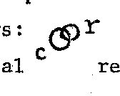
indicating a mainly organisational orientation with some operational research influence. It is worth noting that much of the impetus for setting up an Institute for Operational Research within Tavistock came jointly from people like Trist, Emery and others in the Human Resources Centre who realised that the problems they were becoming involved with in doing socio-technical studies often required the analysis of technical processes in OR terms, and from Neil Jessop and people in the OR Society who realised that to leave out of technical studies the social and psychological problems of the working group often resulted in mere part-solutions.
Some early examples of 'double-0' projects
The first two big projects tackled by IOR were `double-O' projects and were deliberately planned to be such. They were both carried out by teams of OR and social scientists. One, the Coventry project, was a four-year study of the processes of policy making and planning in local government and will be referred to in more detail later. (All I need to say at this stage is that the project started as a joint approach but ended, as far as reporting, as two separate studies.) The other - a two-year study of communications in the building industry - started on the assumption of a joint approach, proceeded as though on a 'deficiency’ basis (you do your bit and I'll do mine), but ended with one report, although with two clearly defined orientations: Part I was called operational research; Part 2 was called sociological research; however Part 3 - indications for future research - was jointly written, and recommended, amongst other things, research involving a mix of many disciplines, of which the social science/OR combination should be part of the mix. Even in this early attempt at a 'double-O approach, it is interesting to note how the two streams appeared to be fusing together over the duration of the project. For example, in the pilot phase of the study, the contribution of OR was heavily on established techniques such as CPM and on developing techniques to define and measure performance as approaches to the problems of coordination and communication, whereas the social science contribution concentrated on roles and relationships in the building team. In the main phase of the study, it is possible to discern, if not integration of the two approaches, at least a degree of interpenetration. Specific developments included a socio-technical analysis of the building process in terms of interlocking sub-systems (of operations, of resource controllers, of directive and adaptive functions, and of social and personal relations) and a technique for the systematic approach to the processes of design (AIDA) which has found application in other fields, such as planning. One important development from this work in the building industry was the recognition that the building process itself was an example of a multi-organisation. The multi-organisational theme is taken up by Michael Norris later in the day.
Recent developments
The historical progress of interpenetration between the two approaches from these early attempts to the present day could be summarised as follows:

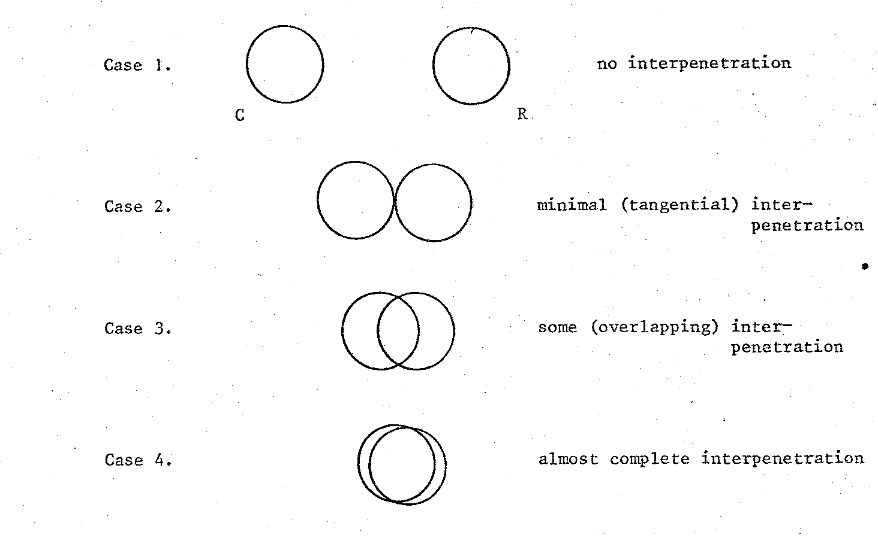
Case 4 represents more of an aspiration than the actual position currently, and Case I is probably rarely encountered as such a clear-cut example of separation. (Even Bennis's airline stewardesses and Sofer's management selection examples were hardly 'pure' examples.)
An alternative way of looking at the progress of interpenetration is suggested by an adaptation of Blake's Managerial Grid. Blake used a two-dimensional framework to locate managerial style, where the y-axis represents the degree of concern for people, and the x-axis represents the degree of concern for production. We could think of an adaptation of this model where the y-axis becomes the degree of concern for (or utilisation of) organisational research (using explicit social science concepts) and the x-axis relates to the degree of concern for (or utilisation of) operational research methods.
More simply, we can look at 'concern with process' and 'concern with content' as the respective axes;
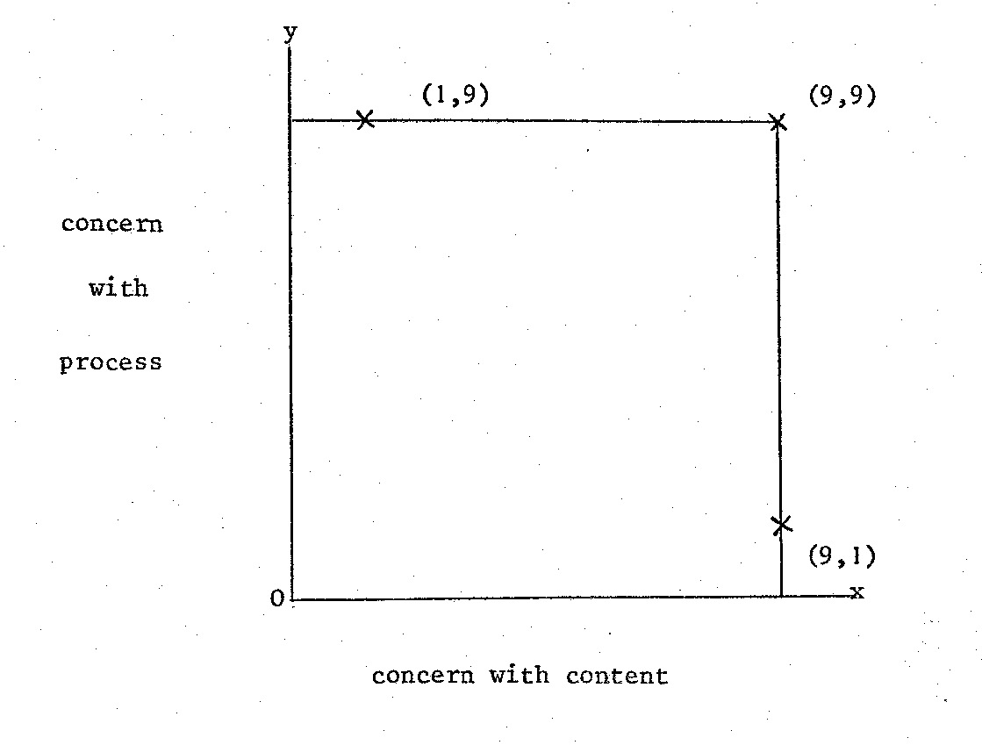
Thus, borrowing. from Blake, we could attempt to define a (1, 9) research style as a deliberately conscious attention to the social and psychological process of a problem with little concern for content or technical variables; similarly a (9, 1) research style would imply a concentration on the operational, technical or mathematical content of a problem with minimum concern for human, social or organisational needs. As with Blake's assumption of the ideal managerial style, (9, 9) would be the desired direction to which to aspire.
I prefer to view the essence of an integrated 'double.-O' approach to a project as having an appropriate (rather than equal or maximum) degree of concern for process and content. I use the word 'appropriate' to indicate having regard to the resources that are available.
To give a more tangible example of what I have in mind, I would like to use one of the recent case-studies that we have been involved in. We have chosen a relatively small-scale project rather than one of the bigger projects simply because otherwise it would take too long to describe the background. The study chosen'- a project on working relationships in an ambulance service - was carried out by John Luckman and myself on a part-time basis over a relatively short initial time span. It does, however, illustrate some of the essential points of the ‘double-O’ approach.
AMBULANCE SERVICE CASE STUDY
COOR were asked to undertake a survey of the relationship between operational ambulancemen in a large city station and control staff located in another city about 15 miles away. The Chief Ambulance Officer for the area had met with staff representatives of the ambulance station and Control and was planning to set up a panel of enquiry to "examine, analyse and report on statistical information in relation to emergency and routine work standards of performance before and after transfer of Control" and to “examine and report on the working arrangements within the station-and Control, taking into account the specific points already identified as problem areas by staff representatives".
A preliminary meeting with the Chief Ambulance Officer and one of the union representatives from the station ambulancemen convinced us that the inclusion of statistical analysis in the panel of enquiry terms of reference was of less importance than trying to explore the nature of the relationships between the two groups of staff -ambulancemen and Control. We proposed a series of interviews at the outset and offered to look at performance statistics a little later. We also proposed a small steering group with representatives of the management and the main unions involved in Control and in the station.
After 4 months, based on approximately 20 man-days of work, we presented a brief report based on a large number of single and multiple interviews with staff and lengthy group discussions with the Steering Committee.
We reported that relationships were poor because of the different personal attitudes, and the misperception and low level of mutual understanding of the two parties concerned. Past events contributing toward the problem were:
- re-organisation of the NHS in 1974. The city station transferred from local authority to health authority;
- introduction of a rank structure in the service;
- transfer of Control. The control staff had until 18 months previously worked side by side with the ambulancemen in the same building.
Current matters affecting the relationship appeared to include:
- a lack of universally agreed measures of personal performance and quality of service;
- inadequate resources available to deal with an open-ended service which was increasing and contained an appreciable measure of inappropriate demands;
- too little joint participation in decision-making at the interface between those ordering transport and control staff, and between control staff and ambulancemen;
- different perceptions of discipline versus informality.
We concluded that the relationships between control staff and ambulancemen were being aggravated by a "spiral of reciprocal misperception" in which each party mistrusted the motives and misunderstood the actions of the other. It was the extra dimension of the spiral which led to changes in action or attitude which in turn increased the level of misperception.
The predominant factors in the spiral were:
- the feelings by controllers of poor cooperation by the ambulancemen;
- the feelings by ambulancemen of a loss of job satisfaction.
Contributory factors were the feelings of ambulancemen that the workload, particularly at peak times, was too high to sustain continuously. The lack of cooperation was most keenly felt by controllers when the ambulancemen from the city station were slow to respond to blanket calls to attend an emergency (ambulancemen from other stations appeared to be more willing). The ambulancemen from the city station were most agitated about the frequency of loss of meal breaks that had been building up over recent months. Both parties, but for different reasons, felt that radio procedure needed to be re-examined and both parties, again for different reasons, were questioning whether the planned journey system (the bulk of the work done by ambulance-men) was working effectively in the city setting.
We suggested that there could be no clear-cut solutions to these problems until they were shared and talked about more widely, perhaps augmented by occasional exchange of staff between Control and the station. We also proposed that a study be made to define an operationally useful measure of workload. Finally we stressed that the "how" of bringing about change was as important as the "what" and proposed an action research approach with a dual commitment to find and to implement solutions to the problems through a group process involving the participation of representatives of all parties assisted where appropriate by independent resource people.
During the ensuing months the steering group addressed the problems of misperception with our assistance and gradually reduced the tension that had existed previously. This is not to say that there were no more 'incidents' but the knowledge that there existed a forum where they could be discussed 'informally and in depth, prevented the previous rapid regression to entrenched positions. Meanwhile, our attack on the workload measure problem began to clarify the extent of the claim by ambulancemen that the workload was excessive.
We found that routine statistics are collected from the ambulancemen's daily log sheets and totalled for each station each calendar month. The primary purpose of statistical data collection was:
(i) to count patients carried in total and by a number of different categories, e.g. emergency, urgent and planned on the one hand, and admissions, discharges, out-patient and day patients on the other;
(ii) to determine mileage and petrol consumption.
Further statistics on response time and activation time for emergencies and mismatch between arrival and appointment times for planned cases were also extracted from records.
However, there was no ready-made statistic which showed the workload intensity per man or per crew which the ambulancemen could readily co-relate with their current perception of a heavy and demanding workload. Intensity of ambulance workload is extremely difficult to measure in a situation where part of the work is of a random nature and where resources to deal with it have to be based on a notion of 'cover'. The best that could be done with the routine statistics was to calculate the patients carried per driver at each station in the area. In a typical month this was shown to range from 123 in the station under study down to 17 for the smallest station in the area. Although these figures were pointing in the right direction, all parties felt that there were a number of complicating factors which may have distorted the picture - the principal factor was the use of one-man ambulances which carry far greater numbers of patients, and which were based in larger numbers at the station under study.
We therefore planned a special data collection exercise in which we singled out the week-day daytime shifts and distinguished between the workload of two-man and one-man ambulances. Our subsequent analysis demonstrated that the station under study now lay in fourth position in a rank order of intensity of workload. Moreover the three marginally` higher intensity workload stations were in another division which had its own Control separate from the central Control being studied.
Although there were still a number of factors which might affect the workload measure these were now felt to be relatively insignificant and there was clear support from the ambulancemen's colleagues throughout the area that a case for a closer look at ways of containing or even reducing workload in the station under study was a matter of priority. Furthermore, the control staff now had an incentive to look again at the planning system which seemed to be less effective than that operated by the other Control.
Steps were therefore taken to set up an ambulance usersTgroup with representatives from the local hospitals and GP's. Within three months the workload had been reduced by approximately one half of the previous years increase without. any obvious difficulty or complaint, thus substantiating the ambulancemen's claim that there had been a number of inappropriate demands. Secondly, more attention was paid to the planning system. There was a small but significant increase in the proportion of work planned 24 hours in advance (e.g. hospitals were asked to try and arrange transport for discharges earlier) and this reduced the disruption to planned work caused by short notice journeys. Finally, although to some a retrograde. step, a two-tier system (with some ambulances retained solely for emergency, urgent and short notice work) was introduced for the station on an experimental basis during the morning shifts, and has been retained since that time.
SOME COMMENTS ON THE CASE STUDY
There are a number of points that. I would like to highlight about this case-study in an attempt to provide a possible basis for mapping the degree of interpenetration between the organisational and operational aspects.
Strategic variables and presenting problem
First of all, the strategic variables were identified by the client system as performance statistics and working relationships. The presenting problem concerned differences between controllers and ambulancemen in the interpretation of performance statistics. The dynamics of the underlying problem did not become clear until later, but the main features were that the ambulancemen, instead of enjoying their own individual Control and relating to controllers on first name terms, were now required to relate to a new set of controllers, many of whom they had never met, and who they saw as remote, impersonal and inappropriately bureaucratic.
Ever since the move to central Control, relationships had been deteriorating. In general, the control staff perceived the arnbulancemen as lazy and uncooperative, whereas the ambulancemen saw the controllers as insensitive and dictatorial. Matters came to a head when following an emergency call there was, according to Control, a delay on the ambulancemen's part on reaching the scene. In this particular case, strict procedure had not been followed, and a patient, who was seriously ill, subsequently died. The ambulancemen contested that there had been any delay, but the two ambulancemen involved were dismissed. Their dismissal was strongly resisted, with hints of industrial action by the unions: as a result of an independent enquiry however, the two men were re-instated. Following the reinstatement, it was agreed by management and staff representatives that an exploration by an independent body would be made of the statistics of performance, relating separately to routine and emergency work as well as the measures which could be taken to improve working relationships. This was the point at which we became involved. Thus although the emphasis of the problem as defined by the client was on content, with process suggested as an optional extra, we sensed that process should be the first priority, and content should be looked at later.
Relationships with client system
We were aware that the funds available for outside help were meagre.. and felt, however, that if change were to be generated, it required the thrust to be located within the client system. The problems became progressively more defined with each meeting of the Steering Committee, the reduction of tension being the common objective to emerge for all interest groups. The main interest groups involved were the management, the controllers and the ambulancemen. Both the controllers and the ambulancemen were represented on the Steering Committee by their appropriate unions. Management was represented by the Chief Ambulance Officer and his Deputy. From time to time, we reported back to the Steering Committee and this arrangement worked well. Later in the study it was agreed that there should be a series of joint forums comprising men from the ambulance station and control centre. These forums were intended to provide opportunities +~ for members of the two sides - other than the Steering Committee members -to meet and talk about their problems and to attempt to resolve them without the intervention of either management or the researchers. Apart from initial discussions to assist in the planning and issuing of some guidelines to help Steering Committee members to chair the meetings, we took no part in the forums. We saw ourselves as resources to the client group, rather than its leaders.
Emphasis and role of researchers
As researchers we encompassed skills in social science and statistics and saw ourselves partly as diagnosticians, partly as statistical tutors and partly in the role of making proposals and bringing the parties together to test out the feasibility of developing problem-solving relationships and producing changes. The statistician in the research team also hoped to expand his change agent skills through working with an experienced colleague on a people-centred field engagement. We saw our role as multi-functional:
(a) Investigative
To look for clues leading to an understanding of the problem.
(b) Educative
To identify dysfunctions in the perceptions of each party, to compare one with another and to bring people together as a means of remedying any misperceptions.
(c) Specialist
To apply their special statistical skills to the measures of performance which were in dispute, and to make proposals.
(d) Evaluative
To provide an unbiased assessment of ambulancemen's performance. (This was a role which the conflicting parties desired the researchers to be in, it being relevant that both parties believed that right was on their side.)
We spent some time on the ambulance journeys ourselves; to our surprise we found it boring rather than exciting. This was because our days on the job were like most of the days ambulancemen put in - nearly all routine planned work, with emergencies occurring only very infrequently. We noted that there was a lot of idle time resulting from waiting about which could not be filled in by ambulancemen in any satisfactory way.
We also experienced some of the feelings of frustration ambulancemen complain about. Also, at the end of the day it was all too apparent to us that it was possible to get stuck in a traffic-jam on the way to a patient. If then the driver was 'harassed' by Control, the resulting frustration could be intense. We fed back some of these experiences.
Systems aspects
To an extent, the ambulance study presented some aspects of 'a multi-organisational problem. Other organisational interests involved were: the hospital and GP referral network - the origin of the ever-increasing demand; other ambulance services in adjacent areas - immediate reference groups in terms of creating precedents; the Department of Health & Social Security - the body vested with statutory powers in terms both of available cash and of acceptable standards; and of course the general public - both in the roles of patient and of tax-payer.
We found themselves posed with a dilemma: on the one hand, since the ambulance-men knew the geography of the town in which they were operating, as well as the traffic conditions and something of the current response situation at the hospitals, there seemed a case - for motivational reasons as well - for locating more of the decision-making with the ambulancemen; on the other hand, controllers were at the point where requests were received and could therefore more adequately assess the nature of them, in relation to what was occurring throughout the area as a whole. Where the decision-making should take place was one of the questions which had to be answered against the background of concern for the patient. We recognised that to some degree the system is concerned to protect itself: for should tragedies occur, following the acknowledgement of more autonomy and decision-making to ambulancemen, and enquiries to be put in train, who then would be to blame? The situation appeared similar to Menzies' classic example of a social system operating as a defence against anxiety .
Final changes and outcomes
There has been some reduction in dissatisfaction arising from the misperceptions which the two groups have of each other. Structures, such as the Steering Committee and the Forum, enhanced the opportunity for the two groups to enter into a dialogue but relationships still remain fragile. The practice of visiting each other's territory, once taboo, has now occurred.
At first the controller representatives were not as skilled as the ambulancemen's representatives in handling interpersonal processes. They had to learn to express more of what they felt rather than what they ought to say. They also experienced further learning in that they no longer try to discount the past by advocating that a veil be drawn over it; they have gradually realised that the intensity of feeling and the different perceptions of it between the parties have to be faced.
In spite of our attempts to encourage members of the Steering Committee to become involved in inventing appropriate statistical measures, interest has proved particularly difficult to sustain. The ambulancemen in particular, do not possess this kind of culture, although progress towards the development of an appropriate performance measure would seem to be in their interest. Particularly so since we also believed that the official statistics were not discriminating enough between good and bad performance and to this end, we produced an index which takes into account the peaking of journey demand throughout the day. This index showed Station A to be one of the busiest stations in the area, but still did not fully reflect the way that ambulancemen perceive their workload.
This gap in perception, (i.e. between what statistics showed and what the men felt) was that attention was directed once again to content (i.e. to workload). As a result of a prepared meeting with a liaison group of ambulance users (e.g. hospitals and doctors) the workload was significantly reduced.
CONCLUDING REMARKS
In summary, the ambulance project started off as being seen by the client as close to a (9, 9) content/process problem. Our resources (to do the work) and the client resources (to pay for it) did not however permit more than a (5, 5) input. Our judgement of the tense industrial relations situation suggested that the early stages of our involvement should be closer to a (1, 9) approach (i.e. concentrating on process).
It is interesting to note that in terms of the clients' initial problem definition, the "area of concern" was narrow rather than broad. Statistics was the thin end of the wedge which allowed the parties to contemplate the idea of bringing in outside experts. Both parties felt sufficiently non-threatened (and each probably felt confident that they would be proved "in the right"). It is doubtful, however, if we would have made any progress had we started to plunge in straight away on content (i.e. statistics). It is also doubtful that we would have been allowed to start at all if the project had been formulated exclusively in process terms (i.e. by looking at relationships between the parties).
However, after a while, although tensions were reduced sufficiently for people to talk to one another and to listen, it became obvious that process (e.g. group discussion) had now run out of steam, and the orientation moved to a (9, 1) approach where the concentration was more heavily on content (e.g. developing from statistics an appropriate index of performance). Later, when sufficient progress had been made with this index, the orientation changed to nearer a (5, 5) approach where the content aspects were technical experiments involving vehicle utilisation and journey planning and the process aspects were social innovations like the setting up of joint forums for opportunities of the two sides to meet and talk without the intervention of either management or the researchers.
In conclusion, I would like to make a few general comments drawing not just from this particular study but from a number of recent studies that we haven't had time to deal with in detail. One piece of important personal learning has been not to try too hard at first in deciding whether a particular project is predominantly OR or organizational change, or whether a content or a process orientation is most appropriate. I have found it best to start with a problem - as defined by the client - and to take it as data but not necessarily a mandate: the presenting problem may not always be the 'real' problem, but for the client it may be very real in that it is 'where it hurts'. Most organisations 'know' what their problem is and often what they should do: it is how to do it that is usually the difficult part.
Usually you have to pay attention to both content and process and to move from one to the other as the situation requires. Content may well be the best way to start the relationship - it is often less threatening than getting involved head-on with process - but you must be prepared to switch the focus, perhaps several times in the course of a project. Sometimes you have to do both at the same time, and operate explicitly in a double-task mode.
This requires the development of interdisciplinary competence in individuals, as well as of multi-disciplinary teams.
It should be remembered that the client too, has human resources: they also can become action researchers involved in collecting and analysing their own data. Change is more likely to be acceptable if people affected by the change have been involved in collecting their own. data.
Successful implementation of change, like diagnosis, has its content and process elements. Both are necessary. To rely entirely on the rationality of a cognitive model does not work. 'Similarly, there has to be something more tangible to offer than congruence of values.
Perhaps the most crucial role for the 'double-O' change agent is in the implementation stage. He can help the client system to keep its corporate nerve just at the point where so many projects founder. As we have already brought out, and other speakers will, during the course of the day, elaborate on this, the quality of the relationship with the client is pivotal. If this is so when working with single organisations, how much more so in working with multi-organisations, as Michael Norris will indicate in his presentation.

OPERATIONAL RESEARCH AND MULTI-ORGANISATIONS
by Michael Norris
Paper for OR Society National Event on 'OR, Social Science and Strategic Choice", 24 October 1979.
Introduction
When I've talked about our work in the public sector to OR audiences of practitioners from industrial settings, I have noticed a sort of blankness come over some people. I don't think this has been because of my personal style; after all, the public sector people there have often nodded appreciatively. In other words, there seems to be some sort of 'cultural gap' between the experiences of many OR people working in industry and those who are confronted by the problems of public service: in one, it is relatively easy to adopt what one might call the classical paradigm of operational research - a single decision-maker, with objectives, who has 'a problem' which needs 'to be solved'; on the other, there is a set of people with ideas about 'public service' who,, at the lower levels, have to confront the dilemmas raised by either obeying the rules or doing what they think is right and who, in the more senior positions, see their major problem as relating to inter-departmental, inter-authority and political competition, collaboration and cooperation.
Yet, similar problems are not really so unfamiliar in industrial organisations: conflicts between sales people and those responsible for stocks, between production and transport, are frequent, and, at a higher level, issues about relationships between different companies come to the fore, whether in the shape of bilateral agreements (with an eye on the Monopolies Commission) or in the arena of employers' federations, industrial training boards and the like. In other words, and this is what I'm going to talk about today, many key issues for our economic enterprises, as well as for public authorities, are multi-organisational in nature.
I do not think there is any particular point in trying to define this term - multi-organisation is where you see it, and where you find it useful to think about problems from a multi-organisational perspective. Further, an attempt at definition could take us into a whole set of other distinctions between ideas of inter-organisational relations, network organisations and social ecologies, together with an account of the contexts in which these ideas are useful.
Instead, I will try to proceed through examples, drawn mainly from the public sector. Our experience is that it is often much more easy to get some grip on the nature of multi-organisational problems when looking at this sector - here, one can find many agencies who all have a job of serving the public good, but whose primary tasks differ. Think, for example, of local planning authorities with their job of promoting the orderly use of land by deciding where various sorts of facilities should be located (factories, houses, whatever) and the Regional Water Authority who have a duty to provide both water and sewerage arrangements for those developments. Both are serving the public, but they may have very different perspectives on what is good or sensible. For the first, there may be complex problems of deciding on what is a balanced and sensible pattern of development of the spatial arrangement of activities, taking into account political as well as technical concerns; for the other, a duty to get on with the job but also a budget constraint, which can inhibit their ability to service what the planners have in mind.
In such circumstances, you may have a problem which is me. This does not necessarily mean that you are a problem for me. Further, you may not trust me enough to tell me some of the things I would need to know to make things better for you. This can be seen as politics - both the struggle to maintain values that are important and "the art of the possible". If we are clever and can find a good way of working, we may be able to intervene - as OR workers - so that areas of conflict and misunderstanding are reduced and cooperation enhanced.
Further, I believe that the sorts of theories emerging from our work in public sector multi-organisations have a lot to offer to the practice of OR within apparently unitary organisations in the private sector. In this sense, the public sector, where multi-organisational activity is readily observable, constitutes a sort of laboratory where lessons can be learnt for use in other contexts.
At the end of the day, we shall be talking about what has come to be known as the 'Ackoff debate', which seems to be something to do with the idea that a 'systems' orientation can provide the background theory against which further progress can be made. Against this, there are dissenting voices which say that what we should be concerned with is 'power' and that the systems frame is a hall of mirrors which distracts us from what the real issues are. Personally, I find, as an erstwhile social anthropologist, these frames to be both interesting and useful heuristically for describing and talking about what is going on. At the same time, as an operational researcher, I often find them uninteresting insofar as they divert attention from operational problems that people face; what to do, when, and how to go about it.
Audiences
This raises the question about who I am talking to. Whose operational problems am I addressing - those of 'managers' in the public services or in industry, those of the OR manager negotiating his project assignments, or those of the OR practitioner carrying out his work? I guess much of the frustration about our Journal arises precisely because we find it difficult to identify audiences precisely enough: we have general papers, case-oriented papers and theoretical papers, but none of them seems to speak adequately to the practitioners' problems of "what to do?". My talk is mainly aimed at addressing some of these difficulties. We are all, I believe, in some senses, in the multi-organisational game and can do with some insights which will help us to cope with the problems we confront.
I will start with a 'general paper' on some of the findings of the IOR work on multi-organisational decision-making, drawing on studies of how people actually do it. I will then move on to some 'case-oriented' material which talks about what IOR has been able to do for people involved in multi-organisational situations. And, in conclusion, I will be touching on some theoretical points for the practice of OR, before we get into your viewpoints. Throughout the talk I will be trying to bring out the more practical implications of the material.
Sources
Some of the more general thoughts derive from work that John Friend and Chris Yewlett, together with an Australian political scientist, John Power, did in a piece of 'pure' research on the planned expansion of the town of Droitwich, in Worcestershire; and also from my own recent involvement in a remarkable community centre in Peterborough - The Cresset. The case material comes from a variety of sources, including projects we have done in hospitals; in the development of coordination between local authorities in areas of multiple deprivation in Clydeside; in the building industry; and in relationships between development planners and the people who provide infrastructure such as roads, sewerage, health and social service facilities. The last two relate to our work on strategic choice which is described in another paper. I will only be able to give you a taste of what this is about.
My thoughts about OR practice draw heavily on a study we did on the role of regional planning in this country (which deserves a talk in itself) as well as our experiences in these other studies. This will take us into issues about the way the OR practitioner sees himself in his job. At this point, I would like to acknowledge the important contributions to my thinking of John Stringer whose original paper on Operational Research in Multi-Organisations in the ORQ in 1967 has been a touchstone for judging the progress we have made. Another important influence has been our colleagues in the Tavistock Institute, who have studied for a long time what it means to be interrelated with others in and between organisations. We also have a major debt to our clients who have asked us to study with them the problems of working in multi-organisations. The great majority of our more recent major projects (in large construction sites, central government-local government relations and the public provision of social and infrastructure services) have been explicitly addressed to the problems that organisations confront in relating one to another; and without this access and the belief that we had something to offer, we could not have advanced our thinking to the point it has reached today. I hope we can share this thinking with you now.
General Paper
To me, one of the most important findings from IOR's Coventry study was that in practice some of the most important difficulties in making decisions arise from your uncertainty about what somebody else is going to do. It may be what a competitor's pricing policy is going to be or, as in a Coventry case, what the decision of a government department is going to be about the line of major national highways. This takes us beyond the conventional distinction between controllable variables and uncontrollable variables into negotiable variables. I mean that there are parameters of major importance which you do not control but which you can influence or negotiate about. Only if you are very powerless do you just have to accept them as uncertainties which you can do nothing about.
The IOR work in Droitwich was primarily aimed at understanding how this adjustment of one's relationships with other organisations took place. The title of the book about this project, "Public Planning; the inter-corporate dimension", underlines the main slogan from the project - "corporate planning is not enough".. If you have sufficient power, you can, to use Ackoff's terminology, be proactive or interactive rather than simply reactive to those other organisations who influence your ability to get things done. The task of the Droitwich development team was to expand the very old town of Droitwich from a population of 6,000 to 30,000 as the result of agreement about how to handle overspill population from Birmingham. It worked to a committee which included the Borough Council of Droitwich itself, and Worcestershire County Council as the authority which would have to provide services to the town expansion. Birmingham City Council, as the authority exporting population to Droitwich, also had a major interest. The book describes decision problems like the allocation of land to industry; the processes of community development where social institutions for a new population have to be developed; and the provision of shopping facilities where the interests of the established shopping centre of Droitwich were at odds with the need for new facilities for the expanded population of Droitwich.
The question was, how people managed to arrive at some decisions about these points, bedevilled as they were both by political differences (arising from the different interests of various constituencies) and uncertainty about the factual implications of any decisions that were taken. A key notion was the "reticulist (or networking) skill"; there are some people who are more adept and adroit at understanding how their problem relates to problems which other people are facing and are therefore in a better position to understand how some sort of fruitful compromise might be achieved.
For instance, settling issues about the allocation of pieces of land for particular industrial purposes was made a lot easier by the people concerned on the Droitwich side knowing about the particular problems facing the industrialists. . With this knowledge, they were able to design allocations which would work as opposed to doing their allocations on the basis of theory. Where the uncertainties were greater, it was the ability to negotiate some sort of temporary understanding that was crucial: for instance in agreeing with Birmingham and others the way in which houses should be allocated to 'key workers'.
This could be conceptualised as to do with relationships between different 'policy systems' where various people, and sometimes the same person with multiple roles, serve the aims and objectives of differing organisations and therefore have to work to different policies, rules and cultural patterns. The pattern of contact found necessary in the case of the key workers included relations with industrialists, public service employers and various categories of potential tenants as well as the local authorities. In other policy areas, the network included, for instance, government departments and voluntary organisations.
You will see that the picture of organisational self-sufficiency that is put about in a lot of OR theory is completely inadequate in this sort of context. The alternative view - organisational interdependence - explains why March and Simon talk about "satisficing", Lindblom about "incrementalism" and "partisan mutual adjustment" and, more hopefully, Etzioni about "mixed scanning" as a way of both recognising the bargaining that goes on between organisations and the need for a wider view in which that bargaining can take place.
But underlying some of the Droitwich experiences is a set of problems about organisational designs: the influence of various people on the development process was a consequence of their organisational positions, as well as their personal skills and networks, and it is a legitimate question for operational research to consider how organisational structures for multi-organisational working might be designed. Eric Trist has written a lot about this, in particular the need for "middle-level organisation" to combine the virtues of large organisations (in terms of their access to resources) and to offset some of their vices (such as bureaucratisation and inflexibility). Diagram 1 shows the community centre I have been working with. You will see it is a complex which involves a whole range of organisations - at least 15 - in the same setting. These organisations have created their own multi-organisation to advance their common purposes and one of my concerns has been with the problems they face in managing themselves within this setting. But from a more general - or scientific - viewpoint, my major question is, "Why does it work?" - and therefore, "What can be learnt?" that is applicable elsewhere. Some of the answers relate to overcoming bureaucratisation through interrelating the various organisations’ primary tasks, all of which are to do with servicing individuals, families and communities. Another important factor seems to be that, because the various services have been located near to each other, the opportunity arises for coordination to be influenced directly by the ordinary citizens who come to The Cresset - they can more easily make their own connections, conscious or unconscious, between services. One might call the underlying design 'cybernetic' because of its emphasis on feedback, and so, in this case, I find the systems frame a very useful way of approaching description and analysis.
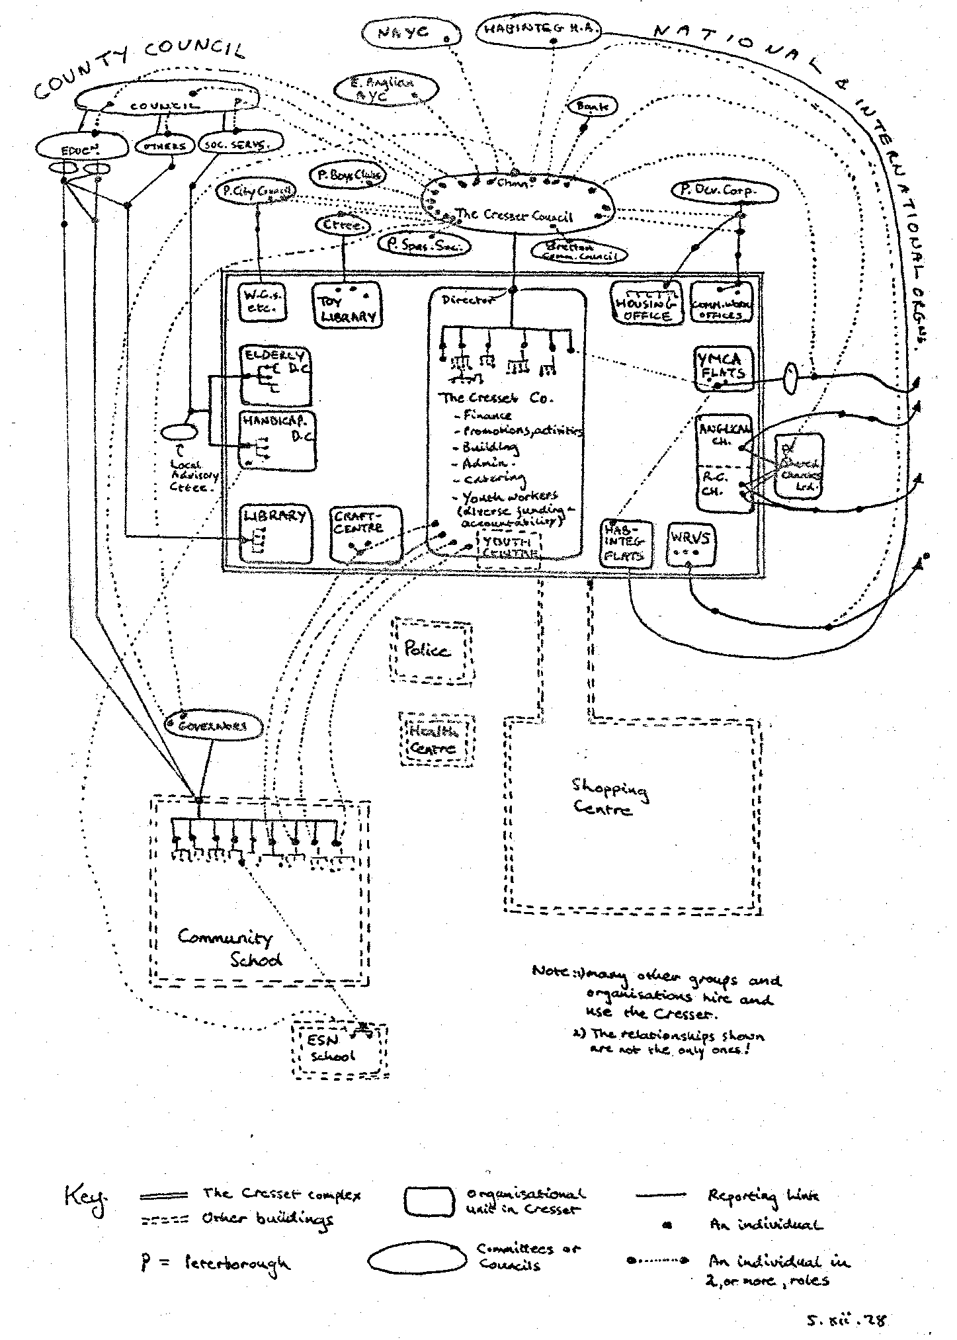
Diagram 1: A Sketch Organisational and Physical Map of the Cresset
I am not trying to say that this sort of organisational design provides a bed of roses; the very openness of the multi-organisational system tends to lead to pressures which in turn are reflected in sometimes hostile relationships between the various units. Under these conditions, the problems may be evident but the solutions may lie as much in the management of inter-organisational and inter-personal relationships as in making operational decisions about the employment of men and materials.
I shall return later to the implications this has for the role of the OR worker in such a situation. Put in rather abstract terms, these come down to what one might call "managing cultural and value gradients". To take a simple example, we were working with two local authorities who were cooperating in trying to improve conditions in deprived communities: in one, the Administrative Department was very powerful and very much the focus for official activity in the authority. Not surprisingly, these people assumed that, in the other Authority, Administration would be equally important and therefore addressed much of their correspondence to Administration in the second Authority. However, their assumption was wrong - in fact, the Administration there was a quite weak component in the corporate management system and somewhat peripheral. The consequence was that there were delays in getting any response to written material and so on. The general lesson is that it is worthwhile in inter-organisational working to make a conscious investment in appraisal of how the other organisation works.
In one of our regional planning projects, we developed a framework for this which we call the GAS Model, shown in diagram 2.
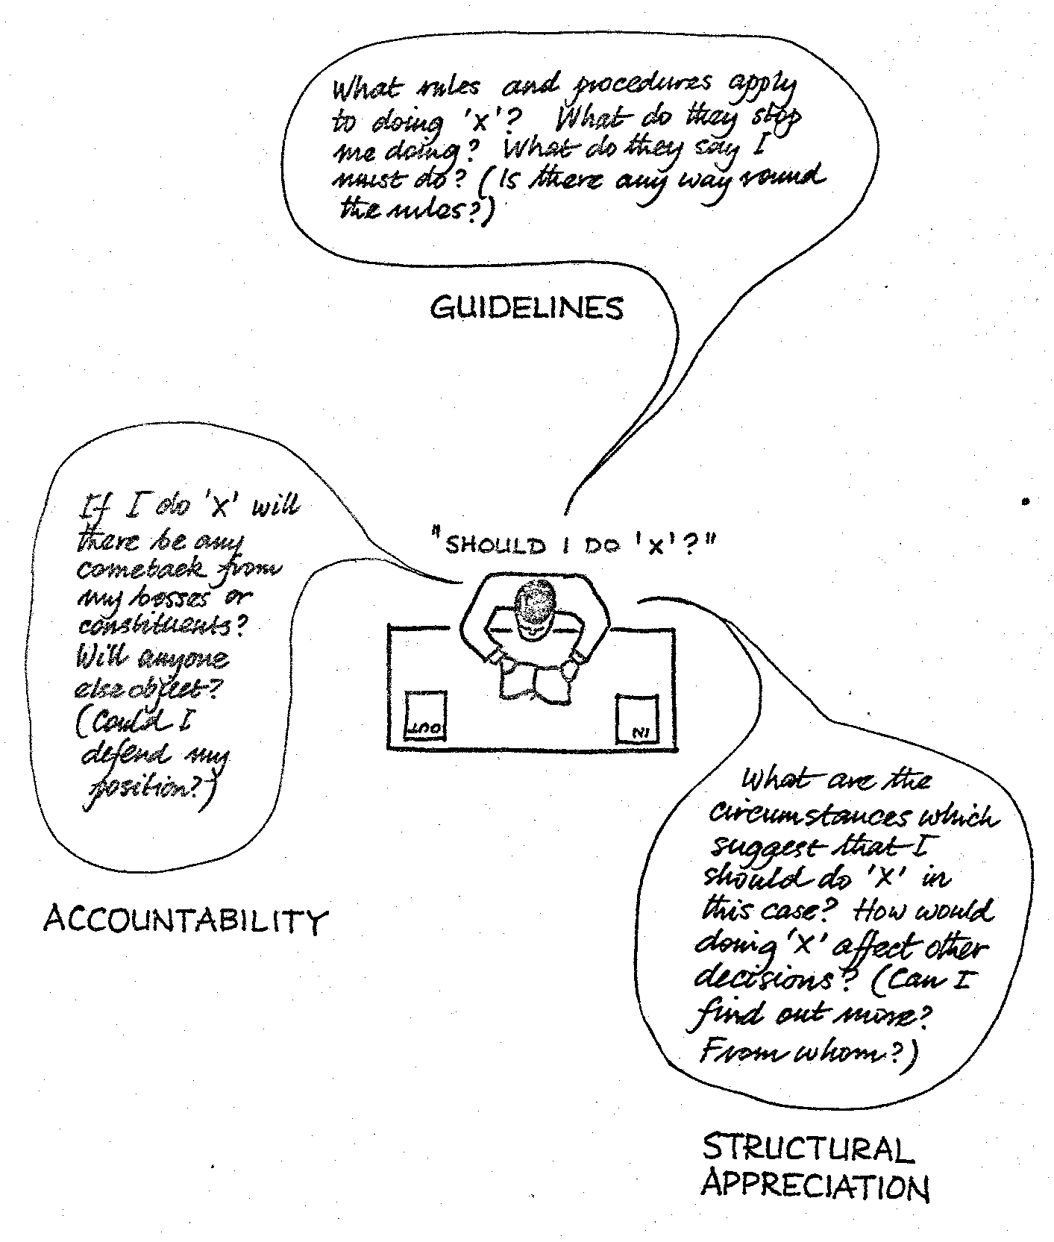
Diagram 2: the use of discretion
You will see the influences on a decision are modelled as consisting of guidelines, the sorts of instructions that officials, or workers, have from above, which may take the form of specific rules or broad objectives; accountability to one's boss or peers or other people (which in the case of public services may come from different sources from those through which guide- lines are imposed); and what we have called structural appreciation - the way in which that person or organisation thinks about their problems the sorts of information that they take on board, the way they understand and analyse it, and so on. This framework provides a guide to understanding how another organisation works.
Of course, in practice, many people intuitively know that they have to make this sort of attempt to understand another person's position before entering into any sort of negotiation with them; for instance, salesmen often have to get some feel for the organisation they are trying to sell to if they wish to make any sort of impact. However, our experience is that in practice there are other people who certainly do not make an adequate effort to direct their work in this way, and this framework has certainly been found useful in promoting mutual understanding in some circumstances. Of course, it is often well-nigh impossible to get owt-for-nowt - you don't usually find out about how other organisations work without a quid pro quo, and I expect you are all aware of the pressure on you to make some sort of calculated indiscretion - to let other people know about how your organisation works - when you are trying to find out something from them. In some of our recent work on relations between local authorities, we have found the theory of cooperative games, for instance, Nigel Howard's work on metagames, to provide stimulating insights into this sort of phenomenon.
Case Studies
Case studies of OR in work for multi-organisations or even for two organisations simultaneously are fairly rare in the literature. I can remember a national meeting at which a study was described of arrangements between Metal Box and the Steel Industry for managing stocks of steel in their joint interest - and also some OR for international organisations - but these are comparatively rare examples. I suspect one problem is that the technology of applied mathematics does not, in view of our scientific understanding of multi-organisations, often provide an approach which will give a great deal of leverage on inter-organisational problems. Our own experience began with a study of the building industry back in the mid-sixties in which a consortium of various interests - builders, suppliers, architects, and so on - came to the Tavistock Institute with a request to study problems of "communications". It was this project that led to the first formulation of AIDA - the analysis of inter-connected decision areas - as a useful tool for getting people from diverse settings to study their problems jointly and so to reach some sort of sensible solution or compromise.
Recently, this line of work has taken us into the sort of problem I mentioned before about the coordination of investment by various agencies in developing land; for instance, the relationship between the development of housing, roads, sewerage, education and social service facilities. The COOR team worked with about 10 different authorities on various problems of coordination that they faced, and I would just like to outline one. This derives from Norfolk where, as you may know, there is quite a high rate of population increase and pressures for development as people have relocated from London. One of the problems the planners faced was how to phase the development of two existing small towns, identified in the Structure Plan as growth centres, into larger communities, and how, and if, they could get the necessary services supplied to these towns. The top of diagram 3 shows the picture of the problem as seen by the planners. Here we have a set of connected areas of concern which they saw as being the strategic focus of their problem. However, the problem of the water authority had a very different shape, as shown at the bottom.
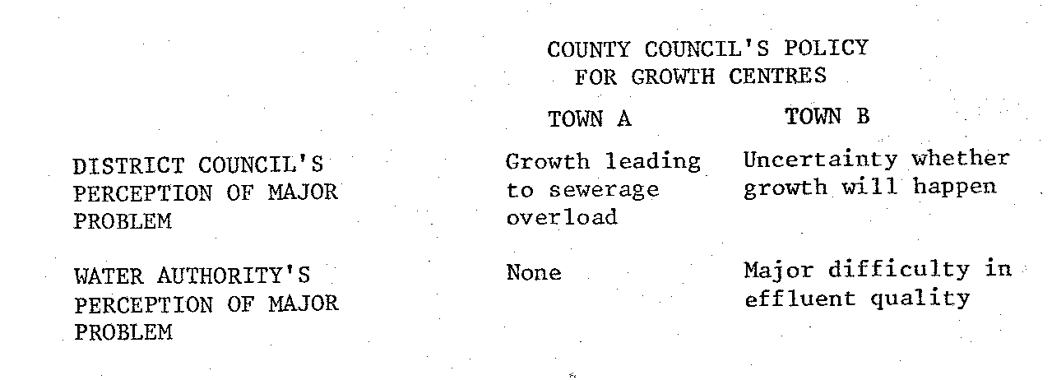
DIAGRAM 3

It was only by putting these together that the joint planner-water authority organisation could start to appraise the realistic possibilities and reach some sort of understanding about what was possible.
This puts into practice what I've been saying about managing cultural gradients, and getting an appreciation on both sides of the nature of problems, coupled with instituting the appropriate form of organisation for getting people together to search creatively for an answer to the question, "What is to be done?". This is not to say there is always an answer to such problems: once, for instance, in applying a similar approach to the care of the elderly, priorities for development turned out to be irreconcilable - but still the process managed to find some operational improvements which could be implemented without commitments about future expenditure of any great magnitude on either side.
Another approach, which moves away from a decision orientation to that of organisational design, is the 'means-ends diagram'. For instance, diagram 4 shows a map of the thinking behind the joint approach of the Regional and District Councils in Strathclyde to improving the local authority response to multiple deprivation. The main usefulness of this map, so far, has been in getting an understanding of the different perceptions various actors have of each other and their role within Council's initiative.
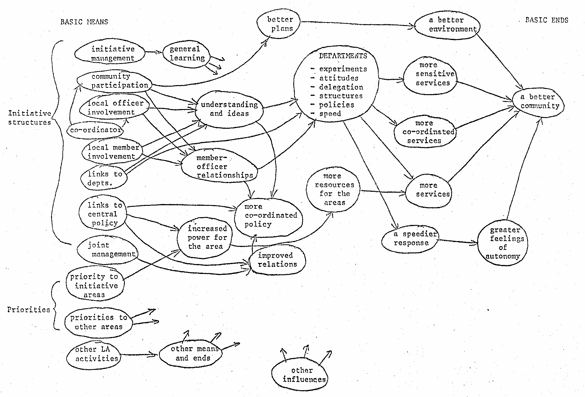
Diagram 4: A Sketch of Means and Ends in the Initiative

Theoretical Models
So far, I have emphasised the technical aspects of our case studies, insofar as I have been talking about techniques the OR scientist can use to help people to understand their problems. But in many of the important areas of work in which we can attempt to produce a more scientific, or perhaps rational, approach to decision-making, this is rather a naive view. The experts - OR men, planners or whatever - often constitute an organisation in their own right. Thus, they are one organisation operating in a multi-organisational context, and in principle are no different from the others. This means that they have to negotiate, arrive at agreements about how they should conduct their work, decide on the management of their boundary -who should get information and how, and what sort of authority they will have to do this. Again, this might seem a truism but again, in practice, it is too often the case that experts somehow consider themselves to be different from other people, to be imbued with virtues which others lack, and to have no offsetting vices. This idea of neutrality would be all very well if one had infinite time to carry out the work - but, as we all know, this is not the case: OR people, like others, have to decide on priorities for action, which corners to cut, who to treat as important and whose interest can be dealt with through lip-service, and so on.
One of the clearest examples from our experience is that of the regional strategy teams referred to before: since there is no regional level of government in England, any process which attempts to look at a region of the country must necessarily be multi-organisational in its sponsorship. The solution that was adopted was for the regional strategy teams to be commissioned Jointly by the recently abolished Economic Planning Councils (a Quango of appointed businessmen, local authority people and academics); central government (mainly through the Department of the Environment) and the County Councils of the region (ranging in number from 3 up to 12).
Under these circumstances, the regional strategy team has a considerable freedom of choice - however tight its remit - over the interconnected areas of its organisation, the technology it uses, its products (written and invisible) and its processes, in the sense of the timing and sequencing of activities. How is it to decide on what choices to make given that these are interconnected? The key, we suggested in a joint study with Birmingham University, was to conceive of the team as negotiating its role - expectations about its behaviour - with various parts of its environment (seen in organisational and political as well as other terms). In this sense, a choice of role is a choice from a variety of possible stances the team could take towards its steering committee and other bodies in the region. Such stances could range from a relatively passive expert role to one of active mediation between interest groups.
How are roles to be negotiated? All we could do was to offer rather complex check-lists of points to be borne in mind - including their interconnections with other points. This approach can be criticised as not being normative enough - but it does, I think, correspond to the reality of making judgements in this sort of field: there is no data base to calculate the best course of advance. Rather, one is in a process of interrelating with organisations on whom one depends for facts and opinions and contributions towards consensus and compromise; inevitably, therefore, the process becomes one of mutual exploration. So, as for other organisations, corporate planning is not enough when it comes to deciding how to conduct a project. Technology can help but it needs to be of a fluid and responsive kind.
To sum up, operational research for multi-organisations is a process of negotiation - a process in which you explore and are explored by others and in which the opportunities for change. are highly unpredictable and must be sought and worked for. Indeed, one may learn as much during the process of negotiating the start of a project as one learns during the technical work. I think if we reflect on various pieces of work we have done, we will see that this is a key point for operational research practice.
But what does this do to the values of operational research? I would emphasise once again that the OR team is but one organisation in a system - or a set of power relationships if you prefer - and this in turn implies that the ways of working and the balance between technical and organisational work are not given. In some ways, this may seem to cast us on a sea of uncertainty where we do not know what our role is and find it difficult therefore to know what to expect of ourselves and to ask others to expect of us. It also means having to tolerate the reality that there may be no truth or optimum to find and that progress may come more from developing trust. A systemic consequence is that the OR team may feel itself to be pulled apart - and it may actually split - as it tries to respond to the various organisational constituencies it serves. Such stresses call for a high order of skill at the personal level in understanding how these feelings arise and thinking how to respond to them - often in circumstances where thinking becomes extremely difficult. T his takes us more into issues about the training of operational researchers as action researchers than I can possibly cover today.
Conclusion
I hope what I have said has been sufficient to give you some impression of the sorts of consideration that arise in multi-organisational work and sufficient evidence that, as I suggested at the beginning, there is a lot to be learnt from multi-organisation work that can profitably be applied in apparently unitary organisations.

USING STRATEGIC CHOICE AS A FRAMEWORK FOR COMMUNICATION
by Allen Hickling
Paper for OR Society National Event on 'OR, Social Science
and Strategic Choice', 24 October 1979.
This paper follows on from and is directly related to what Michael Norris has said about the difficulties of working in the inter-organisational arena.* It is about a general approach to strategic decision-making which has been found useful when working with planners and managers in a variety of practical contexts. This approach - which is called Strategic Choice - is grounded in the experience of working with people who are grappling with difficult and often dimly understood problems. It involves modelling some aspects of decision-making behaviour (in a fairly simple and non-mathematical way), which tend to be neglected by analysts even though they are very important in practice. From this conceptual starting point, we** have tried to piece together a way of working intended for use by groups of people facing real decisions on a day-to-day basis.
The Strategic Choice approach
The first point to make is that we use the word 'strategic' in a particular sense, to imply interconnected, rather than high-level, decision-making. We find the word 'choice' a useful one in that it helps us to bypass certain over-worked and often confusing terms like 'planning', 'policy making' and 'management' as they are used in large organisations - including the organisations of local government in which much of this work has been carried out.
One feature of local government: which makes it a particularly good laboratory for the study of strategic decision-making is that much work is done through group processes - committees, working parties, Council and pre-Council meetings. Particular features of strategic decision-making which stand out after watching these processes at work are:
- that issues continually seem to change shape over time, emerging, coalescing, submerging and reforming in ways that often make them hard to track systematically;
- that the technical and political aspects of problems tend to be very hard to disentangle, whatever the organisational pressures to draw a clear boundary;
- that commitments to action tend to emerge incrementally wherever issues are seen as interconnected;
- that people are all the time concerned to strike a balance between pressures to make decisions and their awareness of shortage of information on which to act.
As these observations may suggest, we have found ourselves drawn like many OR workers towards a decision-oriented approach to problems. In this case, it is an approach which covers many aspects of planning and decision-making processes, and it has many ideas and concepts, techniques and methods attached to it.
* Norris, M. "Operational Research and Multi-Organisations".
*" Research staff of the Institute for Operational Research now the Centre for Organisational and Operational Research of the Tavistock Institute of Human Relations.
But we deliberately underplay the idea of an advanced technology whether it is hard or soft - aiming more for what might be called an intermediate technology, which is strong enough to provide a framework for relating ideas, but flexible enough to be easily adapted to different situations.
Unfortunately, it is impossible in this paper to discuss all we have learnt about this way of working*. Therefore, it is necessary to make a choice as to which aspects to focus on for the purposes of this event. The first thought was to take one part of the approach, such as problem structuring or the management of uncertainty. In this way, it would be possible to expose the technology involved - but it would perhaps be a little misleading in that any one part is essentially dependent on the others. Alternatively, a case-study would provide a glimpse of the approach in an appropriately practical setting,But this would involve talking about the problem as well as the approach, and to do so effectively would take too long. In either case, it would be difficult to address in any depth what it is that has been unique about the new work. For this, it is necessary to focus on those aspects which have grown out of the interplay of the social sciences and operational research - epitomised in the overlap between the two Os - Organisational and Operational - in our name.
The Strategic Choice approach as a framework for communication
Therefore, this is going to be about one specific aspect of Strategic Choice - its use as a framework for communication in group working (especially inter-organisational group working). Michael Norris has already mentioned the difficulties people face in such situations - difficulties which often find expression in some form of conflict. Unfortunately, Strategic Choice, like any other approach based to some extent on a rational model of human behaviour, may be ineffective in resolving real conflicts. However, use of the approach in multidisciplinary, multi-professional and multi-organisational groupings is based on the belief that many conflicts are unreal in the sense that they are the result of failures to communicate. Better communication will reduce the number of these unreal conflicts. But even more important is the point that where the conflicts are real, at least those involved have a better chance of knowing what they are all about, and, even though some differences will remain, opportunities for agreement in some areas may emerge. Conflict need not paralyse the decision-making process, and even if some compromise is necessary at least the worst of its disadvantages can be avoided.
Working in the inter-organisational arena tends to lead us to the need to involve more people - people from a variety of backgrounds with differences which can be attributed to disciplinary, professional and organisational, as well as personal factors. These factors lead to considerable difficulties of communication.
* For those interested in a more complete understanding of the Strategic Choice approach to planning and decision-making, references are given in footnotes1 and 2.
For example, consider the word 'settlement'. This very same word can have very different meanings for different people. To a lawyer it would mean the legal resolution of conflict; to a mining engineer, geologist, or architect it would mean something probably unpleasant to do with the. results of subsidence; while to a planner, especially if he is working in a less developed country, it would probably mean a group of dwellings such as a village.* Of course, this is of no consequence if they are talking to colleagues with similar backgrounds: another lawyer will understand what the first lawyer meant, and so on. The trouble occurs when people with different backgrounds get together -and it is this type of getting together that we are talking about -using the same language, but using the same word to mean different things because of the different ways in which they see the world.
Another example is the situation in which a structural engineer, a social scientist and an architect are discussing the design of the metal handrail on a particular bridge. The engineer says it is too high, the social scientist says it is too low, while the architect says it is just right. In this case, they are using different ways to describe the same thing - each looking at it from their own point of view. The engineer is saying it is too high because he is thinking in terms of stress and strain, elastic limit and bending moments with reference to structural stability. The social scientist says it is too low because he is thinking in terms of space, perception and reaction with reference to human behaviour. The architect says it is just right partly because he designed it in the first place and has a certain pride in his creation; but also partly because he is thinking in terms of rhythm, form and economy of materials with reference to aesthetics. It is obvious that they all have much to contribute and the potential benefits of them working together are enormous - but, unfortunately, so are the difficulties.
Therefore, we have spent much effort in developing those aspects of Strategic Choice which can contribute to the communication process. But this is not some form of new language which has to be learnt before you can use it, although ideas are involved and ideas have to be expressed in words. For example, we use ideas such as that of a decision area. Like most Strategic Choice ideas it is very simple: there are such things as areas of decision within which there are alternatives from which one has to be chosen. The words 'decision area' could be described as jargon but we have made very considerable efforts to use every-day language wherever possible.
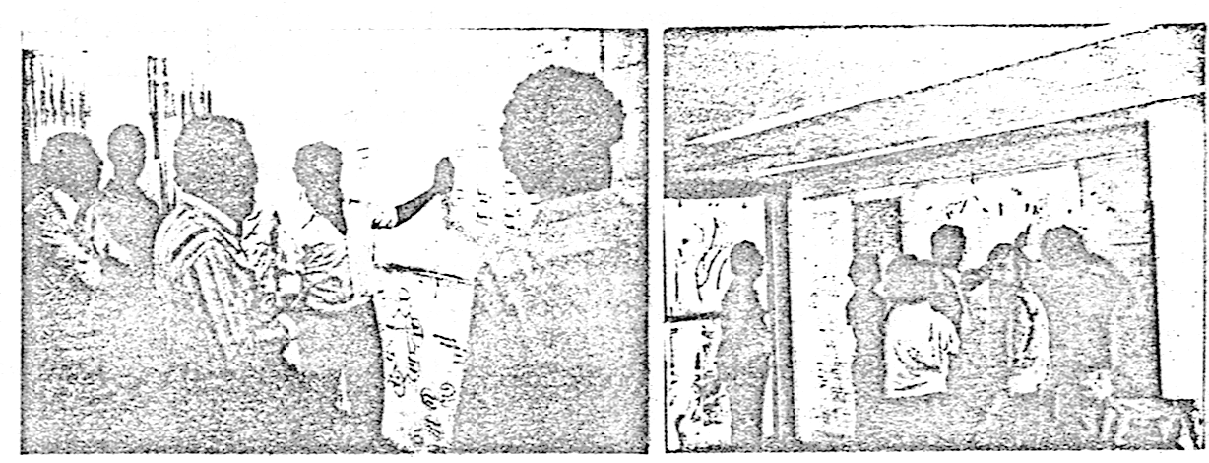
Groups working with Strategic Choice
* My thanks are due to Donald Schon for this example.
So, it is not so much a language as it is an elementary technology; and, even more importantly, an open technology. An open technology is one which is very simple to pick up, which almost explains itself, and which is visible and easy to share. It is one which avoids the problems of 'black-box' technologies, such as the computer models, which are of direct value to those few who have been involved in them, but which are almost impossible to share with others and the results of which have to be taken on faith by those concerned. Therefore, in order to open the technology and to make it visible, we try to communicate in as many different ways as possible. As already mentioned, we use words, both spoken and written - usually in the form of lists or notes; we use graphics in different ways, some as illustrations, some as frameworks, some quite simple, some quite complex; and we use mathematics where it is appropriate, but that is not often. Remembering that we are talking about groups of people working together, we have developed a method of using large sheets of paper on which a number of people can cork at the same time. This allows two things to happen - the first is the sharing of the ideas with the people around us, and the second is the recording of what has been done, which is vitally important in order to have something to come back to each time one recycles to that part of the process.
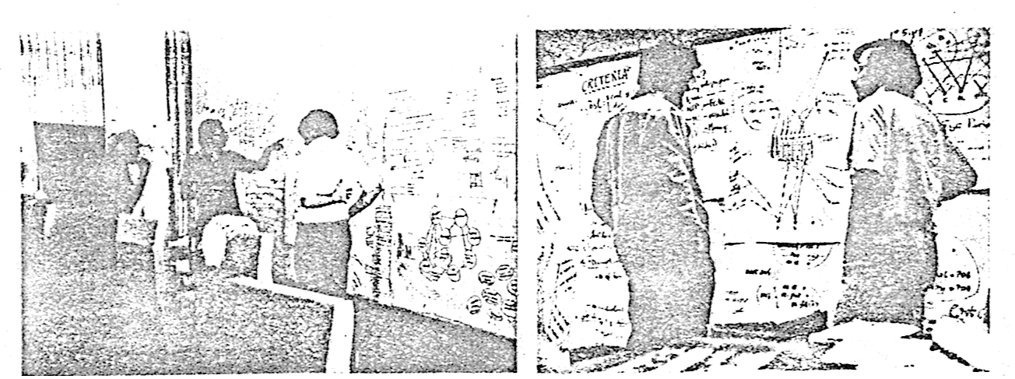
Using large sheets of paper on the wall
The process of Strategic Choice
Thoughts of 'coming back' and 'recycling' in the process arise out of one of the principal concepts of Strategic Choice: a view of the process of decision-making as a learning process - a learning process which continues until one of two things happens. Either a point is reached at which we have sufficient understanding of the problem that we feel confident that a good solution can be chosen - or, as is much more often the case, time runs out and a decision has to be made anyway..
Most of us in OR are well accustomed by now to iterative methods of problem solving; yet many people still believe that the most rational and scientific approach to problem solving means working in a linear, unidirectional way. However, in addition to being less effective in analytical terms, linear thinking can be counter-productive in terms of the efficiency of learning and it inhibits creative thought and innovation. Much more helpful is the realisation that learning processes are cyclic and iterative.
This raises one of the major hazards involved in adopting the cyclic process: it is very difficult and time-wasting to try to communicate in a cyclic way. Using a cyclic process, operations are undertaken in many different combinations and sequences as is appropriate to the task in hand. However, presentation in this form is not only difficult to follow - but it also sounds illogical. At least this now means that ideas can be presented in an order which will express the underlying logic of their relationships rather than that of a fictional process. Unfortunately, this fails when trying to describe the process itself. Speech and writing are for most people linear processes, and as a result of the cyclic process tends to be 'stretched’ into a linear format when these forms of communication are used. Therefore, please remember throughout that although the process may sound linear - it is in fact cyclic.
Now it is necessary to choose somewhere to start. In fact, using a cyclic process, it does not matter where one starts. I have chosen to start more or less where a traditional decision-making process would start - with a problem (see diagram 1).
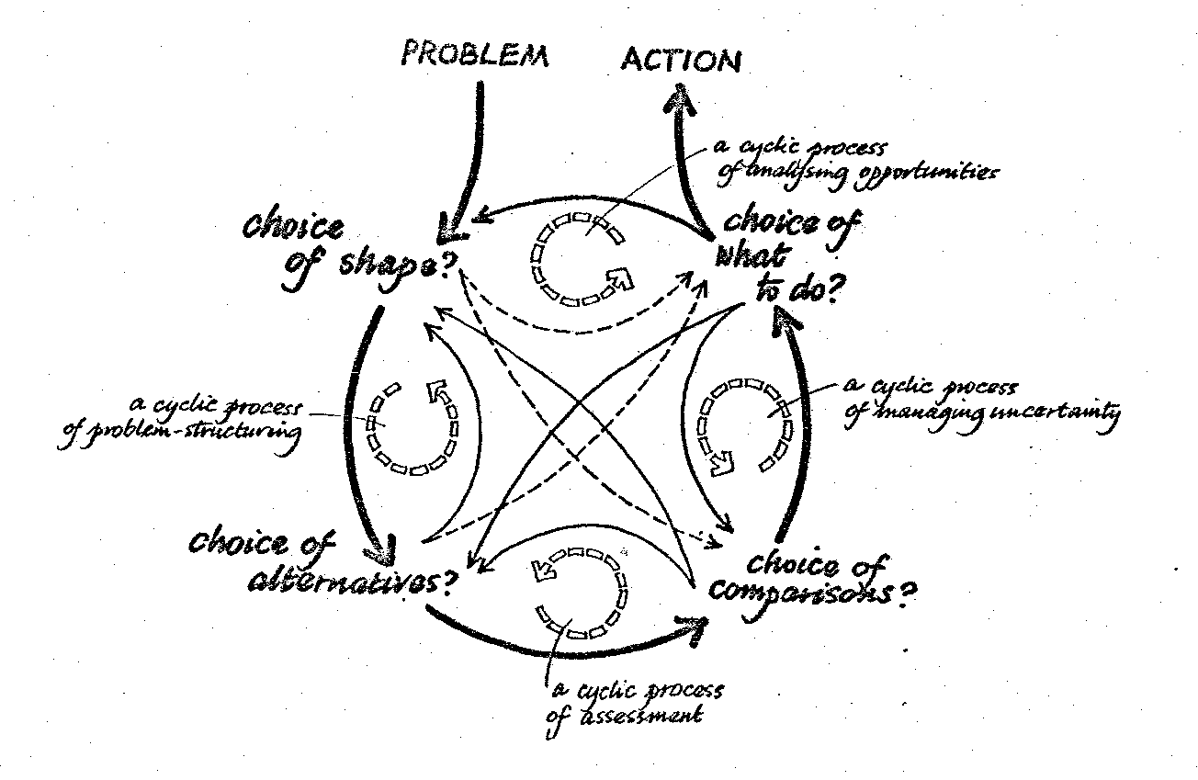
Diagram 1: the process of Strategic Choice
Then, given that there is a problem, the first question to ask is what shape is it? In this, it is a matter of trying to decide what comprises the problem ; and what does not. Defining the problem by exploring different ways of bounding it, remembering all the time that in a cyclic process, unlike a linear one, there is no irreversible requirement 'to get it right'. It is much more a case of choosing a definition and trying it out - working with it until it needs to be revised, and then changing it.
The next question to ask is what are the alternative solutions to that problem? And it is more than likely that as soon as we start to answer this question, we find that we have got the wrong problem. Or at least that we have not got all of it - or some of it is irrelevant. In any case, we can go back and put it into better shape. This, combined with the formulation of a reasonable range of alternatives, is a cyclic process of problem structuring.
Then, when the shape of the problem begins to feel right and we have a reasonable range of alternative solutions, it is time to move on again and we ask how do they compare? And of course this in turn will tend to pose questions about what we had before, and frequently may make us want to change it; in which case, we do. It is necessary to understand that recycling is important, and is possible from any point in the process back into any other point.
Eventually, we come to a point where it is important to think about making choices, and we ask what shall we do? If we have got the timing right, our first look at this question will do much to inform the earlier formulation of the problem, and we will have time to go back and do it again and again - and again - until, hopefully, some actions can be decided upon. At this point, it is important to remember that it is not necessary to have the answer to everything, because the remainder can be recycled for further review and analysis.
Going backwards can be a creative thing to do. But so can skipping forward. For example, when trying to define the shape of the problem, it is frequently helpful to skip forward - to look at the point of decision. Asking the question about what we should do in combination with defining the shape of the problem is, in effect, a cyclic process of analysing the opportunities available - defining the area in which it is feasible to search for solutions. Skipping forward and recycling are twin processes which we all use intuitively, and it is sometimes difficult to differentiate between them. The important thing is to recognise what we are doing, because only in that way we can learn to do it better.
Now, just before getting into the use of the approach, there is one other point which should be mentioned. It is that in Strategic Choice there is a variety of ideas, techniques and frameworks for working, some of them taken straight from OR or adapted in some way, and some of them new. However, it is important to treat them like tools in a tool-box; that is, very selectively, using judgement as to which tool is most appropriate for the task in hand. It is not the sort of technology which demands a rigorous sequence of operations, or which demands specific combinations of tools to be used. There is a wide variety of ways in which they can be used and it is a matter of using judgement in practice - using tools selectively from the tool-box.
Identifying the problem
One of the most significant difficulties in the identification and the definition of problems is the fact that different people have different perceptions of the world. This is a perfectly normal, day-to-day state of affairs but one which can nonetheless cause difficulties when it comes to defining a problem precisely enough for sophisticated techniques to be brought to bear. The problem lies not so much in the different perceptions themselves, but in the difficulties people experience in sharing their perceptions with others in a way that they can be compared realistically .
Therefore, we have developed the idea of a decision graph, which shows decision areas in the form of circles and their interdependence in the form of lines connecting them together. Decision areas have already been explained as areas of choice between alternatives, but their interdependence represents the fact that the choice in one area will affect the choice in the other. This is a representation of the fact that choices made in those areas separately might well be different to choices made when considering the two together.
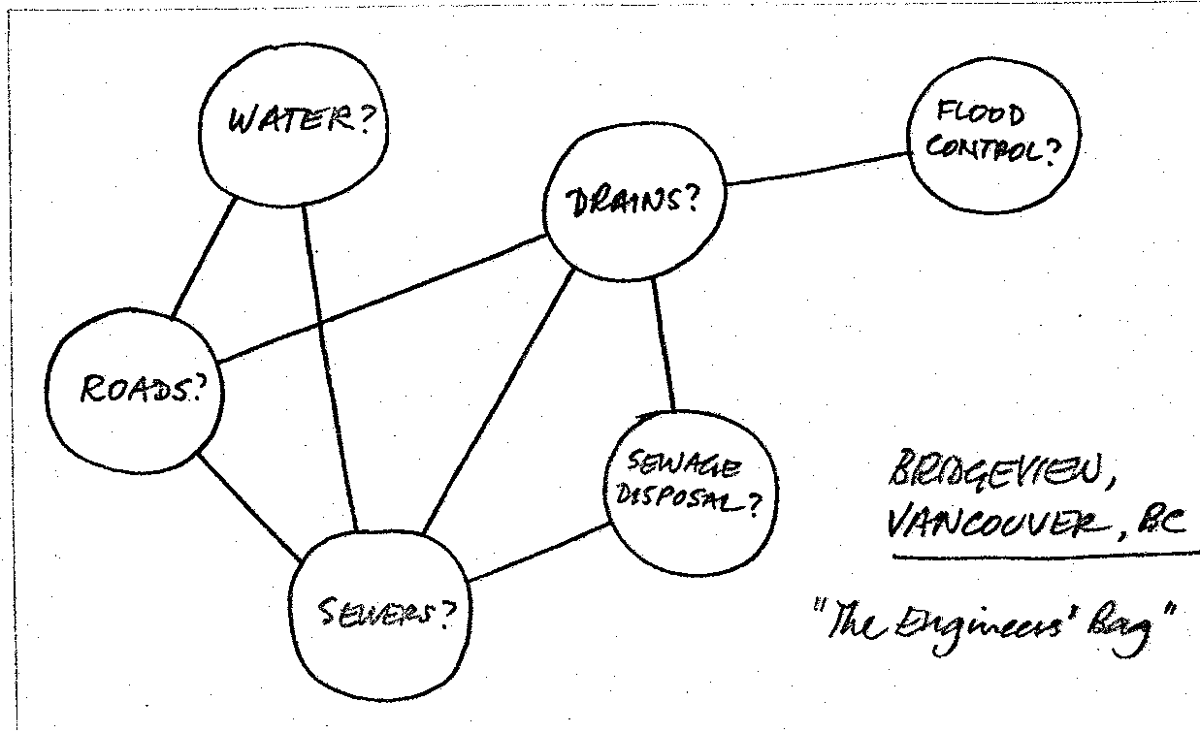
Diagram 2: Decision graph (community planning, Bridgeview, Canada)
This example (diagram 2) is taken from the case of a low income community in Canada. Let us take a look at the decision area at the top - this was labelled 'water' - and it had to do with whether the old water supply pipes, which were actually made of wood, should be replaced or not. The decision area just below it, labelled 'roads', had to do with the scale of repairs to be made to the roads: whether there might be none; whether they should just fill in the pot-holes; or whether there should be a major reconstruction of the roads - providing a completely new bed. These two decision areas were interconnected simply because a major reconstruction would make the provision of a new water supply much more feasible. Another decision area is labelled drains. This was to do with storm drains - how to take away the rainwater - and the choices that were likely to be faced here had to do with whether indeed the ditches were satisfactory: whether they should just be cleaned out; or whether a completely new system of kerbs, gutters and gulleys should be provided. This is obviously connected to the question of roads. But it is not connected to the question of the water supply. It may well be feasible to leave the existing water supply but to provide drains or vice-versa; even if there was a major reconstruction of the roads, the two decisions could be taken independently and are thus not connected.
At this point, it would be appropriate to point out that there is not time to go into every example in detail. Therefore, the intention is to show a variety of examples, with the aim of providing a feeling of what it is like to work in this way. To provide a flavour of the many different ways the approach can be used -- of how people seem to be able to take the framework we are providing, and to adapt it to their own ways of thinking while at the same time adapting themselves to it. For example,, the next decision graph taken from a study of Morpeth town centre (diagram 3) contains numbers instead of names for the decision areas because those doing it felt more comfortable that way. Also, the very rough quality of the diagrams is an essential part of the cyclic process in action. There is no point in spending time drawing highly polished diagrams when the act of producing them is itself part of the learning process - usually learning about how it should be changed to reflect the new understanding. In passing, it is worth noticing that this decision graph was also expressed in the form of a 0/1 matrix (which has its value for more formal analysis).
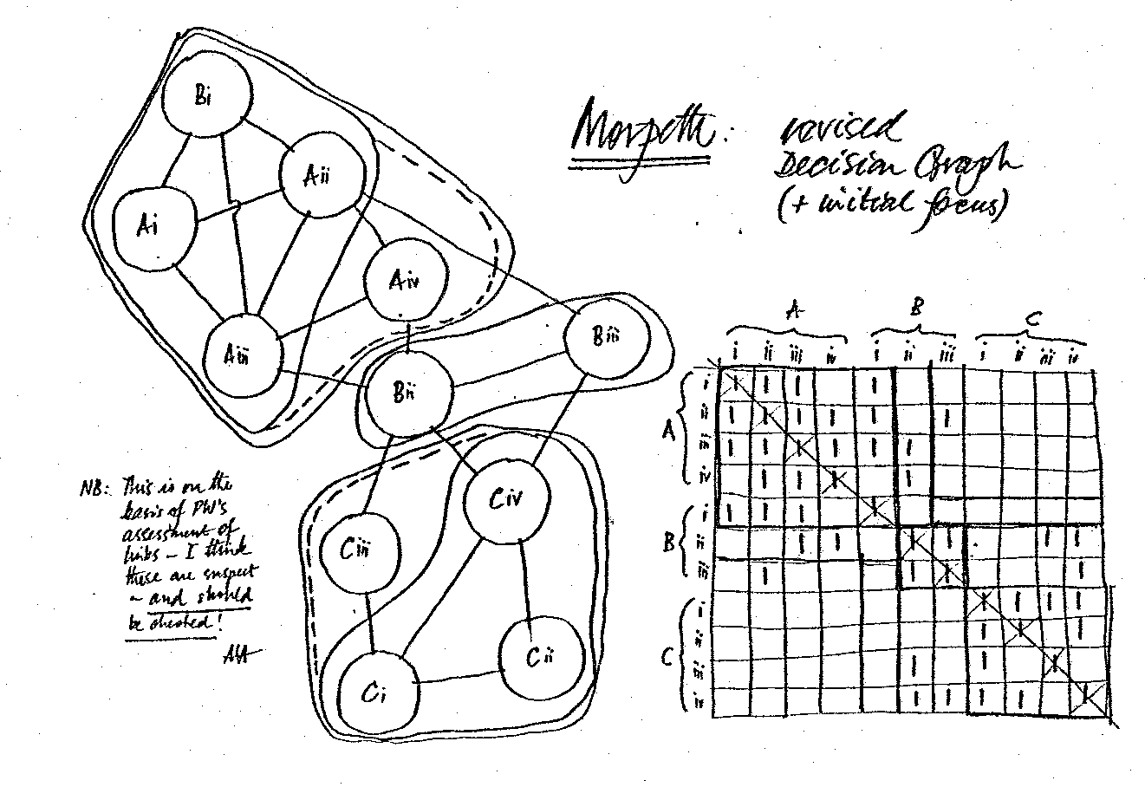
Diagram 3: Decision graph and matrix (town centre redevelopment, Morpeth, UK)
In fact, the first decision graph was an early one within the process of incrementally building up a more complicated one (diagram 4). This complexity raises two points. The first is that when talking about a framework for communication, we are talking specifically about a framework for communication within working groups. The sort of work which they develop is very often totally confusing to anybody else and therefore it is not a framework for communication between that group and the outside world. An interpretation process is very often necessary into terms which can be more readily understood by others. Unfortunately, this leads to the process being rarely visible in the product, making the use of case-study material very difficult. The second point is that this example illustrates the accommodation of different points of view. At the top of the graph there is a part which is in fact the first graph we looked at (diagram 2), as put forward by the local engineers. Most of the lower part of the diagram represents the view of the land-use planners, although a small part at the left is that of the transportation experts. We now have three perceptions of the world related to each other through the framework, thus allowing work to proceed.
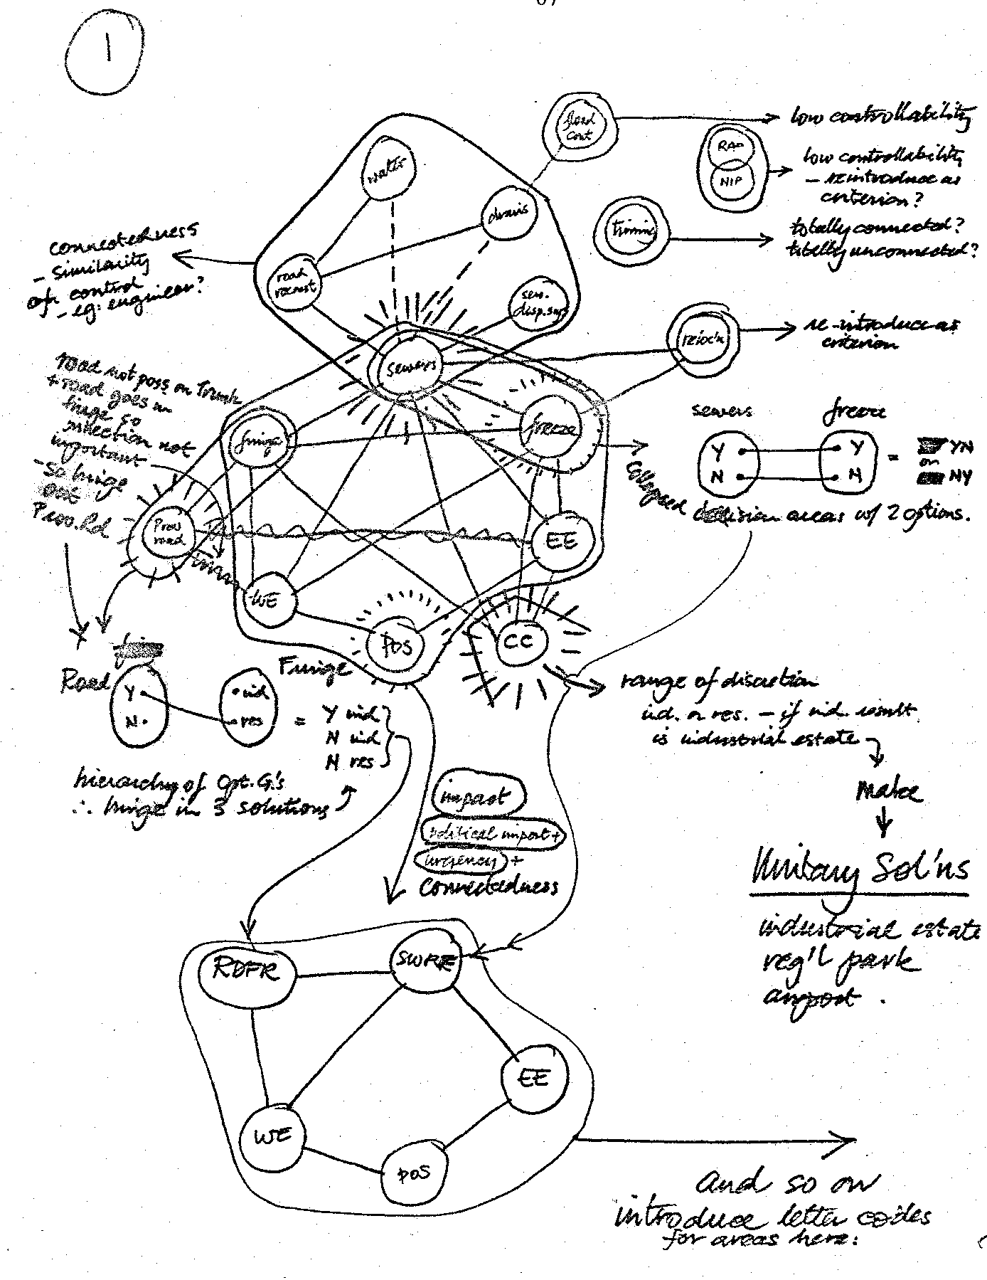
Diagram 4: Full decision graph (community planning, Bridgeview, Canada)

Analysing opportunities and establishing a focus
Such a statement of the problem, albeit a simplification, is still too complex to work with altogether, and it becomes necessary to establish a part of it to begin working on. In terms of the process diagram, this can be carried out in two ways:
politically by crossing the top to deciding what to do; or more technically by moving down to the generation of alternative solutions. The first of these is a process of analysing the opportunities we have for doing something. It includes looking particularly at what we might be expected to come up with at the end of the process. It enables a realistic look at what is feasible in political terms and what is not; remembering here, of course, that political has a little 'p’ and not a big one. For example, this may mean avoiding suggesting to the managing director alternative solutions which incorporate one of his pet hates; it may mean, for example, avoiding proposals which are contrary to stated policy of a particular council.
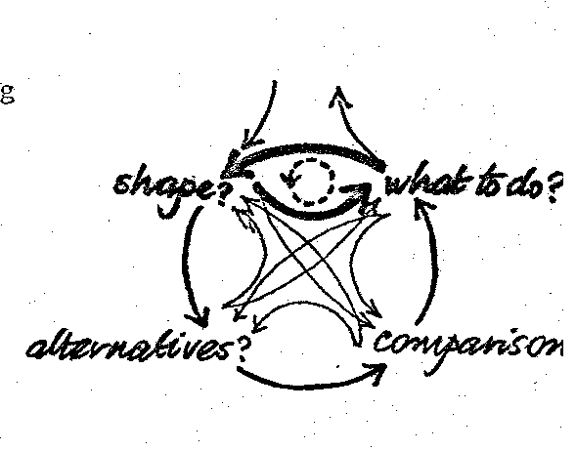
In fact, it is interesting to note here that a decision graph, being focused on decisions which are to be taken at the end of the day, is a form of expression of what might be called the solution space - the area in which solutions will be sought. Thus it can be analysed in very simple terms, as in this materials management example from Sao Paulo, Brasil (diagram 5):
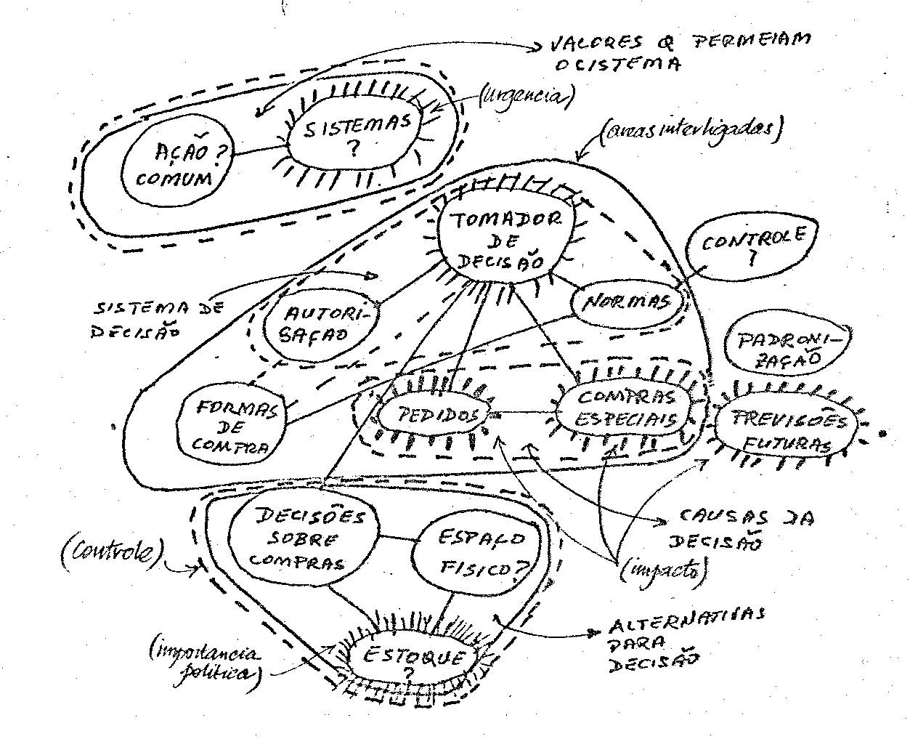
Diagram 5: Analysis of decision graph (materials management, Sao Paulo, Brasil)
- the impact of decisions;
- the controllability of the decisions;
- the urgency of the decisions;
- and the political importance of decisions.
This sort of analysis usually enables a part of the problem to be identified as a suitable part to work on initially. This has implications not only for the analysis, but also for the people to be involved. For example, a problem, and the multi-organisational group working on it, may be reduced if a decision area (or decision areas) can be shown to be unconnected to the main graph and in the control of a specific agency. Of course, allowance has to be made for the focus to change as time goes on and as the learning process takes place.
Problem structuring and generating alternative solutions
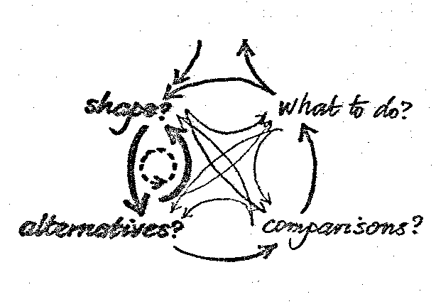
The second way of analysing a decision graph to find an appropriate focus involves moving down the left-hand side of the process diagram towards the generation of alternatives, in a cyclic process of problem-structuring. In this, more technical but nonetheless simple criteria are used:
- the interconnectedness of decisions;
- and the range of discretion, or the breadth of choice within the decision areas.
With the identification of a sub-problem of this sort, more detailed analysis is possible, and we can start looking at the range of alternative solutions. We can look at the options within the decision areas which will enable us to begin to identify alternative solutions which we might like to consider. In this example of an option graph taken from a city planning exercise in Teesside a few years ago (diagram 6), 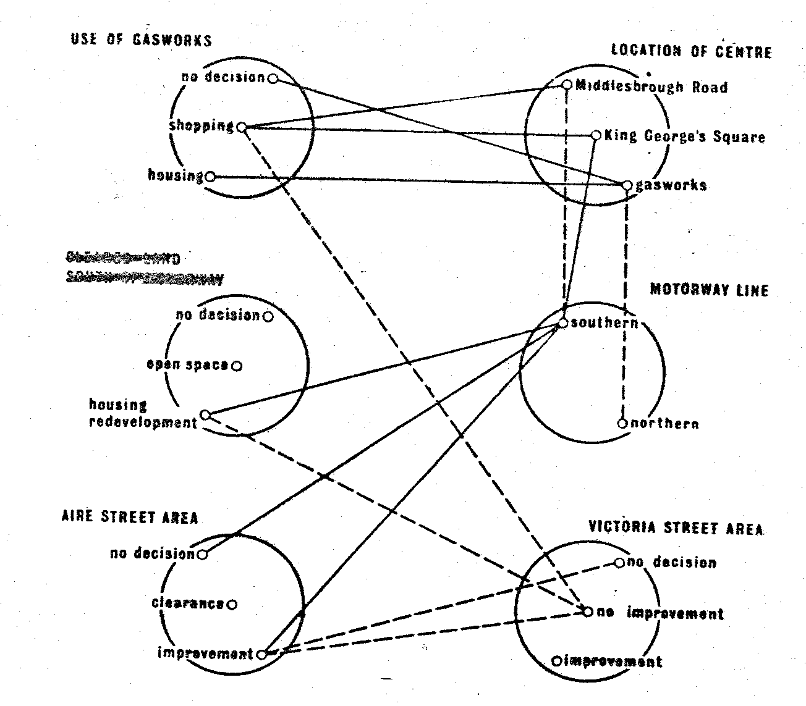
Diagram 6: Option graph (city planning, Teesside, UK)
there are options within the decision areas. (In passing, it is worth pointing out that this formally drafted graph has had to be changed although it was thought to be final!). Typical options are in the choice of motorway line, for example: whether it should be the southern or the northern route. Also in the decision area about the use of the gasworks site where there are alternatives of using it for housing, or shopping, or not using it at all. There are similar options in the other decision areas. Here, it should be noted that the lines between the options are not the same as the lines used in the decision graph; in this case, they represent negative relationships - options which cannot be taken together for some reason - and they are called option bars as opposed to decision links.
Such option graphs can be complex or simple. Even a relatively trivial option graph with few decision areas, such as the one (diagram 7) developed from the first decision graph, can be extremely helpful in clarifying the thinking which is going on between two or more people.
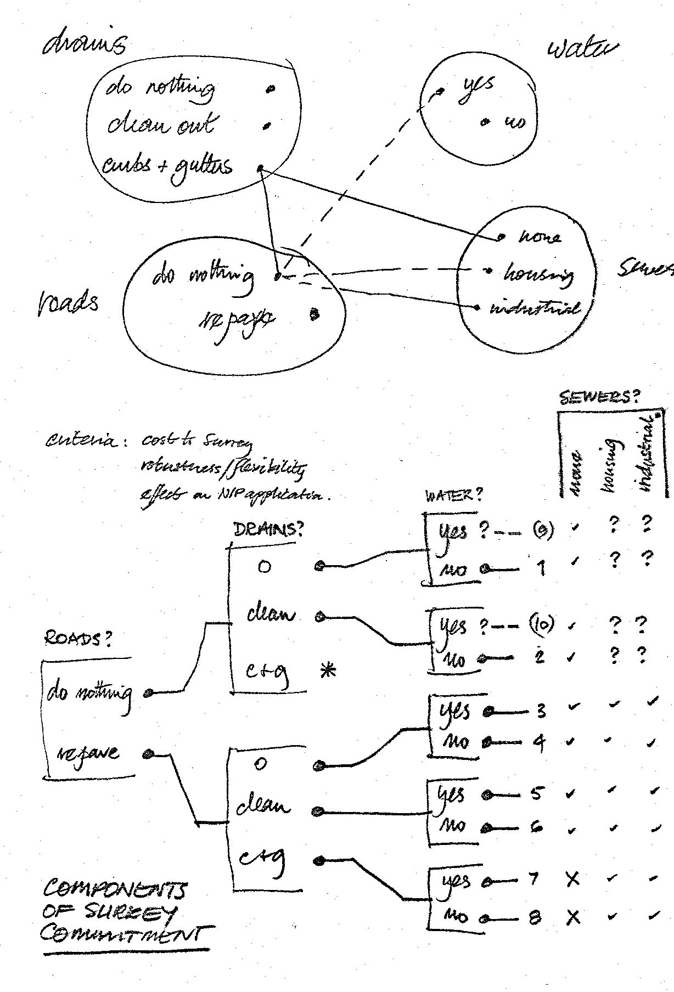
Diagram 7: Option graph and solution tree (community planning, Bridgeview, Canada)
This diagram also contains an example of one way of taking the option graph one stage further. Taking one option from each decision area represents a solution, and solutions can be shown in various forms:
- a tree, as in this case (diagram 7);
- or a simple list which might be produced from a computer, as in this industrial example of the design of a shoe last (diagram 8);
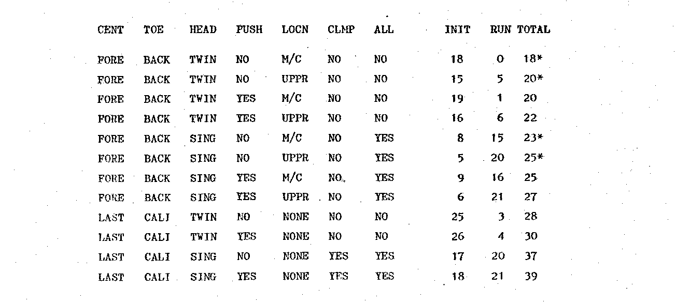
Diagram 8: Solution list (design of a shoe last, UK)
- or a cross between a tree and a list, which is called a solution table as in this planning example from Rotterdam (diagram 9);
- or a stream as in this example from the Structure Plan produced in Cleveland for East Hartlepool (diagram 10).
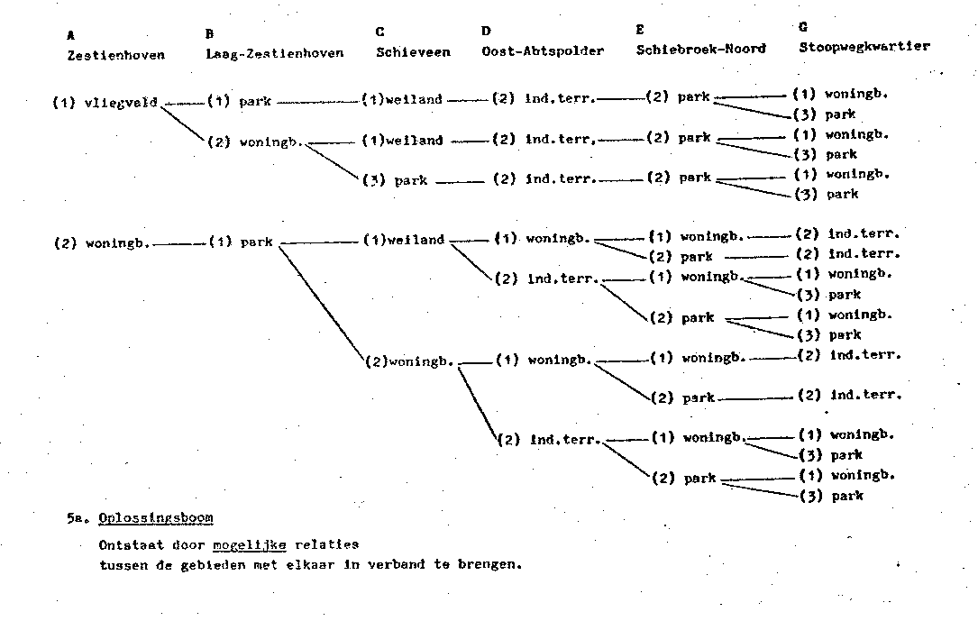
Diagram 9: Solution table (city planning, Rotterdam, The Netherlands)
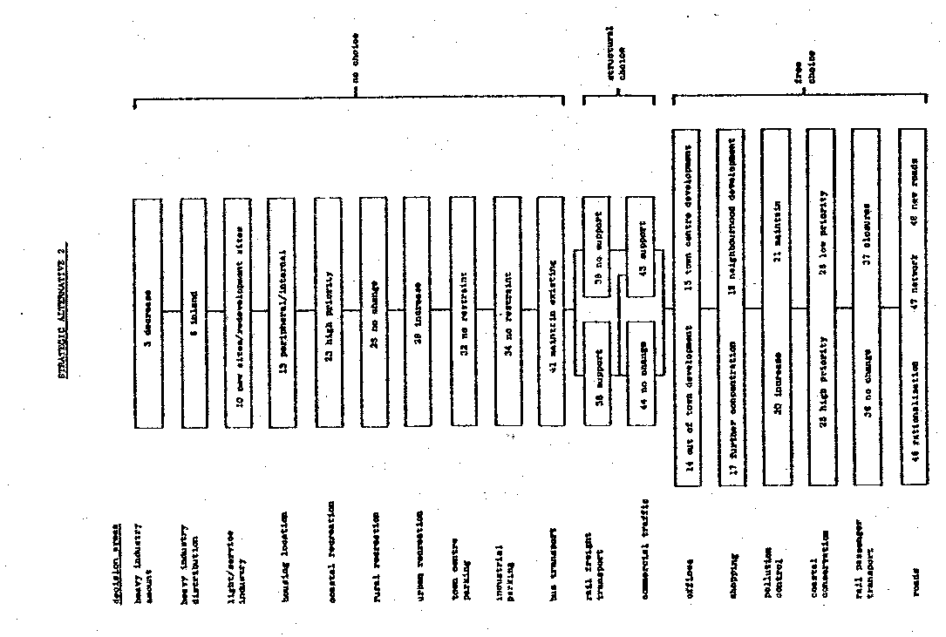
Diagram 10: Solution stream (structure planning, Cleveland, UK)
This is another example of how the approach can accommodate many different ways f working, and thus a variety of people - if one form is not understood, another might. In fact, the same information is used however it is displayed; it's just that different aspects of that information are revealed by the different forms of expression.
Comparing alternative solutions and exploring preferences
We are moving now down to the bottom of the process diagram, ready to swing around from the generation of alternative solutions to comparing them, and this is the area in which many of the more sophisticated techniques are available. Much work has been done by others in this area and perhaps it is for this reason we have done relatively little on the techniques involved. There is, in fact, a computer program for most of what has just been described so far, which can be used to some advantage at this point.
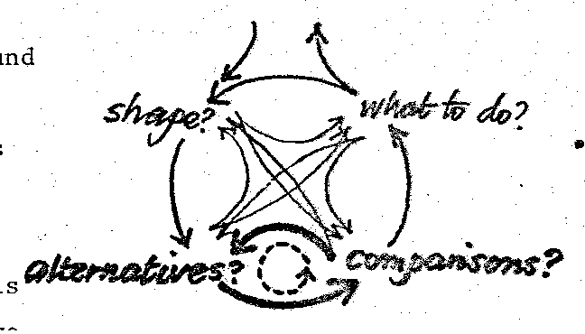
For example, part of the solution table from a project programming case' in Ibiza (diagram 11) includes a range of the quantifiable criteria. But we have been more concerned with the accommodation of unquantifiable criteria: in the bridge handrail example, this means things like danger and aesthetic value rather than structural stability. We have shown that scaling systems, such as used in Which? magazine, i.e. the more stars the better, the more black dots the worse, yes/no, good/bad/ indifferent, etc., can be used in conjunction with numbers for the more quantifiable criteria. We have also done some work on taking into consideration different points of view. Take, for example, the cost criterion. Generally speaking, cost is considered to be bad, and so indeed it is if you have to bear the cost. On the other hand, you are the person receiving the payment that that cost represents, then perhaps cost is not such a bad thing at all. Just as there were different views of the world which led to different definitions of the problem, so there are different views about which solutions are nice and which solutions are nasty; which are good and which are bad.
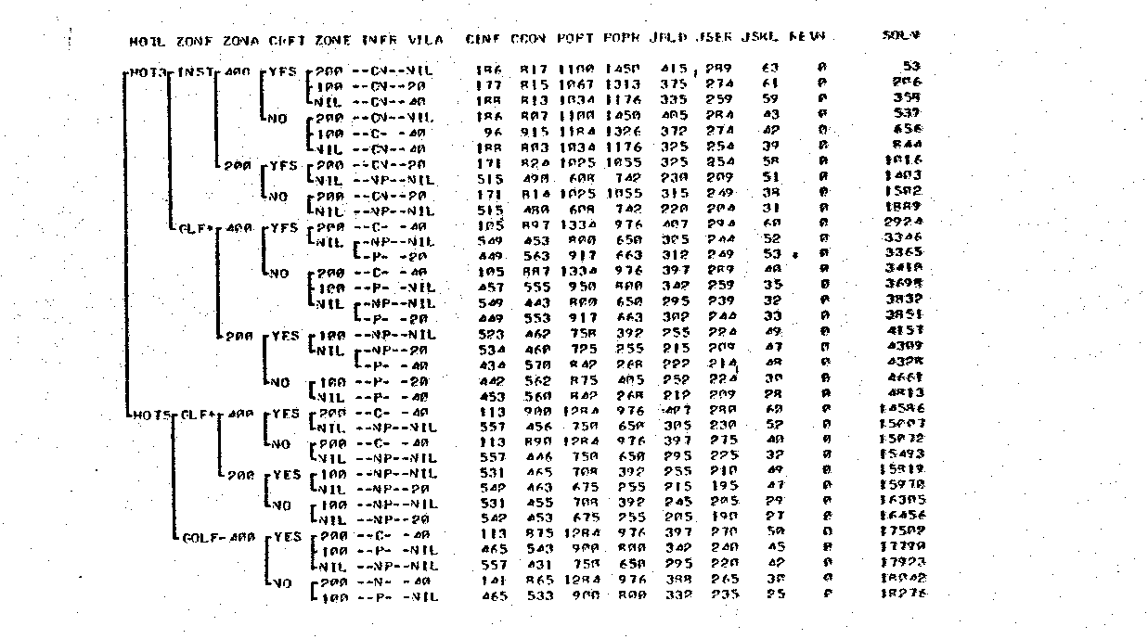
Diagram 11: Solution table with criteria (project programming, Ibiza, Spain)
However, the fact remains that, in spite of all the work being done in trying to improve the situation, it is still very difficult. Much of this difficulty can be attributed directly to the existence of uncertainty and it is perhaps this, more than anything else, that has directed our attention away from the processes of evaluation towards ways of dealing with the uncertainty. But let us look at this uncertainty before moving on to ways of dealing with it. Uncertainty pervades all aspects of the work of evaluation. It exists in the choice of the most appropriate range of criteria to consider: that is which ones are the ones we should use because obviously we cannot use all of them. Very often, the temptation is to use those most easily quantified and for which information is readily available. Then there is uncertainty about how to make the assessments in terms of these criteria. There is obviously uncertainty about how the future is going to work out but there is also uncertainty about which forecasting technique to use, which sources of information are most likely to be relevant and, if probabilities are to be used, how they should be established. And then there is the question of the values which have to be attached to the criteria. These are the judgements as to whether an effect is nice or nasty and I have already mentioned that any given effect will be nice to some people and nasty to others. Such value-judgements are the most obvious ones.
However, there are many, many others being made all the time throughout any planning or decision-making process. They have to be made; they are essential. It is wasteful to try to eliminate them because it is impossible to do so, and it is dangerous to try to suppress them because our understanding of them will be inhibited. One of the primary characteristics of Strategic Choice as a framework for communication is that it allows the value-judgements to be exposed and, once they have been exposed, then they can be examined and explored. In the earlier decision graph (diagram 4), for example, there were value-judgements as to which decisions were important and which were not; indeed, which should form an initial focus and which should be left out. There were value-judgements about which were interconnected and which were not. In the option graph (diagram 7), there were value-judgements about which options should be included in which decision areas. There were value-judgements about which options combine well and which do not. In the listing of solutions, there are value-judgements about which form of listing to use, which brings us back to comparing solutions, and the value-judgements about the range, scale and value of the criteria which are very significant.
Categories of uncertainty
The concept of uncertainty, as being the paramount factor causing the difficulties in the cyclic process of evaluation taking place at the bottom of the process diagram, leads to the need for methods of dealing with it - the management of uncertainty, which is the process taking place at the interface between the technicians and the decision-makers in the right-hand upward swing of the process diagram. Unfortunately, although uncertainty is an important thing to talk about, it is very difficult to talk about, and it is in this that Strategic Choice makes a contribution. Therefore, we have found it necessary to develop a model of uncertainty which will help us to come to grips with it. It is a very simple model based on a general situation in which some set of decision-makers are experiencing difficulty in make a choice (diagram 12). There are three fairly common reactions to such a state of difficulty; reactions which we have found it useful to interpret as responses to different forms of uncertainty. The first is a call for more information in various forms - ranging from the simplest checking of facts to the development of the most sophisticated predictive models. This we see as a response to uncertainties about aspects of environment in which the decision-makers are operating. This kind of uncertainty - the one which tends to be most systematically addressed in OR models - we call UE for short.
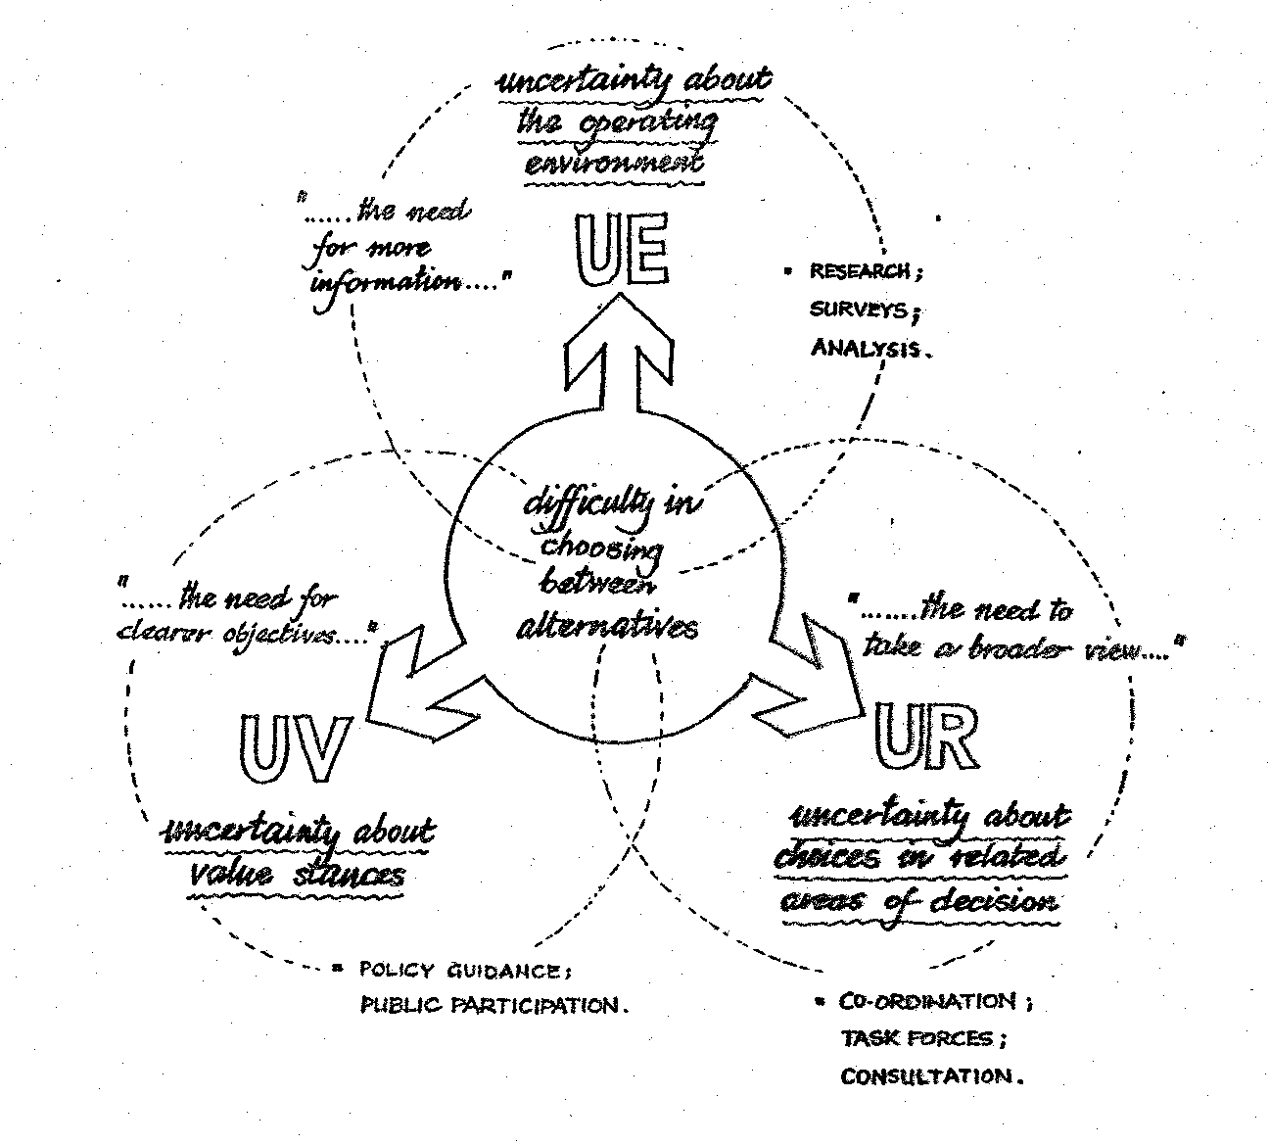
Diagram 12: a classification of uncertainty
The second is a call for clearer objectives, policies or guidelines to help clarify the directions in which the decision-makers should be trying to move. This can be interpreted as a response to uncertainties about guiding values - UV for short - or in OR terms, uncertainties about appropriate trade-offs between disparate types of effects.
The third - and the one which leads most directly to our view of planning as Strategic Choice - is the difficulty which arises because the problem is being tackled in too narrow a context: it should be looked at together with various other related problems. This we interpret in terms of uncertainties about intentions in various related fields of choice (called UR for short). This leads people towards a search for more co-ordinated decision-making - a search which may mean trying to work jointly across the boundaries with other departments or indeed other organisations.
Moves in each of the three directions can be seen as 'a good thing', and arguments made for greater comprehensiveness in analytical work, in the articulation of guiding values, and in expansion of the horizons of decision-making all at the same time. But in practice this is rarely possible because each kind of response to uncertainty makes claims on limited resources, and in many cases there are insistent pressures to reach an early decision.
The management of uncertainty
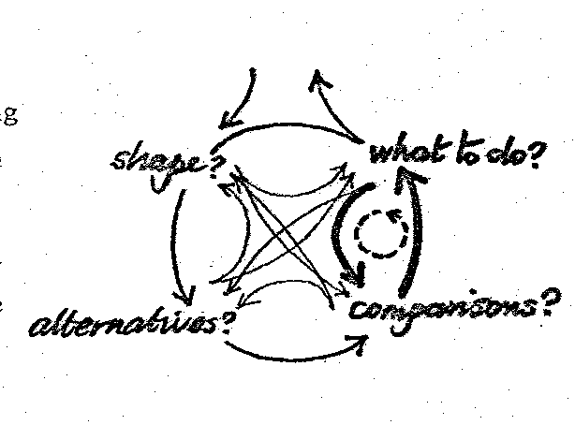
Uncertainty pervades all parts of the process, but managing it involves moving up the right-hand side towards the more political part of the process diagram, and deciding what to do. In the final analysis, there are only two things one can do about any uncertainty - accept it, or reduce it. It can never be eliminated. However, before choosing which way to deal with it, there is much we can do to understand it better.
Using the simple three-way model of uncertainty, we can begin to get to grips with questions about the type, the strength and the relevance of the uncertainties. There are no strict rules about this but, as is demonstrated on this city planning example from Brasil (diagram 13), we can begin to plot uncertainties along the three dimensions:
- the type of uncertainty according to the three-pronged model;
- its strength according to the size of the 'blob` we use;
- its relevance in terms of centrality to the particular problem being addressed by placing the uncertainty nearer to the centre of the diagram.
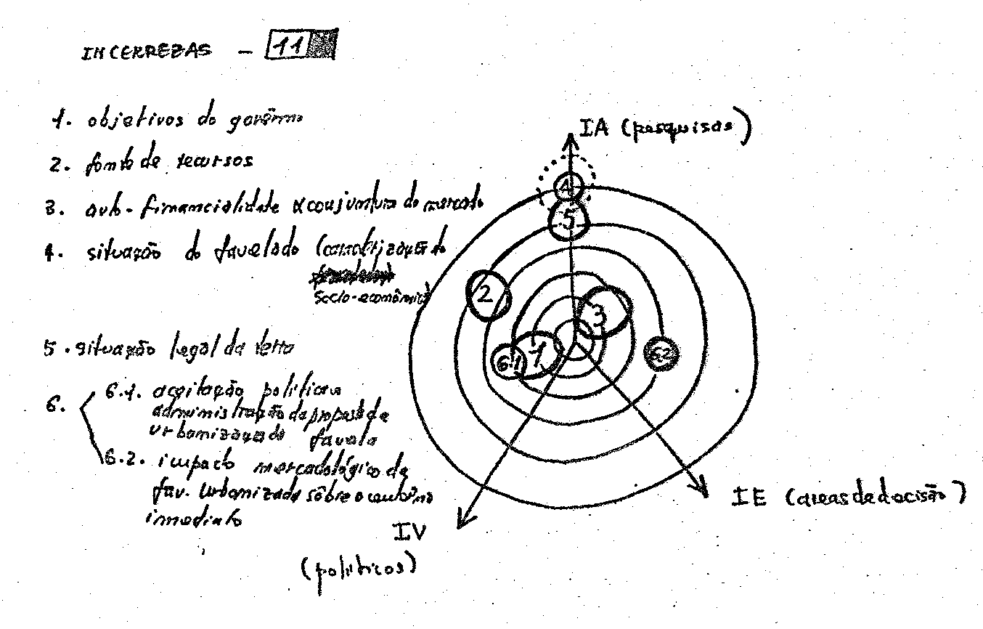
Diagram 13: Analysis of uncertainties (city planning, São Paulo, Brasil)
Many of the difficulties remain. For example, how do you assess the strength of uncertainty? Perhaps the idea that some uncertainties cost a lot to reduce or take time to explore may be used. In terms of relevance, the sensitivity of solutions to that particular uncertainty may be a measure. Just as with the criteria for forming an initial focus, some imprecision of our definitions is deliberate - forcing the value-judgements to be exposed just at the time when they would be suppressed in a conventional approach.
One Strategic Choice concept which can be extremely helpful is that of surprise limits. In this, one uses the surprise of another person as a crude but quick measure of the size of uncertainty they are experiencing. For example, if somebody has made an estimate, you can ask how surprised they would be if they were wrong. Would they be surprised if it were double or half the estimate - thus obtaining a range around the estimate, which is defined by the degree to which they would be surprised at being wrong. In effect, what Strategic Choice can offer here is a framework for the mutual exploration of uncertainties so that it is possible to get to know them.
In order to make progress in managing uncertainty, as in the upper right-hand part of the process diagram, the key idea is one of treating the strength of commitment as a variable. In decision-making terms, at the extreme this means making no decision - actually choosing to make no decision as being the most sensible thing to do at this particular time. It also allows delayed decisions and interim decisions. This can be expressed as a commitment package, such as in this example which is taken from the Canadian local planning case (diagram 14), which is yet another framework, this time used as an aid for discussing what to do. There are two fundamental parts to a commitment package:
- those things which we are going to do now, whether they be actions or explorations to reduce uncertainty;
- those things which we intend to do in the future, consisting of delayed actions and contingency plans.
The idea of treating commitment as a variable is very important in reaching decisions in a group situation. It is now possible to agree to do things about a part of the problem, dealing only with the most essential things, and leaving other things till later.
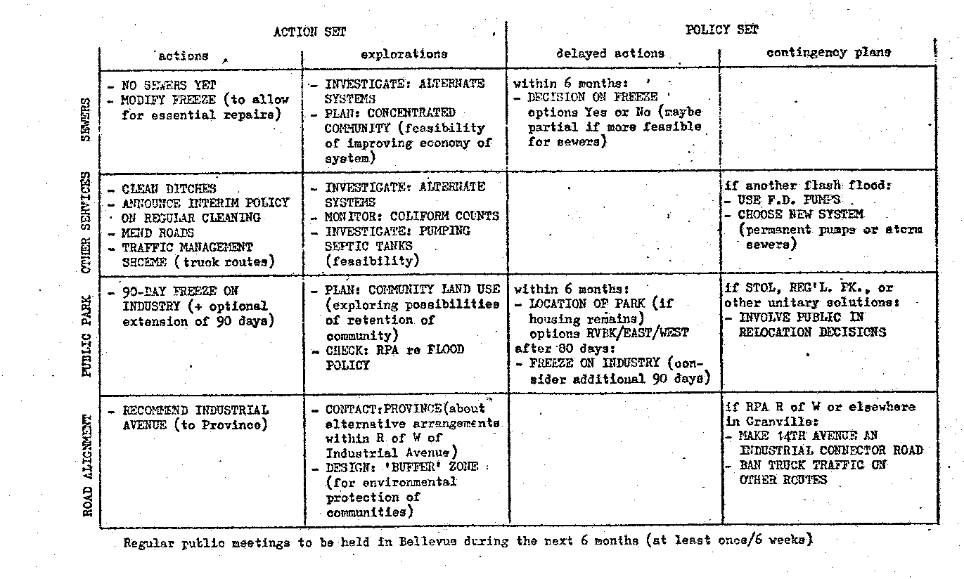
Diagram 14: Commitment package (local planning, Bridgeview, Canada)
Or, if it is impossible to agree what to do, it may be possible to agree on what not to do - and so on. Often, much time can be wasted trying to decide now things which can well be left to the future, things which sometimes in the event never have to be decided anyway. Often, decisions about what to do can be reached by groups with opposing policies. The uncertainty about the causal relationships between the action taken and the effect it will have enable both parties to see the action as being in pursuance of their policies. (Although, when there is a mutually agreed policy, the same uncertainty about causal relationships can create endless difficulties deciding which actions are most likely to be consistent with it!)
I think, at this point, it is worth remembering that much of our work has been done in the public sector and therefore working towards a continuous process of planning and decision-making has been a central concern. The commitment package is of very great relevance in this respect. It is not necessary for the cyclic process to be continuous, but it certainly enables a continuous process and the commitment package framework is a vitally important component in this respect.
Conclusion
This then has been a quick review of one contribution that Strategic Choice can make to the processes of inter-organisational planning and decision- making. Its principal function in this context is that of a framework for communication, particularly communication about some of the most difficult factors which people have to deal with, such as value-judgements and uncertainty - factors which usually underlie the conflicts which are often a characteristic of working in the inter-organisational arena.
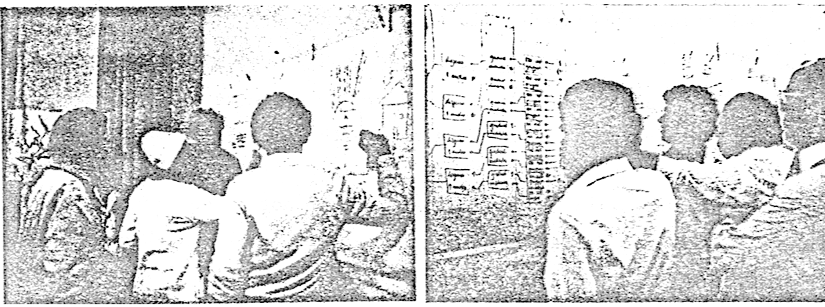
Using Strategic Choice as a framework for communication
The fundamental idea is one of exposure of the difficulties and the provision of the means for doing that. There may be only a few parts which can be said to be identifiably OR, although one or two bits are likely to feel quite familiar to the OR practitioner. The reason for this is that often, rather than use specific OR ideas some of which are quite difficult for a lot of people, we have tried to use the kind of thinking that those in OR use - and in doing so, to provide an open and visible intermediate technology which is accessible to anybody who wishes to be involved.

OR AND STRATEGIC CHOICE: SOME REFLECTIONS
by John Friend
Paper for OR Society National Event on 'OR, Social Science and Strategic Choice', 24 October 1979.
Yes, but is it OR?
What are the implications for the OR world in general of the kind of experience in developing an "intermediate technology" of strategic choice which has just been described? How does it relate to the more usual armoury of techniques that the OR worker brings to the practice of decision-making?
I would like to approach these questions as someone who came to IOR from a fairly straight background of industrial OR experience, and from the disciplinary base in mathematics and statistics which so many of us in the OR world share. I feel that my experience has taken me a considerable distance away from these roots, and from time to time I find myself reflecting why this should be. But I should like to steer these reflections towards presenting some discussion points on the ways in which OR people might be able to make use of intermediate technologies of decision-making in situations of strategic choice which they encounter in their own work. I should mention here, that in keeping with the philosophy we have developed, I am using the word "strategic" in a sense of interconnected decision-making, as opposed to high-level decision-making in terms of a particular organisational context. Jonathan Rosenhead’s paper on "An Education in Robustness" offers one good example of the way in which an individual faces strategic choices in relation to career paths, which could scarcely be considered strategic in a more conventional organisational sense.
First, it's important to acknowledge various dilemmas that we have repeatedly come up against in working with the strategic choice approach. For instance, is the approach primarily a descriptive one, reflecting the ways in which people actually make decisions, or is it more prescriptive, concerned with ideas about how it should be done? Can the approach be considered new, or is it merely a re-hash of various already familiar ideas? Does it help to make decision-making more "rational", or is it a tool of political decision- making, open to manipulation by those with relevant skills? How general is it in its application to different fields and issues? Is it to be considered as a coherent analytical package, as a philosophical approach or - as has been suggested - more as a tool kit from which useful tools can be selected when needed, for use alongside tools from a variety of other sources? Finally, is it or is it not OR?
Perhaps it is a reflection of the way my attitudes have changed with experience that I find myself able to live with such dilemmas without any burning concern to resolve them. This, perhaps, reflects the imperative we have faced in practice to find ways of working with - rather than against - uncertainty: and indeed, to learn to enjoy the experience. I find it intriguing to reflect on the way in which I personally came to espouse this kind of approach; an approach which we would certainly see as "decision-oriented" though scarcely as "system-oriented", to draw a contrast between the two adjectives often used to describe OR.
Even though both these terms are in good currency in the OR world, we do believe there are real differences in stance involved. Does one stand well back from the decision makers to try and form some synoptic view, or does one position oneself as close to them as possible so as to share their transient experiences, their uncertainties, their shifting concerns? Our own stance, as we have tried to indicate, has been to stand close to the decision-makers, whether as individuals or in groups, working with them in the attempt to keep track of difficult issues as they form and re-form over time. We do not claim that this is a superior stance to that implied by systems approach; yet it does lead, in our experience, to some valuable complementarities in perspective. In the field of land-use planning, where much of our more recent experience has been gained, it is interesting that it has become acknowledged that there are two competing bodies of theory about the way in which planning should be done - the strategic choice approach, and the systems approach with its origins in large-scale urban model-building. Both approaches have been heavily influenced by OR thinking -yet, as has been observed by a leading writer in planning theory, Andreas Faludi, it is surprisingly hard to relate the one to the other.
Origins of the approach
Reflecting on the way in which I personally came to espouse this kind of philosophy, I start with the four-year study of strategic decision-making in Coventry city council, which was financed by the Nuffield Foundation and on which I worked full-time when I joined IOR. The other members of the team were Neil Jessop, with overall responsibility for the project, and two social scientists - Hugh Murray, a social psychologist who brought with him, inter alia, some experience in the wartime use of OR, and Paul Spencer, a social anthropologist fresh from two years of field work in East Africa. It was Hugh Murray who spent much effort in building up the local relationships in Coventry which gave us early access to the places where people came together to make decisions - the departmental offices, the committee rooms, and even the smoke-filled rooms of the two opposing political groups. And it was Paul Spencer, as the other full-time team-member, who introduced me to the art of observing decision-making behaviour, helping me to interpret what was going on and to make use of the social scientist's technique of the field note as an essential part of research method - something which would never have occurred to me in my industrial OR career.
It was something of a surprise to me that these two social scientists could be so different in their working methods, and there was a lot of frustration early on over the question of how far people with such disparate backgrounds as ourselves could hope to achieve any kind of clear and joint findings.
Yet I learnt a great deal in ways which were not readily apparent at the time: and the long time-scale of the project provided a chance for me to work out of my system certain preconceptions of what we should be trying to do. In particular, I was much concerned in the early stages with rather grandiose ideas of urban systems simulation, out of a sense that we should have something distinctive and useful to present to our "clients" in Coventry as early in the project as possible. A turning point in my recollection was an early visit from Russell Ackoff. He listened to our account of what we were doing, and quickly disillusioned us in our hopes of making a break-through in the comprehensive modelling of urban systems, at a time when vast resources were being poured into this activity in the United States with comparatively little success. He had alternative prescriptions of what we should be doing; but these we found difficult to relate to our own experiences in Coventry. In retrospect, what he did for us was to help dislodge us from a course on which we could easily have become set for the rest of the project, to the exclusion of any deeper learning from our unique access to the corridors of power in Coventry.
It was around this time that the ideas about classification and management and uncertainty began to emerge. At that time, we were trying to analyse some of Coventry's planning reports on topics such as shopping and the road system, in terms of the information content and the structure of assumptions involved; we were also trying to match this analysis to observation of people's behaviour when faced with difficulties in reaching decisions at meetings. It became apparent that recommendations were being assembled through combining information through a multitude of sources, each of which was subject to various forms of uncertainty. But it took a visit by an American decision theorist - Peter Fishburn - to crystallise the crucial idea that we should think in terms of three general categories of uncertainty - broadly technical, political and structural - in developing our analytical approach.
Serendipity, therefore, played its part in the development of the strategic choice approach. Another significant example of this was the arrival, at an opportune moment, of an early working paper on robustness in decision making by Rosenhead and Gupta. This provided the spark that allowed us to come to grips with the realities of incremental decision-making over time which became so apparent in Coventry.
But just as important to us as the process of picking up new ideas, from various sources, was the painful process of abandoning commitments to earlier preconceptions as we went along. Also, we found ourselves learning some painful lessons in trying to keep a balance between the sense of responsibility we felt to make ourselves useful to decision makers in Coventry and our primary responsibility to the Nuffield Foundation to come up with findings of wider relevance beyond the city.
In the ideology of OR - and also in the ideology of action research as embraced in the Tavistock Institute - the advisory and the research responsibility are supposed to go hand in hand. Yet in practice, we found the balance fluctuating quite dramatically over the four years of the project. About half way through, we found ourselves seen as trusted neutrals whose advice was sought after by various factions in the council. We would sometimes, indeed, be told that such and such a change in organisation was clearly sensible, yet would be seen as a partisan view if put forward by anybody inside the council; how helpful it would be if we, as people without an axe to grind, could put the idea forward instead! Gradually, we found ourselves sucked into the affairs of the council in a way we found quite difficult to handle: the more we tried to be helpful, the more we ourselves became actors in the drama, so that we found our position as trusted neutrals at risk. This leads us into the wider points about relationships between researcher and "clients" which Michael Norris talked about during the morning.
It was dilemmas such as these that led us, towards the end of the Coventry project, to a conclusion that we should withdraw from our local advisory role and concentrate on writing up what we had learnt for a wider audience. In retrospect, this was a wise step, as the book "Local Government and Strategic Choice", in which Neil Jessop and I put forward the fruits of the work,., has provided a platform from which our work has gradually become more widely known among town planners, local government people and others. One suggestion of Neil Jessop's which was particularly valuable was that the book should make extensive use of fictitious case examples of decision-making, drawing indirectly on our Coventry experiences, to illustrate how a more conscious "technology of strategic choice" might help decision-makers in practice.
The publication of these case examples attracted early interest from planners who felt they would like to explore the use of this kind of approach in tackling their own local decision problems. On the strength of this, we were able to launch in 1970 an experimental programme of collaboration with half a dozen local authority teams in different parts of the country and this began to lead us towards the various forms of interactive working with managers and planners of which Allen Hickling has just been giving some examples.
Implications for OR
Returning to the question of the generality of this kind of approach and its relationship to OR in general, I would first say that we do not see the strategic choice approach as in any way a substitute for more advanced "decision technology" where this has proved useful in organisations; clearly, it provides no substitute for the use of queueing models or mathematical programming methods in relation to problems which lend themselves readily to this form of structuring. Where we encounter decision processes which are concerned with the regulation of particular production or operational systems - involving the adjustment of continuous variables - then something more sophisticated is called for than a model of problem structure in which options are regarded as discrete and relationships seen in terms of incompatibilities. Some OR people, indeed, have suggested that the AIDA method is no more than a special case of a more general integer programming formulation; yet this misses the point that we are talking about a method to help groups of people to explore their view about the structure of choices, rather than to search for an optimum within some agreed problem formulation.
So far as the ideas about uncertainty are concerned, we have found these extremely helpful in allowing us to ask challenging questions about the use of more sophisticated OR models from a practical decision-making perspective. For instance, we can look at the extensive use made by planners in the sixties of large-scale models of land use transportation systems, and see them as well-meaning attempts to reduce significant uncertainties of type UE. But we can see disillusionment setting-in once it was realised that many of the most important uncertainties were really of class UR and UV, concerned with related choices and policy values respectively. The UE/UR/UV model allows us to ask what is likely to be the residual variance - in statistical terms - after analytical resources have been invested in the reduction of UE; and whether in this light the investment in modelling activity represents a wise use of resources. Like anyone else, we in OR have to think hard about priorities in allocating the limited resources of skill and experience we possess in the service of decision makers, and if we can avoid profligate dissipation of resources in areas where we can offer decision makers little help in reducing the real uncertainties they face, then it can do nothing but improve the long-term outlook for OR.
At this stage, it is helpful to look back to the cyclic model of decision-making introduced earlier. If we take a comparatively tightly focussed view of the role of OR - and indeed if we follow the definition that appears in the OR Society's Journal - then we see OR scientists having a role to play mainly in the lower reaches of the diagram, concerned with the comparison and evaluation of alternative lines of action. We can see the upper reaches of the diagram as representing the kind of territory in which decision-makers tend to operate at an intuitive level; and we have to ask whether more can be done to establish firm connections between the two levels. This is where we come to the use, in the left-hand part of the diagram, of comparatively open methods of problem-structuring such as AIDA in establishing a problem focus - coupled with the use of general models of uncertainty and its management in coping with the relationships between preferences and practical progress on the right-hand side of the diagram.
What I would like to suggest is that there are two ways in which OR people may like to consider making use of the ideas we have offered. The first is ancillary to the use of more sophisticated techniques; here we believe that the use of intermediate methods of analysis can help from time to time in allowing the OR worker to "loop upwards" from the bottom part of the diagram, to test whether the analytical work is still proceeding on the right lines when the wider context of decision making is considered. Are we still working on the most relevant problem focus, and are we still addressing the most crucial uncertainties of the decision-makers, in the light of the changing realities they face?
The other use I would suggest is in making rough-and-ready explorations in areas of decision making where there are no obvious advanced techniques to apply. In either case, a point we would stress is that intermediate decision technology must also be interactive technology; it should be seen not merely as simpler for the analyst to use, but as helping to open up a dialogue with decision makers on as broad a front as possible and to build up a sharing of perspectives. It is this that presents the most difficult challenge, rather than the development of theory in further depth: we ourselves are far from satisfied with the current state of theoretical development in the strategic choice approach, and welcome dialogue with those who have the capacity to work in more depth on concepts such as robustness and management of uncertainty: but the challenges of interactive working remain, and it is here we believe the main thrust of further development in aids to strategic choice should lie.
CENTRAL POLICY AND LOCAL VARIETY: SOME NEW THEORETICAL PERSPECTIVES
by John Friend
Paper for OR Society National Event on 'OR, Social Science and Strategic Choice', 24 October 1979.
OR and Policy
In this last session prior to the open discussion, my purpose is to introduce some perspectives we are finding increasingly useful in grappling with what are loosely called 'policy issues'.
Especially in the last 5 years or so, 'policy' seems to have been becoming something of a magic incantation. Starting in the United States, the ideas of policy studies, policy analysis and indeed policy sciences have been becoming increasingly fashionable. Conferences and new journals seem to have been mushrooming, and - despite all kinds of confusions about what terms like policy studies mean - there are obviously strong overlaps with what we in OR have come to look on as our own stamping ground. In this country, the recent debate came to focus around the ideas propounded by Ralf Dahrendorf on his appointment as Director of LSE and the subsequent argument about the creation of a "British Brookings". Meanwhile, in government we have seen the establishment of the Think Tank - the Central Policy Review Staff - and the appointment of policy advisors to key departments by both Labour and Conservative governments.
Not only in government but also in the larger industrial and commercial firms, the very term 'policy' has considerable potency because it suggests a closeness to the centres of power; therefore, it tends to draw all those who seek to exercise influence on people at the centre, like moths around a flame.
This centralising view of policy is one which I would like to modify in the course of this talk, by suggesting - largely from our own working experience - that policy-making is really very much more of a polycentric, or pluralistic, process; that central policy-makers are often far less powerful than they appear; and that there are important influences at work all the time to reduce the influence of central policies on local decisions - forces which we can call contra-policy influences. The study of these limitations on policy making must, we believe, be regarded as quite central to any putative science of policy whether we are working in the public arena or in other fields.
Policy Studies in IOR
In view of the origins of IOR, it is not surprising that concerns about policy have been around since the very early days. In talking about extending the field of application of OR - one of the four initial aims set for IOR by its two parent organisations - there was a sense that OR should be aiming to make a stronger impact at a policy level in organisations. Quoting from the final version of the proposal agreed by the Joint Tavistock/ORS Working Party in 1962, - a proposal much of which was drafted by Neil Jessop - the statement appears:
"OR has been slow in penetrating the broad social and economic sphere, where policy decisions affect the life of the ordinary man profoundly".
Even accepting that OR may have made a good deal of progress since 1962 in making up for this deficiency, the statement still provides a good text to which to relate what I want to say. The question to be addressed, perhaps, is whether we can understand more fully the influences which have impeded OR in its penetration of "the broad social and economic sphere", and come up with any practical ideas as to what we should do about them.
In addressing this question, I should like to refer first to a couple of early pieces of IOR experience in the sixties and comment on the way in which the idea of 'policy' came up. First, the Nuffield project in Coventry was actually entitled "Policy Research for Local Government". In the research proposal, it was suggested that local government was a fertile field of study as it could be seen as a microcosm of central government itself in the complexity of its departmental and political relationships. This is a view which we would wish to modify somewhat in the light of experience, and I will come back to this later. But the project did bring us up against the problem of trying to disentangle such frequently used terms as policy, planning, coordination and management, all of which tended to be bandied about in talking about the decision processes of the authority. We concluded that the simplest way of describing the idea of policy, as distinguished from these other terms, was to think of policy as a 'whenever' word. In effect, the idea of policy is generic rather than specific in its application to decision situations. Whether explicitly or otherwise, it tends to carry a sense of categorising future decision situations which cannot be foreseen individually, and attempting to articulate what kind of response will be seen as appropriate whenever a situation falling in one category as opposed to another may arise.
Then, in the work carried out by IOR staff in hospital management in the sixties, the idea of 'operational policies' came very much to the fore. The term was used to describe the sets of ground rules to which people work in managing the complex day-to-day activities of hospitals, involving such things as admission and discharge of patients, assignment to wards, and deployment of medical, -nursing and other resources. In existing hospitals, such operational policies would often have grown up gradually over time and therefore be largely unwritten. But severe problems tended to arise in new hospitals where the incoming staff would have to adjust their practices to a new physical layout and an untested organisational structure. Therefore, a problem arose of thinking in advance about appropriate operational policies, and seeking as far as practicable to codify them in written form, while trying not to inhibit the processes of adaptation and learning through which these policies might subsequently evolve. Several early studies were directed towards this kind of 'policy design', in close consultation with medical, nursing and administrative staff. This experience helps to illustrate the idea that policy-making can often be quite a humble local business; the corridors of power in Whitehall or Washington are by no means the only place where research into policy formation becomes appropriate.
Nevertheless, the programme of work that began in the late sixties for the Civil Service Department - and in particular IOR's close involvement in the formative stages of the location of government review - did begin to bring us into contact with the processes of policy formulation in Whitehall. A central problem was that of how far dispersal to the regions of particular parts of government with policy responsibilities would cause "communication damage" in the decision process of the government machine itself, to weigh against any gains in bringing new employment to the regions. As a part of this study, a short exploration was carried out into the communication patterns of Civil Servants and Ministers who worked in one part of government which was already operating far from Whitehall - the Scottish Office. In this study, much was learnt first-hand about the importance of informal communications and cultural influences in keeping the machinery of government working smoothly.
In 1971, a brief but fascinating opportunity arose to become involved in a more fundamental study of the organisation of long range policy-making in central government - this time, not in Britain but in the Federal German Republic. The idea proposed to us by Professor Fritz Sharpf - then a consultant to a group reviewing the structure of inter-departmental coordination in the Federal Civil Service in Bonn - was that long-range policy planning groups at an inter-departmental level might be formed not on a purely ad hoc basis but with the help of some systematic modelling designed to explore the relatedness of different policy areas in terms of the similarity of their impact profiles. Techniques such as multi-dimensional scaling and cluster analysis were brought to bear on this problem and some limited trials were carried out to obtain input data through a Delphi approach involving groups of middle-range Civil Servants.
While the study was only a pilot one lasting six months in all, there was much to be learnt from it - not least, we had to come to grips with the very limited policy influence of central government in a Federal State where a great deal of legislative and executive power rested with the individual Länder.
One general observation we were able to make from the work both in Bonn and Whitehall was that the closer the OR scientist moved towards the heart of central government, the more necessary it became to accept a limited role as expert rather than a broader role as process consultant. Because of the sheer weight of conflicting interests to which senior Civil Servants tend to be subjected, this may well be almost inevitable, unless the researcher has either an exceptional degree of good luck or an exceptional level of access to influential people. But this is an observation which applies less strongly to local government; and at this level, we have found ourselves able to get involved in the realities of policy making as a process somewhat more directly, as the following experiences will show.
Technology for Policy Making
In 1972, IOR was approached by a team of town planners from the then county Borough of Worcester, who were trying to prepare a new 'Structure Plan' for the city and had come across the AIDA approach while reading a book on systematic design methods. At that time, the idea of a structure plan was comparatively new, even though it is now established as the lynchpin of the new development plan system in Britain. The significant point about the Structure Plan is that, in contrast to the old style development plan, the emphasis is now placed on the submission of written statements of policy rather than the drawing of zone boundaries on maps; therefore the design problem could no longer be seen as primarily a spatial one. Some pilot work by IOR on the use of AIDA in this context was sponsor by Worcester City Council itself, and this in turn led to a broader program involving several of the new county councils, supported by a longer term research contract from the Department of the Environment.
From this project, some significant insights emerged about the use of written policy as a mode of intended control, or at least influence, over decision-making behaviour. In particular, the opportunity arose at an early stage of the research to sit in at the Examination in Public of one or two early structure plans. The 'EIP' is a new kind of public inquiry in which many governmental and private agencies are encouraged to express their views on a submitted plan prior to its approval by central government. What emerged from these experiences was that the choice of wording in a policy statement could often become a key aspect of control; questions of softer versus harder statements, and of specific versus more ambiguous wording, generated a lot of controversy and were obviously very important to some of the participants who went to considerable trouble and expense to challenge particular statements.
Accordingly, when working alongside planners in using AIDA to develop sets of policy alternatives, we found that we were beginning to use choices of more restrictive versus more permissive forms of policy statement as explicit variables in our analysis. We also found ourselves developing techniques to help the planners in working systematically at varying levels of generality from broad statements of aim to more specific statements of intent - all the time attempting to provide a two-way bridge between these levels of choice, rather than work deductively from broad aims to specific proposals as in more conventional concepts of systematic planning method.
Well over a dozen county councils in England and Wales, and Regional Councils in Scotland, have now made some use of AIDA and strategic choice concepts in their structure plan work, and several are continuing to use the approach without any assistance from ourselves or other OR scientists. In some cases, counties have carried out experiments in involving politicians and even members of the public in this kind of "policy dialogue". This of course raises questions about how far the particular decision technology and its language are made explicit to all participants; in practice, it seems possible to make quite a lot of progress with the analytical aspects kept discreetly in the background.
As more and more counties have completed work on their first structure plans, attention has turned to the problem of monitoring, and a further research project was recently conducted in this field. The main point worth mentioning here is that a review of alternative theories of monitoring helped clarify in our minds the reasons why more conventional models of monitoring - drawing on production and management control situations - rarely produced happy results in the urban planning field. There appeared to be three explanations for this: first, the multiplicity of organisations jostling with each other to exercise control over the local use of land; secondly, the indirectness of control instruments, relying largely on assumptions about the ways in which general policy statements are expected to impinge on local decision-making; and, lastly, the volatility of the guiding values compared to the time scales of policy influence. This last factor meant that ideas about comparison of "performance" with "objectives" could become highly unrealistic - bearing in mind that any democratically elected council can choose to introduce radical shifts of policy orientation from one year to another. The upshot of this study was a set of recommendations about the importance of a more forward looking approach to the monitoring of emergent issues, in contrast to an approach based on more conventional ideas of performance monitoring.
Contra-Policy Influences
While this work was going on, other studies of community decision-making, of the kind already discussed by Michael Norris, were helping to illuminate problems of policy influence as experienced at the receiving end. The Droitwich study, for instance, provided a clear view of the way in which local decision makers, charged with a specific task of enlarging a town to four times its previous size - were all the time being buffeted about by multiple policy influences from government departments, local authorities, and other bodies. At the time of our research, they were in theory around half way through implementing a fifteen-year development plan; but in practice this plan had receded to become no more than a background influence compared to the continually shifting social and economic policies of government. This was well illustrated when we carried out a short experiment with a group of local administrators and professionals to exchange their impressionistic views about the probable starting dates of various local construction projects. Each professional tended to be conscious of different sets of policy constraints, knowledge of which was very imperfectly shared even though they were working as a team in the same day-to-day management process.
From the Droitwich study, the idea arose of the "policy system" as a necessary yet severely limited vehicle for decision making. Such a system we defined as any system of arrangements within which some set of role-holders expect to make a succession of decisions relating to a particular class of problems, while subscribing to some shared "policy code". Such policy systems can be defined at many different levels; policy systems to deal with narrow categories of problems tended to be nested within other broader systems, while an important characteristic of public planning is the existence of compound policy systems, where people must take account of guidelines from more than one source.. For instance, an elected local authority must take many kinds of decisions about housing not only within its own policy guidelines but also within others set by central government, creating all kinds of difficulties where there are differences of political colour.
But in Droitwich it became clear that formal policy systems were of only limited value in the making of decisions about all the various complex local issues that arose. Much depended on more personal networks of communication across and within organisational boundaries, providing an essential lubricant in the management of the planned expansion programme, with various key individuals deploying a high degree of "networking" skill in coordinating the actions of various agencies at a day-to-day level. What became apparent was that informal coordination of a 'bottom-up' character was at least as important in practice as the more conventional 'top-down' mode of coordination from some central point of authority. We find it useful to illustrate this by drawing a simple diagram, which is reproduced in Figure 1. This contrasts the perspective of a single. policy maker who, from some kind of central position, is trying to influence the decisions of several more local decision makers, with the perspective of a local decision-maker who may in practice find himself subject to would-be influences from several more 'central' policy makers. The more policy makers there may be, the more difficult he is likely to find it to solve his current local problems within the constraints of their various policy codes, and the more he is likely to resist the often grossly simplified categorisations which these policies appear to impose on the subtle realities with which he has to deal.
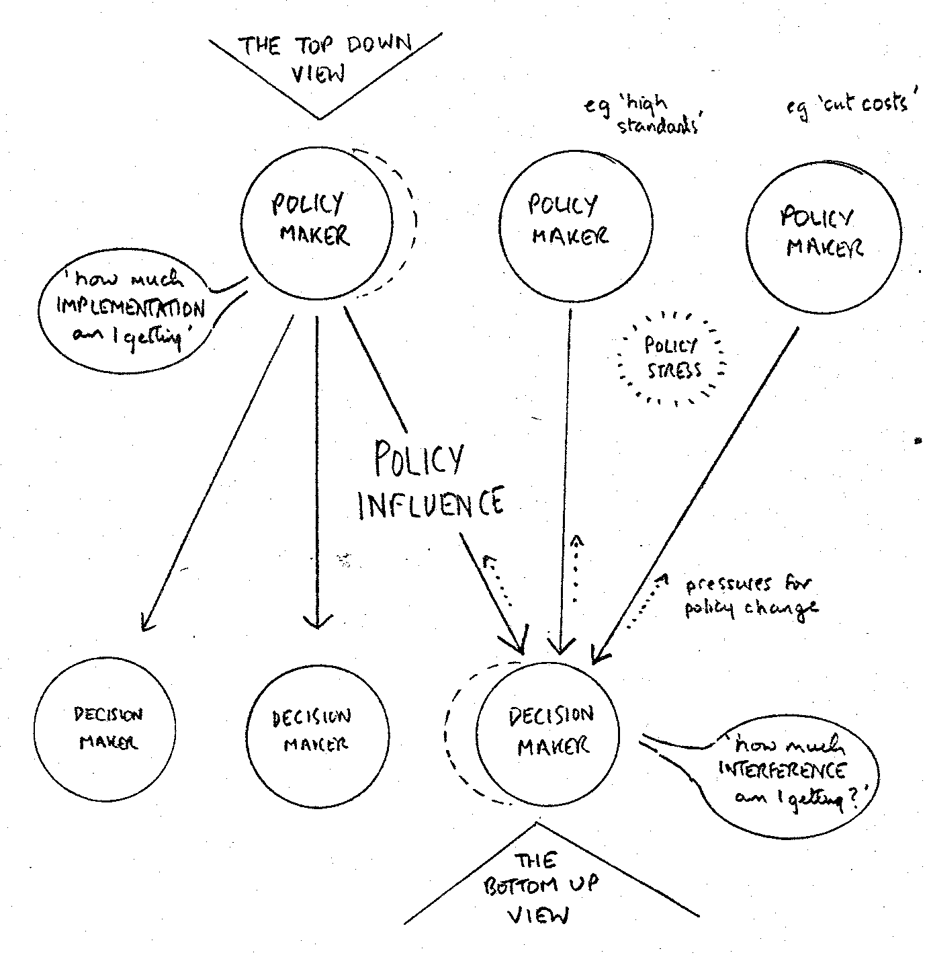
Figure 1: Two Perspectives of Policy Influence
We therefore have two very different views of policy influence: and whereas the policy maker tends to be concerned about 'implementation', and to worry about failures of influence in these terms, the poor local decision maker tends to see policy influence more in terms of 'interference' with his freedom of action, especially where this comes from several sources - for instance, central government, local government, trade unions, professional associations. A useful concept to describe his dilemmas is that of 'policy stress', which we define as a state of difficulty experienced in making decisions under the conflicting influences of two or more policy positions. In practice, we find that the phenomenon of policy stress provides an important force in setting up pressures for adaptation of established policy positions. Through this and other pressures, established policies tend to become eroded over time, and it becomes important to understand these processes of erosion just as it is important to understand the processes of policy formulation themselves.
We are now beginning to build up some dimensions of what can generally be called a "contra-policy" perspective to the realm of policy studies. The difference between policy and contra-policy perspectives is set out rather more systematically in the table below:
POLICY MAKERS' CONTRA-POLICY
Perspective of: PERSPECTIVE PERSPECTIVE
PROCESS: Policy Formation Policy Erosion
INFLUENCE: Implementation Interference
COMMUNICATION: Policy Writing Policy Reading
RESOURCE MANAGEMENT: Resource Allocation Resource Acquisition
What our experience strongly suggests is that it is just as important to understand the phenomena in the right hand list as it is to understand those in the left hand list, if OR is to come to grips with basic issues about policies and their influence on decision making, whatever the operational context may be.
Policy and Community
Of course, the idea of two levels of activity - one involving general policies and the other involving specific decisions - is a gross simplification when it comes to looking at the many levels of decision making influence which may exist both in large organisations and in the broader public policy realm. The two circular diagrams in Fig. 2 set out to give a map of the whole range of relationships that can span the gulf between the central policy process of a national government, and the life of any one individual within a specific family and community setting. This helps to show a stark contrast in perceptions of centrality and remoteness. To the individual man, woman or child, central government is very remote from the centre of his or her daily life; but to people in central government the myriad of individuals they serve are also bound to appear remote - with overworked Members of Parliament trying desperately to provide a connecting link between one extreme and another.
One thing that takes on significance in these two models is the intermediate role of local authorities in relation to a whole range of services on which the life of local communities depends. For illustrative purposes, the two diagrams tend to over-emphasise the part played by statutory services in the life of an individual, as opposed to the role of those voluntary and market activities which are shown, in a more impressionistic way, in the right hand sector of each diagram. To a marked extent in the statutory service sector - and to a lesser extent in the commercial and voluntary sectors - the role of local government appears as one of introducing cross- cutting threads at one or more intermediate levels between central government and the individual. The larger and more complex the country concerned, the more intermediate levels of government are likely to be found, providing opportunities for 'intermediate policy systems' to become established, with benefits in terms of overcoming tendencies to remoteness yet with corresponding costs in terms of the complexity of policy processes and the resulting symptoms of policy stress.
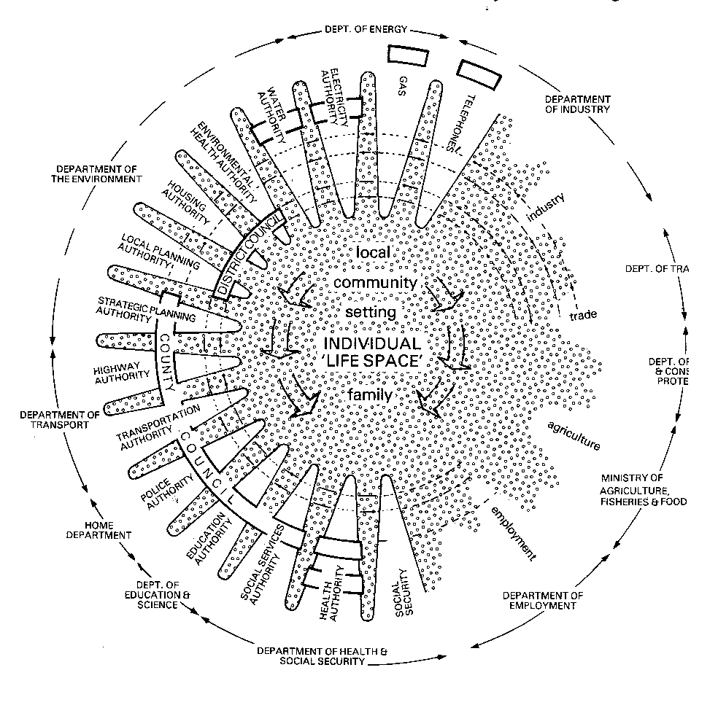
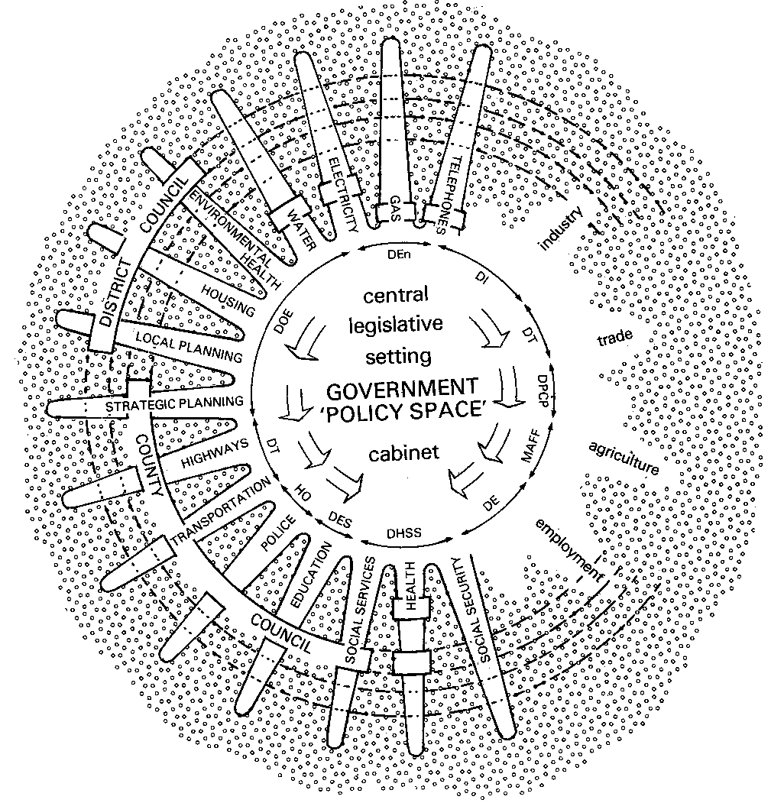

A NATIONAL VIEW A CITIZEN’S VIEW
(case of an English Shire County)
Figure 2: Two Views of the Provision of Local Services

A good way of bringing the two diagrams together, for the purposes of conceptualisation, is to consider the two central circles as forming two ends of a barrel, with the various sectors of community services bent back to form the staves and the local authorities providing the hoops to hold it together in the middle. This is, of course, a deceptive analogy - but it is a helpful one in some respects. Where it breaks down is in its suggestion of symmetry between a single governmental perspective and a single individual perspective: in practice, of course, the idea of the 'individual' is a sweeping generalisation which suppresses all the subtle sources of variety in the lives and characteristics of people. This variety can be looked at in cybernetic terms - though what it implies, in a democratic society, is very much more than the development of a requisite variety in some monolithic central control system.
Policy in Perspective
What I hope all these ideas help to convey is a sense of the very real limitations of 'policy' as a source of influence on people's lives. In practice, people have to live their domestic and working lives within a whole variety of 'codes', some written, some unwritten: legal codes at one extreme, codes of operational practice and of interpersonal behaviour at the other, and what we call policy codes falling somewhere in between. All these codes are bound to be limited to their capacity to cope with variety; all are bound to conflict from time to time and to be subject to various pressures of erosion and reformulation. We have lately been carrying out research, under an SSRC grant, on the dynamics of policy conflict and change in one particular setting where these processes are much more clearly visible than most; the somewhat ritualised processes of Examination in Public of county structure plans. Here, many kinds of bodies can take part in the ritual of policy debate, from central government departments to local chambers of commerce, amenity groups and residents' associations. Such “EIP’s” are now being held, in many parts of the country, and I can recommend anyone who is interested in following up these ideas to go along and sit in for a day or two.
While local government processes tend to offer a particularly accessible laboratory for policy studies, we have been able to observe some of the same underlying processes going on in other settings where we have recently worked. For instance, they appear in studies of work organisation at the coal face, which have been building on earlier Tavistock work in this field, and also in studies of problems arising at large power station construction sites where people owing allegiance to many different contractors, trade unions, and other organisations, have to establish some local modus vivendi in trying to sustain the momentum of construction work.
In all these settings, it is clear that informal networks provide an important counter-weight to established policy systems; but we are aware that different contexts provide different sets of incentives and constraints so far as informal relationships are concerned. For instance, the idea of 'co-ordination' across organisational boundaries may be in good currency in the public sector, where different agencies are supposed to pull together; in the private sector, however, competition is supposed to be the name of the game, and the idea of coordination across organisational boundaries can carry very different undertones.
There is much further work to be done to explore the implications of such differences between organisational contexts. But, in general, it is clear to us that there is much to be gained by adopting a pluralistic model of policy - looking at public policy in particular as essentially a 'business', in the sense of a widely dispersed human activity in which people are all the time interacting selectively and, in effect, trading with each other in various types of resources; including information, authority and goodwill. There is, we believe, much to be learnt here from ideas about political economy with which political scientists have now been engaged for some time.
Implications for the Role of OR
What does all this imply for the world of OR? At one level, I am sure that all of us come up against loose usages of the term "policy" both in relation to our own operational concerns - whether we work in industry, in universities or in other settings - and also in relation to the affairs of the wider world in which we live. I hope therefore that some of the perspectives on policy which I have tried to introduce will be of interest, and that they will provide a reasonable match with experience; but this is something that we can perhaps debate in our final discussion session.
In terms of OR techniques as opposed to questions of wider outlook, I feel that the whole field of "policy design" is a fascinating one, which is quite under developed at the moment yet full of potential. From our work in the comparatively well-structured field of structure plan policy writing, we have been able to gain insights into the way in which people in practice wrestle with choice of words as design variables, and compatibility among different policy statements as the main design criterion. We have seen how difficult this criterion can become in circumstances where there is continuing instability, even turbulence, in the world around the policy-makers; and we have seen the subtle forms of negotiation that arise where there are many centres of policy-making through which representatives of different interests are seeking to exert influence over decisions. All this, we would like to think, has implications not only in the governmental field but also in such fields as industrial relations, international affairs: and the role of law in society. These are all fields in which the stances struck through statements of "policy" - whether expressed verbally or in writing - are continually being appraised in terms of semantic content and consistency. In this kind of field many people are continually playing very subtle games, with both personal and organisational dimensions, the content of which I feel provides a very fertile field for the introduction of OR thinking.
In the light of this sense of the potential for an OR contribution to the development of a science of policy choice, it surprises me that the recent argument about the launching of a policy studies initiative in Britain -the so-called "British Brookings" idea - should have been conducted in what seems to me very shallow terms, with next to no discussion of general ideas about policy process and with an underlying assumption that any new British organisation in this field should be located as close as possible to Whitehall. I would like to feel that we in OR, with our close orientation towards the realities of decision-making in a variety of organisational settings, could do much to assert the potential for a more truly scientific approach to policy processes as well as policy issues -recognising inter alia the subtle contra-policy processes which we believe are a crucial influence on the dynamics of policy change.
I have deliberately put these arguments in terms of the OR world in general rather than the role of ourselves in COOR, because we see ourselves as quite a small part of the wider OR world, and indeed also as playing a fairly modes role in relation to the connections between the OR world and other relevant fields of social, managerial and political science.
In what directions should we in OR be willing to move in the eighties, if we wish to increase the relevance of our kind of approach to the "broad social and economic sphere" in which policy decisions can affect the life of the ordinary man, woman or child profoundly? We tend to hear a great deal about the desirability of "integration" between different approaches; but I would prefer to use another term, which has already been introduced in the paper by Bryant and Luckman and which seems to me to come closer to the spirit of what is called for. That term is interpenetration - an idea which can be illustrated by interlocking the fingers of two hands. I would suggest that there are three kinds of interpenetration which are important to the influence of OR on policy processes:
- the interpenetration of OR and the social sciences
- the interpenetration of action and research
- the interpenetration of policy and contra-policy perspectives.
None of these aims will be easy to realise. So far as the OR/social science relationship is concerned, people in organisations will always tend to look for solutions to what they see as either operational or human problems - and it is too glib to suggest that they should always be asked to look at the two in parallel. Also, no one scientific approach is likely to be appropriate in all cases - and we in COOR attempt from time to time to give serious debate among ourselves - aided at times by the use of strategic choice concepts - to the question of how much overlap between the two 0's is appropriate to our own future orientation. The interpenetration between action and research is also more complex and more demanding than the catchphrase "action research" might suggest - and, as indicated by Michael Norris, it can involve complex negotiations when approaching inter-organisational issues, in which it is well worthwhile looking carefully at the role of the researcher and the research organisation itself. Lastly, the interpenetration of policy and contra-policy viewpoints - of bottom-up and top-down perspectives - itself demands the capacity to work with people who make decisions at many different levels in organisations, or in less structured community settings, and to share their day-to-day concerns and uncertainties.
So none of these exhortations are easy to follow and the call is not for adoption of a single preferred approach, so much as a readiness to learn new ways of working across the gaps between various complementary approaches. There remains a great deal of challenging work to be done, both at the conceptual level and in relation to the various fields of operational concern in which all of us in the OR world earn our livings.

OR, SOCIAL SCIENCE AND STRATEGIC CHOICE
Opening of General Discussion
John Stringer
To open the discussion on the work of IOR (now COOR) I want firstly to try to set what we have heard in the context of the "Ackoff" debate on the future of OR, then to consider the relevance to the changed and changing management problems of the rest of the century of the two paradigms which the "Ackoff" debate compares and the third paradigm which is implicit in IOR's work. Then I would like to pose the question of the necessary and sufficient conditions for this third paradigm to be developed and applied. For instance, could, would, should, it influence the style of management research conducted in universities? Finally, and still assuming that there is something we believe worth pursuing, I want to pose a further question of how a paradigm which stresses that "process" is an important attribute of "product" can be disseminated without falling into the trap that the product is seen and seized upon, and the, process ignored. I believe it is because this happened to OR in the last 20 years or so, that the "Ackoff" debate is now having to take place.
The Three Paradigms
I don't care much about the future of OR per se, but I do care about the existence of "messes" (to use one of Ackoff's own terms), which we do not know how to manage or to manage our way out of. Multiple deprivation on the social scene and the problems of restructuring and technological change on the industrial scene, are two examples of such "messes" and, incidentally, both contribute to a third "mess" of the future of employment and of finding enough interesting things for people to do.
The first paradigm - "conventional OR" - can be criticised because it concentrates on the modellable and is rooted in "the data" and hence in the extrapolation of established operations. Thus it is usually seen as inapplicable to strategic questions. Furthermore, the emphasis on optimisation reinforces certain values in a situation at the expense of others. We have to admit that the "product" is often ineffective, or not cost-effective because the "process" - being based on an ideal of rational behaviour - does not speak to the felt concern of significant actors. Nevertheless, conventional OR has made a powerful contribution to management theory and practice.
The second, or "Ackoff" paradigm is concerned with the design of a desired future and the means of getting there, and is therefore based on a hopeful strategic philosophy. Ackoff himself stresses the importance of the aesthetic, that is, in this meeting's language, of the process. His "idealised redesign of the system" looks like fun - which is by no means to be underrated as a symptom of creativity. He utilises modelling and data handling skills but sub-ordinates them to the design process. Nevertheless, somehow - and I cannot argue this in other than subjective terms - the Ackoff style of planning process seems threatening. Perhaps this is because it looks omniscient and depends upon a form of benevolent autocracy. I feel that, for many, it removes essential props and forces them too far out of the territory in which they feel comfortable. I suppose too, that many of us take it all with a pinch of salt.
The third paradigm which we have been hearing about today also stresses process. It starts from the multifarious felt concerns of the many actors in a situation, uses rather simple models as aids to communication but not in an "expert" way; it is not necessarily rooted either in "the data" or in "the future" but attempts to operate between these. Most importantly it attempts to maximise the rate of accumulation of shared learning on a kind of "steepest ascent" principle.
In passing, all three, being action oriented, can be contrasted with the "behaviour-explaining" paradigm of academic management research, drawing its inspiration as it does, not from management problems but from the disciplines of the social sciences.
Management problems
I now want to signal a few things about the management problems of the coming years. The first thing to observe is the importance of pluralism. It can no longer make any kind of sense to pretend in the validity of unilateral management authority based on ownership or vested power. (I sense a better understanding of this fact in the UK * than in Australia, perhaps because of the former's closer proximity to Scandinavia and West Germany.) I understand, for example, that some British trades unions are now sending people to courses on corporate planning. No doubt this is a case of getting to know how the other side do it but on the whole, I see this as a hopeful sign, much more so, for instance, than the planning agreements between government and industry which were being discussed at the time I left the UK three and a half years ago.
The second important fact is that the world economy is now very noticeably moving in the direction of specialisation. Within an organisation the growth of specialisation or differentiation of function, for reasons of efficiency leads to a parallel growth of organisational devices for integration to ensure effectiveness.
Presumably, therefore, in the larger picture we may expect an increase in need for inter-organisational boundary-crossing processes of decision making. One consequence of the trend to a specialised world economy is that you should not look at what other corporations or other nations are doing and just copy them, you have to find out what to specialise in yourself in order to complement the others. Here is the relevance of Ackoff's "design of a desired future" paradigm.
A related matter is the fact that, whereas in the past a number of capitalist owners wishing to pursue a particular joint purpose might form a single-purpose temporary joint stock company, such an option is less available. Joint stock companies themselves have acquired corporate personalities independent of their obvious purpose (and incidentally therefore giving rise to the need for corporate planning to define "purpose" from time to time) and have a strong corporate will to survive reinforced by present day ideas about obligation to employees. This militates against formation of owner-directed joint stock companies for the pursuit of a shared purpose. The modern equivalent is the joint venture between large corporate partners. The effect of all these tendencies is, I believe, to increase the amount of management which takes place in what I once called a multi-organisational setting, although I did not define this term adequately at the time. Perhaps I can just illustrate by diagram 1, which shows the multi-organisation involved in a typical coal mining project in New South Wales.
* The matter has been confused, however, by rather sterile debates on the necessary structures to achieve "industrial democracy".
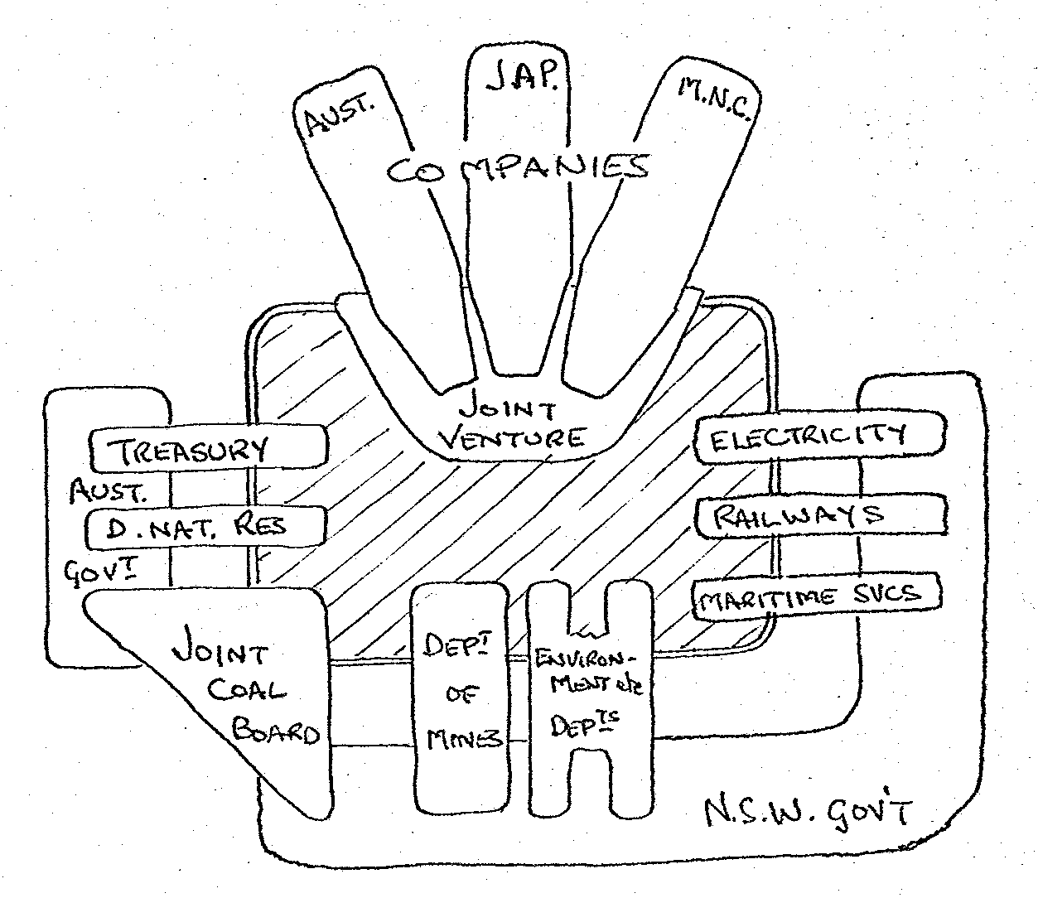
Diagram 1: A typical ‘Multi-organisation’ – a coal project in NSW

The fact is, however, that there is little science of inter-organisational relations.
"Too much sociological theory and research has been based mainly on the model of a single organisation, and attention has been focused on its internal processes, by and large. Surely this dominant model is not sufficient to analyze newer and more complex organisational forms such as the interlocking networks of organisation in the civil service, the multi-campus state university, regional consortia of educational institutions, multi-outlet distributive organisations in business, and multi-plant industrial concerns. Having become rooted in its social and technological environment and more complex ways, organisations find themselves both constraining and being constrained by these environments in new ways. Yet investigators of formal organisations have barely begun to attack these new relationships (Smelser and Davis, 1969, p. 65).”
We may ask how this situation has come about and surmise that it derives from the fact that research typically does not start from where the problems are. With all the ideas in good currency being about what happens within organisations rather than about what happens between them, we have in recent times come to believe that problems can be solved by wholesale reorganisation. What knowledge there is about inter-organisational relations is therefore precious.
I have deliberately tried to stress the industrial need for better understanding of inter-organisational relations, since IOR's work has been predominantly in the public domain. One important difference is that in the public sector the need for co-ordination is regarded as obvious and desirable, whereas in the industrial context it raises the bogies of cartel and collusion and unfair access to price sensitive information. Much of the public regulation of industry is based on the belief that these forms of collusion are bad although it is interesting that industry is increasingly pointing to the high cost entailed in such detailed regulation.
In short we should be prepared for the emergence of new, modified or adapted forms of inter-organisational relationship and if we can help to recognise them as they emerge and assist in their effective emergence, then we shall be where the action is.
Conditions for the research process
Here I must be brief; the two essential conditions are (i) access to interesting situations, and (ii) an appropriately experienced scientific team.
We have seen instances of an interesting "mess" being presented, not in terms of what the problem-owners "feel" but in terms of what they think is an appropriate formulation to attract the scientists, or to get them "onside". Some of the most intellectually fruitful IOR work has occurred, however, when the client has been too desperate to play these games. Perhaps this should be contrasted with the stultifying effect which occurs when those in Government responsible for placing research contracts have their own belief in the relevance of one type of methodology - and one only. Ashby's law of requisite variety should be sufficient to warn us of the dangers of this.
Access to interesting situations is a matter of maintaining a wide network of contacts, of skill in spotting promising "messes" and of negotiating skill in gaining access on terms acceptable to all the parties. We have heard something (and need to know more) about this.
This brings us to the skills and experience of the scientific team. I can illustrate this with diagram 2. Two axes are shown (there should be more) differentiating between the factors of skill in modelling (conventional OR) and in working with inter-personal and inter-organisational relations and with change, respectively. The "feasible region", within which people do "COOR-type" work is, I suggest, like that bounded by the shaded lines. Now we have three things which need to come together. First, the "real" problems, lying somewhere on the diagonal. Second, the points at which access to these problems can be negotiated - typically seen as closer to one or other of the disciplinary axes. Third, the personal attributes of the scientific team.
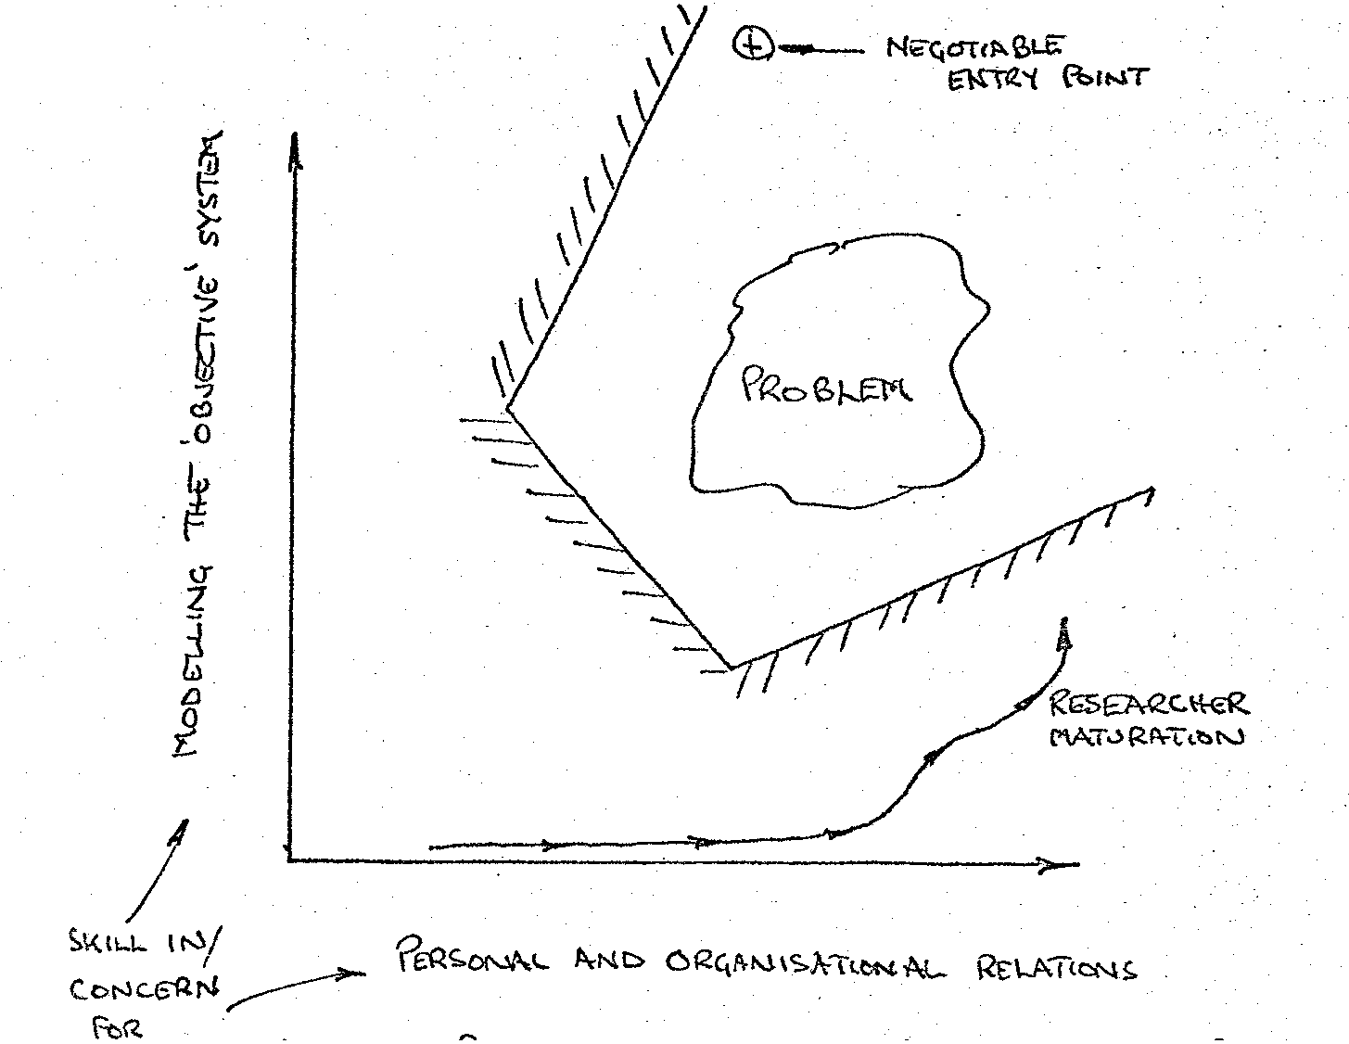
Diagram 2 – Conditions for Problem-centred Research
It is too much to expect people whose basic orientations are at right angles to one another, to be able to combine to produce a synergy at 45 degrees. But it is possible if each can rotate his or her orientation. This is the process of maturation, and differs markedly from the "brilliant youngster" on which science tends to pin its hopes.
But this raises difficult questions of how people can acquire the necessary maturity, departing from their disciplinary origins in the process. Where are they to gain the experience? What career paths are open to them? Those who believe that the answer to the access and implementation problems which OR groups often suffer can be solved by a simple injection of behavioural science lubricant, should think again. We need a process for developing "mature" scientists in the sense that I am using that term here. I now understand, although I don't condone, the pressures which militate against Universities either providing such people or legitimating their research style.
Dissemination
Here I have even less to say. Writing and talking about it are severely limited; the learning process has to be experiential. The experiments with `Linkage'⁴ and the forthcoming Tavistock Action Research Training Program look interesting and useful.⁵ But I must confess to being woefully short of fresh ideas as to how to bring Paradigm 3 into common currency.
Let me therefore place the questions I have raised in the context of diagram 3, and leave it to the discussion to take us round a few more whirls. Remember, though, the criterion all the time is "maximum rate of shared learning", so that when the whistle blows the actions we take are as soundly based as the circumstances permit. In a complex world, that is all we can hope to do.
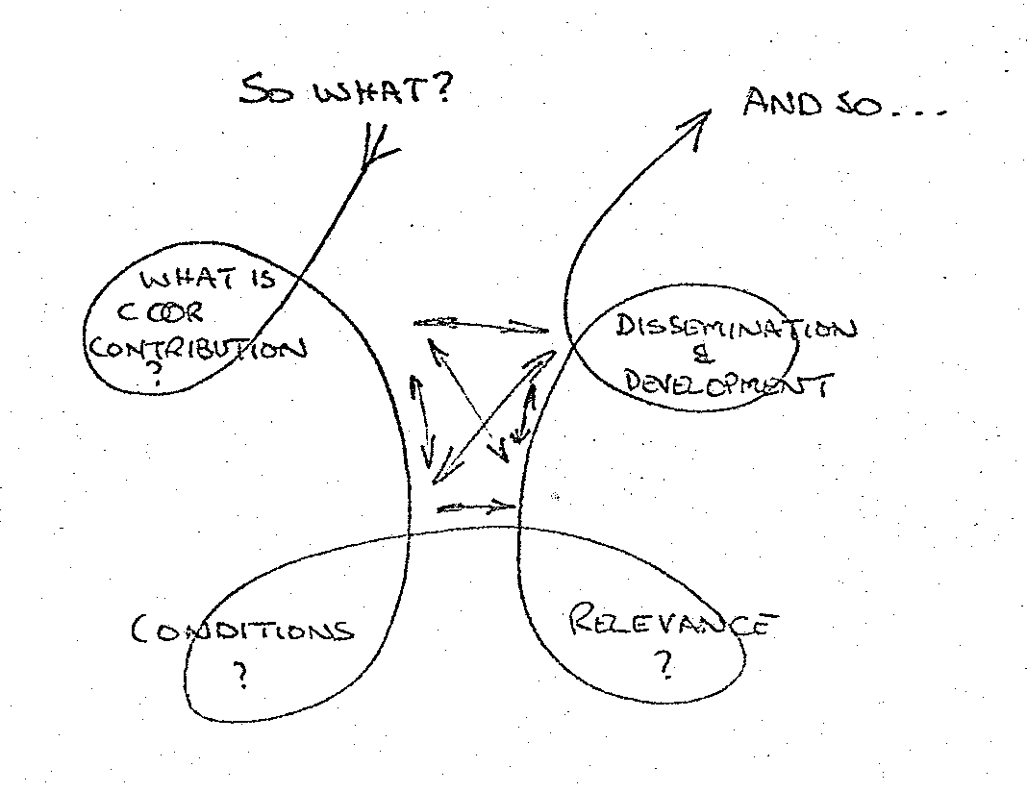
4. Centre for Organisational and Operational Research. Linkage.
(Further information can be obtained from John Friend, Centre for Organisational and Operational Research, The Tavistock Centre, Belsize Lane, London NW3 5BA (telephone 01-435-7111).)
5. Tavistock Institute of Human Relations. Action Research Training Program.
(Further information can be obtained from Alastair Bain at The Tavistock Institute of Human Relations, The Tavistock Centre, Belsize Lane, London NW3 5BA. (telephone 01-435-7111).

Tavistock Institute of Human Relations. Annual Report 1977/78.
Operational Research Society. A proposal for. an 'Institute for Operational Research'; recommendations of Joint Working Party with the Tavistock Institute of Human Relations, CR/115/1962.
Institute for Operational Research. IOR: the First Four Years, 1963-1967 May 1967.
Institute for Operational Research. Industrial Support of Basic Research in OR. 1969.
Morgan, J.R. and Luck, G.M. The Investment System in the Firm. Institute for Operational Research Monograph No. 1, December 1978.
Drake, R.I., Morgan, J.R., Pollard, J. de B and Quinn, P. A Career System Integrating an Assignment Model with Subjective Information and Individual Aspiration. In: Clough, D.J., Lewis, C.G. and Oliver, A.L. (editors).Manpower Planning Models. English Universities Press, 1974
Luck, G.M., Luckman, J., Smith, B.W. and Stringer, J. Patients, Hospitals and Operational Research, London, Tavistock Publications, 1971.
Tavistock Institute of Human Relations. The Place of Research in Social Choice. A symposium dedicated to the memory of William Neil Jessop. 1970.
Stringer, J. Operational'Research and Public Policy. Paper to Second International Research Conference on Operational Research. University of Sussex, 1976.
Bennis, W.G. Theory and method in applying behavioural science to planned organizational change. In: Lawrence, J.R. (ed.) Operational Research and the Social Sciences. London, Tavistock Publications, 1966, pp 33-76.
Trist, E.L., Higgin, G.W., Murray, H. and Pollock, A.B. Organisational choice: capabilities of groups at the coal face under changing technologies. London, Tavistock Publications, 1963.
Friend, J.K. and Jessop, W.N. Local Government and Strategic Choice. 2nd edition: Oxford, Pergamon Press, 1977.
Tavistock Institute. Interdependence and Uncertainty: a study of the building industry. London, Tavistock Publications, 1966.
Blake, R.R., Mouton, J.S., Barnes, L.B. and Greiner, L.E. A Managerial Grid Approach to Organizational Development. Harvard Business Review, 42, 1964
Menzies, I.E.P. A case-study in the functioning of Social Systems as a defence against anxiety. Human Relations, 13, 1960, pp 95-121
Ackoff, R.L. "The future of operational research is past". Journal of the Operational Research Society, 30, 2, 1979, pp 93-104. and "Resurrecting the future of operational research". Journal of the Operational Research Society, 30, 3, 1979, pp 189-199.
Stringer, J. "Operational Research for 'Multi-Organizations". Operational Research Quarterly, 18, 2, 1967, pp 105-120.
Friend, J.K. and Jessop, W.N. Local Government and Strategic Choice. 2nd edition: Oxford, Pergamon Press, 1977
Friend, J.K., Power, J.M. and Yewlett, C.J.L. Public Planning: the inter-corporate dimension. London, Tavistock Publications, 1974.
Ackoff, R.L. Redesigning the Future. New York, Wiley, 1974
March, J.G. and Simon, H.A. Organizations. New York, Wiley, 1958.
Lindblom, C.E. The Intelligence of Democracy: decision making through mutual adjustment. New York, Free Press, and London, Collier-MacMillan, 1965.
Etzioni, A. The Active Society: a theory of societal and political processes. London, Collier-MacMillan, 1968.
e.g. Trist, E.L. "A Concept of Organisational Ecology" (invited address to the three Melbourne Universities). Mimeo, 1976.
Friend, J. and Noad, A. "Inter-organisational Linkage: towards a useful theory`". Linkage Two, London, IOR, 1977.
Friend, J., Norris, M. and Carter K. Regional Planning and Policy Change: the formulation of policy guidelines in regional strategies. London, Department of the Environment, 1978
Howard, N. Paradoxes of Rationality. Cambridge, Mass., and London, MIT Press, 1971.
Higgin, G.W. and Jessop, W.N. Communications in the Building Industry. London, Tavistock Publications, 2nd edition 1965 and Interdependence and Uncertainty: a study of the building industry, London, Tavistock Publications, 1966.
Friend, J.K., Hickling, A. and Luckman, J. "The Development Plan System and Investment Programmes" (SPICE). London, COOR/19, 1979.
Noad, A. "Negotiated Research in Complex Fields". London, COOR/6, 1978.
Hart, D., Hickling, A., Norris, M. and Skelcher, C. "Regional Planning Methodology. A report to the DOE" (in draft). Birmingham, Institute of Local Government Studies, and London, COOR/4, 1978.
Friend, J.K. and Jessop, W.N. Local Government and Strategic Choice: an operational research approach to the processes of public planning. 2nd edition: Oxford, Pergamon Press, 1977.
Hickling, A. Managing Decisions: the Strategic Choice Approach. Rugby, Mantec Publications, 1974.
Bather, N.J., Williams, C.M. and Sutton, A. Strategic Choice in Practice: the West Berkshire Structure Plan Experience. Geographical Paper No. 50, Department of Geography, University of Reading, 1976.
Bunker, R. Making Decisions in St. Albans. Built Environment, Vol. 3, No. 4, June 1974, Pp 316-318.
Cardinal, C. et al. The Application of Strategic Choice to the Preparation of an Urban Structure Plan for Worcester City. in: IFHP Papers and Proceedings, International Congress, 24-30 August 1975. International Federation for Housing and Planning, The Hague, 1975.
Dekker, F. et al. A Multi-Level Application of Strategic Choice at the Sub-Regional Level. Town Planning Review, Vol. 49, No. 2, April 1978, pp 149-162.
Jones, W.L. and Morgan, J.R. Use of Decision Diagrams to Examine Tooling Problems. The International Journal of Production Research, Vol. 6, No. 2, 1967, pp 123-134.
Hickling, A. and Luckman, J. Exploring Perceptual Differences Attributable to Organisational Variables - A Case Study. London, Centre for Organisational and Operational Research, IOR/957R, 1978.
Luckman, J. An Approach to the Management of Design. Operational Research Quarterly, Vol. 18, No. 4, 1967, pp 345-358.
Centre for Organisational and Operational Research. The AIDA Program: A User's Guide. London, Centre for Organisational and Operational Research, IOR/884R, 1978.
Wedgwood-Oppenheim, F. Planning Under Uncertainty. Local Government Studies, 2, April 1972.
Hickling, A., Friend, J. and Luckman, J. The Development Plan System and Investment Programmes. London, Centre for Organisational and Operational Research, COOR/19R, 1979
1. Rosenhead, JV (1978). An Education in Robustness. Journal of the OR Society, 29: 105-111.
Gupta,S.K. and Rosenhead, J. Robustness in sequential investment decisions. Management Science, Vol. 15, No. 2, October 1968.
Friend, J.K. and Jessop, W.N. Local Government and Strategic Choice: an Operational Research Approach to the Processes of Public Planning. 2nd Edition: Oxford, Pergamon Press, 1977. Reprinted 2013 by Routledge in Routledge Revivals series.
Friend, J.K., Wedgwood-Oppenheim, F., et al.. The LOGIMP Experiment: a Collaborative Exercise in the Application of a New Approach to Local Planning Problems. Centre for Environmental Studies, CES IP 25, London, 1970.
Operational Research Society. A proposal for an 'Institute for Operational Research'; recommendations of Joint Working Party with the Tavistock Institute of Human Relations, CR/115/1962.
Friend, J.K. and Jessop, W.N. Local Government and Strategic Choice: an Operational Research Approach to the Processes of Public Planning. 2nd edition: Oxford, Pergamon Press, 1977.
Luck, G . and Stringer, J. Hospital Operational Policies at the Commissioning Stage. London, Institute for Operational Research Health Report No. 3, 1970.
Elton, M.C.J.E., Hill, P.M., Hunter, J.M.H., Millen, D.W. and Turner, T.P. An Approach to the Location of Government. Operational Research Society/The Institute of Management Sciences International Conference, London, 1970.
Mayntz, R. and Scharpf, F.W. Policy-Making in the German Federal Bureaucracy. Amsterdam, Elsevier, 1975.
Cardinal, C. et al. The Application of Strategic Choice to the Preparation of an Urban Structure Plan for Worcester City. In: IFHP Papers and Proceedings, International Congress, 24-30 August 1975. International Federation for Housing and Planning, The Hague, 1975
Hickling, A. AIDA and the Levels of Choice in Structure Plans. Town Planning Review, Vol. 49, No. 4, October 1978, pp 459-475.
Floyd, M. Structure Plan Monitoring: Looking to the Future. Town Planning Review, Vol. 49, No. 4, October 1978, pp 476-485
Friend, J.K., Power, J.M. and Yewlett, C.J.L. Public Planning: the Inter-Corporate Dimension. London, Tavistock Publications, 1974.
Friend, J.K. The Dynamics of Policy Change. Long Range Planning, Vol. 10, No. 1, February 1977, pp 40-47.
Howard, N. Paradoxes of Rationality: Theory of Metagames and Political Behaviour. Cambridge, Mass.: M.I.T. Press, 1971.
Ackoff, R.L. The future of operational research is past. Journal of the Operational Research Society, 30, 2, 1979, pp 93-104.
Ackoff, R.L. Resurrecting the future of operational research. Journal of the Operational Research Society, 30, 3, 1979, pp 189-199
from: Introduction to Evan, W.N. "Inter organisational relations" 1976.

