Modelling the Northern Powerhouse
Aidan Cross, Jack Snape, Rachel Tadd, Chris Storey
Rail Analysis Manager
Transport for the North
YHORG was reinvigorated with an exciting talk by Aidan Cross and his colleagues on 14 November 2018. Aidan Cross, Rachel Tadd, Chris Storey, and Jack Snape gave presentations of their respective project areas within Transport for the North (TfN) and the opportunities and challenges facing the northern region of the UK with respect to changing economies, urban growth, transport infrastructures and improved technologies.
Aidan Cross joined TfN in 2016 to lead development of the evidence base for Northern Powerhouse Rail. He introduced the complexities of the geographical region of the north of England including the existing infrastructure and transport network. There is a strong link between transport and economic growth. Therefore, to help grow the north, it is key that major interventions are made along the principal transport “corridors” between the cities and towns of the North. Northern Powerhouse Rail is part of this and will be in addition to but make use the planned HS2 lines which will improve speed and connectivity. Away from rail, the major road networks need to be improved as well as making use of new technologies to increase efficiency of current infrastructure. TfN is a small organisation but works with academics and government on the analytics of a big problem with complex data and new technologies.
Jack Snape leads on wider economic modelling at TfN, exploring the impacts of transport investment on businesses and households in the north. He discussed the impact of faster travel through urban agglomeration increasing the productivity of land and creating ‘knowledge spill-overs’ where greater interactions between people and business increase innovation. As better transport reduces the travel time between the northern of cities, so business are able to access a greater labour pool and people are able to take advantage of more jobs and trading opportunities. A Systems dynamics model has been designed to model this. NELUM (Northern Economy Land Use Model), shows how growth and change affects attractiveness to employers and to the population. Transport costs and infrastructure are key to access and employment. Open questions remain such as how the North can transform into a functioning polycentric economy, what role specialism between cities could play, and wider social welfare impacts such as how to ensure inclusive growth in the economy
Rachel Tadd works as part of TfN’s data analytics and modelling team, where she leads work on demand forecasting for transport models as well as on internal quality assurance processes. She explained the Northern Transport Modelling System and how it links with the economic model NELUM. As the modelling area is within the North of England this is impractical for detailed simulations: as such there is a mismatch between the spatial detail within the models. To manage this, TfN have developed integration tools for the conversion of demand and supply between the transport and economy models. Rachel discussed how much data is now available from technologies such as mobile phones showing movement, as well as ticket sales (although it was noted that ticket prices can be inconsistent according to route choice). Data has also been segmented differently making it more complicated to match over the region and time periods. Also data can be categorised in different ways. Despite the modelling challenges the outputs are vital building blocks in planning future changes.
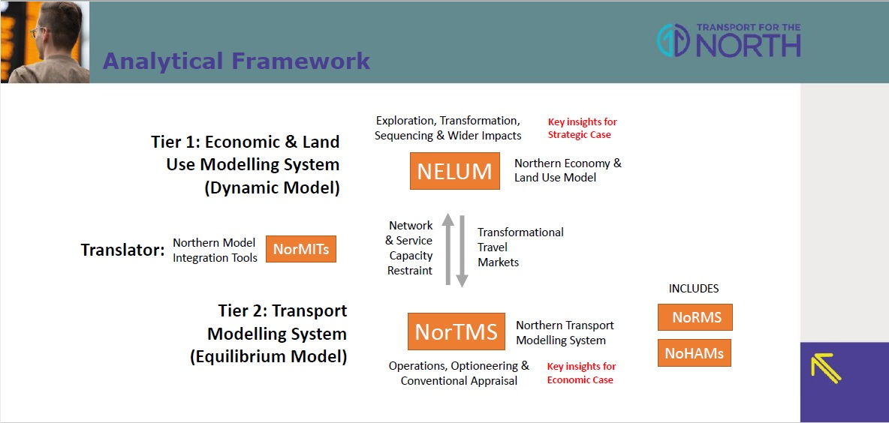 Copyright Transport for the North
Chris Storey has been with TfN for 3 months as a modelling and analysis officer. He explained the IT framework that was designed to facilitate analysis and sharing. The design takes into account the need for clear provenance and high level visualisation. As a new design it has been built to take into account cloud capabilities with an integrated visualisation platform. Role based permissions are embedded and reuse of code and analysis is made possible as a valuable resource for users.
The team was passionate about the work and value in working on such an important area for the North. The audience were engaged and asked a variety of questions relating to the economic modelling, security issues, practical considerations of people who actually might be more productive on longer rather than shorter journeys, and why their local train service was consistently delayed.
The presentation gave a clear overview of the strength of OR and analytics in approaching big problems but with a need to work at a local level.
Further details of the presentation can be found here:
http://www.theorsociety.com/Pages/Regional/yhorg_reports.aspx

