SIX IMPORTANT DIRECTIONS FOR RESEARCH IN PUBLIC POLICY CHOICE
Introduction. There are several inter-related directions of field-grounded research in public policy and planning processes which were pursued by teams in the Coventry office of the Institute for Operational Research (IOR) between the late 1960’s and the early 1980’s, in the course of a succession of public policy projects, some supported by UK government departments and some by national research councils. The research directions to be reviewed in this note are all closely intertwined, but will be introduced here under the following six broad headings:
- Inter-organisational linkage
- Mapping public policy landscapes
- Dynamics of policy change
- Design of public policy dialogues
- Design of public policy engagements
- Negotiated project engagements

None of these research directions has so far been prominent on the radar of the academic OR community. For the primary focus within OR has been on the development and application of logical and mathematical methods to support people facing complex decisions within organisations. From that perspective, the most important contribution of IOR tends to be regarded as the development of the Strategic Choice Approach, viewed as a leading example of a category of interactive problem structuring methods. This view contrasts with the more dynamic view which reflects the origins of SCA in inter-disciplinary research into public planning processes. In that context, it developed as a decision-centred philosophy of planning under competing pressures for commitment and for response to multiple sources of uncertainty. The contrast between these perspectives is illustrated below:

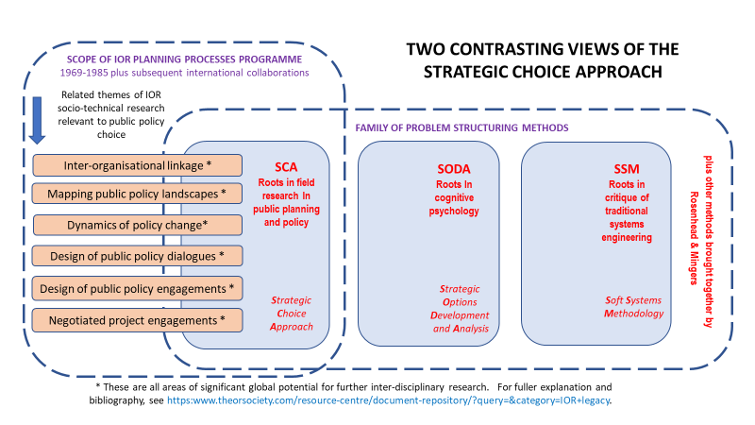

The six research directions explained. The sections that follow present fuller background on the six directions of policy-relevant research that became prominent between the late 1960’s and the early 1980’s for teams from the former IOR planning processes group in Coventry. References will be given at the end of this note to books, to journal articles and to a set of unpublished documents that have recently been lodged in the IOR legacy section of the document repository on the OR Society’s website. Most of the articles are to be found in planning and policy journals which do not normally appear on the horizons of students of operational research and management science. These references should be of value as starting points for future researchers who have opportunities to conduct further investigations into the challenges of developing public policies in any important field of social, environmental or economic concern.
Research direction A: Inter-organisational linkage. In the earliest policy research projects of IOR, challenges of inter-organisational decision-making were recognised as pervading most worlds of public policy, and thus as an important priority for fundamental research. An opportunity to undertake such research arose in 1968 when the UK’s recently formed Social Science Research Council agreed to support IOR in first a short pilot study¹ and then a fuller three-year research project on the theme of Decision Networks in Regional Development². The focus of this research was on a fifteen-year inter-agency development programme to expand fourfold the population of the small town of Droitwich in the English Midlands, as a contribution to accommodating “overspill” population from the regional metropolis of Birmingham. This programme was managed through a multi-disciplinary development group accountable to a joint committee of the responsible county and district councils. The research team explored the politics of this partnership as it addressed a succession of local challenges, while the policies of the relevant governmental themselves shifted through time. From this research they developed a pluralistic view of the processes of developmental decision making through a complex and evolving network of mandatory, negotiated and inter-personal linkages cutting across organisational boundaries; and they began to explore the wider implications for the design of inter-agency relationships relating to any other such development initiative. There is now an exciting scope for the design of similar methods in exploring 21st century challenges of inter-organisational partnership within different national configurations of public administration¹².
Research direction B: Mapping Public Policy Landscapes. In order to build a fuller picture of the wider pattern of relationships surrounding the Droitwich development, a graphical mapping method was introduced. This started with a two-dimensional base map in which the vertical dimension represents territorial scale and the horizontal dimension represents a distinction between public and private organisations. On this base the research team superimposed a series of overlays, each indicating the locus of the various organisations and individuals involved in a different area of decision at the time of the research. By superimposing these overlays, a fuller picture could be built up of the complexity of formal and informal relations surrounding the Droitwich scheme. Future researchers should be able to develop this kind of mapping method further, in order to map future public planning networks with the additional help of computer database technology, applying principles of the kind that have now become widely used in the design of geographical information systems,
Research direction C: The Dynamics of Policy Change. Several of IOR’s policy projects in the UK during the 1970’s drew attention to the subtle two-way dynamic of policy change, in which top-down pressures from any source of public policy are counteracted by bottom-up pressures from more local policy “agents”. Such local agents may themselves be subject to conflicting guidelines from multiple policy sources which employ different rules of classification in guiding their response to any one potentially complex local case, creating a local situation of policy stress which can itself fuel upward pressure for policy change. A paper outlining this dual perspective of the dynamics of policy change, and the semantic choices involved in the design of policy statements, was first published in 1977 in the journal Long Range Planning⁴. This kind of challenge became prominent in other IOR projects, including a major development project commissioned by the government department responsible for the introduction in England of a new system of county structure plans. These plans involved the presentation of a consistent set of written statements of policy relating to land use, rather than the drawing of spatial maps indicating intended future states. The introduction of a new formal system of Examination in Public of County Structure Plans highlighted the conflicts between organisations representing different public interests that could arise over the choice of wording in these policy statements -not only relating to policy direction but also to level of specificity versus nebulosity in their wording¹².
Research direction D: The Design of Public Policy Dialogues. Although the strategic choice approach to planning in its pure form does not call for a hierarchical distinction between different levels of choice, IOR’s research in the design of structure plans⁵ led to the introduction of a distinction between broad statements of objectives and more specific options of operational policy, as stipulated in the design of the new planning system. This led to the introduction of a two-dimensional grid enabling dialogue about compatibilities between broad statements of objective and specific policy options, enabling elected representatives to explore compatibilities with their specialist advisers, without any requirement to declare preferences in the process. Similar methods have since proved of considerable value in unlocking an entrenched conflict between agricultural and environmental stakeholders in agreeing a regional strategy for water use and conservation in a prime agricultural region in a leading food exporting nation, pointing to a case for further research into the value of such policy design methods in reaching agreement in similar situations of sharply conflicting interests.
Research direction E: The Design of Public Policy Engagements. The project work of Allen Hickling in the 1980’s alongside associates in the Netherlands and other European countries enabled him to contribute to the strategic design of extensive programmes of national environmental policy planning. The resulting designs involved sequences of workshops over several months in which a wide range of stakeholders became engaged not only in planning teams and in other roles of direct responsibility, but also in wider technical, political or implementation roles, as described in Chapters 11 and 12 of the third edition of Planning under Pressure¹⁵. Hickling’s engagement in the design of a first National Environment Policy Plan for the Netherlands paved the way for further experiences in designing programmes of extensive national policy development, including a pioneering National Environmental Policy Plan for Latvia, the strategic design for which is summarised in Figure 102 of Chapter 12.

Research direction F: Negotiated Project Engagements. in 1980, the UK Social Science Research Council agreed to support a six-month IOR project to review the experience of successive past projects which had sought to combine insights from operational research and the social sciences. Drawing on the work of Hylton Boothroyd in his book Articulate Intervention¹³, the project team developed a general model for comparing the experiences of successive negotiated project engagements. Such a temporary engagement was viewed as involving the interaction of people within an agent domain, acting either as consultants or researchers, with other people within a host domain. In many cases the project was also supported or commissioned by people in an external sponsor domain whose concern is to achieve broader learning outcomes. Within each of these domains, people may be influenced by different programme strands of three broad categories: disciplinary, institutional and personal. During and after the period of this brief review project¹¹, this multi-stranded analytical framework was used to ask questions about the ways in which each programme strand had influenced the course of the project, and had in turn been influenced in its further development by the experience of that particular engagement. This general kind of approach, when applied to the review of any completed or ongoing project engagement, has proved of particular value in exploring public policy projects in which there may be not only multiple project agents, but also multiple hosts and, especially in contexts of international co-operation, multiple sponsors as well. Further refinement of this general enquiring method, supported by the development of electronic data bases for recording and sharing the resulting data, could be of wide significance for the future of public policy research.

References. The following bibliography includes not only one published book² but also a selection of articles in planning and policy journals, none of which are as yet familiar to students of operational research. Together they introduce concepts and methods that have been developed through projects within the IOR Planning Processes Programme which are not covered in introductory presentations of the strategic choice approach, yet which have attracted attention in professional communities in public policy disciplines such as environmental planning, political science and public administration. Unless otherwise stated, the papers are authored by the present author [John Friend], in some cases with co-authors.

- 1970 Multi-organisational Decision Processes in the Planned Expansion of Towns. In Environment and Planning, 2, 33-54 (with Hunter JMH).
- 1974 Public Planning: the Inter-Corporate Dimension. London: Tavistock Publications. with Power JM and Yewlett CJL. Reprinted Routledge 2001 in Tavistock Classics series.
- 1976 Planners, Policies and Organisational Boundaries: some recent developments in Britain. In Policy and Politics, 5, 23-46.
- 1977 The Dynamics of Policy Change. In Long Range Planning, 10, 40-47.
- 1978 AIDA and the Levels of Choice in Structure Plans. by Hickling A. In Town Planning Review, 49, 459-76.
- 1979 Planning in a Multi-organisational Context. In Town Planning Review, 51, 261-9.
- 1981 Competition in Public Policy: the Structure Plan as Arena. In Public Administration, 59, 441-62.
- 1990 Planning Concepts, Planning Contexts. In Systems Practice, 3, 195-206.
- 1993 The Strategic Choice Approach in Environmental Policy-making. In The Environmental Professional, 15, 164-75.
- 1995 Developmental Decision Processes; the Evolution of an OR Approach. In International Transactions in Operational Research, 2, 225-32.
- 1998 Negotiated Project Engagements: Learning from Experience. In Human Relations, 51, 1509-42. with Bryant DT, Cunningham JB and Luckman J.
- 2006 Partnership meets Politics: Managing within the Maze. In International Journal of Public Sector Management, 19, 261-77.

See also the following books:

- 1979 Articulate intervention. Boothroyd, H. Taylor and Francis.
- 2001 Rational Planning for a Problematic World Revisited. Rosenhead J and Mingers J. Wiley.
- 2005 Planning under Pressure: the Strategic Choice Approach. Friend J and Hickling A. 3rd edition: Routledge.

For a comprehensive coverage of the philosophy and toolkit of the Strategic Choice Approach to communicative planning, you are referred to the third edition of Planning under Pressure¹⁵. You are also referred to Chapter 7 by Hickling of the book by Rosenhead and Mingers¹⁴, which describes an early application to shaping the policy of the Netherlands government in response to a pressing challenge of agreeing national policies for the transport and storage of volatile petrochemical feedstocks.

John Friend August 2019

