Early Career Researcher Workshop 14th Sept 2020
Warwick University

ECR20 Programme

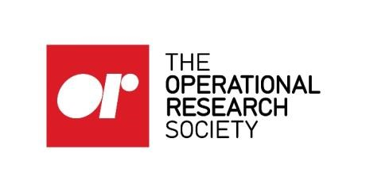
Monday 14 September 2020
8:30 to 9:00 | Registration and Networking
9:00 to 9:15 | WELCOME PLENARY  Conference Suite 1  Kevin Glazebrook
9:15 to 10:15 | GRANT WRITING  Laura McDonnell (EPSRC)
10:15 to 10:30 | MOCK PANEL INTRODUCTION  Kevin Glazebrook and Laura McDonnell
10:30 to 11:00 | Morning Coffee
11:00 to 12:30 | MOCK PANEL A Room 1A  Christine Currie | MOCK PANEL B  Room 1B  Kerem Akartunali | MOCK PANEL C  Room 2A  Kevin Glazebrook | MOCK PANEL D  Room 2B  Arne Strauss
12:30 to 13:30 | Networking Lunch
13:30 to 14:30 | PLENARY- “Playing the academic long game in a short-game world”  Barry L Nelson
14:30 to 15:30 | Q&A PANEL SESSION  Chair: Lucy Morgan, Panel: Barry L Nelson, Laura McDonnell, Kerem Akartunali, Nursen Aydin
15:30 to 16:00 | Afternoon Coffee
16:00 to 17:30 | LIVE GROUP GRANT WRITING
17:30 to 17:45 | CLOSING PLENARY Kevin Glazebrook
19:00 to  20:45 | ECR Dinner at Canopy

