“What could mentoring do for you?”
By Antuela Tako, Professor in Operational Research, Loughborough Business School
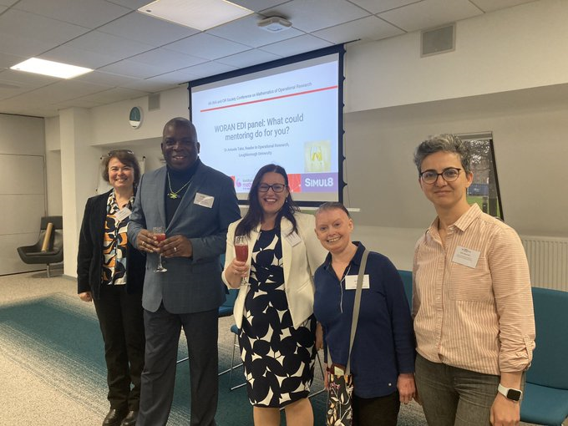
Picture showing panellists from left to right (Corina Constantinescu, Nira Chamberlain, Antuela Tako, Jenny Mason and Selin Ahipasaoglu)
As a member of the Women in OR and Analytics Network (WORAN) mentoring sub-committee, I had the honour and pleasure to lead an equality, diversity and inclusion (EDI) panel to discuss mentoring at the 4th IMA and OR Society Conference on Mathematics of Operational Research. The conference run on the 27-28 April 2023 at the Aston Conferences in Birmingham.
Motivated by the limited familiarity with and access to mentoring in the OR, Analytics and Maths professions, the aim of this panel was to raise awareness about mentoring and its benefits in supporting career development in academia and industry. This can be especially beneficial for women, as well as for people from BAME backgrounds, LGBT or anyone with neurodiverse conditions, who can be perceived less capable and often get marginalised or overlooked in taking up high level leadership responsibilities.
The panellists included a set of select and diverse individuals: Professor Dr Nira Chamberlain OBE, FIMA FORS CSci PhD HonDSc, past president of the Institute of Mathematics and its Applications (IMA); Professor Corina Constantinescu, Professor of Mathematics and Director of the Institute for Financial and Actuarial Mathematics, University of Liverpool; Dr Jennifer Macey, Vice-President Professional Affairs and Industry IMA, Corporate member OR Society & RSS; Dr Selin Damla Ahipasaoglu, Associate Professor in Operational Research and Director of the Centre for Operations Research, Management Science, and Information Systems (CORMSIS), University of Southampton. We had a drinks reception sponsored by SIMUL8 Corp, whose leadership enthusiastically support mentoring.
The audience heard the panellist’s diverse opinions and experiences about mentoring. Nira’s view was that mentees should choose the advice based on their drive and ambition; the mentor is not there to tell you what to do. Corina shared with the audience how rewarding an experience it is to be a mentor and the importance of celebrating success. Jenny spoke about how empowering mentoring can be by having someone who can motivate and support you in pursuing what you need and want and reminded us that everyone, regardless of seniority level, would benefit from a mentor. Selin spoke specifically about women in academia, who may have different career paths and aspirations than their male counterparts and that the mentor can help women build confidence and encourage them to take initiatives and risks, which can lead to more successful careers.
Next, the panellists answered interesting questions posed by the audience. We discussed practical aspects about mentoring such as how to find a mentor, who can be a mentor and more. It became very clear that we all need to be more open to mentoring in our professions, as mentors and mentees. In my view there is NO “wrong” mentoring but goodwill and desire to giving back to someone less experienced than you. It is in our hand to develop an environment where mentoring is woven within our culture and help our community to thrive.
The panel ended with a “speed-dating” networking session where the attendees had the opportunity to practice mentoring in action and to even find a mentor if that was conducive. I was impressed seeing attendees immerse themselves into this session, even though it can be daunting at first.
All in all, the panel was very well received. This gave us all a sense of achievement. I thank the organising committee for inviting me to organise this panel. I look forward to continuing the discussion on mentoring in the future and to hearing any mentoring stories that may have come out as a result of this panel!

